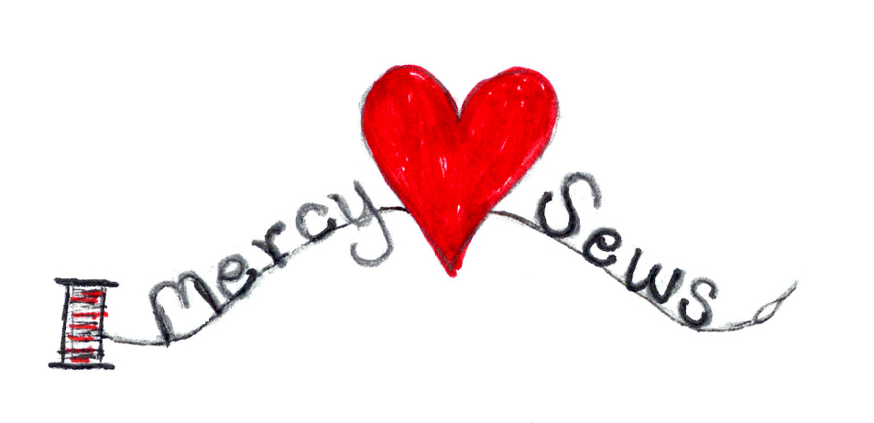

BOYS SHORTS

Any simple elastic waist pattern for a child’s pair of shorts (six months to five years size) can be used to sew shorts. Either solid colors or appropriate patterns are acceptable. Some suggested patterns for shorts include Simplicty Pattern 1605 and Butterik Pattern 5153.

Below is a link to a free pattern called Sunny Day Shorts from Oliver and s:

https://oliverands.com/free-patterns/sunny-day-shorts/

SEAM FINISH FOR RAW EDGES ON SHORTS:

After stitching the seam, press to one side and stitch the seam allowances together with a zig-zag or multi zig-zag stitch. One multi-zig-zag option is to use a 3.0 stitch width and 4.0 stitch length, but you might prefer different settings, or another functional stitch on your machine!

