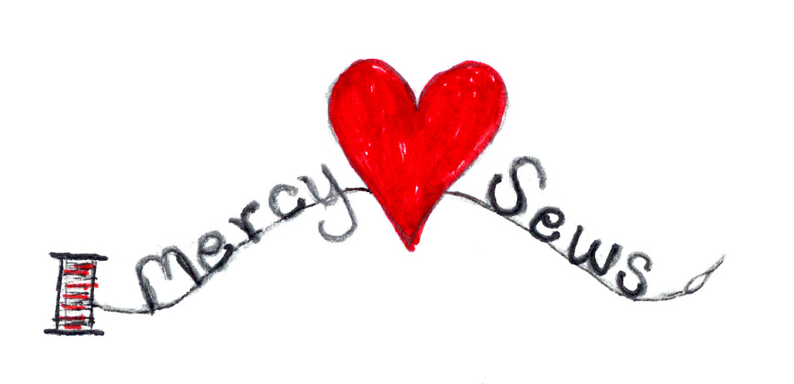

**DUDUZA DOLL CROCHET PATTERN**

**Crocheted African Doll**

- Hooks – F & G

- Yarn Needle for Sewing

- Yarn – Red Heart color Café Latte for Head & Feet

- Small Amounts of 3 different colors for Top, Waistband & Pants or Skirt.

- Red & Black for eyes, nose and mouth.

Working from feet to head:

With Café Latte color and G Hook, leave a tail, CH 33, Turn Sc in 2nd CH from Hook and in each CH to end (32 Sc) CH 1 turn.

Row 2: Working in back loop Sc across to next to last St Sc through 2 loops of last St, turn.

Change Color for pants/skirt

Work 9 more rows the same, leave tail for sewing later.

Change color for waistband, work 1 row Sc across in both loops.

Change color for shirt, work 9 rows same as Row 2. Work next row in both loops.

(Dec Row) Sc in first 2 Sts, Dec 2 Sc together.

Sc in next 3 Sts Dec across. Leave tail for sewing.

Change to face color and F Hook. Sc in both loops across, turn work 8 more rows.

Next 3 rows, Dec as before, leave long tail to sew head & neck.

SEWING – (Bold side of waistband is right side)

With long tail, sew head by running through last row of head, pull tight knot.

Working on wrong side, fold and sew seams with long tails. Do not cut tail for head – will need to close head when turned right side out. Sew in ends, turn right side out. Stuff head then use tail to sew head by running around neck edge.

Pull tight knot, run through again, fasten off. Stuff body, sew feet.

ARMS - Sew through both layers from shoulder to waist. Repeat for other arm.

BOYS – Sew seam in middle of pants for legs.

CAP – with F Hook, CH 4, join to form ring. 6 Sc in ring. Place marker working in back loop, 2 Sc in each Sc (12 Sc).

Back loop 2 Sc 1 Sc around (18)

Back Loop 2 Sc 1 Sc 1 Sc 2 Sc around (24)

Back Loop 2 Sc 1 Sc 1 Sc 1 Sc 2 Sc around (30)

Back Loop next 2 rows Sc around

Change Color – next 2 rows in both loops, Sc around, leave a long tail to sew to head.

BOW – F Hook, leave a long tail to start CH 40 leave another long tail.

Tie bow around neck, use long tail to sew bottom ribbon part to body.

Sew eyes, nose & mouth.

Pattern Courtesy : Linda Laskey

User/Miscellaneous/Crocheted African Doll

