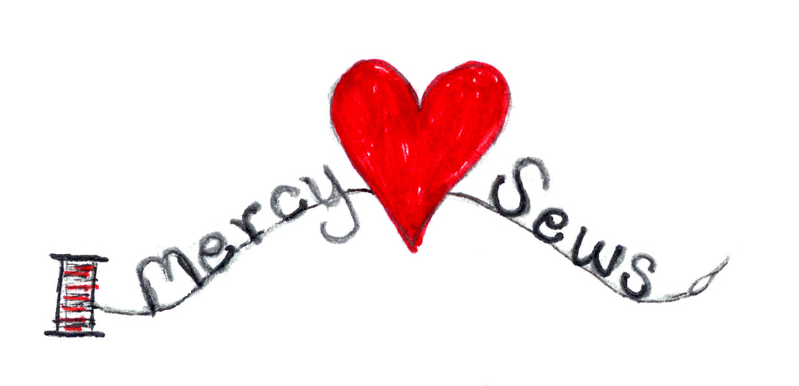

**Knit Instructions for Duduza Dolls**

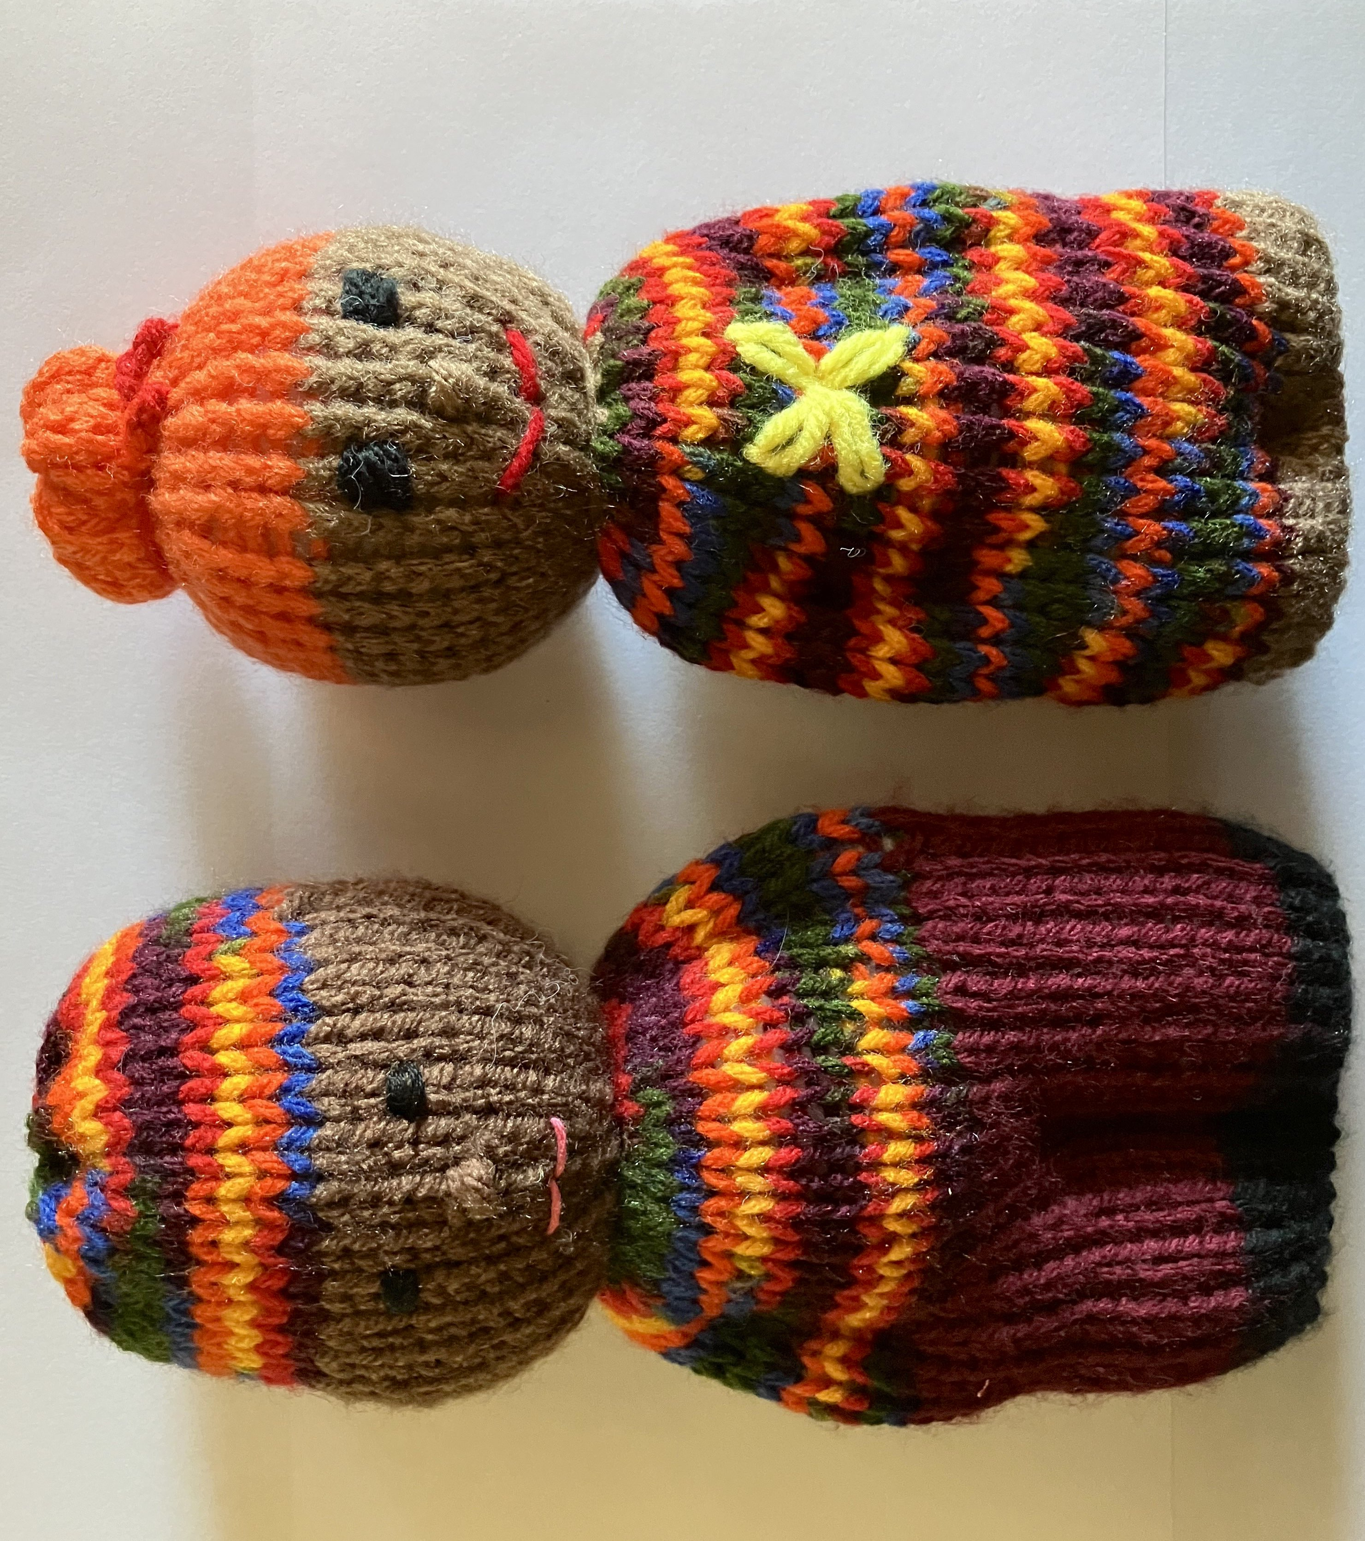

**Materials needed:**

* 4.5 mm 9 inch circular knitting needles OR
  + - Two or Four 4.5mm 7 inch double point needles
* 3 - 4 colors of Yarn (Size 4) (Face Color Red Heart - Cafe Latte)
* Embroidery needle
* Scissors
* Poly fill
* Embroidery Floss or yarn for Eyes, Nose, Mouth and Ears
* Crochet Hook optional for embellishments
* Row Marker optional

Begin Knitting by working from bottom of feet to top of head. It’s simply a continuous Stockinette/Knit stitch when knitting on circular needles or Four double point needles. It creates a V on one side and purl bumps on the back side which is helpful to see when starting and stopping.

If knitting with 2 needles, which creates a rectangle, you will need to alternate stockinette and purl for each side. Once completed an extra step of sewing a seam to create the tube is needed before completion of doll.

**Great Videos How to make the Dolls**

Loom Knit Comfort Dolls by [LoomaHat.com](http://LoomaHat.com)

<https://www.youtube.com/watch?v=RPJwjgItrZ8>

How to Crochet Comfort Doll by CrochetItForward

<https://www.youtube.com/watch?v=OqmlfxjeL_8>

How to add Flower Embroidery to knit doll

<https://www.youtube.com/watch?v=DXTsU_paqi8&t=9s>

|  |  |  |  |  |  |
| --- | --- | --- | --- | --- | --- |
|  |  |  |  |  |  |
|  |  |  |  |  |  |
|  | X |  |  | X |  |
|  |  |  |  |  |  |
|  |  | __ | **__** |  |  |
|  |  |  |  |  |  |

X

**Instructions for Dolls**

1. FEET: Cast on 32 stitches / with 12” tail

**Knit 5 Rows**

2. PANTS/SKIRT: Change Color

**Knit 14 Rows**

3. TOP: Change Color

**Knit 12 Rows**

4. FACE: Change Color

**Knit 10 Rows**

5. HAIR/HAT: Change Color

**Knit 11 Rows**

6. CAST OFF:

At the top of head, Cut yarn with 20 inch tail and using embroidery needle, thread yarn through all the loops and leave loose for finish later.

7. DEFINE FEET and PANTS

Turn work inside out, Using Cast on Tail and embroidery needle, sew the bottom edge together, bring thread and needle back to the middle of feet and turn work right side out. Use needle and thread to sew up the feet through front to back. Change color to pants color and continue up the middle, stopping at4th row. ** For SKIRT, do not sew up pants

8. STUFF DOLL

Stuff doll using Poly fill or leftover yarn. Make sure to push down into the feet and legs and put in enough so that head will be plump.

9. SEW UP HAIR/HAT:

Pull on Cast Off tail to close up the top. Once tight, reinforce the top with four to five stitches, leaving a 2 inch tail if you want to add a pom pom.

10. DEFINE ARMS:

Using Embroidery Needle and sweater yarn color, third column in, sew from pants top,up to 4th row.

11. DEFINE HEAD:

Using Embroidery Needle, start at back of neck, thread face color yarn thru every other stitch, pull tightly and wrap yarn again and knot in the back.

12. COMPLETE EYES, NOSE, MOUTH:

Can use yarn or embroidery thread. Hair, Ears and other embellishments are optional.

OTHER OPTIONS:

**Thicker Coverage of Doll**—Use two strands of yarn instead of one. You can add color this way also by using different colors.

**Dress**—Make the Pants and Top all the same color and do not sew up pants.

**Belt / Stripes**—Change color for last 2 rows of Pants or change color for one or two rows.