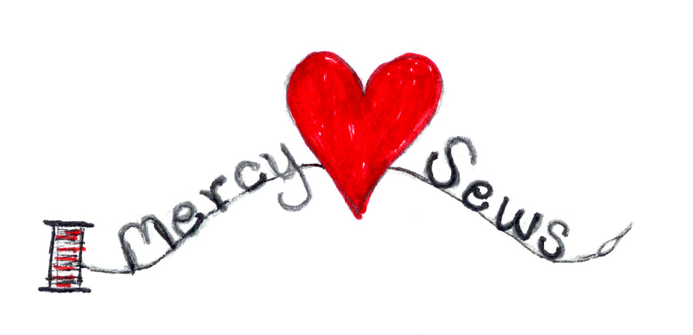

Duduza Dolls or Comfort Dolls are soft, colorful, handmade dolls (knitted or crocheted) that are easy to make. They can be made from scraps of worsted yarn in assorted bright colors. To personalize the dolls for the Pygmy children of Central African Republic, we ask you to make the faces with the Red Heart color, Café Latte. (See below for both Knit and Crochet patterns.)

DUDUZA DOLL KNITTING PATTERN

Overview: (Adapted from The Heart for Africa Organization):

Materials: Worsted weight yarn and bright colors for clothing. Please use Red Heart brown color Café Latte for the feet and face. Use “Fiberfill” for the stuffing.

Needles: US #6 and #7 (#3 and #4 will make a smaller doll)

Instructions: With #4 needles and brown, cast on 32 sts. Work 4 rows in stockinette stitch, leaving a 12” “tail” to gather for feet when completing the doll.
Change colors for Pants or Skirt: Work 16 rows in stockinette stitch. Change colors for belt. Knit two rows (garter stitch).

Change colors for sweater: Work 13 rows in stockette stitch. Next row, P3, P2tog, (P6, P2tog) 3 times, P3. Cut yarn, leaving a 12” “tail” to gather for neck. Change to brown for face. Changing to size 3 needles, work 10 rows in stockinette stitch. Change color yarn for cap. Knit 2 rows (garter stitch) for border. Work 2 rows of stockinette stitch and then decrease as set forth below:

Row 1—(Knit 4, k 2 tog) x 4, knit 4 (24 sts)
Row 2 and all even rows—Purl
Row 3—(Knit 3, k 2 tog) x 4, Knit 4 (20 sts)
Row 5—(Knit 2, k 2 tog) x 4, Knit 4 (16 sts)
Row 7—(Knit 1, k 2 tog) x 4, Knit 4 (12 sts)
Row 8—(Purl 2 tog) across row

,

Finishing: Thread remains sts onto needle and sew up cap. Sew up face. Run the gathering thread through the last row of sweater stitches and, after stuffing head, pull up tightly for neck, finishing off securely.
Sew Up Center Back: Run the gathering thread through the last row of feet. Stuff body and pull up gathering thread tightly, finishing off well.
Complete feet by sewing up center seam and then stitching front to back through both thickness of knitting, i.e., dividing feet, which are stuffed individually. Fold foot across cast on edge at right angles to body and sew up. Finish other foot the same way.

For Boy Doll only: Define legs by sewing through all the thicknesses from feet towards belt, finishing off 2 rows from belt.

Define arms in same way starting 2 rows from neck. Embroider face as desired to give your doll character (Please—no buttons.)

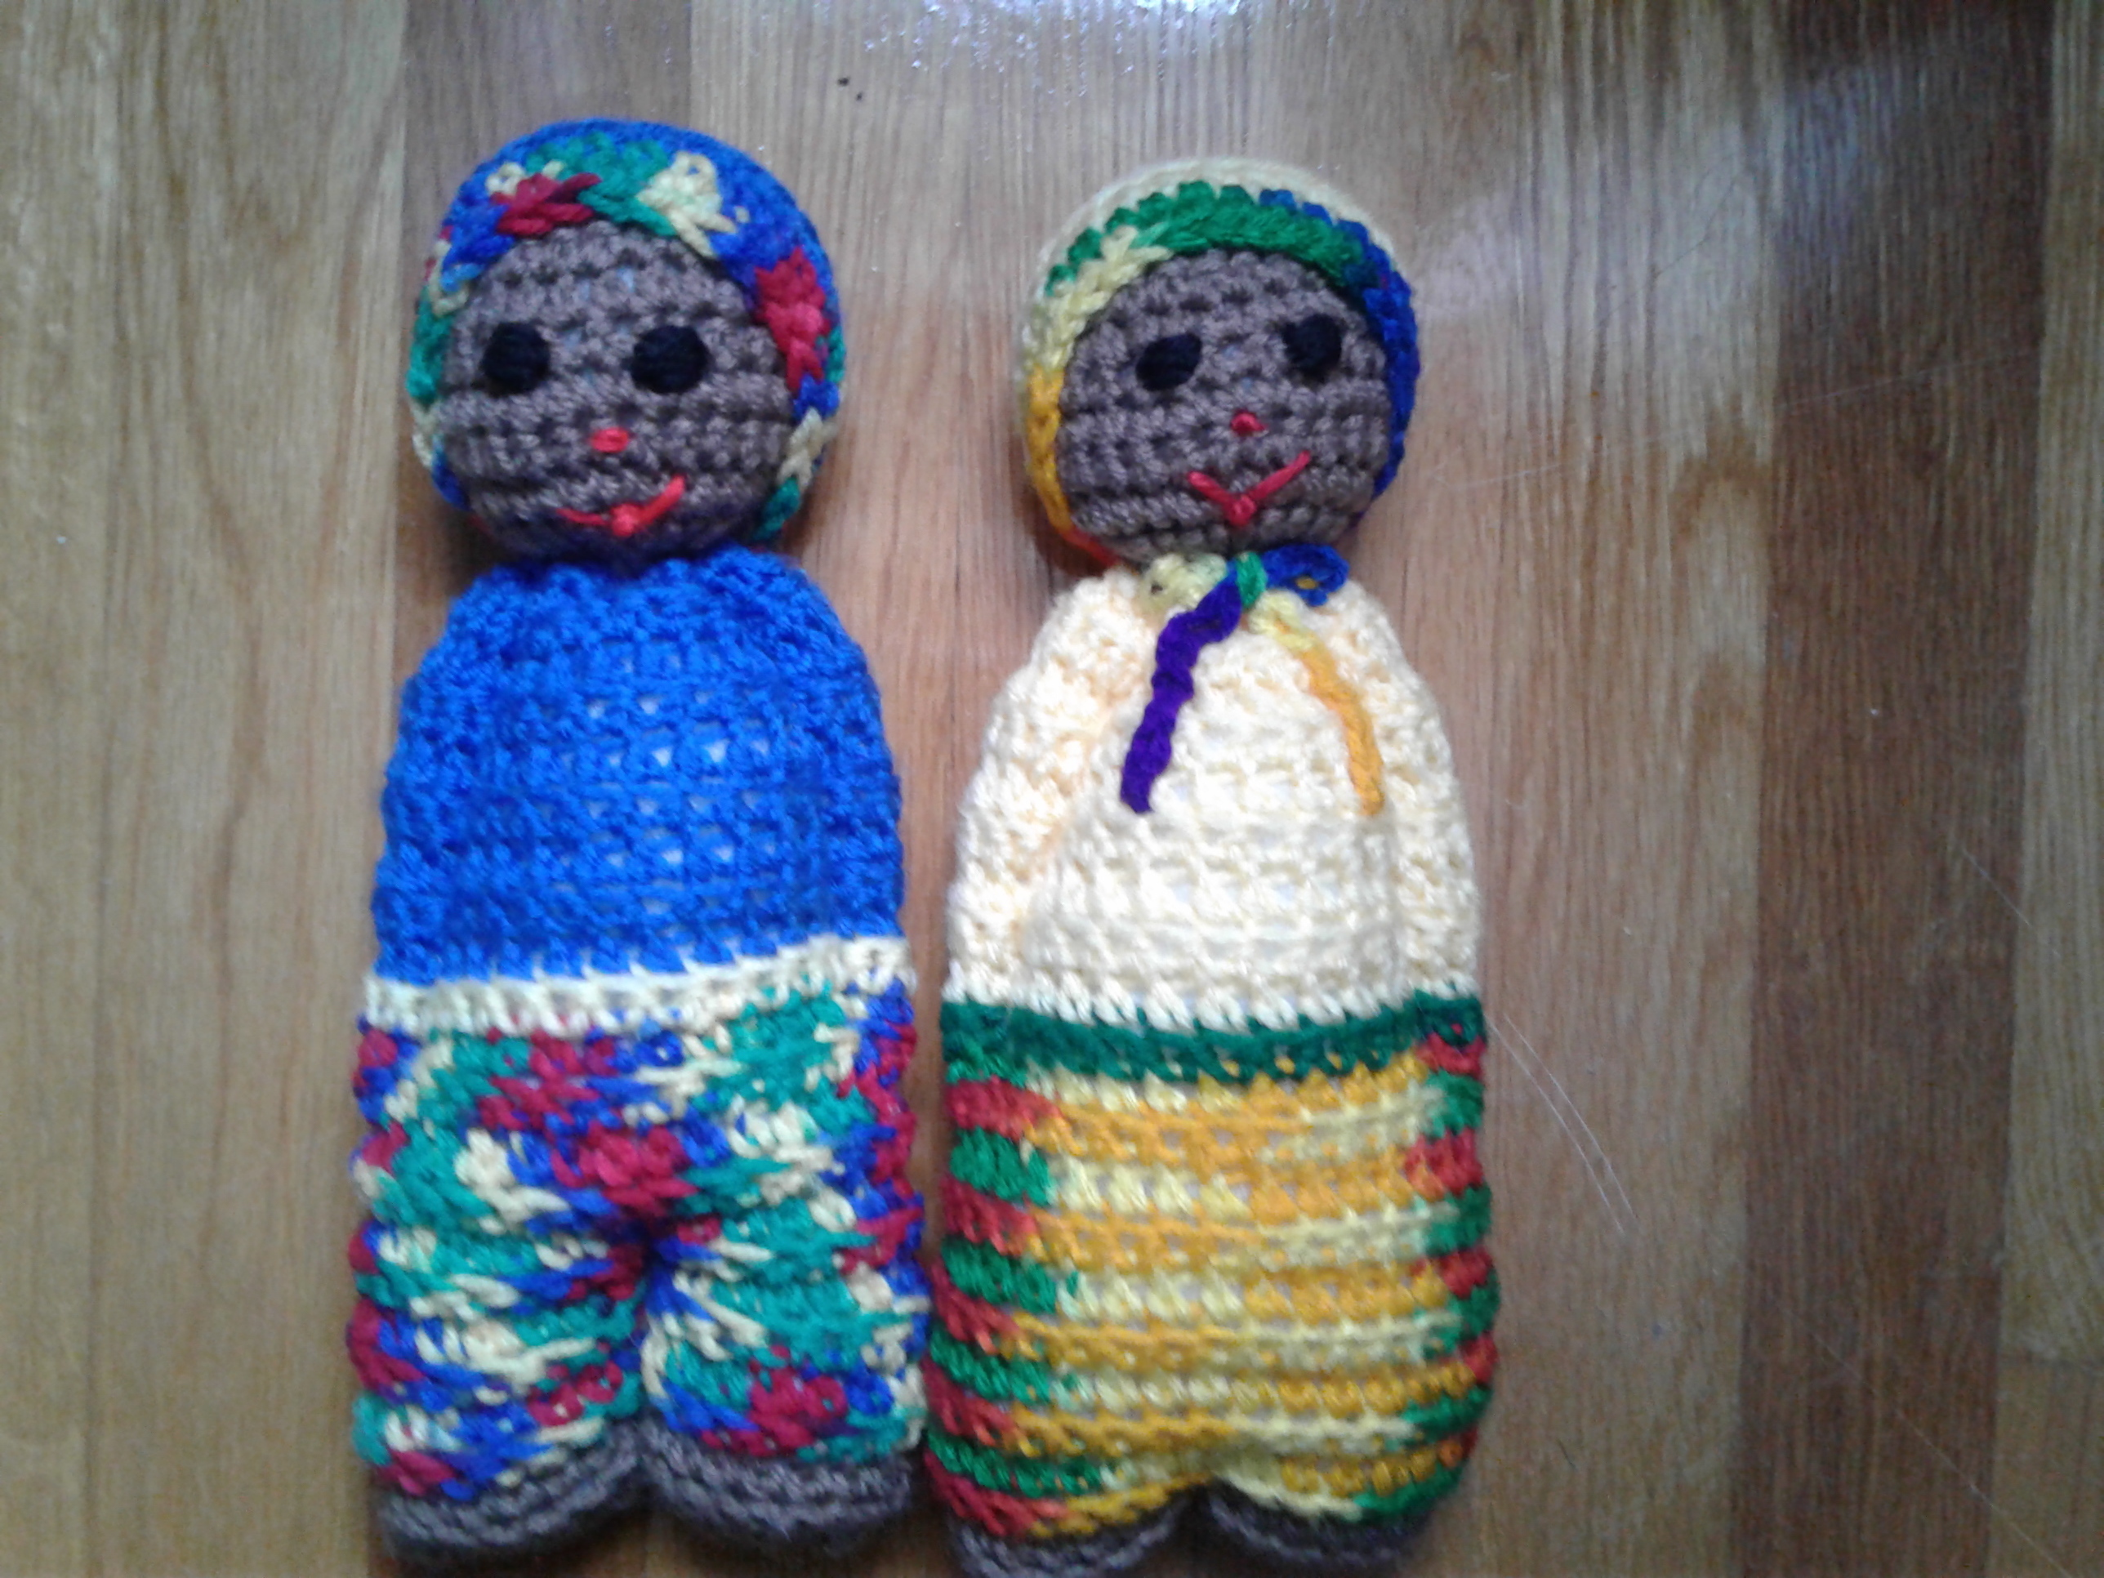
DUDUZA DOLL SCHEMATIC

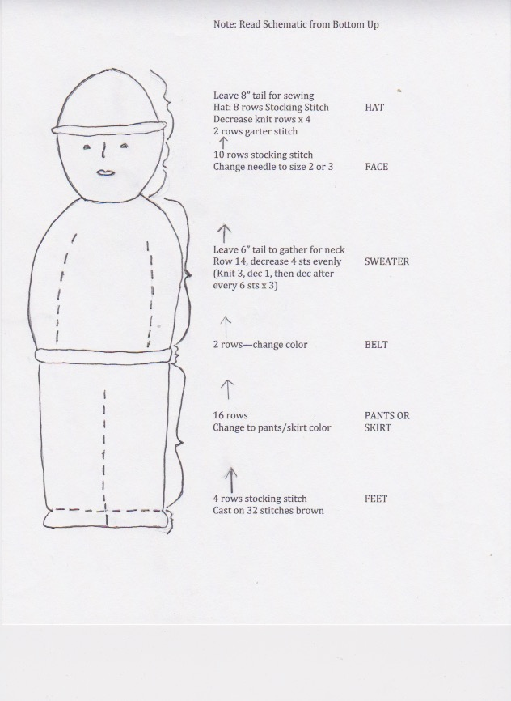

[Schematic adapted from The Heart for Africa Organization]

DUDUZA DOLL CROCHET PATTERN

Crocheted African Doll

- Hooks – F & G
- Yarn Needle for Sewing
- Yarn – Red Heart color Café Latte for Head & Feet
- Small Amounts of 3 different colors for Top, Waistband & Pants or Skirt.
- Red & Black for eyes, nose and mouth.

Working from feet to head:

With Café Latte color and G Hook, leave a tail, CH 33, Turn Sc in 2nd CH from Hook and in each CH to end (32 Sc) CH 1 turn.

Row 2: Working in back loop Sc across to next to last St Sc through 2 loops of last St, turn.
Change Color for pants/skirt
Work 9 more rows the same, leave tail for sewing later.

Change color for waistband, work 1 row Sc across in both loops.
Change color for shirt, work 9 rows same as Row 2. Work next row in both loops.
(Dec Row) Sc in first 2 Sts, Dec 2 Sc together.
Sc in next 3 Sts Dec across. Leave tail for sewing.
Change to face color and F Hook. Sc in both loops across, turn work 8 more rows.

Next 3 rows, Dec as before, leave long tail to sew head & neck.

SEWING – (Bold side of waistband is right side)
With long tail, sew head by running through last row of head, pull tight knot.
Working on wrong side, fold and sew seams with long tails. Do not cut tail for head – will need to close head when turned right side out. Sew in ends, turn right side out. Stuff head then use tail to sew head by running around neck edge.
Pull tight knot, run through again, fasten off. Stuff body, sew feet.

ARMS - Sew through both layers from shoulder to waist. Repeat for other arm.

BOYS – Sew seam in middle of pants for legs.

CAP – with F Hook, CH 4, join to form ring. 6 Sc in ring. Place marker working in back loop, 2 Sc in each Sc (12 Sc).
Back loop 2 Sc 1 Sc around (18)
Back Loop 2 Sc 1 Sc 1 Sc 2 Sc around (24)
Back Loop 2 Sc 1 Sc 1 Sc 1 Sc 2 Sc around (30)
Back Loop next 2 rows Sc around

Change Color – next 2 rows in both loops, Sc around, leave a long tail to sew to head.

BOW – F Hook, leave a long tail to start CH 40 leave another long tail.
Tie bow around neck, use long tail to sew bottom ribbon part to body.

Sew eyes, nose & mouth.

Pattern Courtesy : Linda Laskey
User/Miscellaneous/Crocheted African Doll

