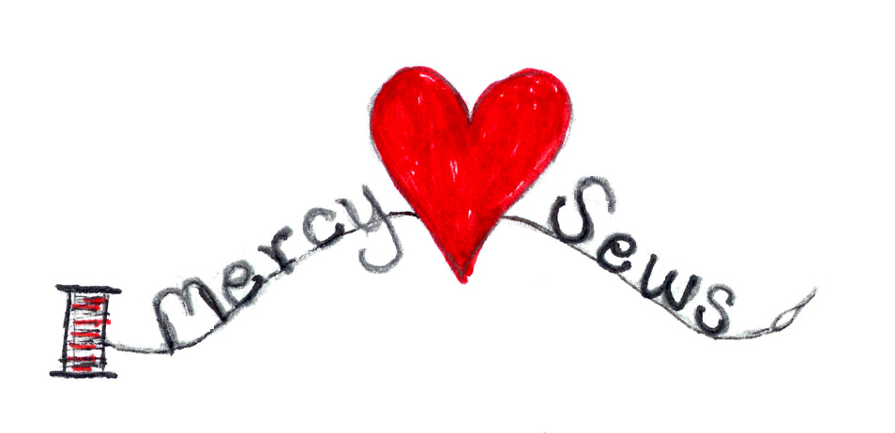

**Travel Yarn Ball and Kit**

This is super helpful to measure out yarn to make one Yarn Ball for easy on the go knitting or to share yarn. This is also helpful to make a kit to share.

For a **Travel Yarn Ball** for one doll, you will need approx 24 inches of yarn per row, and an extra 40 inches of feet color for cast on and another extra 24 inches of hat color for casting off. * You will also need additional yarn for sewing up arms and legs. See complete measurements below.

**Cut yarn** in measurements for each section, using a ruler. Once completed,

begin rolling ball with **cast off** yarn and ending with **cast on** yarn.

You may want to add an extra 12 inches for each color if you are a loose knitter.

|  |  |  |  |  |
| --- | --- | --- | --- | --- |
| **TRAVEL YARN BALL for DEDUZA DOLL** | | | | |
|  | **ROWS** | **Inches Needed** | **12 Inch Lengths**  **“ Loose “** | **Plus Extra** |
| **CAST ON plus FEET** | 5 | 160 | **13** | **4 in** |
| **PANTS** | 14 | 336 | **28** | **12 in \*** |
| **SHIRTS** | 12 | 288 | **24** | **20 in \*** |
| **FACE** | 10 | 240 | **20** |  |
| **HAT plus CAST OFF** | 11 | 288 | **24** |  |

**For Doll Kit** you will also need:

* + **12 inches** each
    - * + **Black Yarn** for Eyes
        + **Face Color Yarn** for Nose/Ears
        + **Red Yarn** for Mouth
  + **5-6** handfuls of toy filling