FLANNEL RECEIVING BLANKET

To make a flannel receiving blanket, purchase one yard of flannel in a solid color or appropriate print, and follow the steps below:

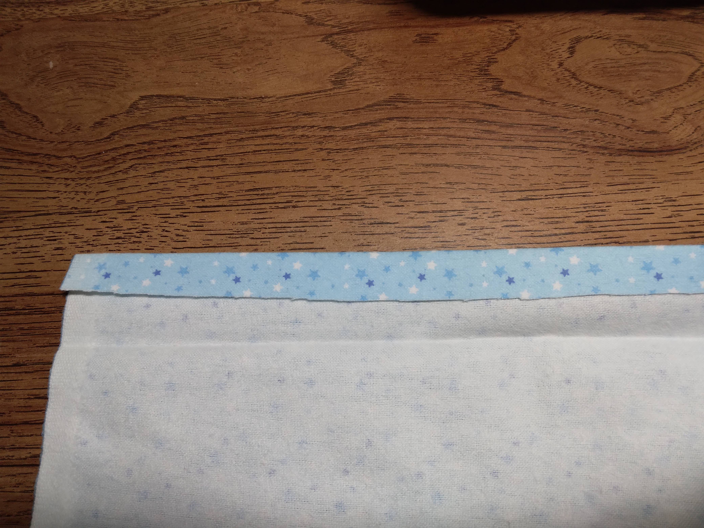

Step One: Starting with two opposite sides of fabric, fold and press or baste ¼ inch of fabric toward wrong side of flannel.

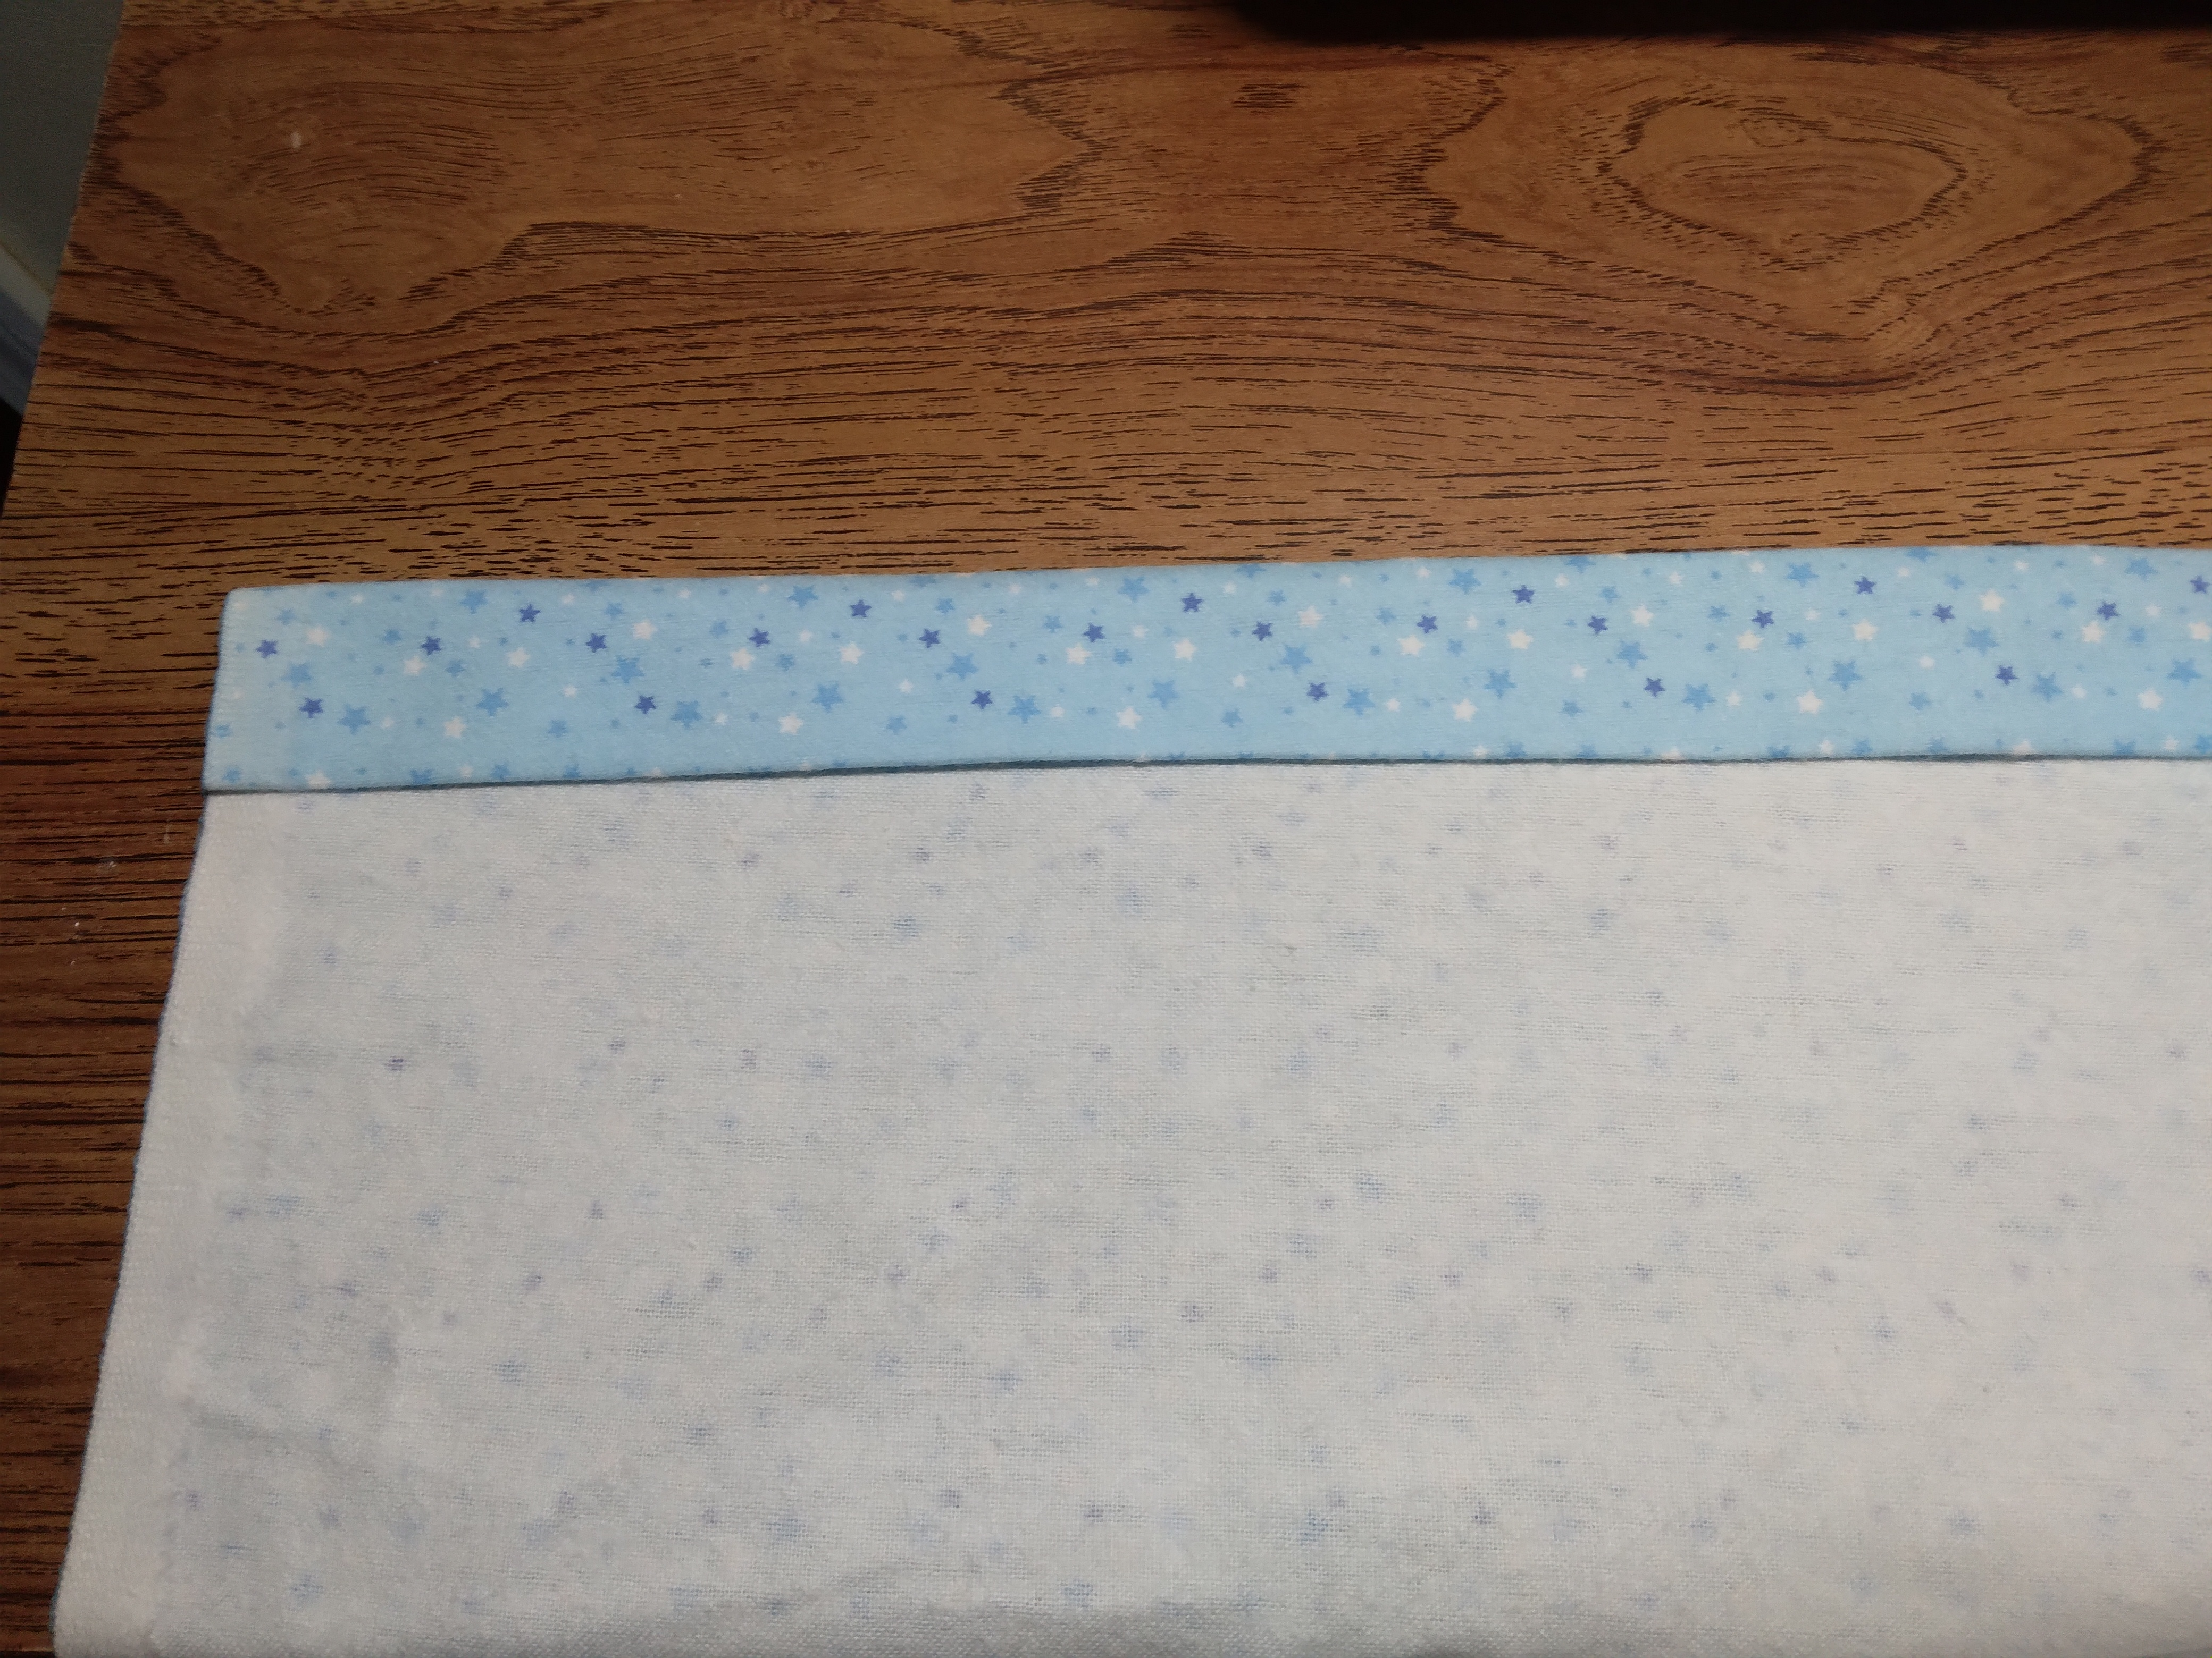

Step Two: Then fold and press or baste 1 1/2 inches of fabric to form hem.

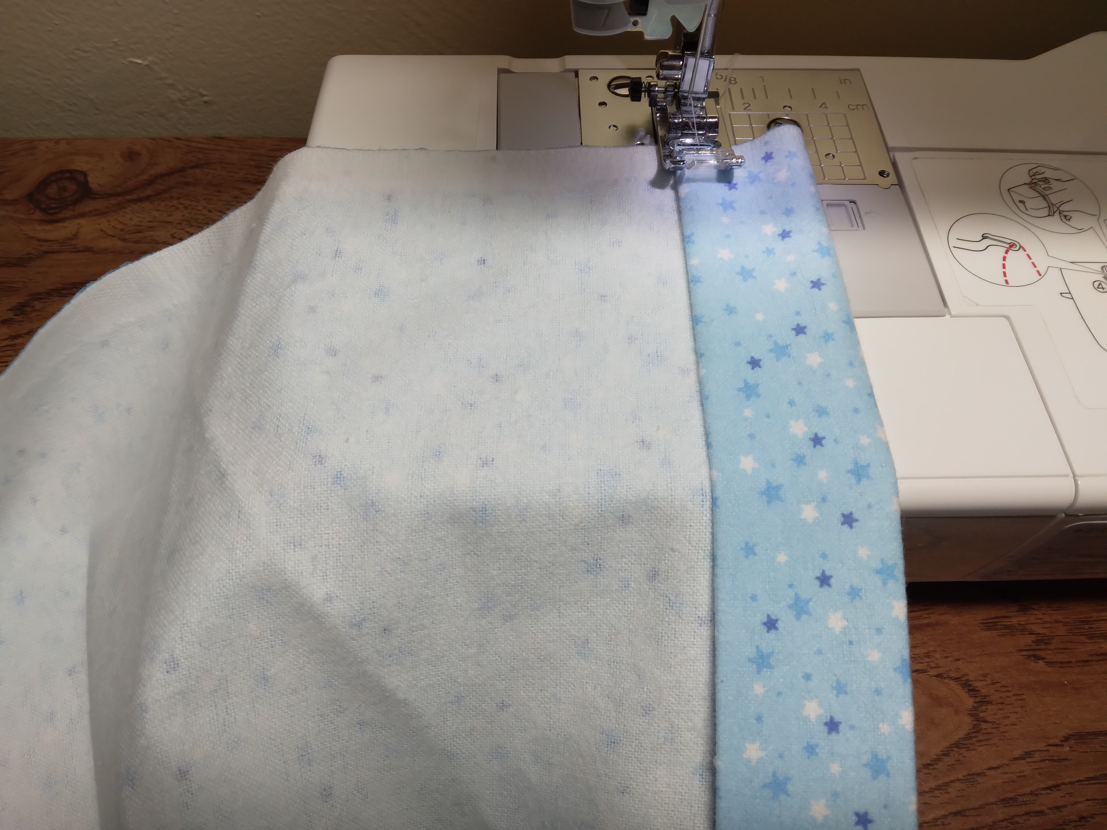

Step Three: Machine stitch hem ¼ inch inside edge backstitching at both ends to secure.

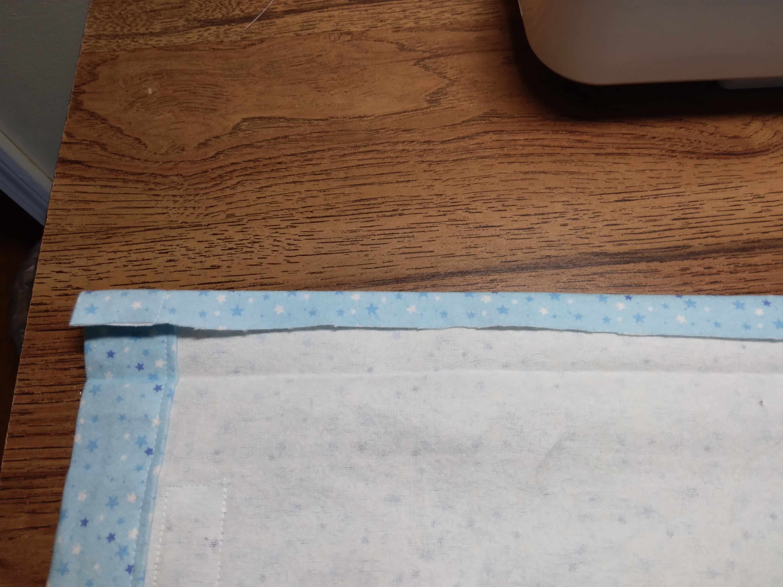

Step Four: With two remaining unfinished edges, press or baste ¼ inch fabric toward wrong side of flannel.

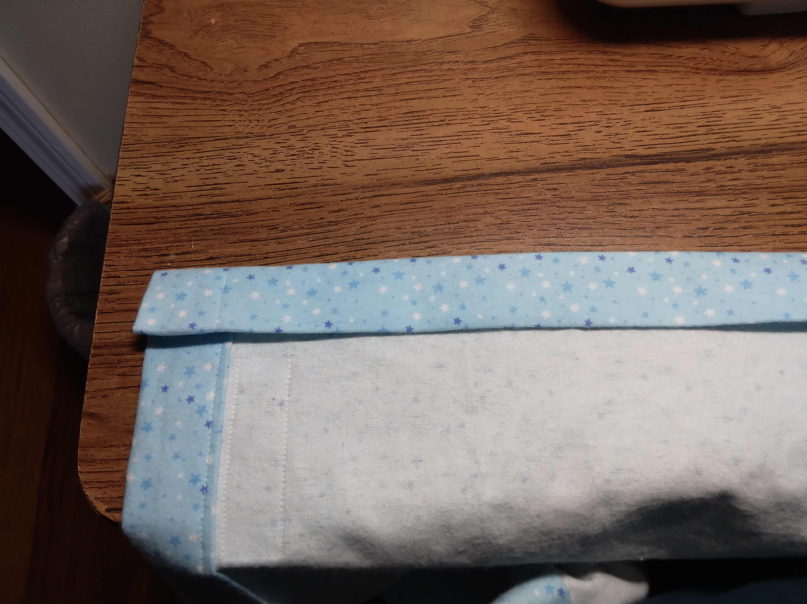

Step Five: Fold and press or baste 1 ½ inch fabric to form hem.

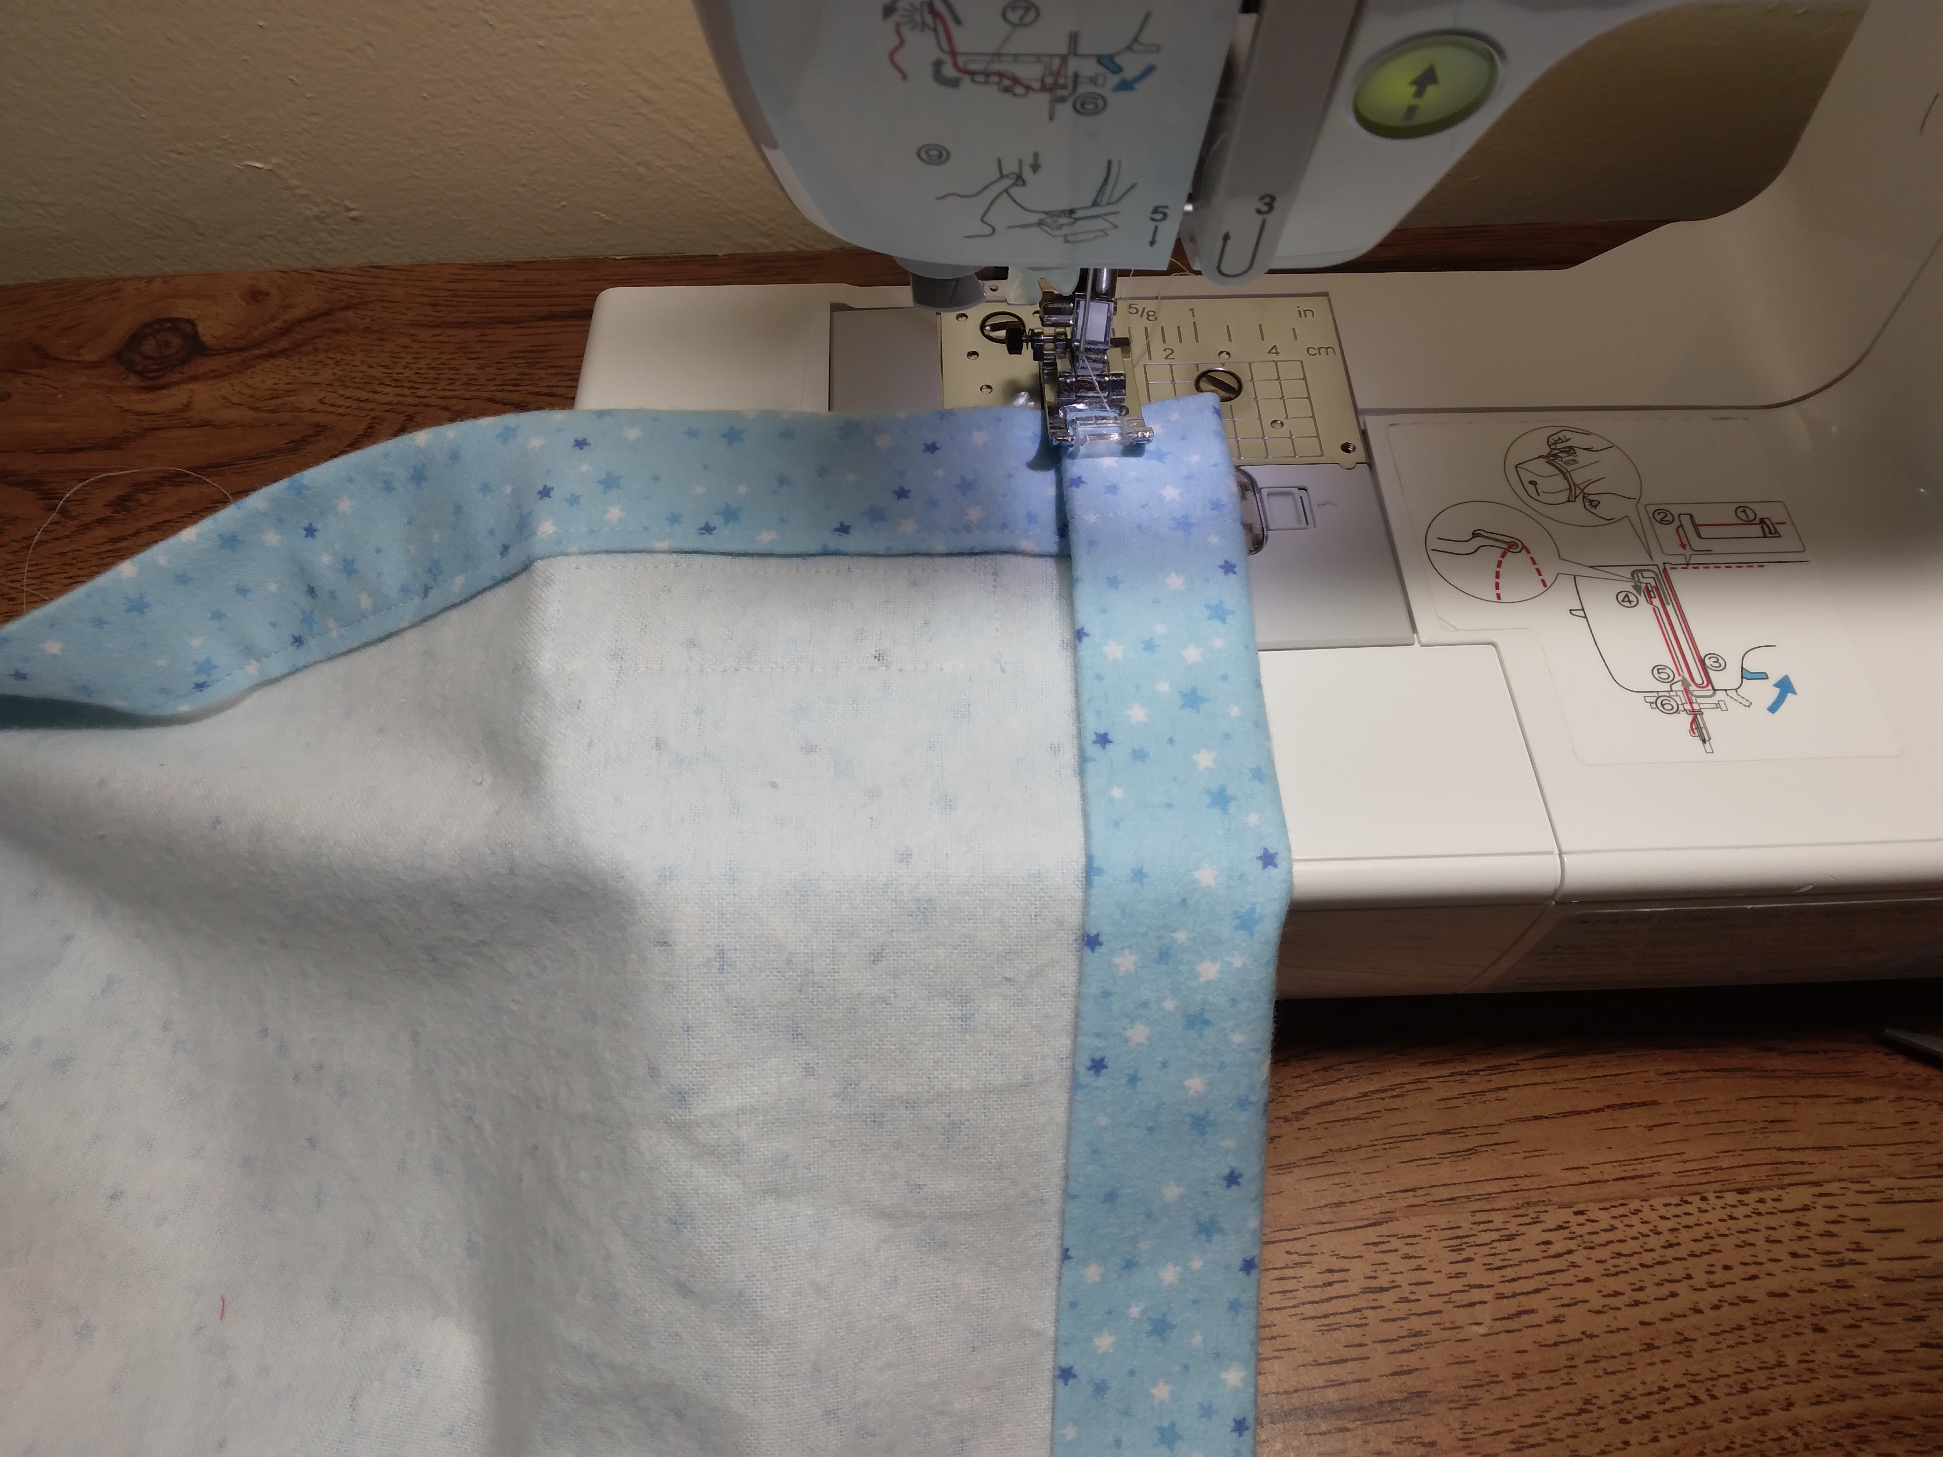

Step Six: Machine stitch hem ¼ inch from edge backstitching at both ends to secure.

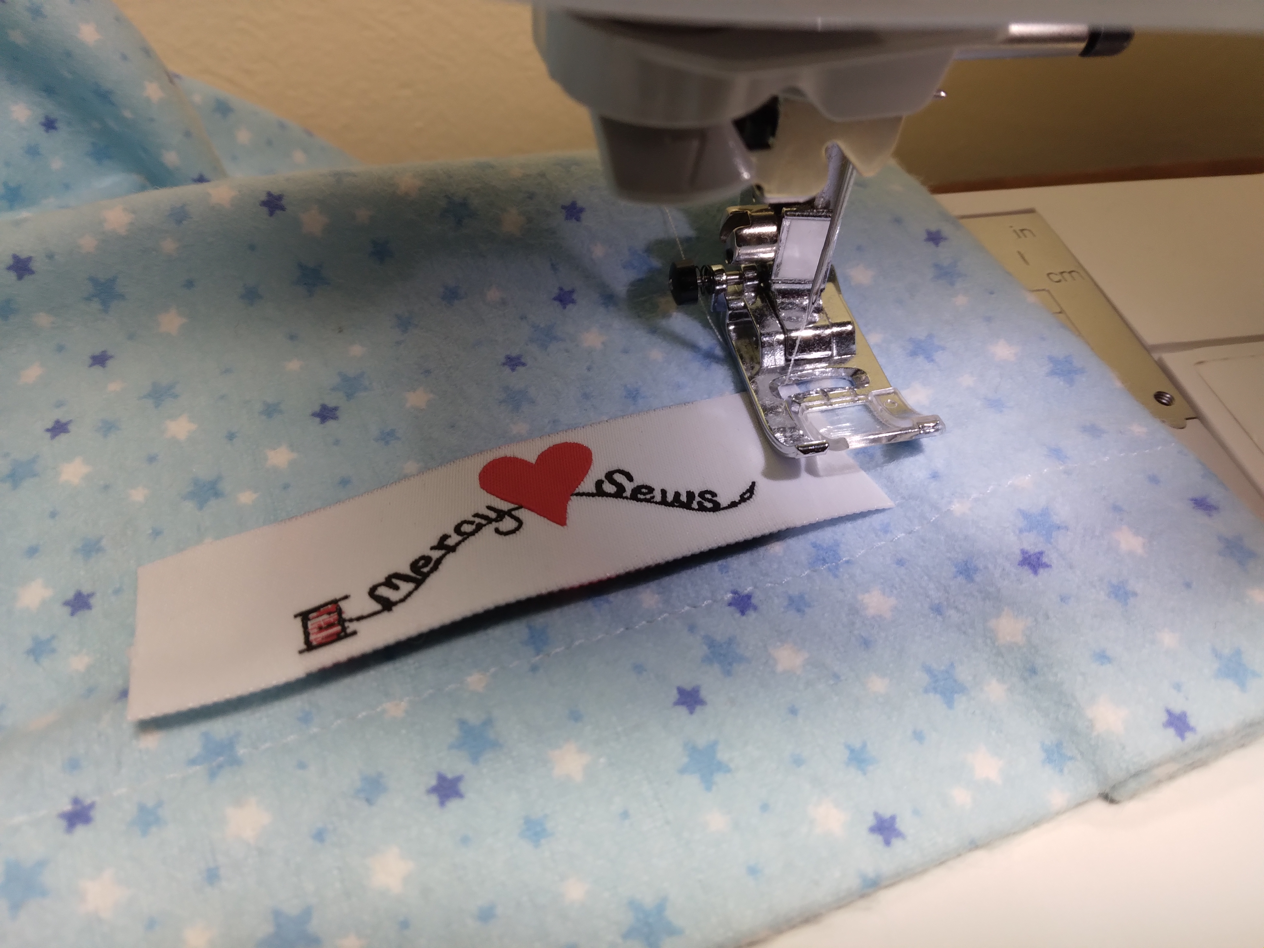

Step Seven: On any corner machine stitch a Mercy Sews label.

You have made a simple receiving blanket for a newborn Pygmy baby!

