HOW TO SEW AN EASY HOSPITAL MASK
(Adult Size)

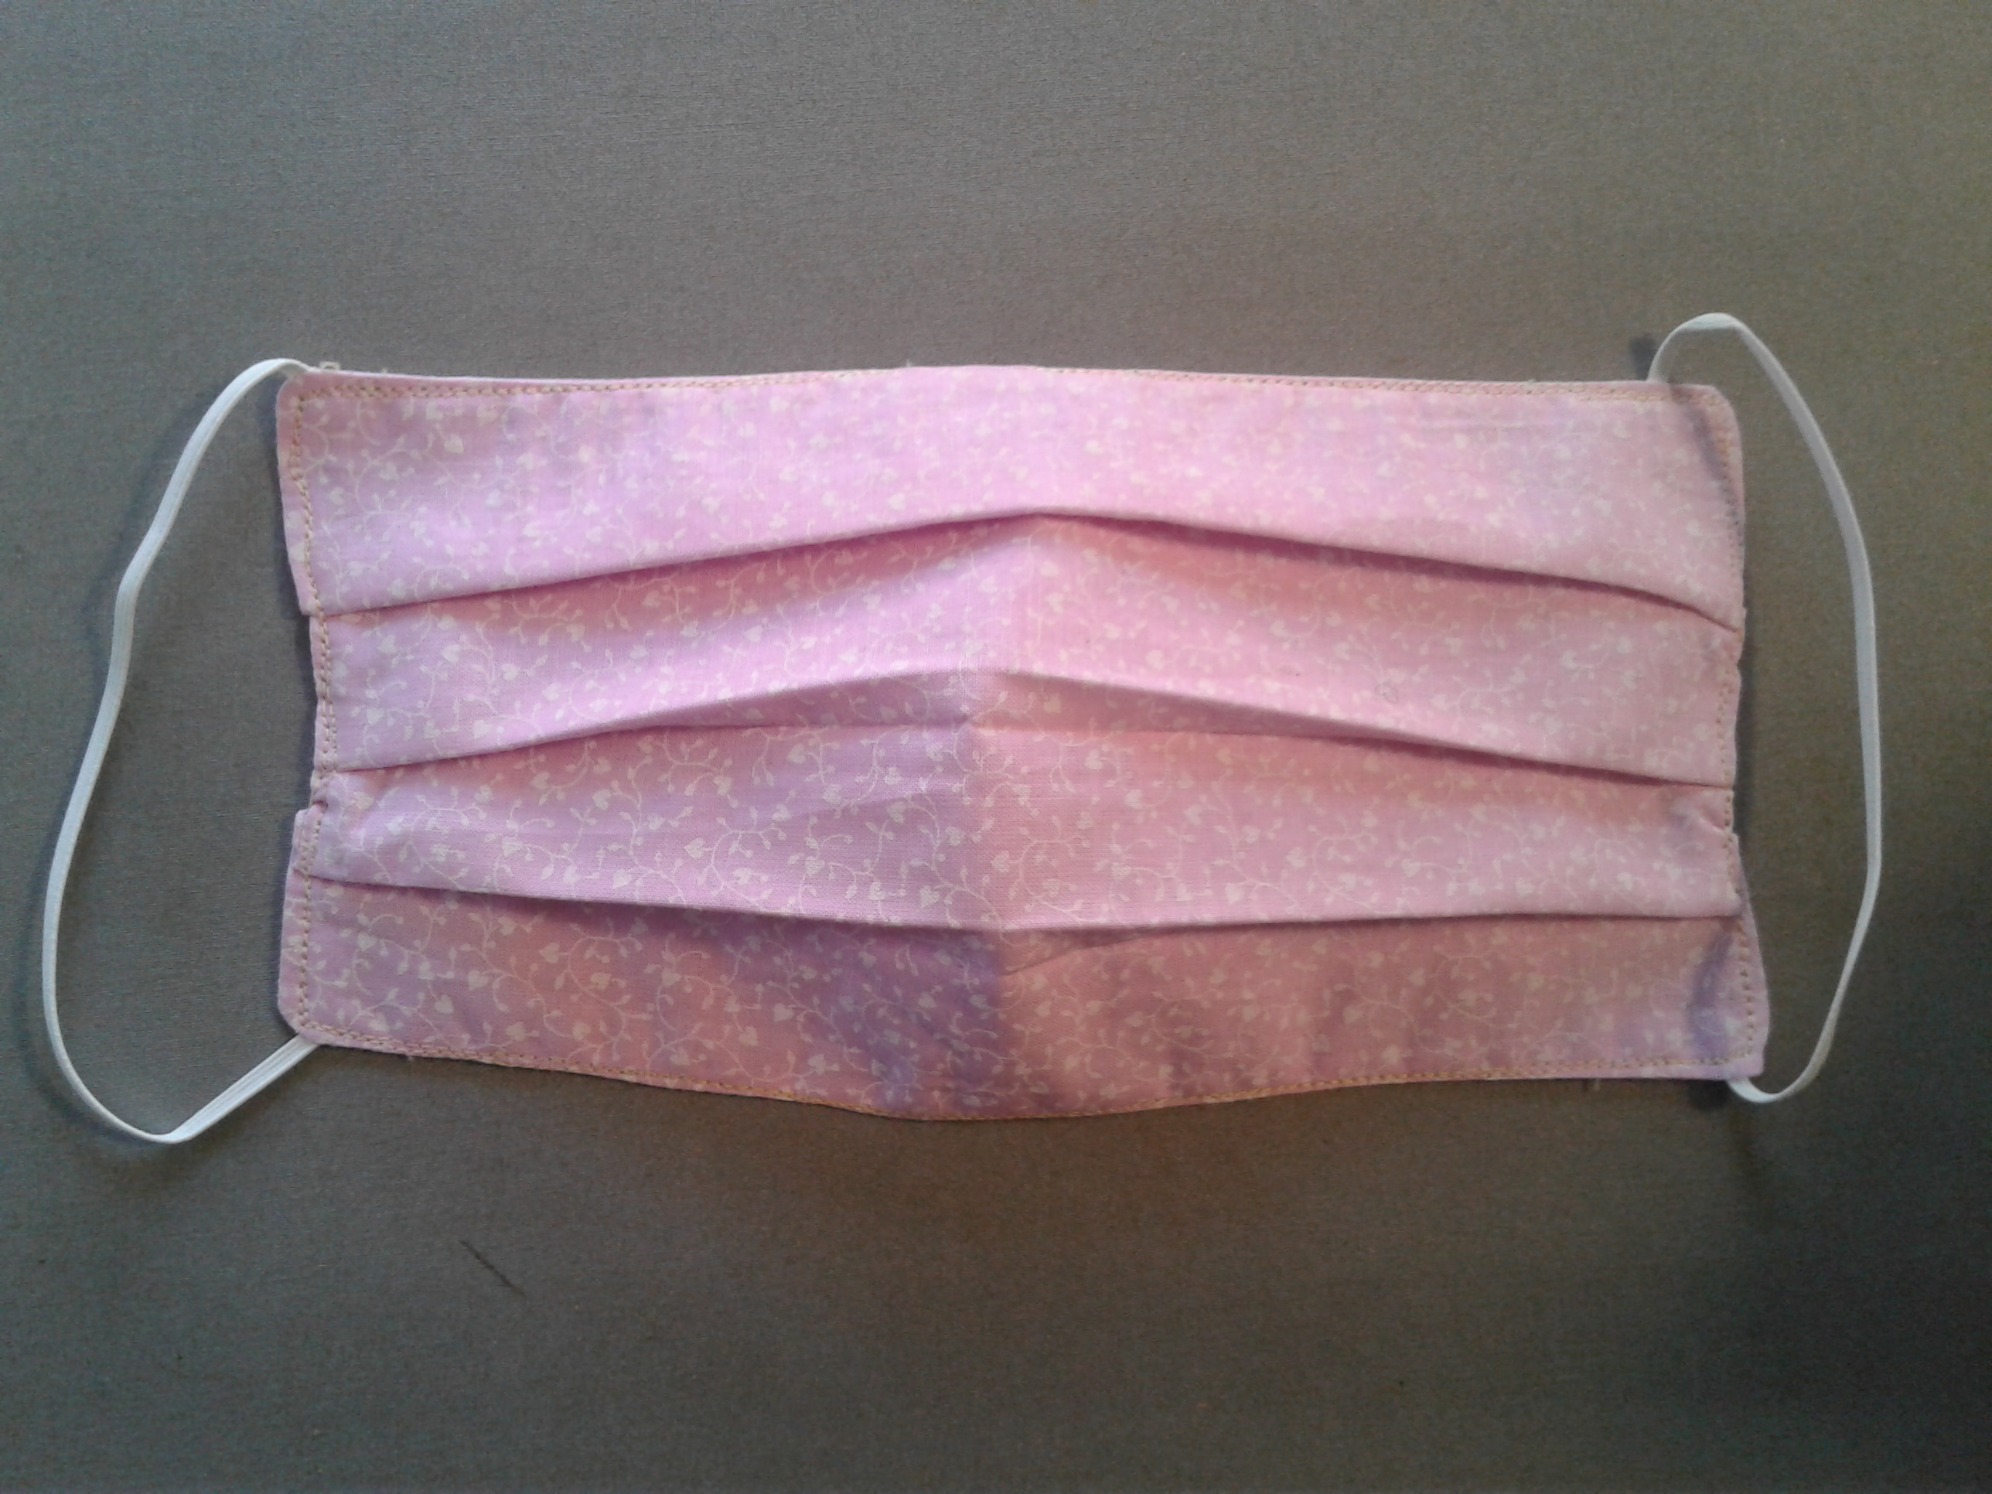

You will need a cotton fabric, or a polyester cotton fabric.
Optional: Use cotton flannel for inside layer.
Use elastic beading cord. (You may also use 1/8” flat elastic.)
Cut elastic 7” long and tie a knot at each end. (DO NOT knot the ends of the flat elastic.)
Alternate Method: Cut 4 bias tape 18” for each tie (one for each corner).

- Put right sides of cotton fabric together. Cut 9” x 6”.
- If using bias tape, please pre-stitch down each length.
- Starting at the center of bottom edge, sew to the first corner, stop. Sew the elastic (or bias tape) with the knot out into the corner. A few stitches forward and back will hold this.
- Sew to the next corner, stop, and bring the other end of the same elastic to the corner (or sew in another bias tape) and sew a few stiches forward and back.
- Sew across the top of the mask to the next corner. Again, put an elastic (or bias tape) with the knot out.
- Sew to the next corner and sew in the other end of the same elastic (or bias tape).
- Sew across the bottom leaving from 1.5” to 2.0” open. Stop, cut the thread. Turn inside out.
- Pin three tucks on each side of the mask, Make sure the tucks are in the same direction.
- Sew around the edge of the mask twice.

Be sure any fabric design is placed horizontally. You may use any colors or prints that are appropriate.

