

Two Methods to Make Bias Tape

METHOD 1

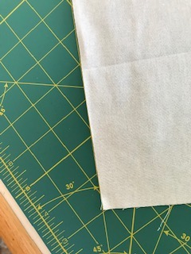

1. Place selvage edge of fabric along the 45 degree line of a cutting mat.

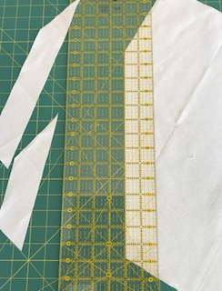

2. With rotary cutter, cut strips 2” apart.

METHOD 2

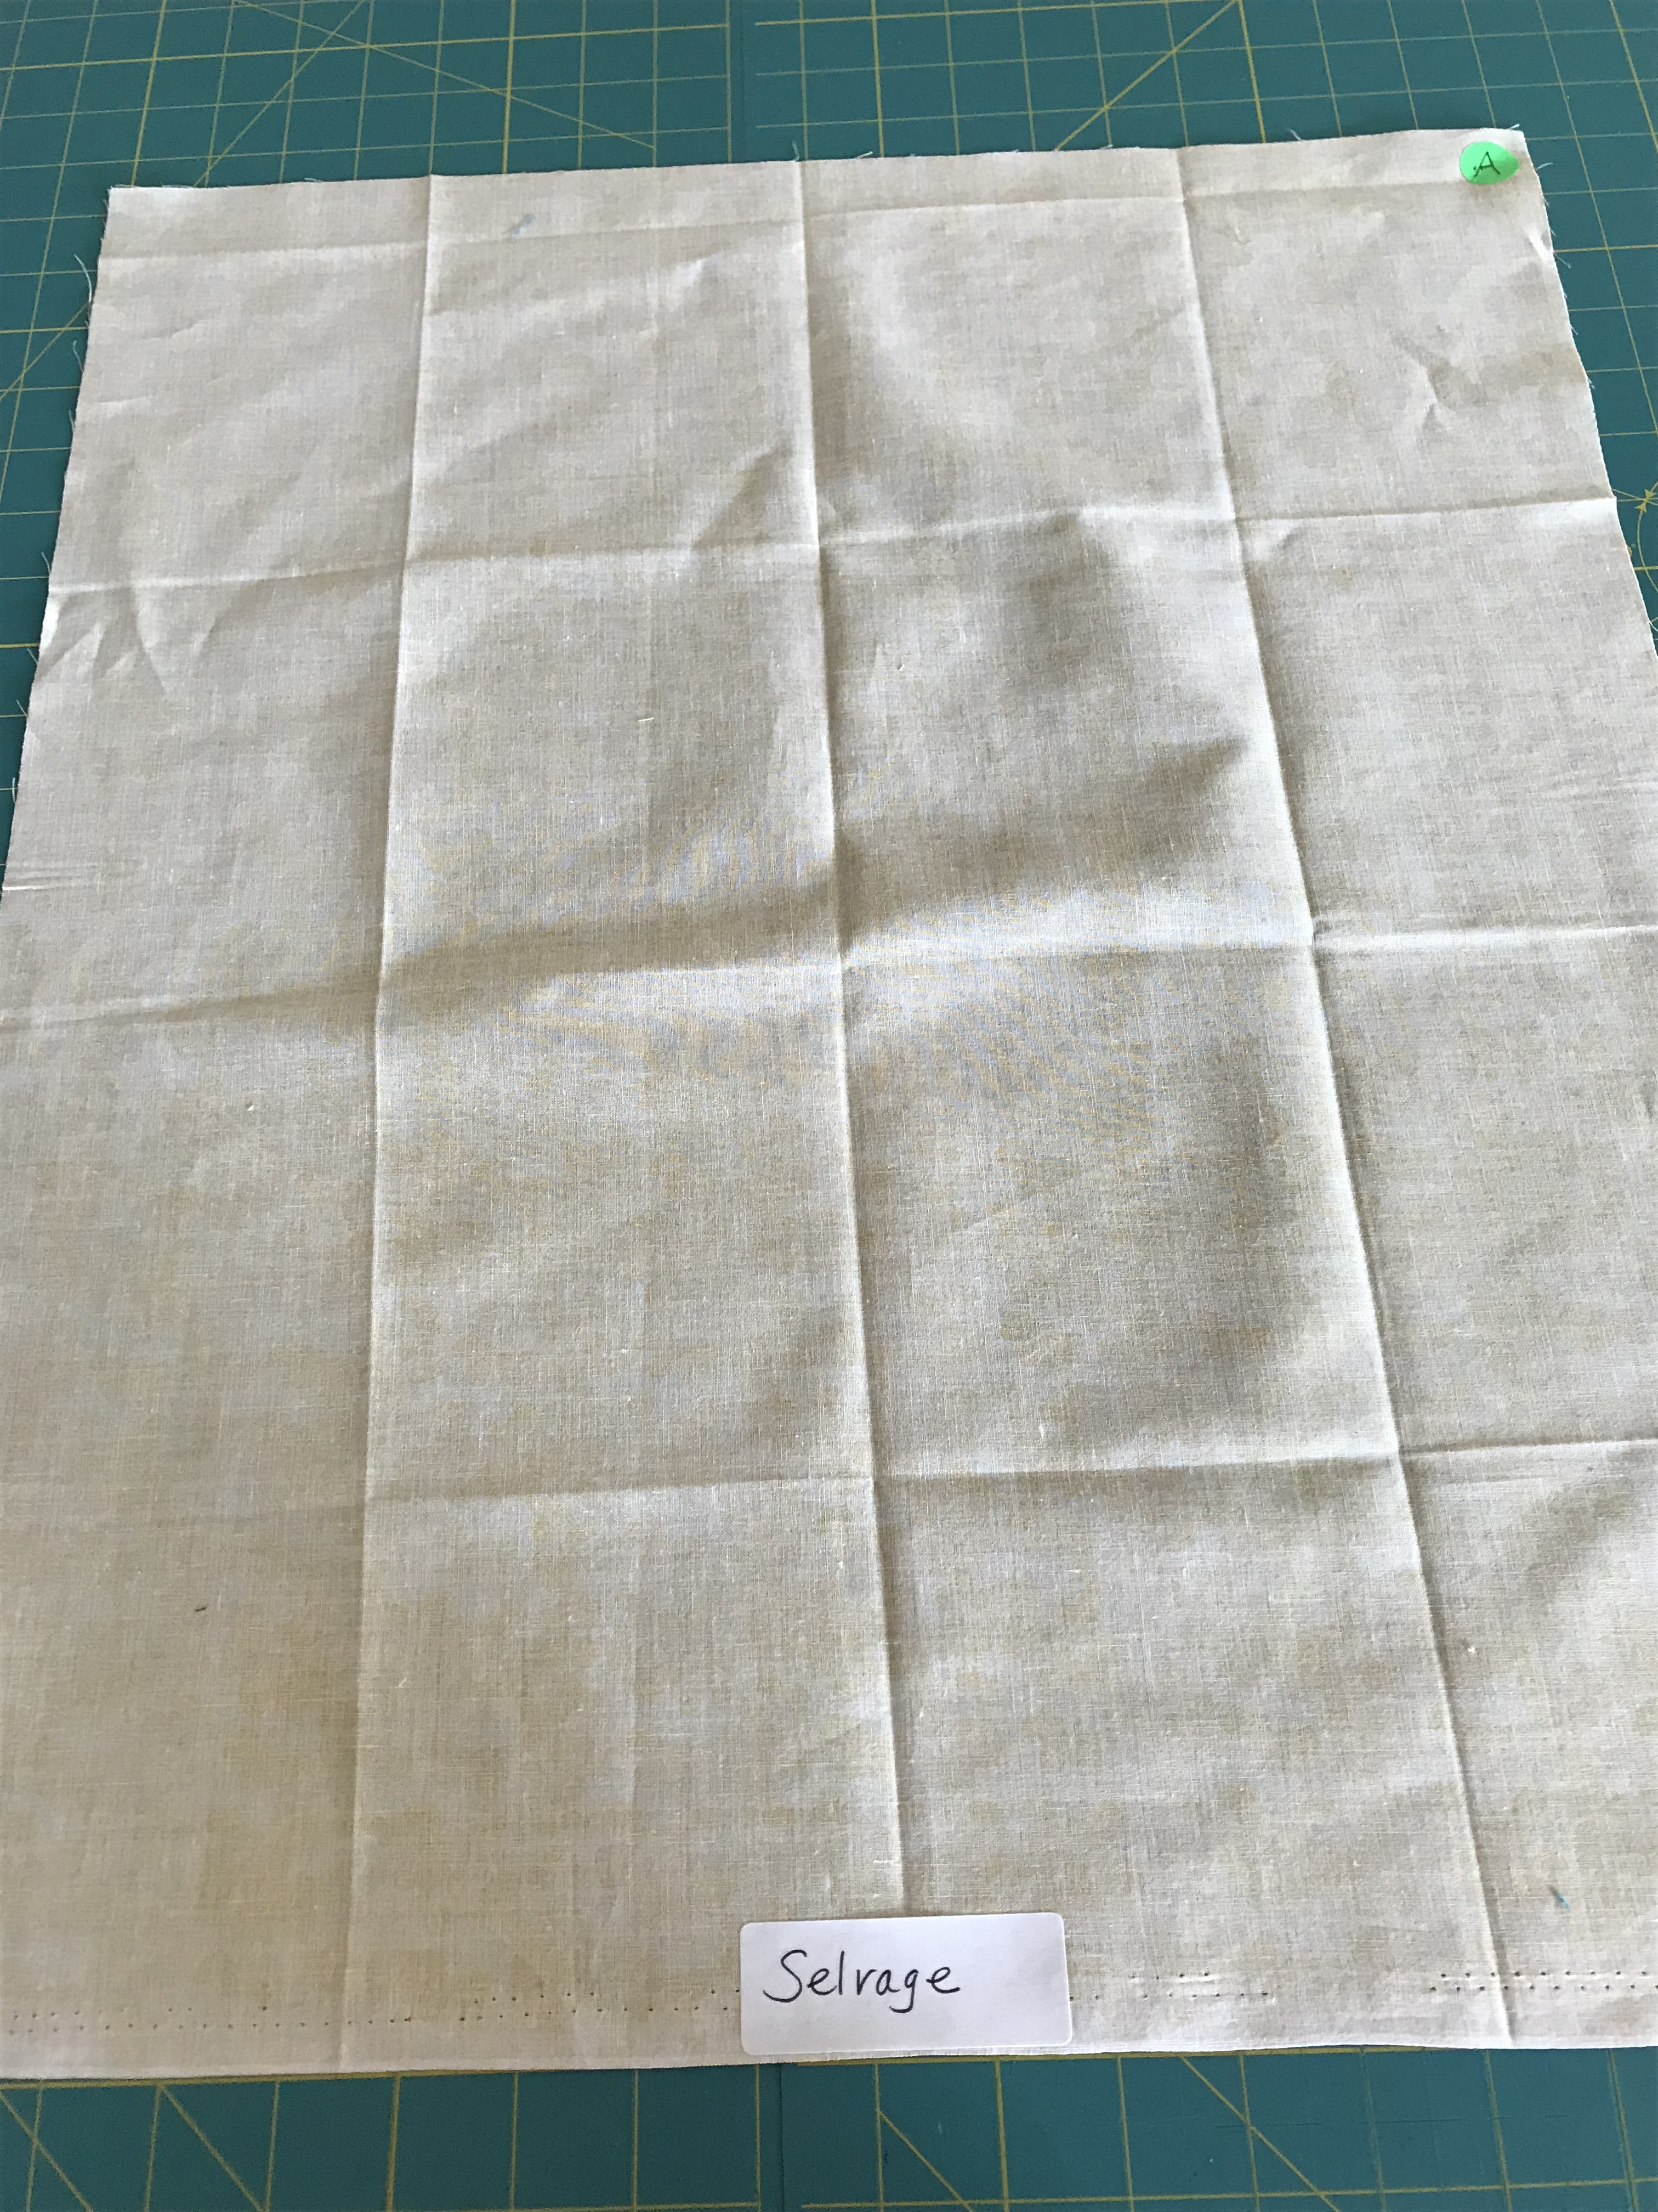

1. Method 2 can be used for any yardage amount. Above is a fat quarter, so there is only one selvage edge. The upper right corner is labeled “A”.

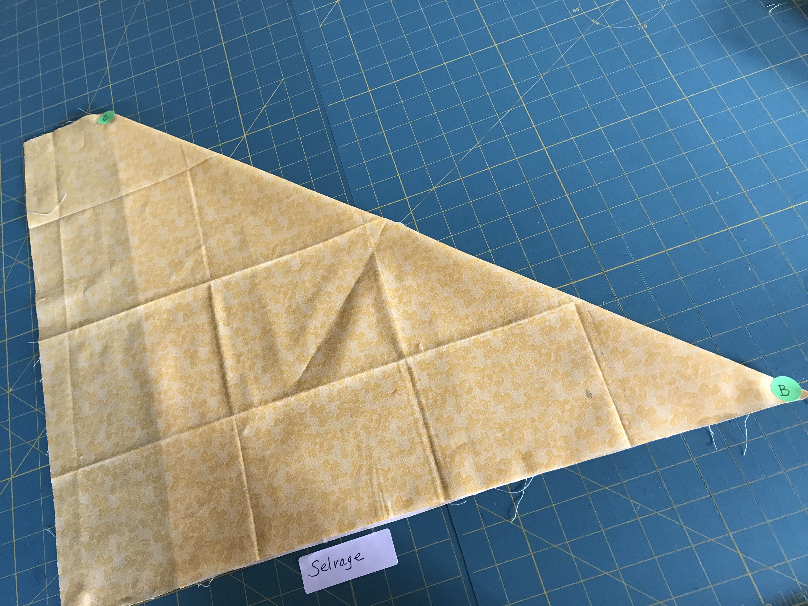

2. Fold corner ”A” down toward the selvage so that the raw edge rests on top of the selvage. Then fold corner “B” up to corner “C” so that all of the folds are stacked.

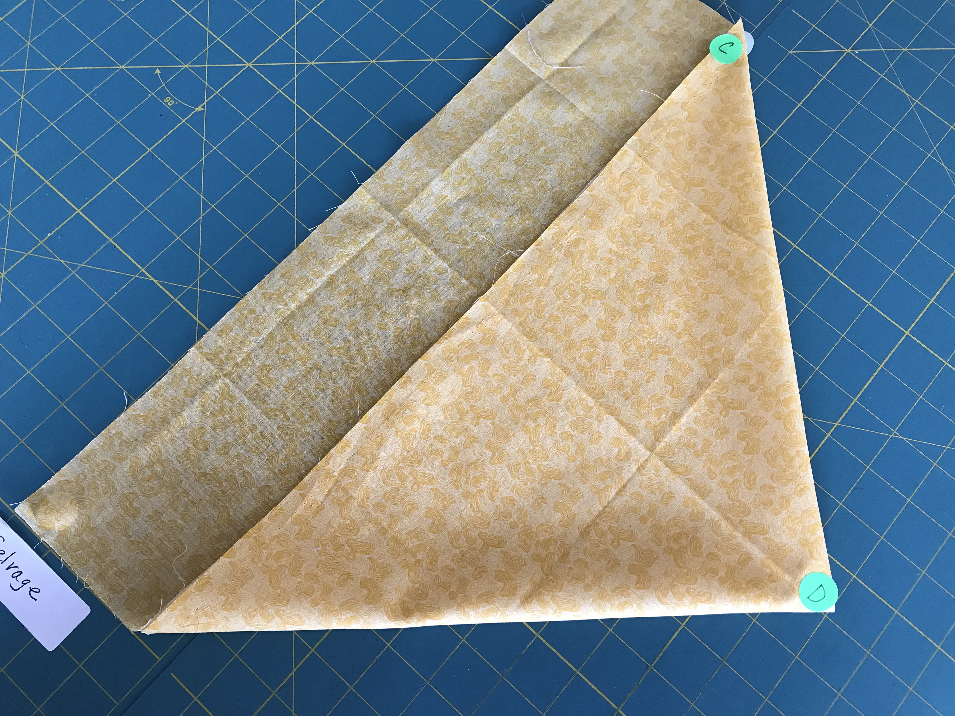

3. Next fold “D” up to meet “C”.

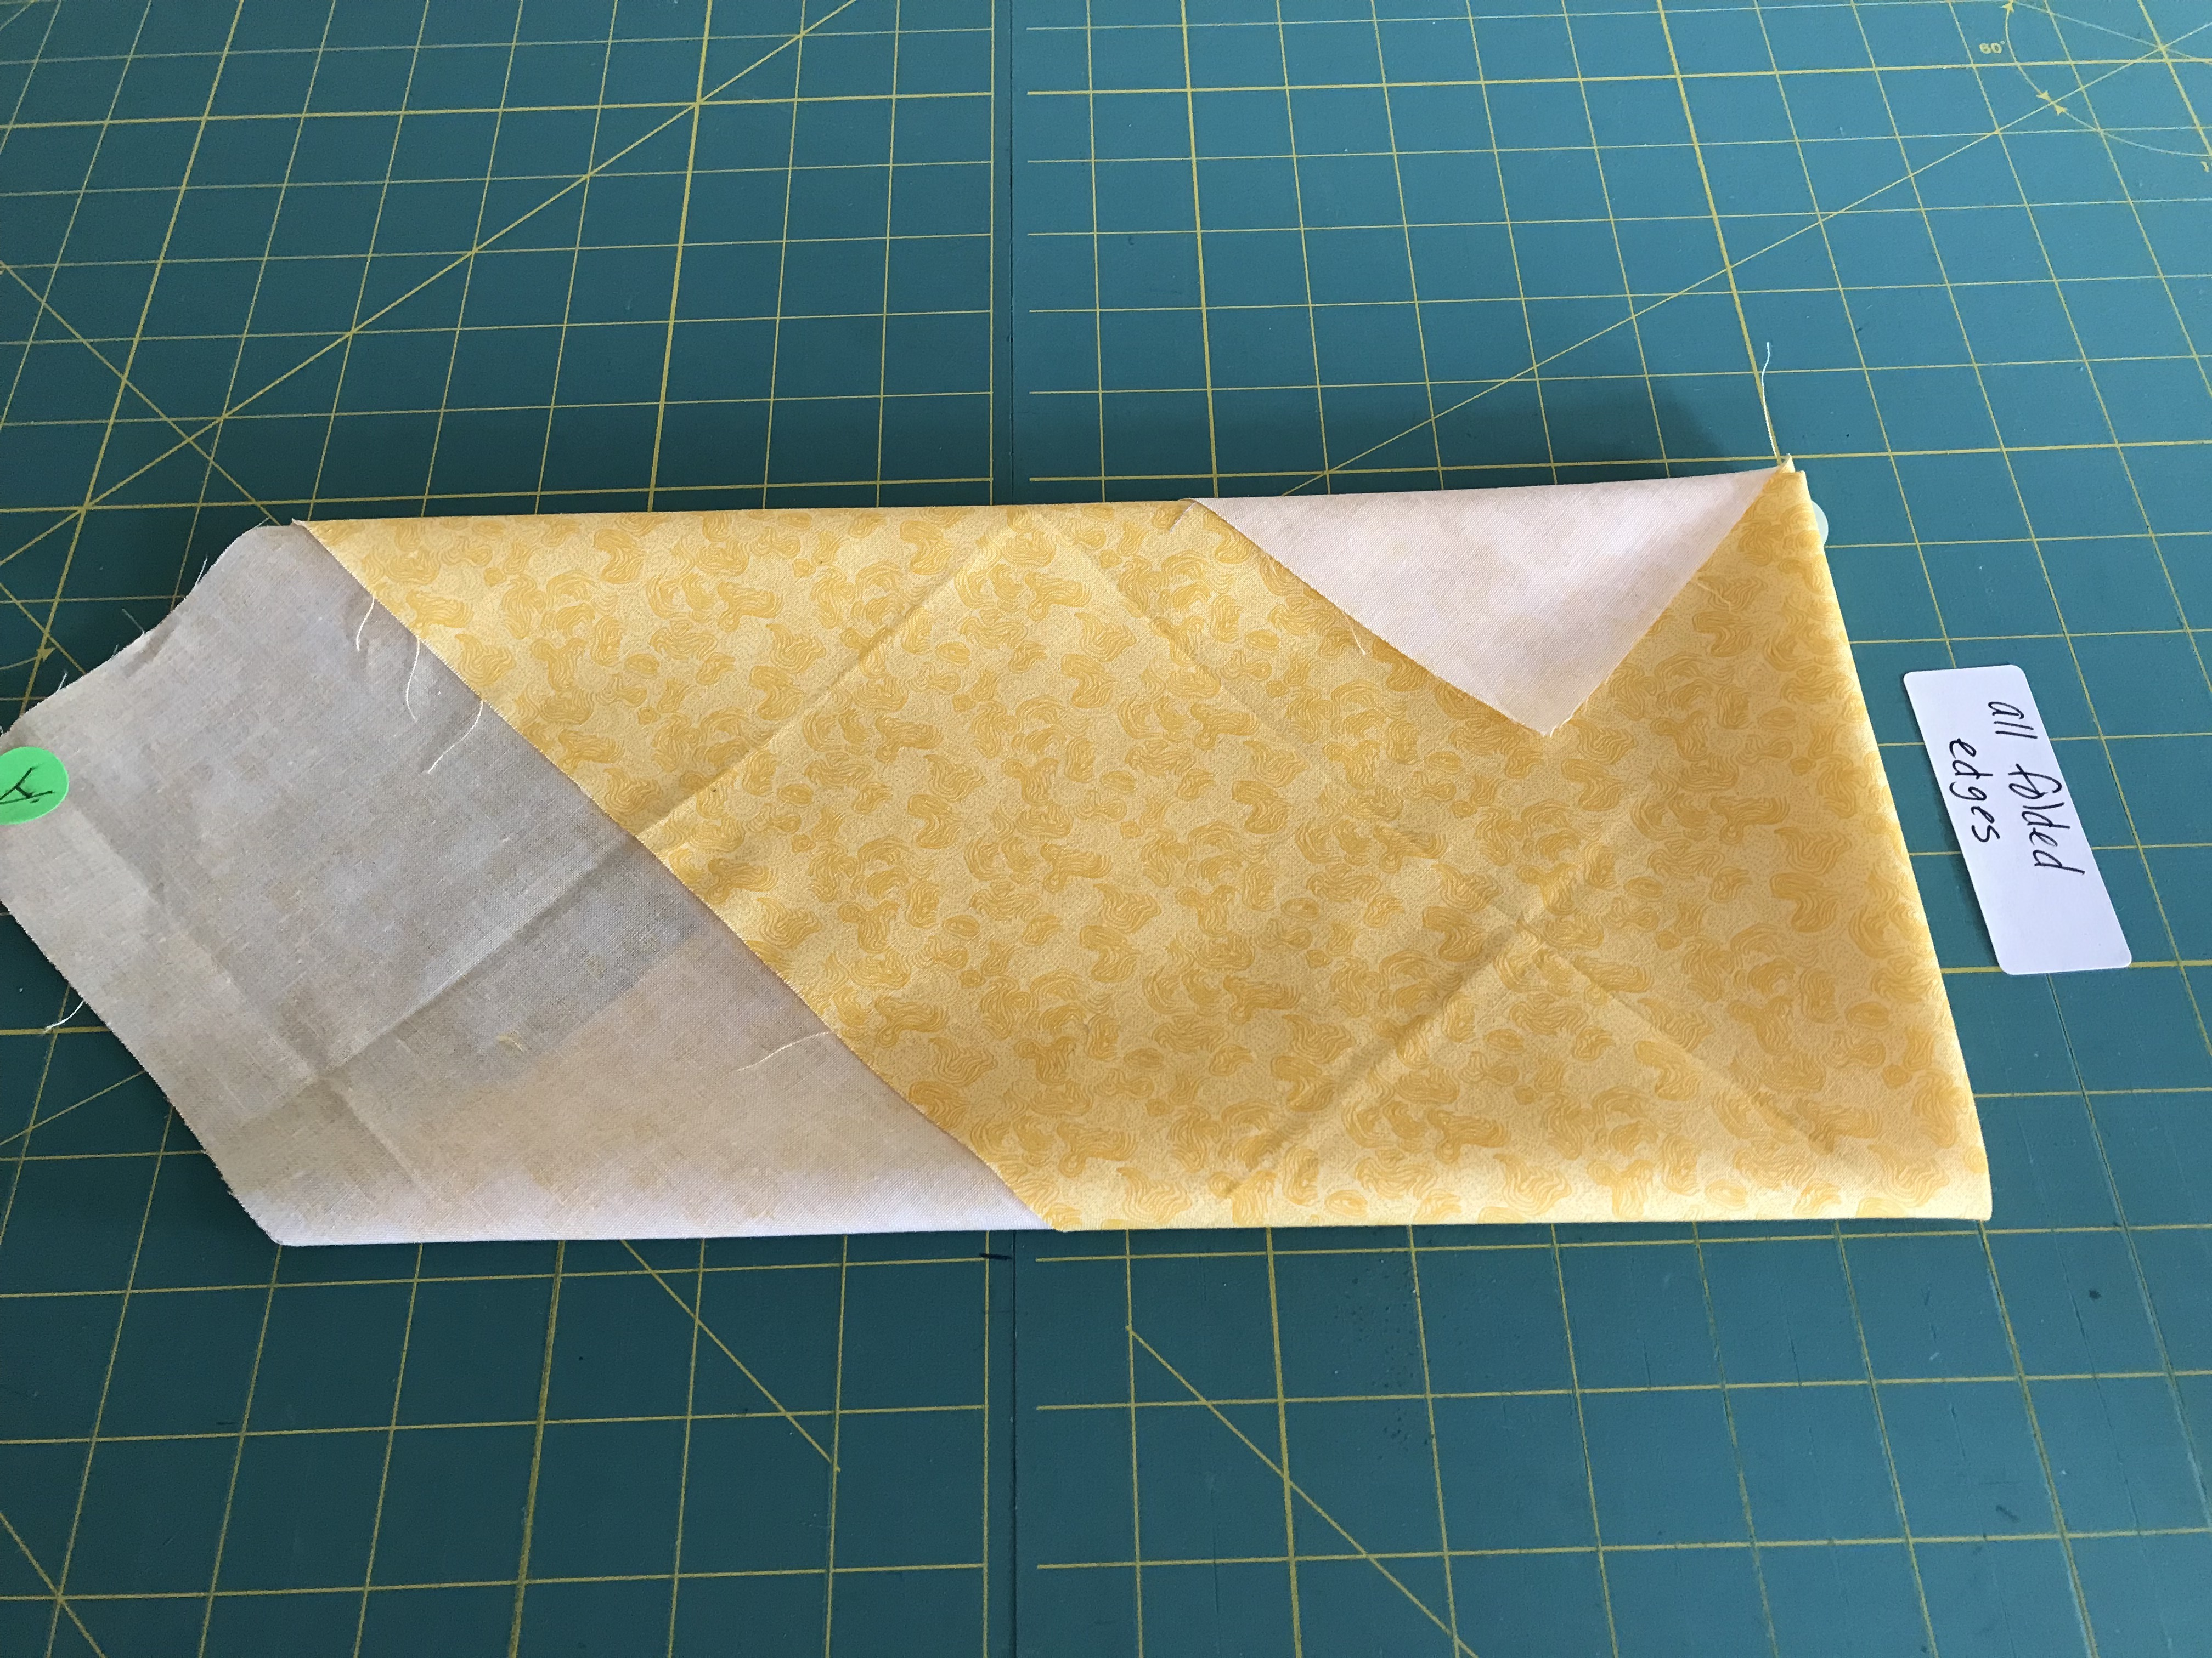

4. Turn pointed flap onto folded stack.

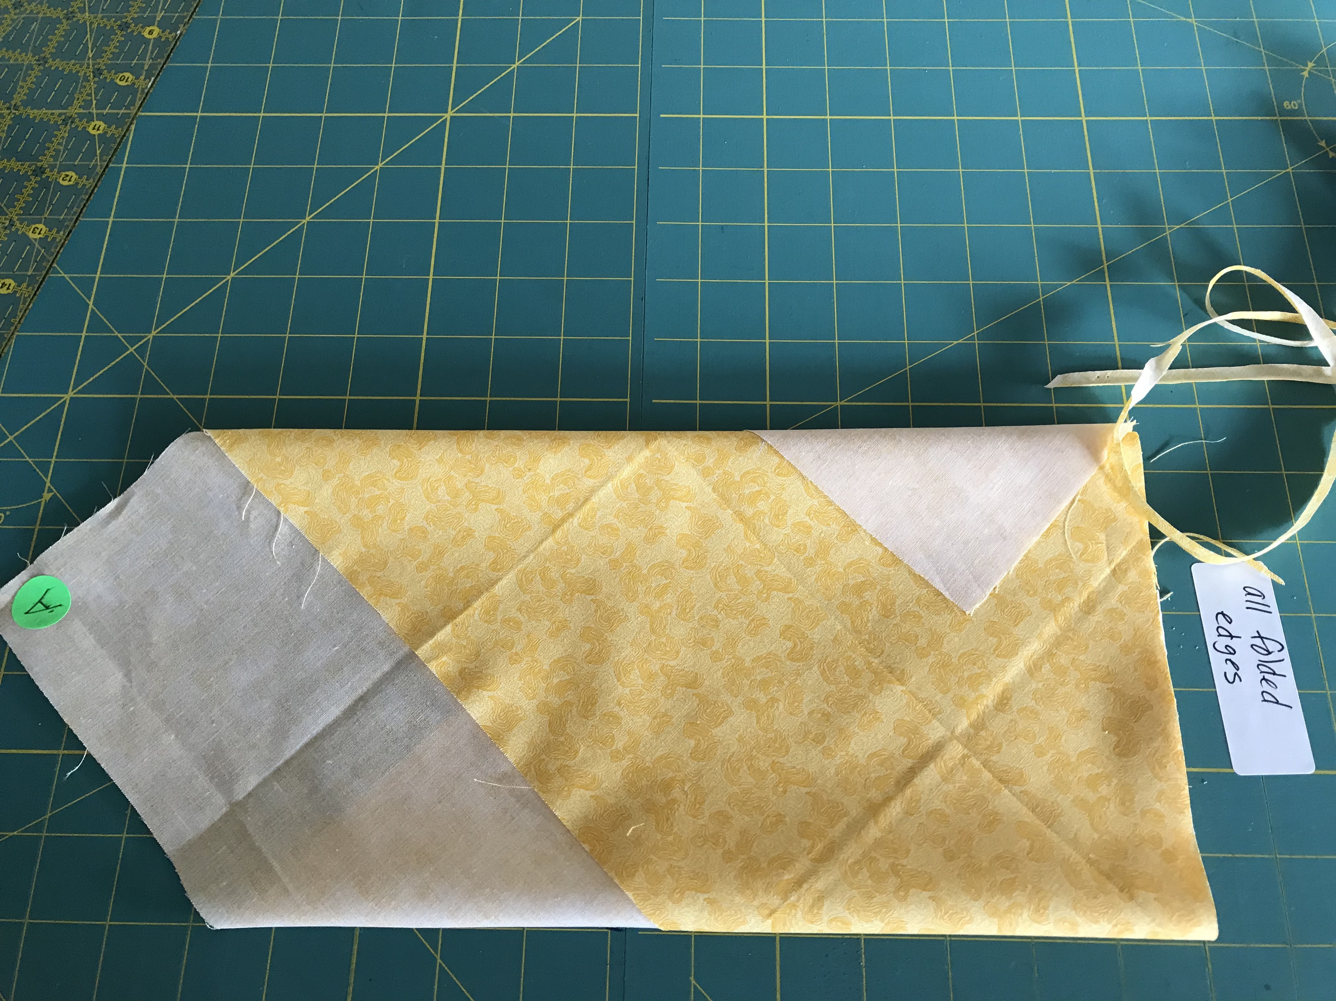

5. Trim thin strip off at folded edge with rotary cutter.

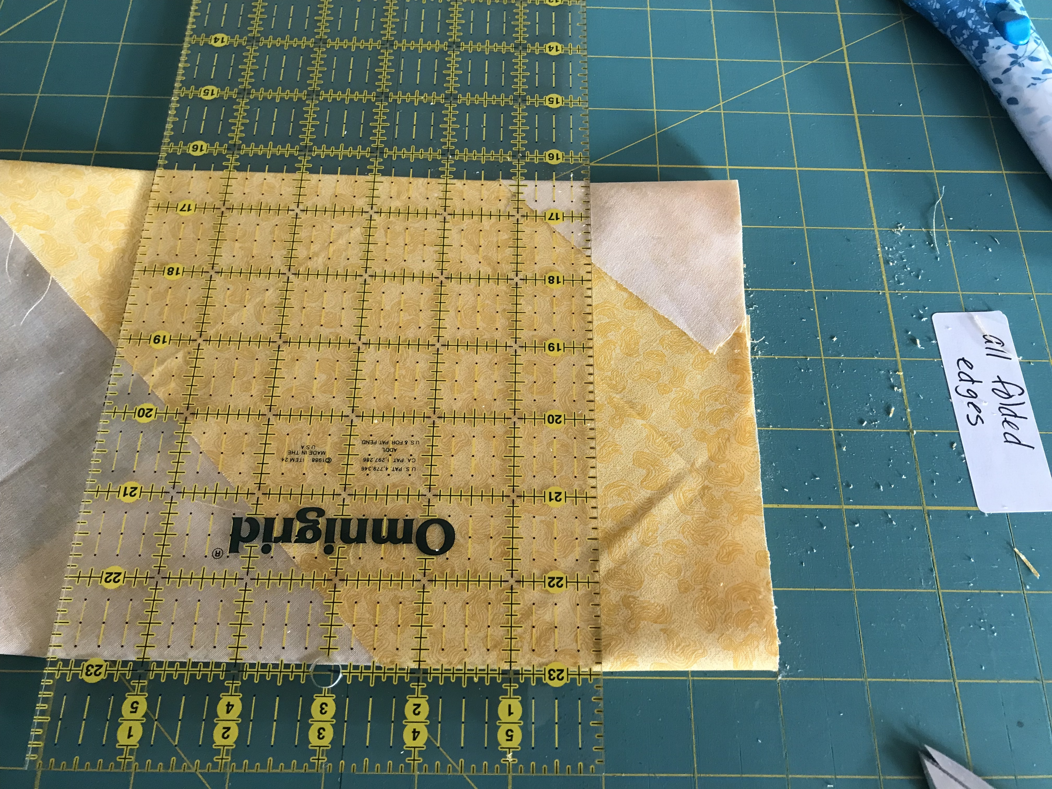

6. Cut strips 2” wide to make 1” wide double-fold tape.

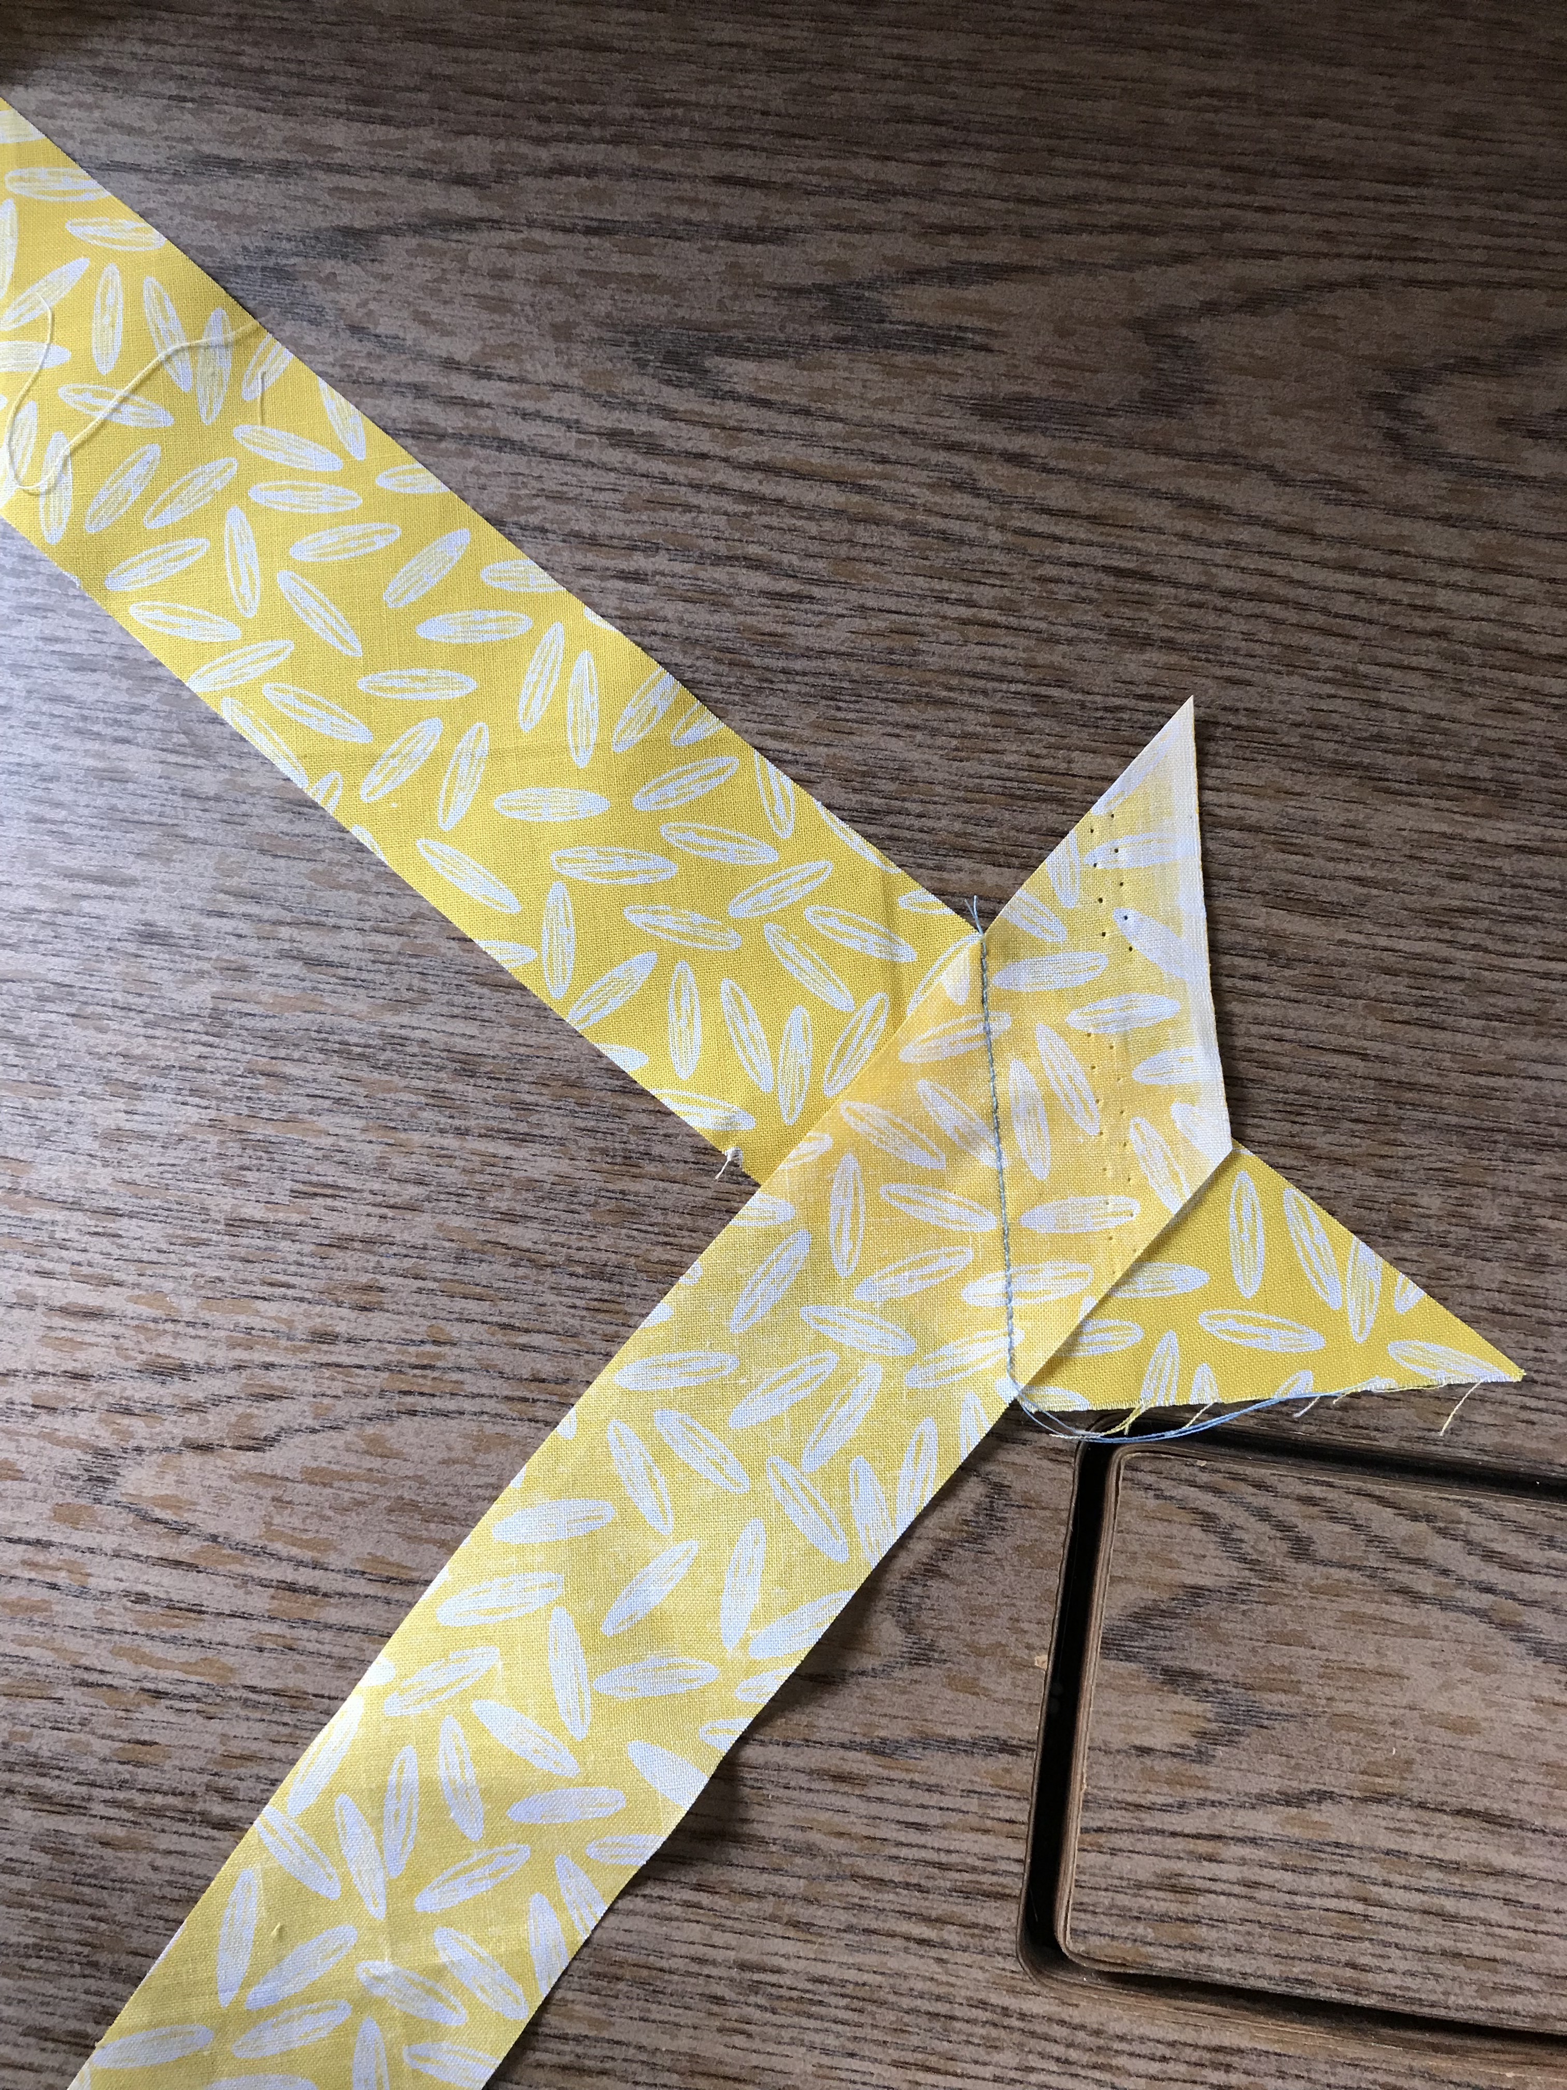

JOINING THE STRIPS:
7. Place strips perpendicular to each other with right sides together. Stitch from corner to corner as shown.

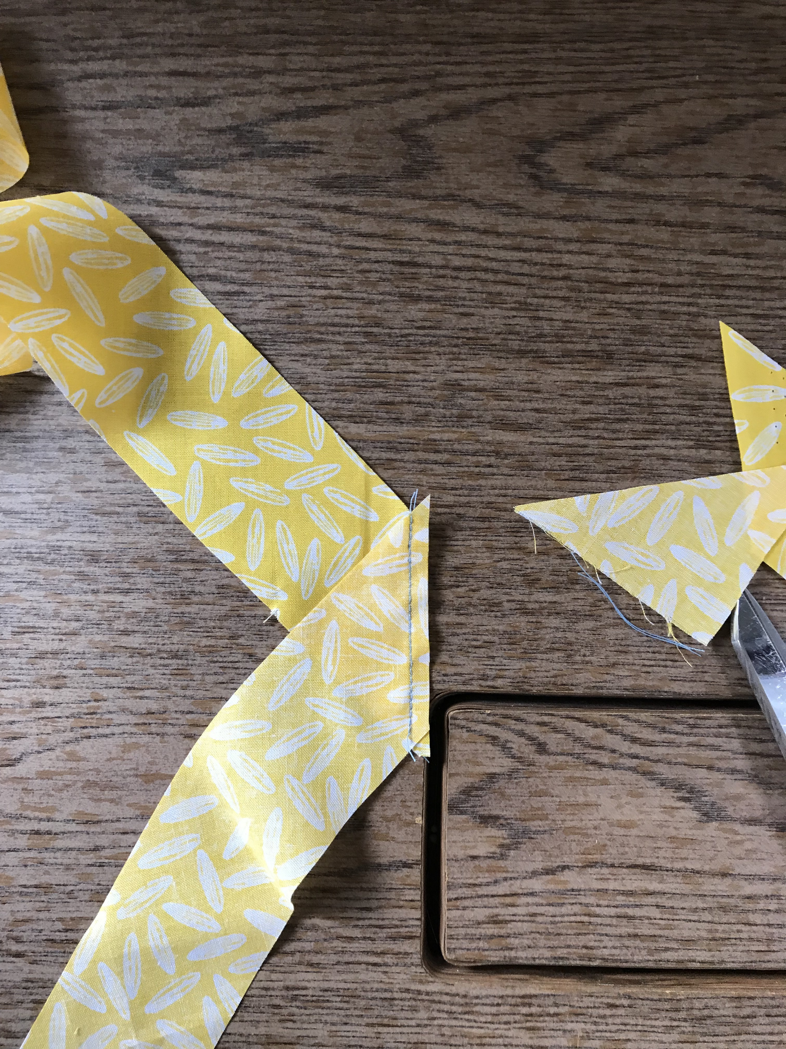

8. Trim seam allowance and press.

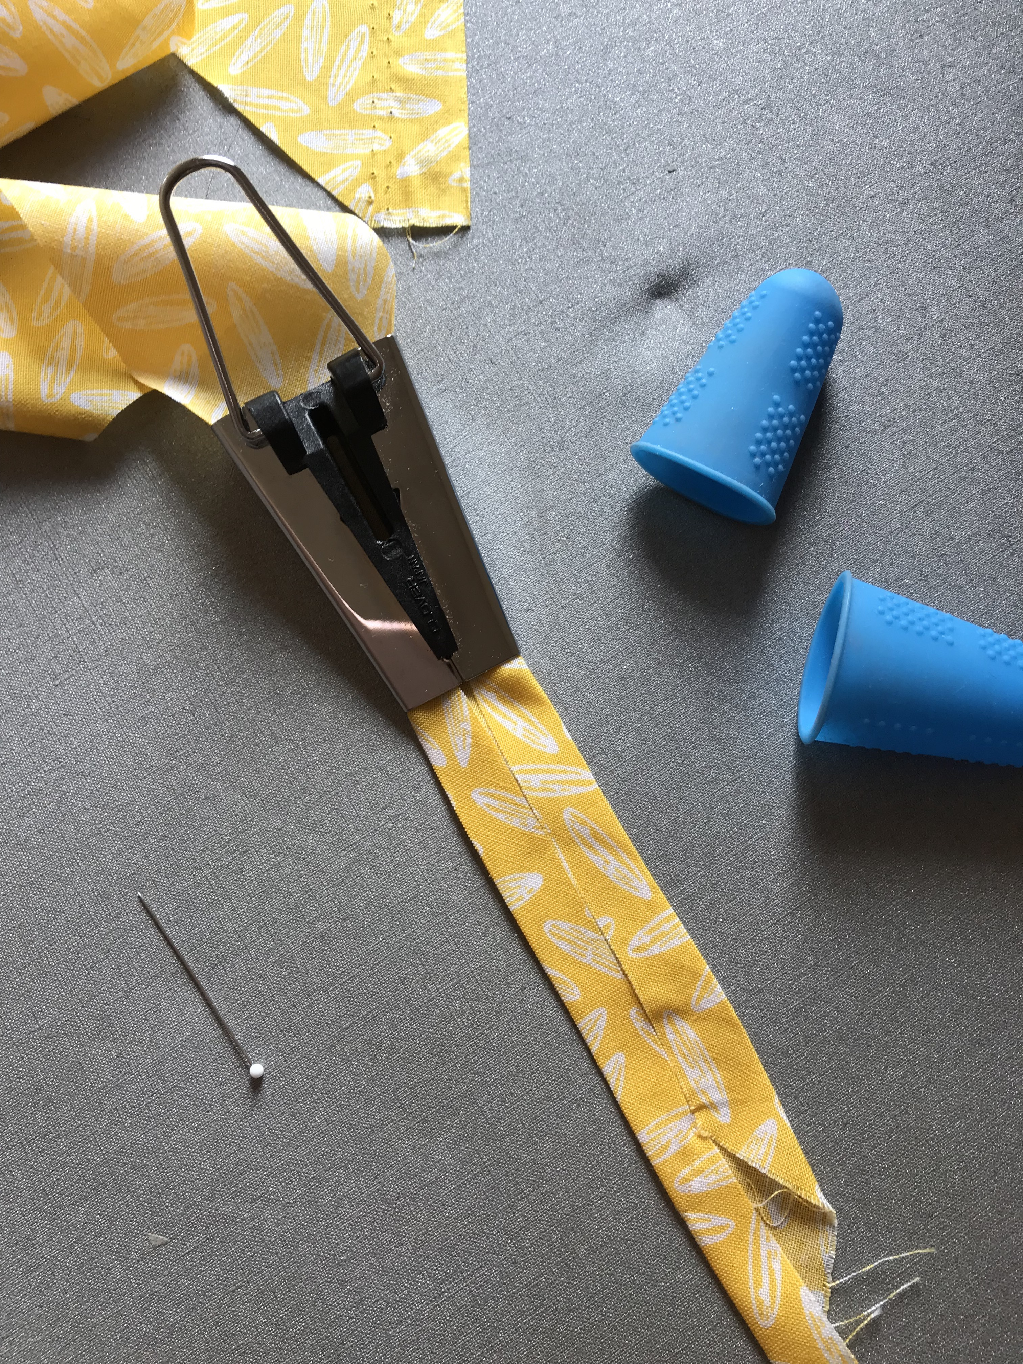

9. Using a 1” bias tape maker (usually found in quilting dept. or notions area), feed the strip thru the tool as you press with an iron. Blue silicone fingertips are sometimes helpful. After this step, fold and press the entire joined tape in half.
Simple, you’ve made your own bias tape!

