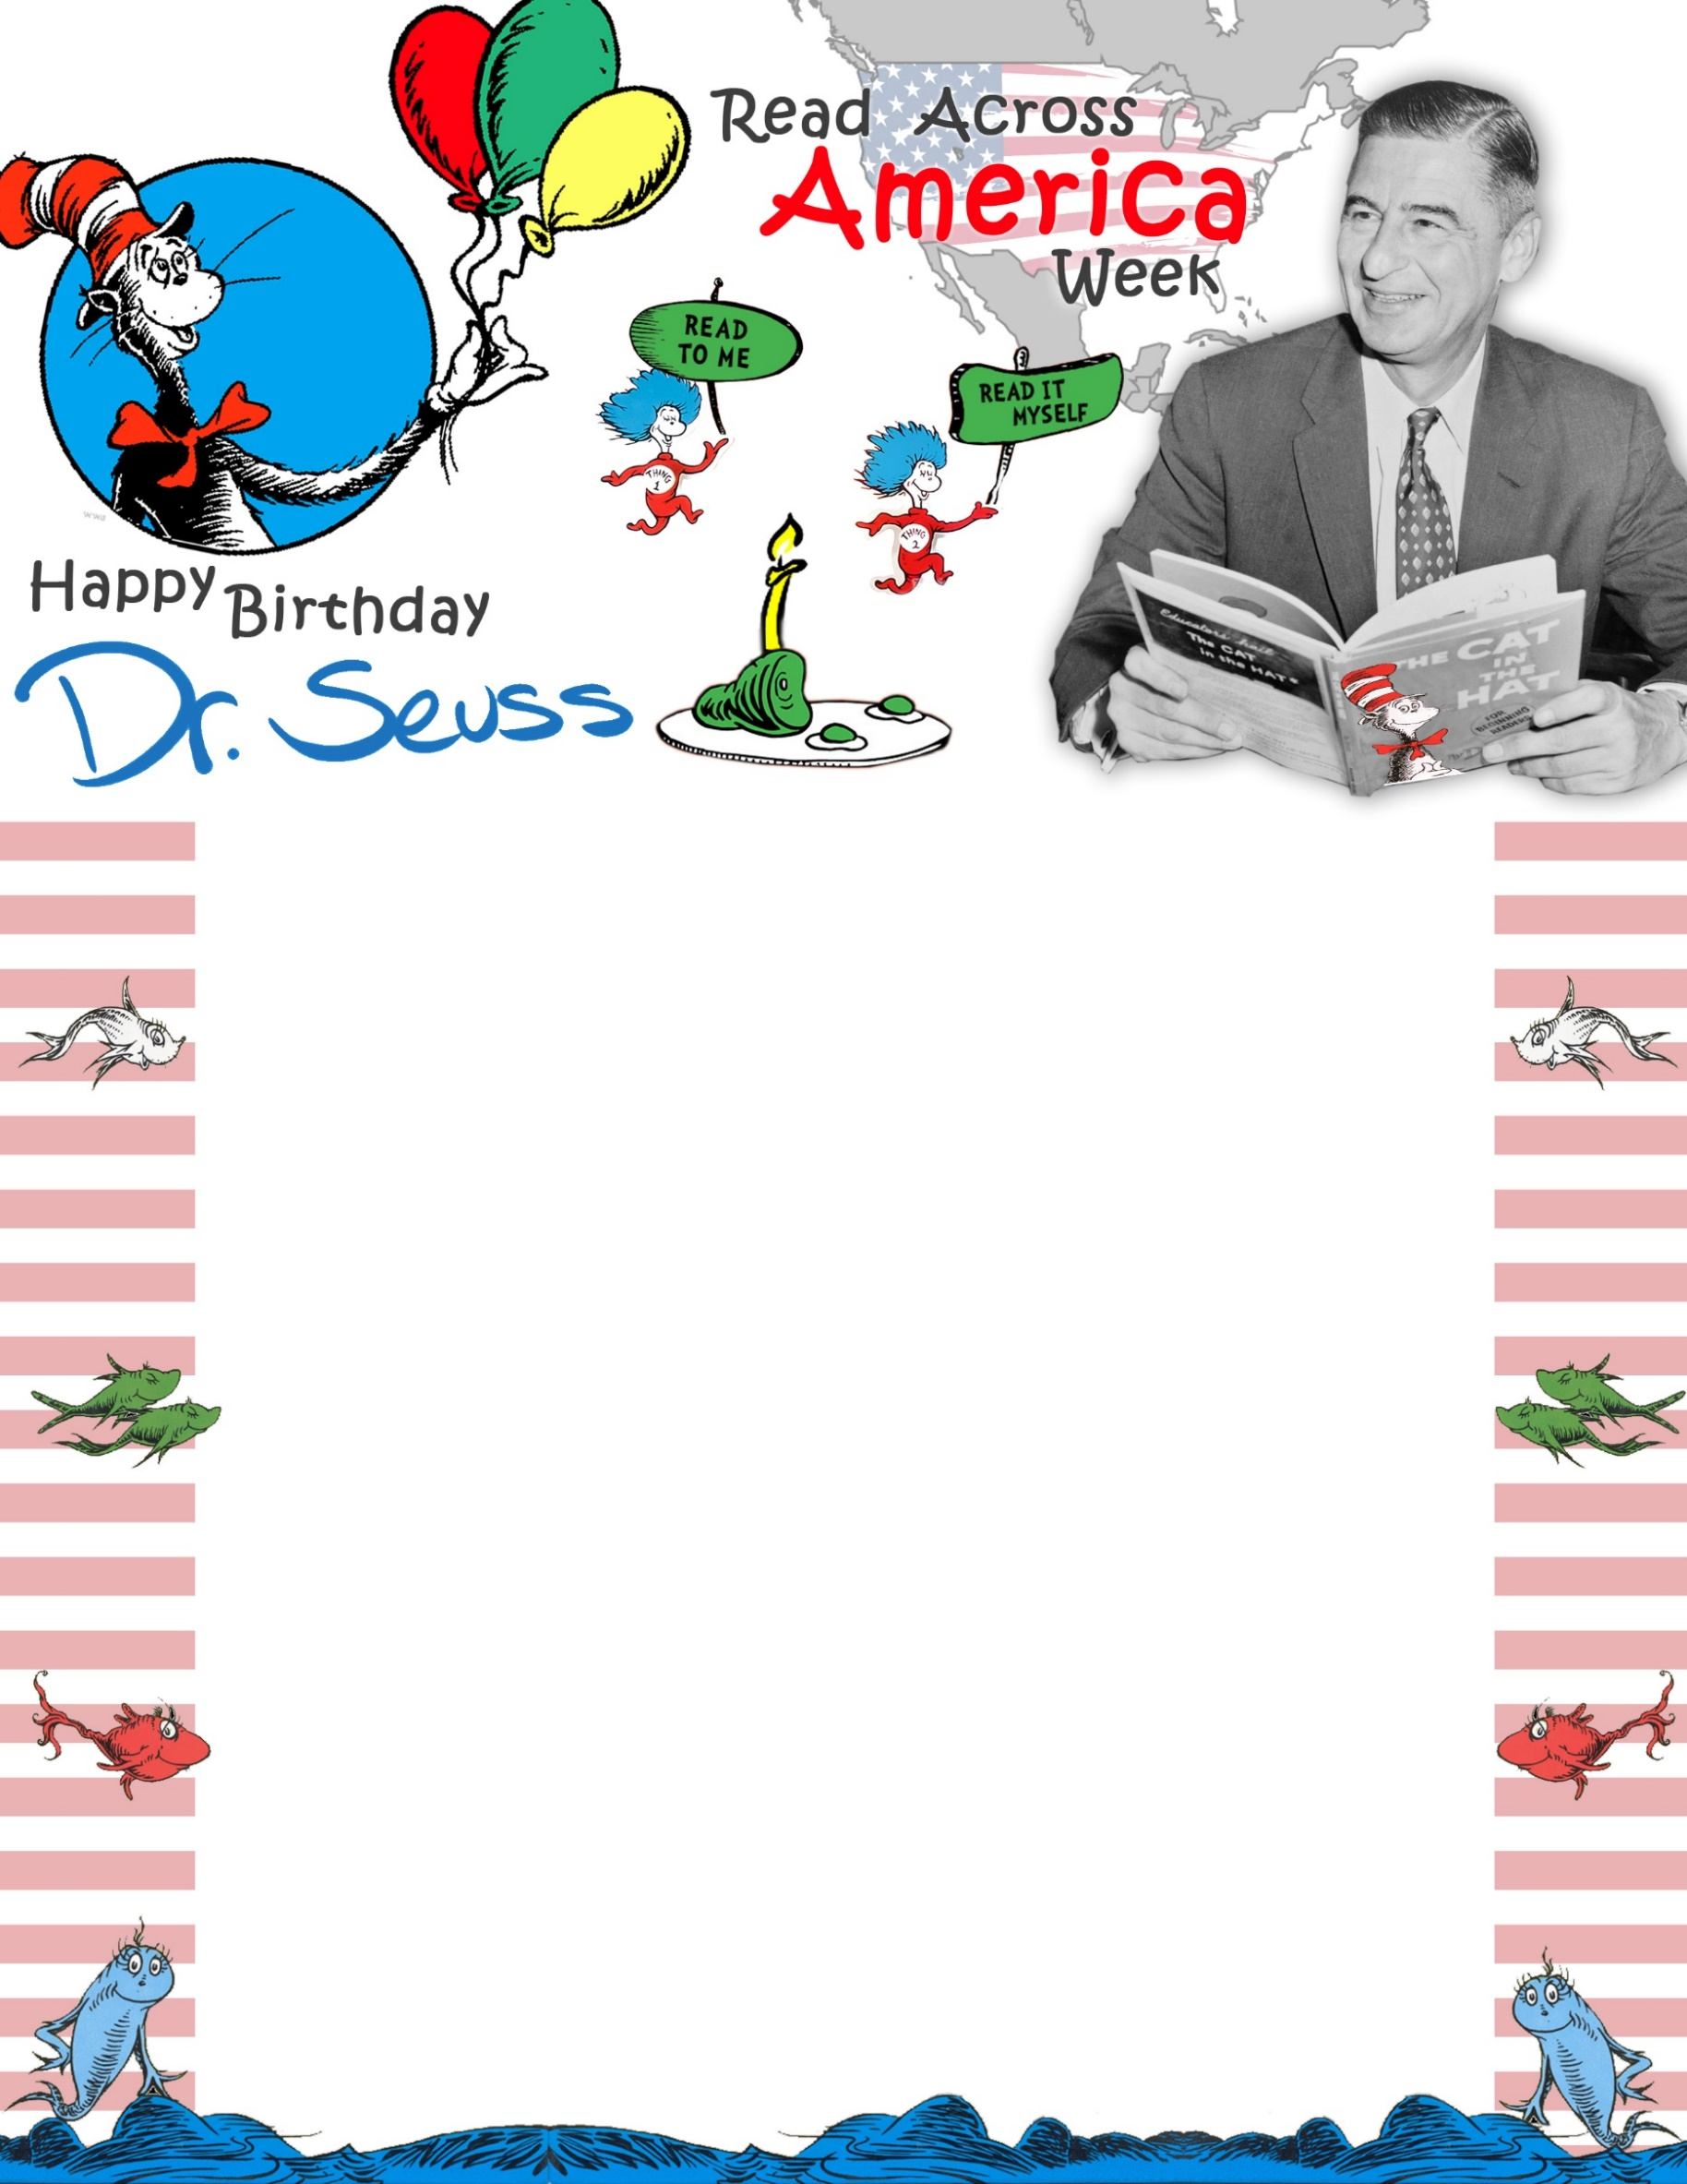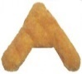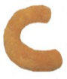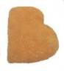

**WEDNESDAY,**

**MARCH 2nd!**

**COME ENJOY**

**CHICKEN NUGGETS..**

**IN CELEBRATION OF DR. SEUSS’ BIRTHDAY!**