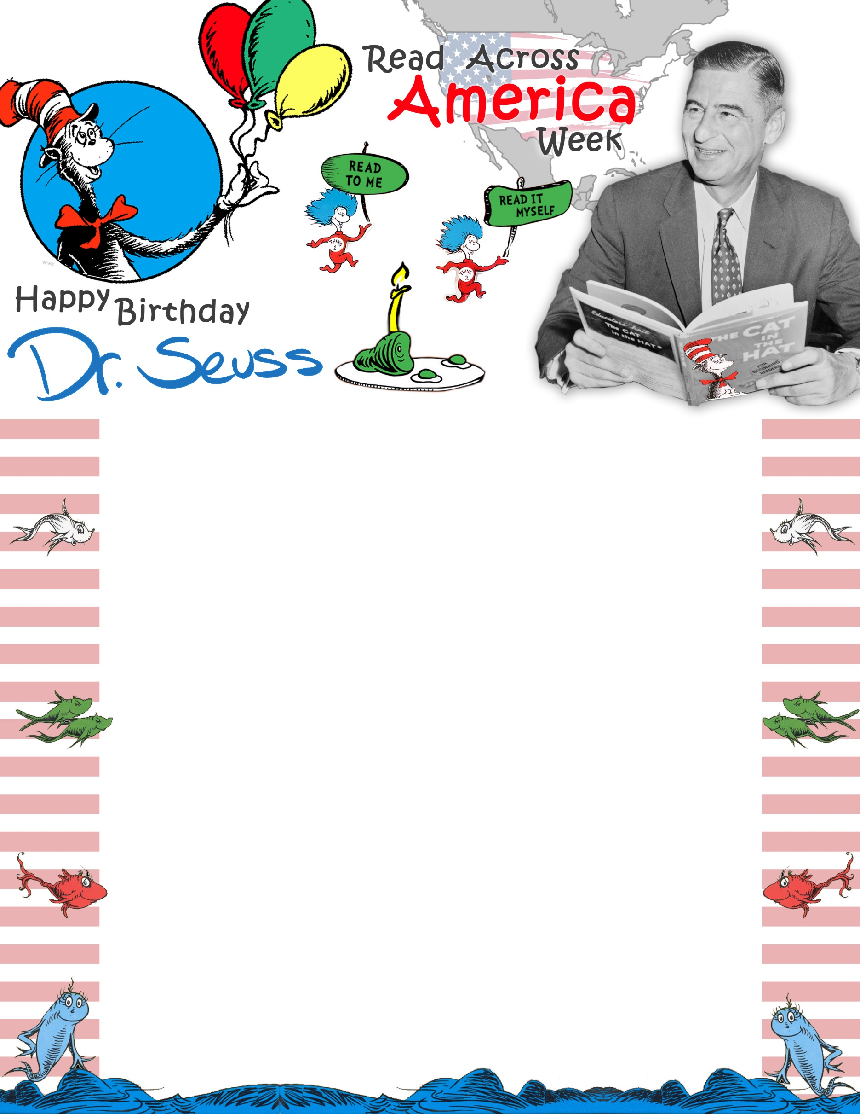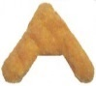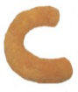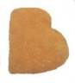

**COME ENJOY**

**CHICKEN NUGGETS**

**FOR YOUR CHANCE TO WIN**

**A DR. SEUSS BOOK!**

**WEDNESDAY,**

**March 2nd!**