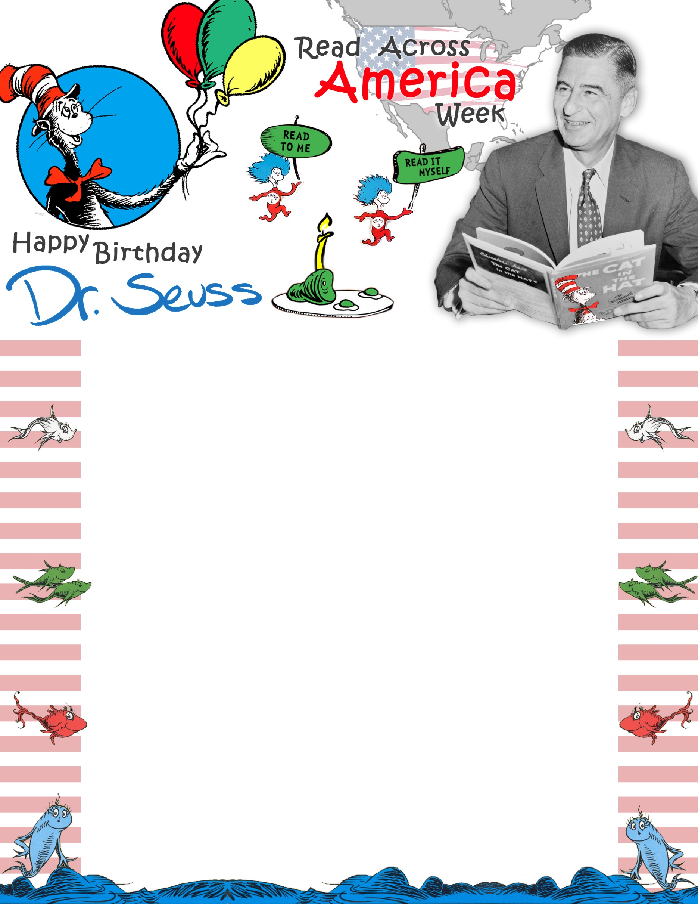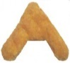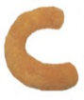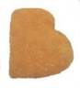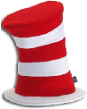

**FOR YOUR CHANCE TO WIN**

**A DR. SEUSS HAT!**

**COME ENJOY**

**CHICKEN NUGGETS**

**WEDNESDAY,**

**MARCH 2nd!**