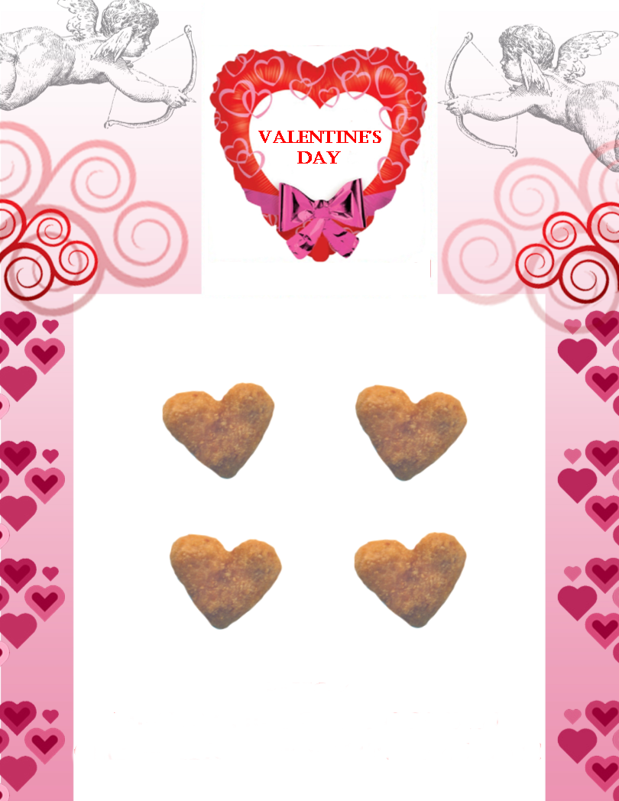

**MONDAY,**

**FEBRUARY 14TH!**

**ENJOY HEART CHICKEN NUGGETS IN CELEBRATION OF VALENTINE’S DAY!**