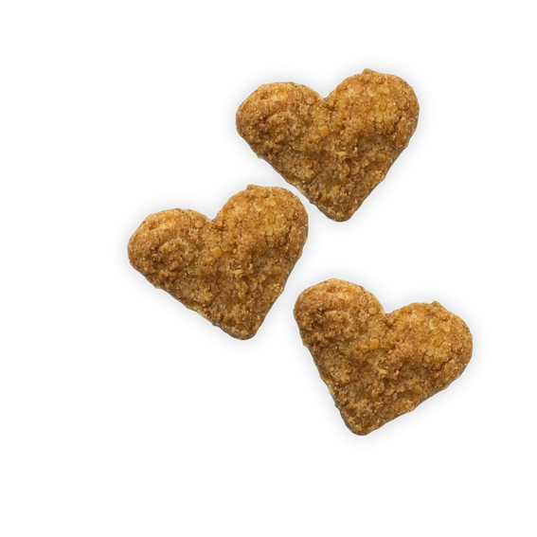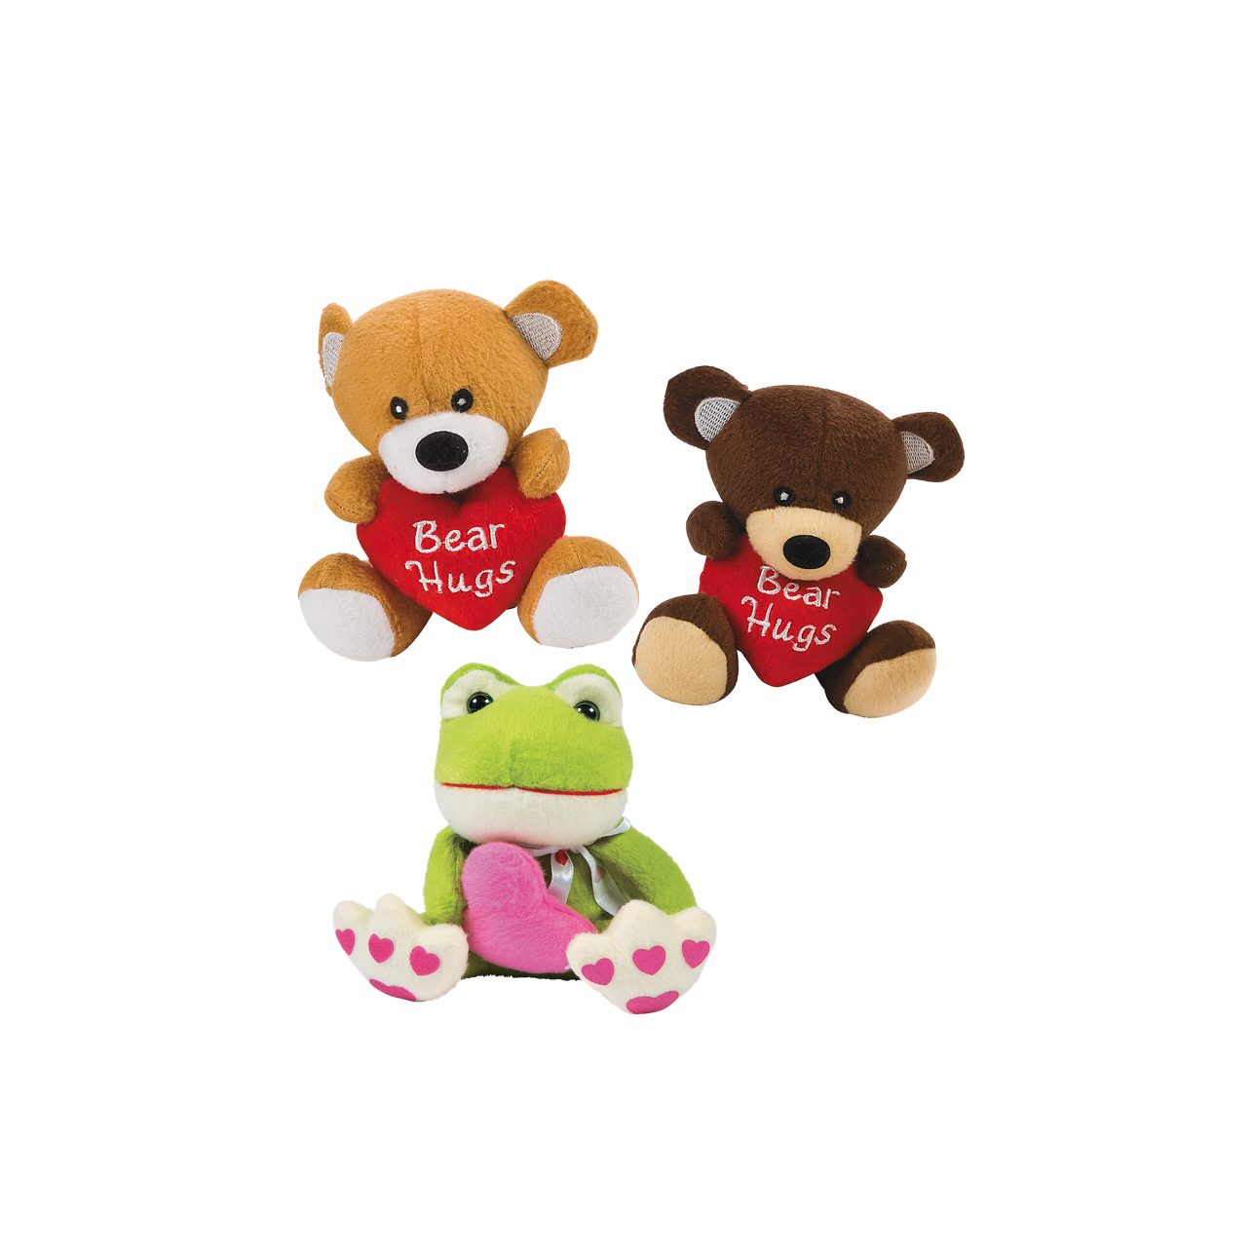

Enjoy our delicious

and fun heart-shaped chicken nuggets for your chance to win a plush Valentine’s

toy!

**Tuesday, February 14th!**

**Valentine’s**

**Day**