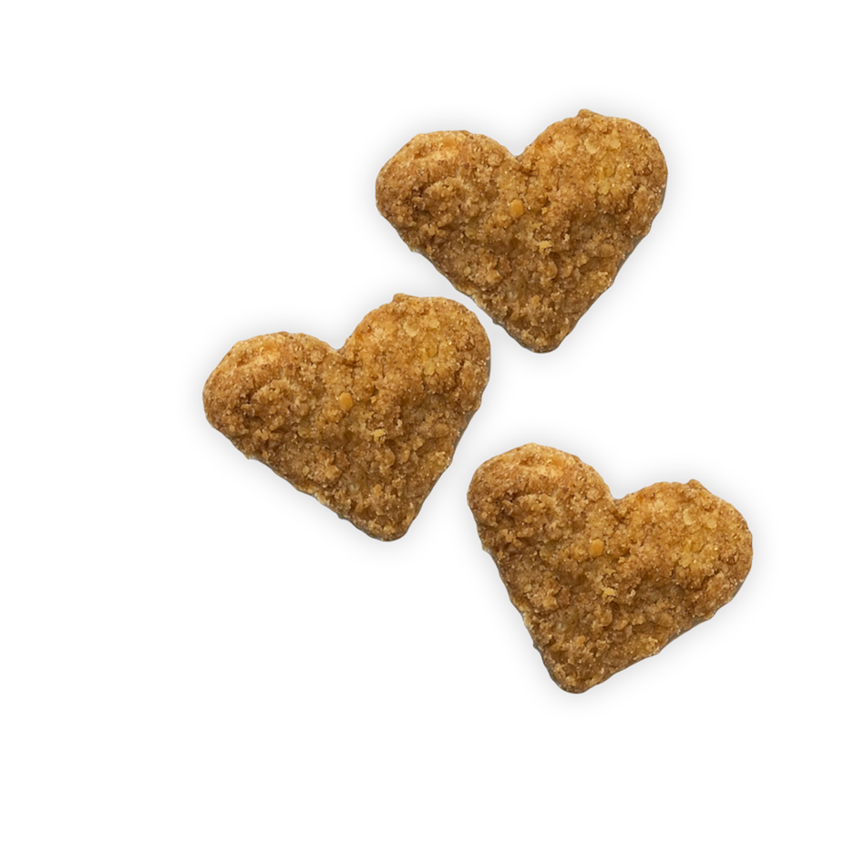

Enjoy our delicious

and fun heart-shaped chicken nuggets in celebration of Valentine’s Day!

**Tuesday, February 14th!**

**Valentine’s**

**Day**