Rappahannock Valley Football Officials Association

7-Man Mechanics Manual

2019 Season

PRIOR TO GAME DAY

ALL OFFICIALS:

1. You are responsible for reviewing the schedule for each week and acknowledging all game assignments. If unable to work the assignment you are responsible for notifying the Commissioner in a timely manner.
2. Ensure all uniforms are clean, neat, in proper repair, all patches are displayed as required and shoes polished.
3. Verify with R what the uniform for the game will be.
4. Pack uniform and equipment to ensure you have all of the required items for the assignment.
5. Ensure all officiating equipment is working properly and in good order.
6. If you have not been contacted by R concerning travel, meeting site and time at least 2 days prior to the game, call R or other crew member for information. Call or contact the Commissioner if you are unable to contact R or other crew member.

REFEREE:

1. Contact each crew member to confirm their availability to work the assignment and providing the necessary information regarding the game assignment.
2. Prepare the appropriate game cards for coaches and the game announcers.
3. Ensure you and all crew members have directions to the game site and meeting spot.

COMMISSIONER:

1. Provide game assignments to all members and coordinate and approve any and all changes needed to the assignments for each game.
2. Coordinate with all Referees for game reports and information needed prior to the assignment which the crew needs.

PRE-GAME

ALL OFFICIALS:

1. Arrive at the game site 90 minutes or as appropriate for the level of game assignment prior to kick off.
2. Verify you have the proper officiating equipment and all functions properly.
3. Actively participate in pre-game conference.
4. Penalty flags should be inconspicuous at all times on the official.
5. Enter field 30 minutes prior to kick off.
6. After completing the below listed pre-game responsibilities, meet with other officials on Linesman’s side of field to exchange and record information on game cards.
7. Move to positions in preparation for coin toss.

REFEREE:

1. Determine the appropriate uniform for the game based on the conditions and weather.
2. Conduct an interactive and complete pre-game conference.
3. Confer with both coaches (home team first) and accomplish the following:
a. Provide information on the crew members and inform the head coach who will be working their sideline.
a. Obtain captains’ names and numbers.
b. Have head coach verify all players are legally equipped.
c. Obtain information on unusual plays.
d. Obtain information regarding length of half time and any special activities.
e. Inform head coach of the appropriate sideline management directions and communications of necessary information will be via the official on their sideline.
f. Discuss the sportsmanship of all involved in the game and expectations.
g. Inquire if there are any questions for the crew.
h. Give head coach starting time, present time, and time for captains to come to coin toss.

UMPIRE:

1. Accompany Referee to confer with head coaches.
2. Rule on legality of player equipment.
3. Rule on any cast or other wraps are appropriate.
4. Inspect, approve and mark all game balls.

LINESMAN:

1. Proceed to inspect the field as appropriate. Verify field is marked properly, goal posts are legal, and there are no safety hazards.
2. Inspect and verify all equipment is in proper working order and safe for use. Ensure the chain crew has a clip and the chains have tape to mark the five yard mark.
3. Meet with chain crew and instruct them concerning their duties and responsibilities.
4. Ensure you know who the head coach is, in conjunction with the Side Judge introduce yourself and discuss sideline management, communications and timeout designation.
5. Escort team on your sideline on and off the field of play before the game and at halftime.

LINE JUDGE:

1. Proceed to inspect the field as appropriate. Verify field is marked properly, goal posts are legal, and there are no safety hazards.
2. Advise crew about field conditions and address any issues with the Referee for correction.
3. Ensure you know who the head coach is, in conjunction with the Field Judge introduce yourself and discuss sideline management, communications and timeout designation.
4. Escort team on your sideline on and off the field of play before the game and at halftime.
5. Have appropriate game card for recording of penalties during the game.

BACK JUDGE:

1. Proceed to 50 yard line and position to view both teams’ warm-ups at center of the field.
2. After teams are no longer using the complete field for warm-ups proceed to inspect the field as appropriate. Verify field is marked properly, goal posts are legal, and there are no safety hazards.
3. Ensure you have an accurate timing device.
4. Locate clock operator advise of official time, review duties and responsibilities including the procedures for the point differential rules.

SIDE JUDGE:

1. Proceed to 50 yard line and position to view both teams’ warm-ups at approximately the nine yard marks on the visitors’ side of field.
2. After teams are no longer using the complete field for warm-ups proceed to inspect the field as appropriate. Verify field is marked properly, goal posts are legal, and there are no safety hazards.
3. Have an accurate timing device to be used as a backup for the 25 second clock or as a backup to the field clock.
4. Ensure you know who the head coach is, in conjunction with the Linesman introduce yourself and discuss sideline management, communications and timeout designation.
5. Locate ball personnel, obtain their names, and instruct them in their duties including they should stay off the field.
6. Escort team on Linesman’s sideline on and off the field of play before the game and at halftime.

FIELD JUDGE:

1. Proceed to 50 yard line and position to view both teams’ warm-ups at approximately the nine yard marks on the home side of field.
2. After teams are no longer using the complete field for warm-ups proceed to inspect the field as appropriate. Verify field is marked properly, goal posts are legal, and there are no safety hazards.
3. Have an accurate timing device to be used as a backup for the 25 second clock or as a backup to the field clock.
4. Ensure you know who the head coach is, in conjunction with the Line Judge introduce yourself and discuss sideline management, communications and timeout designation.
5. Locate ball personnel, obtain their names, and instruct them in their duties including they should stay off the field.
6. Escort team on Line Judge’s sideline on and off the field of play before the game and at halftime.

COIN TOSS

REFEREE:

1. Enter the field on the 45yard line opposite the scoreboard from home sideline to the center of the field; face the scoreboard opposite the Umpire.
2. Signal the other officials to have their respective captains (no more than 4) proceed to the center of the field.
3. Provide the appropriate instructions to the captains regarding the game mechanics, coin toss and sportsmanship.
4. Conduct the coin toss with the visiting teams’ captain making the call before the toss.
5. Provide options to the captain of the team winning the toss.
6. Signal the results of the selection made and record the choice on game card.

UMPIRE:

1. Enter the field on the 45yard line on the scoreboard side of the field from visitors’ sideline to the center of the field; face the Referee with back to scoreboard.
2. Verify the instructions given by the Referee, the selection of the call by the visiting team captain and the results of the selection by the winning captain.
3. Record the results on game card.

LINESMAN:

1. Request captains for your sideline and ensure speaking captain will be on the Referee side of the field.
2. Upon signal from Referee have the captains proceed to the center of the field.
3. Observe the actions of the teams and ensure only the captains are on the field.
4. Position chain crew as appropriate from the results of the selection made.
5. Proceed to the center of the field, verify the results of the selection made and record the results on game card.

LINE JUDGE:

1. Request captains for your sideline and ensure speaking captain will be on the Referee side of the field.
2. Upon signal from Referee have the captains proceed to the center of the field.
3. Observe the actions of the teams and ensure only the captains are on the field.
4. Verify the results of the selection made and record on game card.

BACK JUDGE:

1. Take position on the home team’s sideline next to the Line Judge and assist in preparing the captains for the toss.
2. Upon signal from Referee have the captains proceed to the center of the field.
3. Observe the actions of the teams and ensure only the captains are on the field.
4. If the home team will be kicking obtain game ball and proceed to the center of the field.
5. Verify the results of the selection made and record on game card.

SIDE JUDGE:

1. Take position on the visiting teams sideline opposite of the Linesman and assist in preparing the captains for the toss.
2. Upon signal from Referee have the captains proceed to the center of the field.
3. Observe the actions of the teams and ensure only the captains are on the field.
4. If the visiting team will be kicking obtain game ball and proceed to the center of the field.
5. Verify the results of the selection made and record on game card.

FIELD JUDGE:

1. Take position on the home teams sideline opposite of the Line Judge and assist in preparing the captains for the toss.
2. Upon signal from Referee have the captains proceed to the center of the field.
3. Observe the actions of the teams and ensure only the captains are on the field.
4. Verify the results of the selection made and record on game card.

ALL OFFICIALS:

Receive final instructions from the Referee and proceed sharply to their positions for the kickoff.
Figure 1 – Coin Toss Positions – Seven Man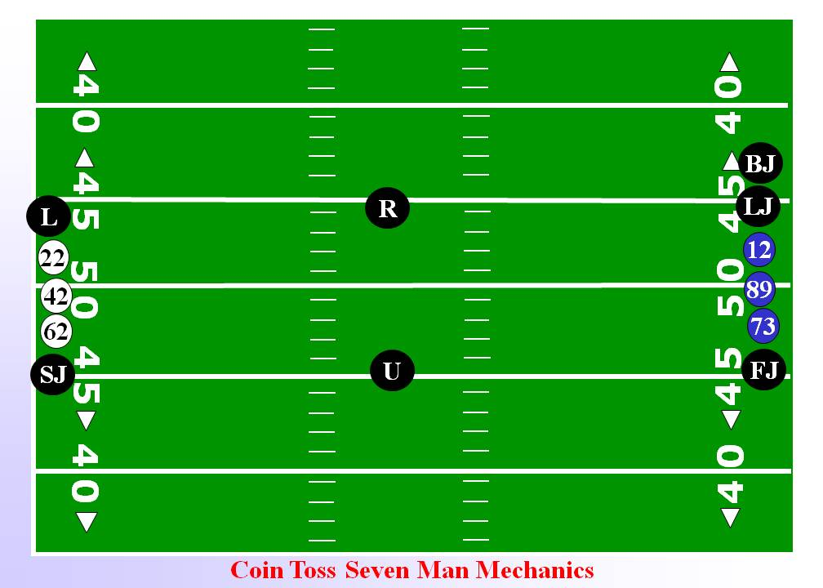

FREE KICKS

ALL OFFICIALS:

1. When requested by Referee and when in proper position, signal ready by raising hand above head.
2. When the ball is legally touched in your area start the clock with appropriate signal.
3. The covering official should see the ball in possession of runner who is down or whose forward progress is stopped or ball out of bounds before sounding his whistle.
4. If ball becomes dead in your area, sound whistle, mark spot of forward progress and give timeout signal.
5. If kick goes out of bounds untouched, or only touched by “K” in your area, sound whistle, throw flag on spot where ball went out of bounds for kick infraction, and give time out signal, if applicable.
6. If kick goes out of bounds touched by “R” in your area, sound whistle, mark spot and give time out signal.
7. Mirror time out signal given by a fellow official where/when appropriate.
8. Whenever a fumble occurs, the covering official will mark the spot of the fumble with a beanbag.

B. REFEREE:

1. Take position in center of field on the goal line or as appropriate for the level of game. Adjust for free kicks following safeties.
2. Count “R” players and confirm count with Linesman and Line Judge.
3. Check with all officials and get appropriate signal they are ready before sounding your whistle to mark the ball ready for play. Observe the kicker, other activity and ensure at least four players are on each side of the kicker at kick.
4. Responsible for the goal line and the center portion of the field. If kick crosses “R’s” goal line, sound whistle and give touchback signal.
5. Once possessed by “R” in your area, responsible for the runner until turned over to the appropriate official, observing action on and immediately around the runner. Once responsibility for the runner is picked up by the other official, observe action around and behind the runner.
6. When a field goal is attempted as a free kick after a fair catch or an awarded fair catch, take a position with kicker and instruct the kicker not to kick the ball until you have sounded the whistle for the ready for play.
7. Responsible for establishing the new series to be awarded based on results of the play.

UMPIRE:

1. Initially take a position on “K’s” free kick line on the visiting teams’ sideline.
2. Count “K” players and confirm with Back Judge.
3. Assist “K” lining up and ensure all players except the kicker are no more than five yards behind the kicking team’s free-kick line. Observe the kicker, other activity and ensure at least four players are on each side of the kicker at kick.
4. After Referee gives ready for play signal, observe the kicker and other activity.
5. Watch for first touching of free kick by “K” and mark spot with beanbag.
6. Watch initial blocks of players. Observe action by K after kick to ensure no blocks are initiated by K until ball may be legally possessed by K or R has initiated a block within the neutral zone.
7. After ball has gone downfield, move in to hash marks closest to your side line; observing action as appropriate.
8. Responsible for “K’s” goal line.
9. When a field goal is attempted as a free kick after a fair catch or an awarded fair catch, take a position on “K’s” free kick line on the home team’s side of the field.
10. After the play, secure the correct ball to be used once the new series is declared.

LINESMAN:

1. Take position on your side of the field at goal line adjust starting position as appropriate for the level of game. Adjust for free kicks following safeties.
2. Count “R” players and confirm with Referee.
3. Responsible for your half of the field and the goal line from the middle of the field to your sideline. If kick crosses “R’s” goal line, sound whistle and give touchback signal.
4. Once possessed by “R” in your area, responsible for the runner until turned over to the Side Judge, observing action on and immediately around the runner. Once responsibility for the runner is picked up by the Side Judge, observe action around and behind the runner. If kick possessed by “R” in Referee’s area observe action near and behind the runner.
6. Responsible for sideline in your area.
7. When a field goal is attempted as a free kick after a fair catch or an awarded fair catch, take a position on “R’s” free kick line on the visiting team’s sideline.
8. When the Referee determines the free kick has a high potential of an onside kick move to the 45 yard line on your side of the field or the midpoint between the free kick lines if the free kick line has moved, and observe the action for illegal blocks, first touching and possession of the ball.
9. Responsible for the spot of the end of the play from the goal line to the 40 yard line.
10. At the end of the down, set chains at forward progress spot (off the sideline).

LINE JUDGE:

1. Take position on your side of the field at goal line adjust starting position as appropriate for the level of game. Adjust for free kicks following safeties.
2. Count “R” players and confirm with Referee.
3. Responsible for your half of the field and the goal line from the middle of the field to your sideline. If kick crosses “R’s” goal line, sound whistle and give touchback signal.
4. Once possessed by “R” in your area, responsible for the runner until turned over to the Field Judge, observing action on and immediately around the runner. Once responsibility for the runner is picked up by the Field Judge, observe action around and behind the runner. If kick possessed by “R” in Referee’s area observe action near and behind the runner.
6. Responsible for sideline in your area.
7. When a field goal is attempted as a free kick after a fair catch or an awarded fair catch, take a position on “R’s” free kick line on the home team’s sideline.
8. When the Referee determines the free kick has a high potential of an onside kick move to the 45 yard line on your side of the field or the midpoint between the free kick lines if the free kick line has moved, and observe the action for illegal blocks, first touching and possession of the ball.
9. Responsible for the spot of the end of the play from the goal line to the 40 yard line.

BACK JUDGE:

1. Take a position on “K’s” free kick line.
2. Request and take control of game ball until kicker comes on to the field.
3. Responsible for timing the 25 second count.
4. Count “K” players and confirm with Umpire.
5. Assist “K” lining up and ensure all players except the kicker are no more than five yards behind the kicking team’s free-kick line. Inform kicker ball should be placed on the kick line at any point between the hash marks.
6. Instruct the kicker not to kick the ball until the Referee blows the whistle for the ready for play. Move to position on “K’s” free kick line on the home side of field. Observe the kicker, other activity and ensure at least four players are on each side of the kicker at kick.
7. Observe action by K after kick to ensure no blocks are initiated by K until R has initiated a block in the neutral zone or the ball may be legally possessed by K.
8. After the kick and the ball has gone downfield observe the kicker and holder for protection within five yards of the free kick line.
9. After ball has gone downfield, move in to hash marks closest to your side line; observing action as appropriate.
10. Responsible for “K’s” goal line.
11. Enforce the penalty for an accepted foul administered on the free kick.
12. When a field goal is attempted as a free kick after a fair catch or an awarded fair catch, take a position behind upright on visiting team’s side of field. Responsible for your upright, the goal line, and signaling results of the kick after conferring with Field Judge. Sound whistle when ball is dead.

SIDE JUDGE:

1. Take a position on “R’s” free kick line on the visiting team’s sideline.
2. Count “R” players and confirm with Field Judge.
3. Assist “R” lining up and ensure all are behind the free kick line.
4. After Referee gives ready for play signal, watch for encroachment.
5. Watch for first touching of free kick by “K” and mark spot with beanbag.
6. Watch initial blocks of players.
7. After ball has gone downfield, move in that direction; observing action away from ball; assume responsibility for runner if he comes into your area.
8. Responsible for the spot of the end of the play from the 40 yard line to the goal line.
9. When a field goal is attempted as a free kick after a fair catch or an awarded fair catch, take a position on “K’s” free kick line on the visiting team’s side of the field.

FIELD JUDGE:

1. Initially take a position on “R’s” free kick line on the home team’s sideline.
2. Count “R” players and confirm with Side Judge.
3. Assist “R” lining up and ensure all are behind the free kick line.
4. After Referee gives ready for play signal, watch for encroachment.
5. Watch for first touching of free kick by “K” and mark spot with beanbag.
6. Watch initial blocks of players.
7. After ball has gone downfield, move in that direction; observing action away from ball; assume responsibility for runner if he comes into your area.
8. Responsible for the spot of the end of the play from the 40 yard line to the goal line.
9. When a field goal is attempted as a free kick after a fair catch or an awarded fair catch, take a position behind upright on home team’s side of field. Responsible for your upright, the goal line, and signaling results of the kick after conferring with Back Judge.

Figure 2 – Pre-Kick Positions – Seven Man

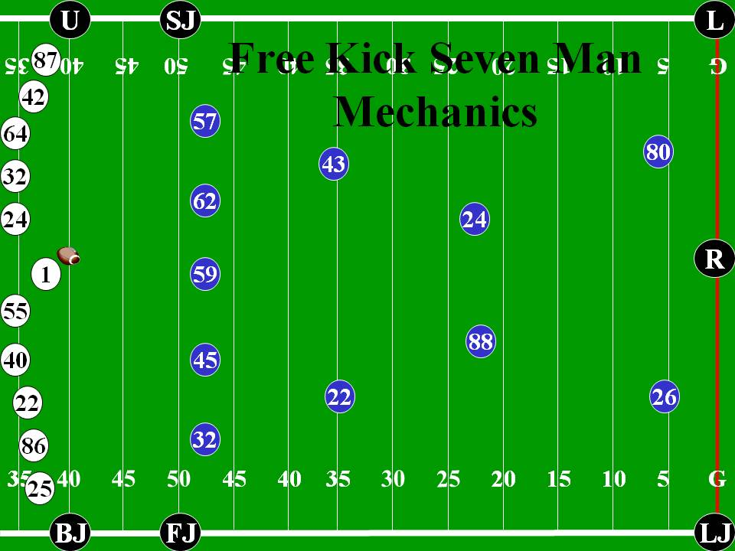

SCRIMMAGE PLAYS

ALL OFFICIALS:

1. Verify the correct down on every play and communicate with other officials.

2. The covering official who has the ball in possession of runner within his zone of responsibility, who is down by rule or whose forward progress is stopped or is out of bounds sound your whistle.

3. If the ball becomes dead inbounds near the sideline and no first down is gained, give the start clock signal using two turns of the arm.

4. When ball is declared dead and a first down is obvious, give timeout signal. NOTE:
When this occurs near the sideline, give the start clock signal using two turns of the arm followed by the timeout signal.

5. If you are the covering official on out of bounds plays, turn to follow the play, sound whistle, give timeout signal, mark the spot, and observe action around runner.

6. When forward progress is near the line to gain, covering official should request the ball to be placed at the spot at the officials’ feet and should request R to determine if line to gain has been reached.

7. Mirror time out signal given by a fellow official where/when applicable

8. Whenever a fumble occurs, the covering official will mark the spot of the fumble with a beanbag.

9. The Back Judge and/or Referee may give touchdown signal on long scoring plays near a sideline only after communicating with appropriate wing official.

REFEREE:

1. Communicate the proper information (down and distance) to all parties and mark the ball ready for play with signal and short blast of your whistle.

2. Count players of team A and give signal to Umpire who will acknowledge by returning signal. A clenched fist at shoulder height represents 11 players. An open hand at shoulder height in front of the body represents other then 11 players.

3. During the count if there are more than 11 players and three seconds has passed since the extra player entered sound whistle and throw flag.

4. Take a position 12 to 15 yards behind the line of scrimmage, outside the tight end and to the side of the QB (usually on the throwing side) and also in a position to observe the snap.

5. Watch for movement in the backfield prior to the snap.

6. After snap cover the ball, runner, and action around player until player enters zone of responsibility for another official’s area.

7. Cover the QB on passing plays, watch for roughing the passer, place from which pass is thrown, rule on illegal passes.

8. Rule on forward or backward passes, other than quick QB pass.

9. Clean up behind plays, which go downfield, watching for illegal acts.

10. When ball is declared dead, move as appropriate to determine next down. Communicate with Linesman number of next down. If line to gain has been reached signal first down.

UMPIRE:

1. Take a position behind team “B” (usually 7-8 yards from line of scrimmage) and between “B’s” ends ensuring a clean view of the center and the ball.

2. Count team “A” players; give count signal to Referee who will acknowledge by returning signal. A clenched fist at shoulder height represents exactly 11 players. An open hand at shoulder height in front of the body represents other then 11 players.

3. Check numbering on offensive line, observe equipment & mouthpieces.

4. Observe action for false starts, snap infractions, and other dead ball fouls.

5. Cover action on snapper and of players at point of attack and then behind runner, watching for holding, illegal use of hands, and/or illegal blocks.

6. Pass plays adjust position as needed to line of scrimmage, watch for ineligible downfield; assist R with tipped pass, pass crossing line of scrimmage and illegal forward pass; assist with passes thrown in front of side and back officials.

7. When ball is declared dead, get forward progress from covering official and spot ball on proper yard line between inbounds markers. Cover ball until R gives ready for play signal.

8. On goal line plays responsible for actions of all interior linemen. If asked by side official, and acknowledged by you, rule on forward progress from your position.

9. On goal line plays signal with a closed hand on chest when you see a downed offensive player in possession of the ball in the end zone.

LINESMAN:

1. Check position of box; verify the down number and line to gain.

2. Take a position straddling neutral zone starting on the side line.

3. Signal to Line Judge only if position of widest “A” player is in the backfield and hold until snap. Responsible for counting and confirming there are a minimum of seven (7) “A” players on Line of Scrimmage. Verify count of offense by observing the Referee and/or Umpire and then counting number of players off the line of scrimmage to ensure a legal formation.

4. Identify the eligible pass receivers’ numbers on your side.

5. Watch for encroachment and false starts. Observe player whose initial motion is toward opposite sideline, responsible for the player in motion towards your position. Observe if movement is forward before the snap.

6. Responsible for your sideline during the entire down.

7. After snap, watch initial charge of linemen. When the play comes into your area, take responsibility for ball, runner and action around him. When the play goes to the opposite side, observe the action behind the play watching especially for late hits to QB behind the Referee.

8. During pass play: a) be ready to rule on direction of quick QB pass towards you; b) adjust position as needed with eligible receivers, observing action around them. When pass is thrown, be in position to rule on pass completion and pass interference. If pass is incomplete in your area, sound whistle and give incomplete pass signal. Help in retrieving ball if necessary.

9. On all plays in your area, mark forward progress/spot with feet together Umpire will spot on the foot farthest downfield. When ball becomes dead in side zone, place ball on foot until next down is determined. Use Side Judge for triangle to relay ball to Umpire. Hold spot until released by Umpire.

10. On plays between the inbound lines, hold forward progress spot with feet together until released by Umpire. When spot is near the line to gain place ball on downfield foot and await instructions from Referee.

11. When ball becomes dead, communicate with Referee regarding number of next down. Signal box to move to forward point of ball after ensuring there are no flags and to change down marker. If new series is declared, move to sideline and reset box, clip, and yardage chains.

12. Responsible for all goal line plays when the snap is inside B’s 5 yard line.

13. On goal line plays (ball snapped on or inside “B’s” 5 yard line), initial move at snap should be towards the goal line to be in position to rule on scoring play. If plane is broken by the ball sound whistle and signal score with proper signal.

14. On goal line plays going out (ball snapped on or inside “A’s” 5 yard line), reverse mechanics are in play at the snap first move should be to the goal line and officiate the play. Observe the play to ensure the position of the ball at end of play remembering the ball must completely be out of the end zone to be in the playing field.

LINE JUDGE:

1. Verify the down number with the members of the crew, position of the box is correct, the box is displaying the correct down and the line to gain.

2. Take a position straddling neutral zone starting on the side line.

3. Signal to Linesman only if position of widest “A” player is in the backfield and hold until snap. Responsible for counting and confirming there are a minimum of seven (7) “A” players on Line of Scrimmage. Verify count of offense by observing the Referee and/or Umpire and then counting number of players off the line of scrimmage to ensure a legal formation.

4. Identify the eligible pass receivers’ numbers on your side.
5. Watch for encroachment and false starts. Observe player whose initial motion is toward opposite sideline, responsible for the player in motion towards your position. Observe if movement is forward before the snap.

6. Responsible for your sideline during the entire down.
7. After snap, watch initial charge of linemen. When the play comes into your area, take responsibility for ball, runner and action around him. When the play goes to the opposite side observe the action behind the play watching especially for late hits to QB behind the Referee.
8. During pass play: a) be ready to rule on direction of quick QB pass towards you; b) adjust position as needed with eligible receivers, observing action around them. When pass is thrown, be in position to rule on pass completion and pass interference. If pass is incomplete in your area, sound whistle and give incomplete pass signal. Help in retrieving ball if necessary.
9. On all plays in your area, mark forward progress/spot with feet together Umpire will spot on the foot farthest downfield. When ball becomes dead in the side zone, place ball on foot until next down is determined. Use Field Judge for triangle to relay ball to Umpire. Hold spot until released by Umpire.
10. On plays between the inbound lines, hold forward progress spot with feet together until released by Umpire. When spot is near the line to gain place ball on downfield foot and await instructions from Referee.

11. When ball becomes dead, observe forward progress in relation to line to gain and communicate to Referee the next down, if line to gain has been reached for a new series, or should ‘take a look’ to make a decision. If line to gain has been reached stop the clock appropriately or as instructed by Referee.

12. Responsible for all goal line plays when the snap is inside B’s 5 yard line.

13. On goal line plays (ball snapped on or inside “B’s” 5 yard line), initial move at snap should be towards the goal line to be in position to rule on scoring play. If plane is broken by the ball sound whistle and signal score with proper signal.

14. On goal line plays going out (ball snapped on or inside “A’s” 5 yard line), reverse mechanics are in play at the snap first move should be to the goal line and officiate the play. Observe the play to ensure the position of the ball at end of play remembering the ball must completely be out of the end zone to be in the playing field.

BACK JUDGE:

1. Take a position in the middle of the field approximately 25 yards, always at least 5 yards deeper then the deepest defensive back, favoring the wide side and adjust based on the formation of “A”.

2. Responsible for timing the 25 second count.

3. Verify the down number with the members of the crew and the line to gain if the distance is longer than 10 yards and communicate to all with the signal for “Two Stakes” to ensure all know the line to gain status.

4. Count players of the defense and give appropriate count signal to Field and Side Judges.

5. Responsible for goal line on plays originating outside of B’s 20 yard line and always responsible for the end line at all times.

6. On running plays, observe initial line charge, watching for illegal blocks by wide receivers; observe action in “B’s” secondary and action in front of the runner.

7. On pass plays, retreat to be in position 15 to 17 yards ahead of deepest receiver, observe blocking downfield. When pass is thrown, be in position to rule on pass completion and pass interference. If pass is incomplete, sound whistle and give incomplete pass signal. On short passes, be in a position to assist side officials if required. Help in retrieving the ball if necessary.

8. Be in position to rule on forward progress on long plays.
9. On plays between the inbound lines, hold forward progress spot with feet together until released by other crew member.
10. Communicate with the Referee and other members of the crew on whether the clock should start on the ready or the snap based on the result of the action on the prior play. If the clock starts on the ready signal from the Referee wind the clock in.
11. Communicate with the Referee inside last minute of the quarter who has the responsibility for timing verification when facing the scoreboard/clock.

SIDE JUDGE:

1. Take a position on the visitors’ side of the field approximately 17 to 20 yards.

2. Verify the down number with the members of the crew and the line to gain if the distance is longer than 10 yards and communicate to all with the signal for “Two Stakes” to ensure all know the line to gain status.

3. Count players of the defense and give appropriate count signal to Back Judge.

4. Responsible for game clock operation and accuracy.

5. Responsible for goal line on plays originating outside of B’s 5 yard line.

6. On running plays, observe initial line charge, watching for illegal blocks by wide receivers; observe action in “B’s” secondary and action in front of the runner.

7. On pass plays, retreat to be in position 10 to 12 yards ahead of deepest receiver, observe blocking downfield. When pass is thrown, be in position to rule on pass completion and pass interference. If pass is incomplete, sound whistle and give incomplete pass signal. On short passes, be in a position to assist side officials if required. Help in retrieving the ball if necessary.

8. Be in position to rule on forward progress on long plays.
9. On plays between the inbound lines, hold forward progress spot with feet together until released by other crew member.
10. Communicate with the Referee and other members of the crew on whether the clock should start on the ready or the snap based on the result of the action on the prior play. If the clock starts on the ready signal from the Referee wind the clock in.

FIELD JUDGE:

1. Take a position on the home side of the field approximately 17 to 20 yards.

2. Verify the down number with the members of the crew and the line to gain if the distance is longer than 10 yards and communicate to all with the signal for “Two Stakes” to ensure all know the line to gain status.

3. Count players of the defense and give appropriate count signal to Back Judge.

4. Responsible for goal line on plays originating outside of B’s 5 yard line.

5. On running plays, observe initial line charge, watching for illegal blocks by wide receivers; observe action in “B’s” secondary and action in front of the runner.

6. On pass plays, retreat to be in position 10 to 12 yards ahead of deepest receiver, observe blocking downfield. When pass is thrown, be in position to rule on pass completion and pass interference. If pass is incomplete, sound whistle and give incomplete pass signal. On short passes, be in a position to assist side officials if required. Help in retrieving the ball if necessary.

7. Be in position to rule on forward progress on long plays.
8. On plays between the inbound lines, hold forward progress spot with feet together until released by other crew member.
9. Communicate with the Referee and other members of the crew on whether the clock should start on the ready or the snap based on the result of the action on the prior play. If the clock starts on the ready signal from the Referee wind the clock in.

SCRIMMAGE KICKS

ALL OFFICIALS:

1. Assume same pre-snap duties as outlined in scrimmage plays.
2. Mark the spot of first touching or multiple first touching with beanbag.
3. Whenever a fumble occurs, the covering official will mark the spot of the fumble with a beanbag.
4. Mirror time out signal given by a fellow official where/when appropriate.

PUNTS

REFEREE:

1. Take a position 2 to 3 yards behind the kicker and wider than the tight end on the kicking foot side to ensure a good view of the kick and all action in front of kicker.
2. Know the yard line of the snap.
3. Count players of team A and give signal to Umpire who will acknowledge by returning signal.
4. Communicate with Umpire and R players protection of the snapper is in effect.
5. After snap cover the ball, kicker, and action around player.
6. Observe and rule on all contact made with the kicker while kicker designation of the player is in place.
7. Observe with a quick look the direction and trajectory of the kick to rule on kicks, which go out of bounds in the air if requested by covering official. Raise arm and chop down at the point the covering official reach the designated yard line you determine the ball crossed.
8. Once kick is away and has crossed the line of scrimmage, watch for action behind line. Move downfield on/near hash mark closest to your position at the kick and observe action away from the ball. Be ready to pick up runner on long returns.
9. Responsible for K’s goal line during scrimmage kick plays returned for score.
10. After determining there are no flags and the spot where ball will next be put in play, motion for the Linesman to move the box and chains give first down signal for the team awarded a new series.

UMPIRE:

1. Take a position behind team “R” usually 7 to 8 yards from line of scrimmage as appropriate opposite of the side the Referee is positioned on.
2. Count players of team A and give signal to Referee who will acknowledge by returning signal.
3. Communicate with Referee and R players protection of the snapper is in effect.
4. Know interior linemen numbers to determine ineligible receivers.
5. Cover action on snapper until he is in a position able to defend himself.
6. Once kick is away, move downfield on/near the hash mark closest to your position at the time of the kick and observe action away from ball.
7. When ball is declared dead, get appropriate ball and spot it.

LINESMAN:

1. Take a position straddling neutral zone starting on the side line.
2. Relay yard line of snap to Referee.
3. Observe position of the players at snap to determine eligibility of receivers.
4. Hold position to rule on kicks crossing line of scrimmage.
5. If your position is opposite the side of which the Referee is positioned (kickers kicking foot side) and the snap is bad and the ball is loose move towards the play to rule on activity. If your position is on the same side of which the Referee is positioned (kickers kicking foot side) hold on the line of scrimmage to rule on all activity.
6. Cover short kicks to your side.
7. Once kick is away, move downfield as appropriate observing action away from ball. Be ready to pick up runner when he comes into your area.
8. Responsible for your sideline entire down.
9. When new series is declared, move to sideline and reset box, clip, and yardage chains on signal from Referee.

LINE JUDGE:

1. Take a position straddling neutral zone starting on the side line.
2. Observe position of the players at snap to determine eligibility of receivers.
3. Hold position to rule on kicks crossing line of scrimmage.
4. If your position is opposite the side of which the Referee is positioned (kickers kicking foot side) and the snap is bad and the ball is loose move towards the play to rule on activity. If your position is on the same side of which the Referee is positioned (kickers kicking foot side) hold on the line of scrimmage to rule on all activity.
5. Cover short kicks to your side.
6. Responsible for your sideline entire down.
7. Once kick is away, move downfield as appropriate observing action away from ball. Be ready to pick up runner when he comes into your area.
8. When ball is dead, remain at spot where play ends. Communicate with Referee the status of the ball and result of the play.

BACK JUDGE:

1. Take a position approximately 5 to 7 yards behind deepest punt receiver, favoring wide side, always inside hash marks and in position to observe all action.
2. Count players of the defense and give appropriate count signal and observe confirmation signal from Side Judge and Field Judge.
3. Responsible for ruling on fair catch. When fair catch is made, immediately sound whistle and signal time out. When fair catch is not made stay with ball until kick ends.
4. Responsible for action on receiver and kick catching interference. Bean bag any first touching observed. Place bean bag at the end of the kick by possession (PSK spot) from sideline to sideline.
5. During a return, responsible for the ball and action around the receiver until released to the official covering the areas the runner proceeds to.
6. Once you release the runner, responsible for action behind the runner.
7. When ball is dead, remain at spot where play ends. Communicate with Referee the status of the ball and result of the play.

SIDE JUDGE:

1. Take a position on visitors’ side of field in line with the BJ 5-7 yards behind the deepest receiver.
2. Count players of the defense and give appropriate count signal to Back Judge.
3. Responsible for action of players in your area of responsibility. Ensure blocks are legal and assist on fair catch if made, immediately sound whistle and signal time out. When fair catch is not made stay with receiver if appropriate to ensure actions are legal until kick ends.
4. Bean bag any first touching observed.
5. During a return, responsible for the ball and action around the receiver until released to the official covering the areas the runner proceeds to.
6. Once you release the runner, responsible for action behind the runner.
7. If kick goes out of bounds in air on visitors’ side, if help is needed raise arm and look to Referee to indicate the yard line for the spot the ball crossed.
8. If grounded kick goes out of bounds, mark spot and give time out signal.
9. When ball is dead, remain at spot where play ends. Communicate with Referee the status of the ball and result of the play.

FIELD JUDGE:

1. Take a position on home team side of field in line with the BJ 5-7 yards behind the deepest receiver.
2. Count players of the defense and give appropriate count signal to Back Judge.
3. Responsible for action of players in your area of responsibility. Ensure blocks are legal and assist on fair catch if made, immediately sound whistle and signal time out. When fair catch is not made stay with receiver if appropriate to ensure actions are legal until kick ends.
4. Bean bag any first touching observed.
5. During a return, responsible for the ball and action around the receiver until released to the official covering the areas the runner proceeds to.
6. Once you release the runner, responsible for action behind the runner.
7. If kick goes out of bounds in air on home side, if help is needed raise arm and look to Referee to indicate the yard line for the spot the ball crossed.
8. If grounded kick goes out of bounds, mark spot and give time out signal.
9. When ball is dead, remain at spot where play ends. Communicate with Referee the status of the ball and result of the play.

Figure 3 – Punt Positions – Seven Man

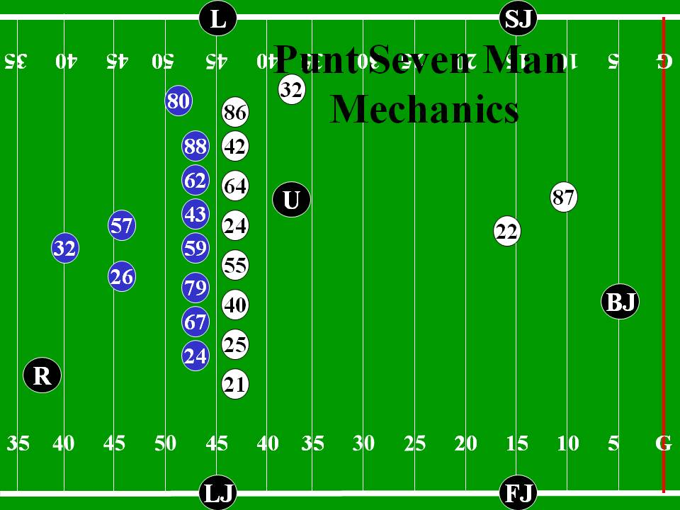
FIELD GOALS and TRYS

REFEREE:

1. Take a position to observe action on the kicker and holder to ensure a good view of the kick and all action in front of kicker.
2. Count players of team A and give signal to Umpire who will acknowledge by returning signal.
3. Communicate with Umpire and R players protection of the snapper is in effect.
4. After snap cover the ball, kicker, holder and action around players.
5. Observe and rule on all contact made with the kicker and/or holder.
6. If pass or run play develops move with play as with any other scrimmage play.

UMPIRE:

1. Take a position behind team “R” usually 5 yards from line of scrimmage favoring Line Judge’s side of the field.
2. Count players of team A and give signal to Referee who will acknowledge by returning signal.
3. Communicate with Referee and R players protection of the snapper is in effect.
4. Know interior linemen numbers to determine ineligible receivers.
5. Cover action on snapper until he is in a position able to defend himself and observe line play.
6. If pass or run play develops move with play as with any other scrimmage play.
7. Obtain ball from Back Judge if appropriate for next down.

LINESMAN:

1. Take a position straddling neutral zone starting on the side line.
2. Responsible for entire line of scrimmage and legal formation.
3. Observe position of the players at snap to determine eligibility of receivers.
4. Hold position to rule on kicks crossing line of scrimmage.
5. If pass or run play develops move with play as with any other scrimmage play.
6. If kick is a Try after kick is made move towards hash marks and observe/assist with line players to ensure smooth transition from play.

LINE JUDGE:

1. Take a position straddling neutral zone starting on the side line.
2. Responsible for entire line of scrimmage and legal formation.
3. Observe position of the players at snap to determine eligibility of receivers.
4. Hold position to rule on kicks crossing line of scrimmage.
5. If pass or run play develops move with play as with any other scrimmage play.
6. If kick is a Try after kick is made move towards hash marks and observe/assist with line players to ensure smooth transition from play.

BACK JUDGE:

1. Take position behind upright on Linesman side of field. Responsible for your upright, crossbar, including any ball contact on either.
2. Count players of team B and give signal to Field Judge who will acknowledge by returning signal.
3. Observe position of the players at snap to determine eligibility of receivers and communicate with other officials.
4. If pass or run play develops move with play as with any other scrimmage play.
5. After kick ends sound whistle and confer with Field Judge, step forward, and give the appropriate signal for result of the play.
6. Retrieve ball for next down and relay to Umpire if appropriate for new series or proceed to free kick line.

SIDE JUDGE:

1. Take a position behind team “R” usually 5 yards from line of scrimmage favoring Linesman side of field.
2. Count players of team A and give signal to Referee who will acknowledge by returning signal.
3. Know interior linemen numbers to determine ineligible receivers.
4. If pass or run play develops move with play as with any other scrimmage play.

FIELD JUDGE:

1. Take position behind upright on Line Judge side of field. Responsible for your upright, crossbar, including any ball contact on either.
2. Count players of team B and give signal to Back Judge who will acknowledge by returning signal.
3. Observe position of the players at snap to determine eligibility of receivers and communicate with other officials.
4. If pass or run play develops move with play as with any other scrimmage play.
5. After kick ends confer with Back Judge, step forward, and give the appropriate signal for result of the play.

Figure 4 – Field Goal/Try Positions – Seven Man

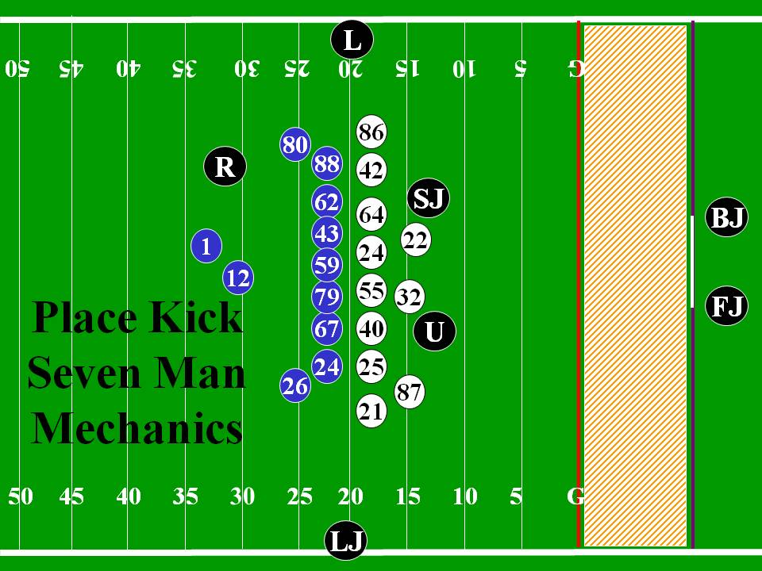
MEASUREMENTS

ALL OFFICIALS:

1. When spot is near the line to gain place ball on downfield foot and await instructions from Referee and stays with ball until Umpire arrives.
2. Mirror time out signal given by a fellow official where/when appropriate.

REFEREE:

1. Make determination as to whether a measurement is needed if so stop the clock with the appropriate timeout signal.
2. Request the Linesman to bring out the measuring device in use.
3. If measurement is in the side zone and line to gain is not made, mark the chain, grasp it at the forward most point of ball and walk with the chain to inbounds spot and spot ball.
4. Give appropriate signal for next down.
5. Based on results of measurement ensure chains are placed properly.
6. Once chains are set mark the ball ready for play and start clock if appropriate based on the result of the previous play.

UMPIRE:

1. Take a position with ball and ensure position to take front stake from chain crew member.
2. Take front stake from chain crew member.
3. Wait for Linesman to verify he has secured the spot of the clip.
4. Pull chain tight making sure it is parallel to the sideline.
5. If ball needs to be spotted at inbounds spot, carry front stake to inbounds spot and acquire new ball from the Field Judge and repeat steps three and four.
6. If the determination is a first down then proceed to the appropriate spot and receive the new game ball from the Field judge for the next down.
7. Stay with ball until the ready for play signal is given and verify the chains are reset on the sidelines.

LINESMAN:

1. Confirm from Referee a measurement is requested.
2. Grasp chain and clip at the yard line nearest the back stake and note where the clip is attached in relation to the yard line.
3. Unless a penalty occurred on the previous down, instruct box to mark position of front stake with the previous down showing. If a penalty occurred on the previous down, instruct box to maintain previous spot for possible penalty enforcement.
4. Place clip on the ground on the spot marked by Line Judge.
5. Hold chain firmly and signal Umpire it is secure to be stretched.
6. If ball needs to be spotted at the inbounds spot, carry chain to inbounds spot and repeat steps four and five.
7. Depending on results of the measurement reset the chain in original position and communicate to box or establish the new line to gain.

LINE JUDGE:

1. Determine the yard line which the clip was set on and mark with foot for Linesman to use for the measurement.
2. If ball needs to be spotted at the inbounds spot, repeat step one.
3. Observe your team and sideline.

BACK JUDGE:

1. Transition to a position to ensure the position of the ball and if necessary hold ball in position during the measurement.
2. After measurement has determined the action for the next down stay with the ball while the new ball is placed for the next down.
3. After chains are set again either for the next down of the series or the establishment of a new line to gain signal to Referee the status of the clock.
4. Give appropriate signal on the ready for play if clock is to start.

SIDE JUDGE:

1. Transition to a position allowing observation of the activities from the spot of the front stake of the line to gain equipment on your sidelines. If line to gain is not made ensure the front stake returns to the original spot.
2. After chains are set again either for the next down of the series or the establishment of a new line to gain signal to Referee the status of the clock.
3. Give appropriate signal on the ready for play if clock is to start.

FIELD JUDGE:

1. Confirm from Referee a measurement is requested.
2. Responsible for obtaining an approved game ball from the appropriate side line for placement after measurement is completed.
2. After chains are set again either for the next down of the series or the establishment of a new line to gain signal to Referee the status of the clock.
3. Give appropriate signal on the ready for play if clock is to start.
END OF FIRST AND THIRD QUARTERS

REFEREE:

1. Mark game card with the down, distance, yard line, and clip of the team in possession. Be sure the information agrees with Umpire’s card.
2. Determine the exact position of the ball on the field in relation to the inbounds spot.
3. At other end of field determine spot for Umpire to place ball.
4. Once all officials and teams are ready, the clock has been reset, and the chains have been moved, mark the ball ready for play.

UMPIRE:

1. Mark card with down, distance, yard line, and clip of the team in possession. Be sure the information agrees with Referee’s card.
2. Determine the position of the ball on the field in relationship with the inbounds spot.
3. Carry ball to other end of field and place ball at spot determined by R.
4. Stay with ball until the ready for play signal is given and verify the chains are reset on the sidelines.

LINESMAN:

1. Confirm location and yard line with chain crew.
2. With Referee and Umpire, mark card with down, distance, yard line, and clip for the team in possession.
3. Confirm down and distance with chain crew.
4. Grasp clip and chain to ensure proper position for resetting of the chains.
5. Instruct chain crew to reverse positions and move to new location.
6. Use clip to reset chains.
7. Verify down, distance, and yard line.
8. Assume time out responsibilities.
9. Indicate to Referee when ready.

LINE JUDGE:

1. Know the yard line and field position of ball.
2. Observe as appropriate and go with teams to other end of field.
3. Stop at the yard line and assist players in huddling near proper yard line if necessary.
4. Assume time out responsibilities.
5. Indicate to Referee when ready.

BACK JUDGE:

1. Transition to a position allowing observation of both teams and the activities of the sidelines.
2. Move to the yard line at the other end of the field.
3. Assume time out responsibilities.
4. Indicate to Referee when ready verifying the proper down for the next play.

SIDE JUDGE:

1. Transition to a position allowing observation of the activities of your sidelines.
2. Ensure the team on your sidelines moves to the proper yard line at the other end of the field.
3. Assume time out responsibilities.
4. Check to see clock has been properly reset.
5. Indicate to Referee when ready verifying the proper down for the next play.

FIELD JUDGE:

1. Transition to a position allowing observation of the activities of your sidelines.
2. Ensure the team on your sidelines moves to the proper yard line at the other end of the field.
3. Assume time out responsibilities.
4. Indicate to Referee when ready verifying the proper down for the next play.

HALF-TIME

ALL OFFICIALS:

1. At the completion of the half proceed to designated area of field or other facilities for duration of the halftime period.
2. Review first half activities and discuss any areas of concern.
3. After second half choices have been made and the captains are returning to the sidelines (if midfield option used), meet with other officials in center of field to review team choice.
4. After all officials have been informed proceed to appropriate free kick positions.

REFEREE:

1. Determine all administration of rules has been completed and declare the half ended.
2. After the mandatory warm up period is over, proceed to center of field with the Umpire and request captains to center of the field (if midfield option used) and give options to the teams.
3. If midfield option with captains is not used have the appropriate official request choice of option from the head coach of team with the second half option.

UMPIRE:

1. After the mandatory warm up period is over, proceed to center of field with the Referee, observe options being given to the captains (if midfield option used) and confirm the selection made.

LINESMAN:

1. Inform coach on your side of the length of half time and time to return to field.
2. Escort the team on your side from the field of play and upon their return at the end of the half.
3. Upon return to the field for the second half, meet with chain crew to discuss concerns or positive points.
4. After the mandatory warm up period is over, find at least one captain (if midfield option used). After receiving the appropriate signal from the Referee have the captain proceed to the center of the field.
5. Stay on sideline while team captains exercise choices for second half and observe the actions of the teams and ensure only the captains are on the field.

LINE JUDGE:

1. Inform coach on your side of the length of half time and time to return to field.
2. Escort the team on your side from the field of play and upon their return at the end of the half.
3. After the mandatory warm up period is over, find at least one captain (if midfield option used). After receiving the appropriate signal from the Referee have the captain proceed to the center of the field.
4. Stay on sideline while team captains exercise choices for second half and observe the actions of the teams and ensure only the captains are on the field.

BACK JUDGE:

1. Proceed to an appropriate position to observe the teams leaving the field and other actions by any player, coach or others.
2. Ensure the game clock is set to the appropriate/agreed upon time for the halftime. Once both teams have left the field signal the clock operator to start the clock.
3. Upon return to the field position yourself near the 50yd line and the nine yard marks and as appropriate signal the clock operator to begin the three minute mandatory warm up period.
4. Stay on sideline while team captains exercise choices (if midfield option used) for second half and observe the actions of the teams and ensure only the captains are on the field.

5. Request and receive the ball to start the second half as appropriate.

SIDE JUDGE:

1. Escort the team on your side from the field of play and upon their return at the end of the half.
2. Stay on sideline while team captains exercise choices for second half and observe the actions of the teams and ensure only the captains are on the field.
3. Request and receive the ball to start the second half as appropriate.
4. If midfield option with captains is not used request choice of option from the head coach of team on your side line if the second half option belongs to your team and relay to crew.

FIELD JUDGE:

1. Escort the team on your side from the field of play and upon their return at the end of the half.
2. Stay on sideline while team captains exercise choices for second half and observe the actions of the teams and ensure only the captains are on the field.
3. Request and receive the ball to start the second half as appropriate.
4. If midfield option with captains is not used request choice of option from the head coach of team on your side line if the second half option belongs to your team and relay to crew.

TIME OUTS

ALL OFFICIALS:

1. Give time out signal as appropriate.
2. If time out request is made to you, note the players’ number or ensure the head coach or designee has requested.
3. Record the period, time remaining, team, and number of the player calling the time out on your game card. Communicate with the other officials the time outs remaining in the half for both teams.
4. Take appropriate position and observe all actions in area of responsibility. Avoid huddling with other officials.

REFEREE:

1. Signal to press box the team charged with the time out.
2. When notified by Umpire ask for teams to get ready for the next play.
3. Mark the ball ready for play.

UMPIRE:

1. Secure spot of the ball and ensure teams return to appropriate sides at completion of time out.
2. Responsible for timing the length of the time out.
3. Stay with ball until R marks ball ready for play.

LINESMAN:

1. Move to appropriate position to observe conference.
2. Observe and determine all substitutions are proper for team on your sideline.
3. Assist Referee in asking team on your side to get ready for the next play.

LINE JUDGE:

1. Move to appropriate position to observe conference.
2. Observe and determine all substitutions are proper for team on your sideline.
3. Assist Referee in asking team on your side to get ready for the next play.

BACK JUDGE:

1. Move to appropriate position to observe conference.

SIDE JUDGE:

1. Move to appropriate position to observe conference.

FIELD JUDGE:

1. Move to appropriate position to observe conference.

PENALTY ENFORCEMENT

ALL OFFICIALS:

1. Give time out signal.
2. Make sure the spot of the ball and flag are covered. Ensure the spot of the ball first and the flag second.
3. If you called the penalty adjust flag if necessary, to the correct yard line. Know the status of ball, type of play, the player committing the foul. Stay close to R to ensure penalty options are given correctly.
4. If you called the penalty, provide the appropriate information to the Referee including the number of the player, team, status of the ball and what the action was causing the foul.

REFEREE:

1. Get from official(s) calling the penalty (ies): status of ball, type of play, team committing the foul, number of the player, and result of the play.
2. Give preliminary signal to press box.
3. Explain options to the appropriate captain.
4. Notify Umpire of the decision, spot of enforcement and number of yards.
5. Give signal to the press box.
6. Give the ready for play signal and start the clock as appropriate from result of the play.

UMPIRE:

1. Secure ball and walk off penalty per R’s instructions.
2. For 5 yard penalties by the defense when measured from back stake, mark off penalty and confirm spot with the Linesman by observing the position of the box.
3. Secure spot and cover ball until R marks ball ready for play.

LINESMAN:

1. Ensure box and chains do not move.
2. Be prepared to move box and chains as appropriate.
3. For 5 yard penalties by the defense which are to be measured from the back stake, after confirmation from the Referee of acceptance instruct the box man to move the box and position at the tape to assist Umpire on spot.
4. Observe enforcement.
5. Communicate penalty information to coaches.

LINE JUDGE:

1. After confirmation from Referee of acceptance assist in the enforcement by marking penalty yardage from position on sideline with the Umpire to verify proper spot.
2. Communicate penalty information to coaches.
3. Record the appropriate penalty information on game card, time, quarter and whether accepted or declined.

BACK JUDGE:

1. Move to appropriate position to observe all activity on the field if not reporting official.
2. Observe team actions and be alert for substitutions, team attendants on field, and player-coach conferences.
3. Observe enforcement.

SIDE JUDGE:

1. Move to appropriate position to cover your side of field or position if area not covered by reporting official.
2. Observe team actions and be alert for substitutions, team attendants on field, and player-coach conferences.
3. Observe enforcement.

FIELD JUDGE:

1. Move to appropriate position to cover your side of field or position if area not covered by reporting official.
2. Observe team actions and be alert for substitutions, team attendants on field, and player-coach conferences.
3. Observe enforcement.

PROCEDURE FOR DISQUALIFICATION OF PLAYER/COACH

AND NONPLAYER

In the event a situation arises where a player, coach, or non-player disqualifies himself, officials are to follow the following steps:

1. Report the infraction with details as to what happened or what the actions were to cause the infraction, player number or coach’s name that is disqualified to the Referee.

2. All officials should record the information on their game cards to include the number or name of coach.
3. The Referee along with the official who has disqualified the individual will accompany the Referee and disqualified player to the sideline and explain to the Head Coach the events causing this disqualification ensuring all parties understand the process and what is expected.
4. All other officials should take appropriate positions to observe the activity on the field as the process is completed.

5. Administer the penalties as appropriate.

6. After completion of the game, before leaving the game site, ensure the Referee has all pertinent information regarding the disqualification for filing of the report on the disqualification. If in the opinion of the R the situation warrants additional statements and information, these should be obtained in writing from the crew members before leaving the game site and include in the game report.
7. Referee is responsible for notifying the Commissioner either after the game or the next morning as appropriate and informs the Commissioner or designee of the situations surrounding the disqualification(s).

Comment: As officials we are expected to maintain a level of composure during situations that at times are difficult. Certain acts of conduct must always be practiced and they are to avoid contact with the player/coach, communication in a professional manner and function as a crew at all times.

POST-GAME

ALL OFFICIALS:

1. Ensure all officials exit the field as a group, make sure all equipment brought out is gathered and returns with crew.
2. Do not seek out coaches or players but do not avoid coaches if they have questions. If coaches wishes to discuss an issue or has a question should be directed to the Referee who can determine appropriate manner to handle.
3. Do not discuss game on field or make any public statement about game to news media.
4. Discuss as a crew any plays, questions or points of emphasis occurring during the game.
5. Provide any pertinent information to the Referee about the conduct of coaches, players or other situations to include in the game report.
6. Leave the game site as a group.

