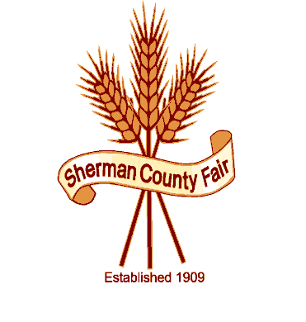
Sherman County Fair
P O Box 45
66147 Lonerock Rd
Wasco, Oregon 97065

COMMERCIAL/COUMMUITY BOOTH APPLICATION
FAIR DATES AUGUST 21st THRU AUGUST 26TH
COMMERCIAL/COMMUNITY BOOTH NAME
CONTACT PERSON’S NAME
PHONE
MAILING ADDRESS
CITY
STATE & ZIP

PRICE PER BOOTH SPACE $25.00

I WILL NEED __________ BOOTH SPACE (S) (BOOTH SPACE IS 8’ LONG)

YES I WILL NEED A TABLE __________

NO I DO NOT NEED A TABLE _______ I WILL BRING MY OWN.

THANK YOU FOR YOUR INTEREST AT THE SHERMANCOUNTY FAIR.
PLEASE FILL IN ALL INFO, SIGN, INCLUDE PAYMENT AND RETURN TO THE ABOVE ADDRESS. BOOTH SHALL BE SET UP NO LATER THAN BY 3:00 PM ON Tuesday AUGUST 21st.
SPACE IS LIMITED, THESE BOOTHS ARE ON A FIRST COME FIRST SERVE BASIS.
APPLICATIONS MUST BE RECEIVED BY 8/17/17.

APPLIC. SIGNATURE DATE RECEIVED BY S.C. BOARD MEMBER, DATE

QUESTIONS CALL BETH 541-980-1821

