Sherman County Fair “Herd” Membership Donation/Annual Renewal

Becoming a “Herd” member is simple. Just mail a donation of any amount to the Sherman County Fair.
Community support for the past 110 years of the Sherman County fairs has been outstanding. Thank you!!! The fair board looks forward to making “your” County Fair better each and every year! The “Herd” membership is now in its sixth year, and again the local community support has been awesome! Everyone that donates and becomes a “Herd” member will have their name displayed at the fairgrounds (look for the big “Herd Member Sign) and on the fair’s website. All donations are tax deductible.

Please contact shermanctyfair@hotmail.com with any questions.
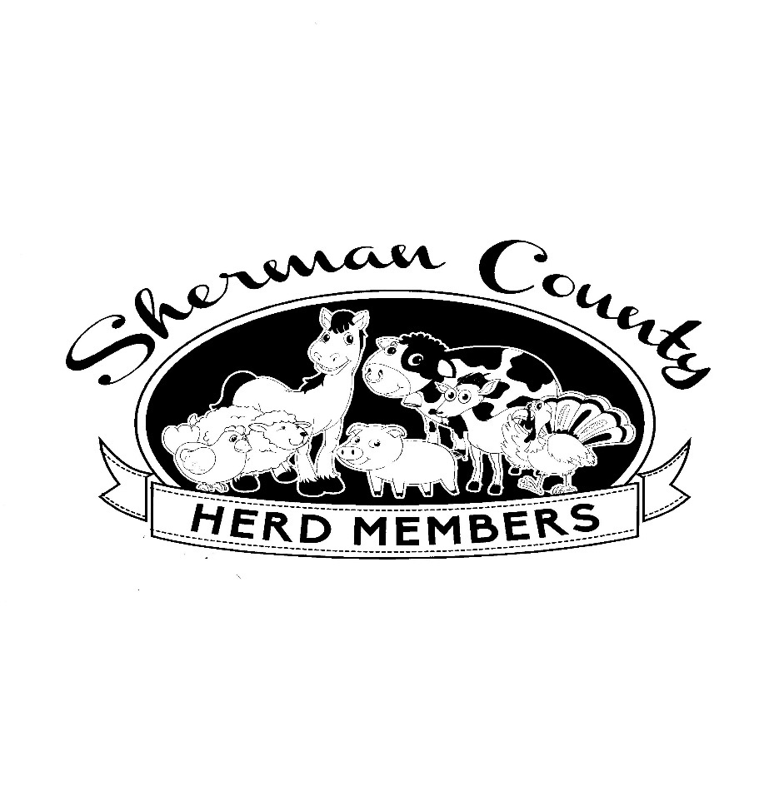
Make checks payable to
Sherman County Fair
On the “memo line” please write “Herd member”.

Mail checks to >>
Sherman County Fair
66147 Lone Rock Road
Moro, OR 97039

