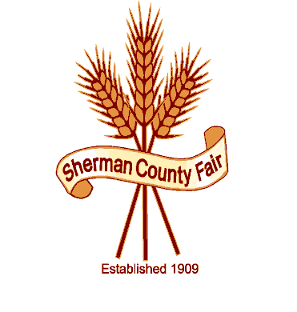
Sherman County Fair
P O Box 45
Wasco, OR 97065
66147 Lonerock Rd ~ Moro, Oregon 97039

VENDOR APPLICATION

OWNER/ Business Name
ITEMS TO BE SOLD

PHONE
MAILING ADDRESS
CITY

STATE & ZIP

BOOTH SPACE NEEDED

YES, I NEED ELECTRICAL
DO NOT NEED ELECTRICAL

THANK YOU FOR YOUR INTEREST AT THE SHERMAN COUNTY FAIR.
PLEASE INCLUDE ANY OTHER INFO THAT WILL BE IMPORTANT FOR US TO KNOW ABOUT.
PLEASE FILL IN ALL INFO AND SIGN BELOW. PLEASE SEND TO ABOVE ADDRESS.
I/WE WILL BE GIVING THE SHERMAN CO. FAIR 15% OF OUR GROSS SALES FOR THE WEEK OF 8/21/19 THRU 8/24/19. DAILY CASH REGISTER TAPES (or a copy of ledger book page) WILL BE TURNED INTO THE FAIR OFFICE, AT THE END OF EACH DAY.

VENDOR SIGNATURE DATE RECEIVED BY S.C BOARD SECREATRY, DATE

