Just One More Dachshund Rescue Adoption Application
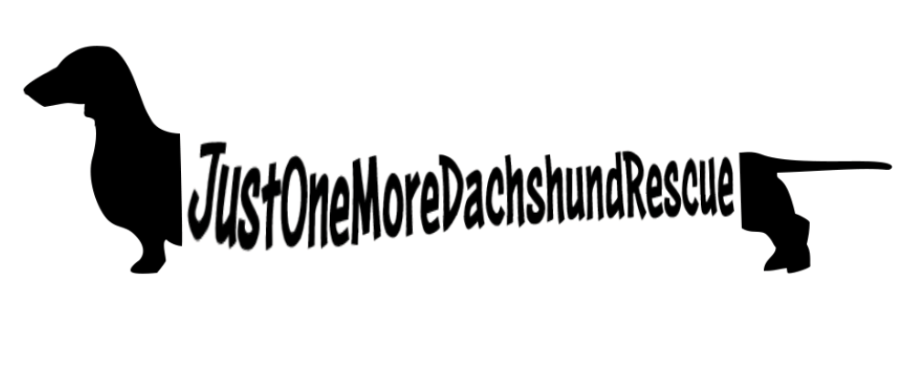
Date__________

Your Name ______________________________________________________________

Address _________________________________________________________________
(PO Boxes not acceptable)

Do you own your home? If not, written approval from landlord allowing a pet is required.

Phone ______________________ Email ____________________________________

Which pet would you be interested in adopting (if name is known): ___________________

Current pets you own who are living in your home:

Name Type (dog, cat, etc.) Age Indoors/Outdoors Owned how long?

1.

2.

3.

4,

5.

What factors have led you to decide to adopt a dog?

Tell us about your family/each person living in your home:

Name Relation Age Experience with animals

1.

2.

3.

4.

5.

Have you ever had to euthanize a pet? If so, please detail the reason/s below, where the procedure was done, and who was with the pet during the procedure:

Please provide the name and number of your veterinarian/s. Please contact them to authorizing their ability to share your animal records and information with our organization.

Please provide the name, phone and email of 3 personal references who can share information on your background as a pet owner and/or rescuer (only one can be a relative).

How many hours per day will the dog be alone and where will he/she be kept?

Other

Please allow up to 1 week for processing of your application. You will be notified via email if your application is not selected. You will be notified by phone if your application is selected and a home visit will be scheduled at that time.

_______________________________________________ __________________
Name - Signature Date

301-706-2000 * Huntingtown, MD
jomdachshundrescue@gmail.com

