

PRELUDE To Thee, O Newly Risen Lord (Riggs) Michele Eiland, organist
Welcome and Announcements please pass attendance pads located on
the inside aisle & pass it down. Susan Murithi, Senior Pastor
Silent Reflection and Opening Prayer
Greeting Time (You may stand up and greet those around you with a
fist bump.)
*Opening Hymn Up From the Grave He Arose (Vs1&3) UMH 322
Children’s Time Sarah Miller
Special Music Hold On (Katie Nichole) Shaylin Petz, Sheryl Cox
Vision and Mission Recitation Mary Meckenstock
Capital Campaign Prayer Linda Stahlman & Rick Kuehl
Leader: Heavenly Father, we ask You to show us how to use our talents, our financial gifts and our time to help us as we place this campaign in Your hands, trusting that You will supply every need. Bless each other with peace, joy, and a deeper sense of Your presence. Multiply these offerings so they may bear fruit
far beyond what we can imagine.
Response: May these gifts help strengthen Your church. May they ensure a legacy that future generations may know Your love, hear Your truth and be transformed in faith.
Leader: May the work we do now become a living testimony of Your
faithfulness, inspiring those who will come after us to continue the mission.
Let this be more than a project—it is an act of worship, a declaration of trust,
and a legacy of love for Your Kingdom.

than

Jese
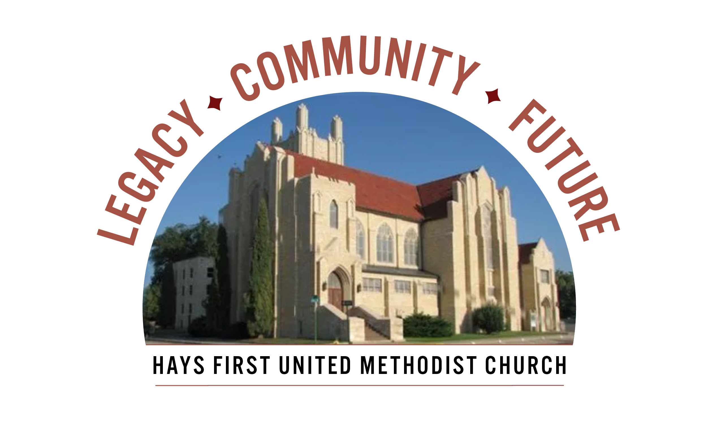 Announcements
Today, April 12, is Pledge Packet Pick-up. Please drop by the Parlor following
any service today and pick up your personalized packet. Each packet includes
a cover letter from Pastor Susan, an 8-page brochure, pledge card, 21-Day Prayer
Guide for adults and a Children’s Prayer Journal.
Capital Campaign event presentation on our proposed campaign projects. Please stop by the Parlor to see a complete listing of events and RSVP for the event of your choice
of coming events.
A. Church Walkaround meet in parlor at 9:30-10:30, TODAY!
B. Rhubarb and Mixed Berry Cobbler with Marcia and Ken for Arbor
Valley Estates, Monday, April 13 from 7:00-8:15 pm.
C, Prayer Vigil, all members, in the chapel and sanctuary, Thursday, April 16
from 7 am – 7 pm. Lets rally in prayer for our church, its members and its
vision.
- Open Table – Young Adults – dinner/Bible Study – Wednesday, 6 pm
- We have Children’s Church and child care available at 10:45 am.
- There are two Adult Sunday School classes-Room 103 and 207.
- Please call office with your graduates from college and university.
- American Red Cross Blood Drive, Monday, May 4 from 12:30-6:30, please call the office.

Birthdays: April 12: Garrett Brening; April 13: Mike Legleiter, Martha Miller, Ana States; April 14: Susan Murithi; April 17: Kay Dees; April 18: Greg Daughhetee, Cathy Russell; April 19: Donna Bieker, Michael Cutting, Benjamin Dumler, Sophie Miller.
Altar Foundation ($153.00)Steve & Marilyn Wood, Wendy Beougher, Jim & Hannah Barrett, Jeff & Marla Copper, Mike & Jill Arensdorf, Eric Leuschner & Jacinda Johnson, Randy & Barbara Clinkscales, Jaci Gottschalk, Dave & Karen Hendrickson, Marva Miller, Duane & Shirley Steffen, Josh & Callie Thomas, Rick & Diane Wolfe, Keith & Kathy Harper, Ron Katt, Troy & Sherri Brown, Mike Cooper, Greg & Gwen Daughhetee, Tom & Debra McDonald, Jarilyn Staab, Donna Weaverling, Carolyn Miller, Keith & Renee Eilts, Mike & Laura Gaughan, Betty Innes, Curt & Jennifer Kitson, Steve & Julie Paul, Ken Griffin & Marcia Bannister, Virginia Lehman, Phil & Linda Stahlman, Brad & Sarah Schumacher, Rodney Ruff, Davis & Marijo Rooney, Eric & Charlotte Rathke, Ernie & Pam Bryant, Joe & Jan Edwards, Sheryl Dreiling, Ralph & Lorraine Howerton, Mary Meckenstock, Gail & Linda Palmberg, Ed & Dixie Janzen, Mark & Becky Kellerman, Eric & Carol Harfmann, Sue Dolezal.
Welcome to Worship
April 12, 2026
Second Sunday of Easter

Response: Grant us clarity of vision so that your plans align with Your
Will. Give wisdom to our leaders, courage to our members, and
Every decision, every conversation, and every decision be guided by Your
Spirit, May your name be glorified.
All: We trust You to lead us forward, step by step, into the future you
prepared, in Christ’s holy name. Amen.

Lord’s Prayer UMH 895
Special Music You Raise Me Up
Caitlin Glassman, Meredith Cory, Raymond Brent
Scripture Genesis 1:27-2:3, Matthew 25:31-45, John 20:19-23 Mary
Hymn Breathe on Me, Breath of God (Vs1&3) UMH420
Interview with Stan Unruh Pastor Susan
Sermon Ever Jumped In The Water? Mark Queen
Faithful Stewardship 1 Chronicles 29:14 Mary Meckenstock
“Everything comes from you, and we have given you only what comes from your hand.”

“Sovereign Lord, Keep us humble and grateful, always remembering that
all we have is Yours. Amen.
Offertory Over the Brook Kidron (Hughes) Michele Eiland
Doxology Praise God From Whom All Blessings Flow UMH 95 Offertory Prayer Troy Miller *Closing Hymn Crown Him With Many Crowns UMH 327
*Benediction Susan Murithi
*Postlude O Lord, Whose Mercies Numberless Michele Eiland
(G.F. Handel arr. Robert Hilfe)

The Church Calendar
Today: Collect Capital Campaign Packets in parlor
8:30 am Traditional Worship, Bake Sale 8-12, parlor
9:30 am Capital Campaign presentation-parlor
9:45 am Contemporary Worship
10:45 am Traditional Worship
5:00 pm Hispanic Worship
Monday: 7:00 pm Arbor Valley Estates, Ken & Marcia home
Capital Campaign
Tuesday: 10:00 am Management Team with Church Development
4:30 pm Spanish Class
Wednesday: 6:00 am Men’s Bible Study
12:10 pm Prayer Powerhouse
3:00 pm Kid’s Club
5:00 pm Worship on Wednesday or WOW
Meal: beef/turkey subs, baked beans, potato or macaroni salad,
Chips, dessert
6:00 pm Spanish/English Bible Study with Pastor Troy
6:15 pm Bell Choir
7:00 pm Chancel Choir
Thursday: 7:00am-7:00pm Prayer Vigil - chapel
4:30 pm Spanish class 7:00 pm Trustees Rm 207
Friday: 12:00 pm Bible Study – Twelve Women of the Bible

Prayer Concerns: Rachel Palmberg, Zachary Kuntz, Kyler Burk, Carla Cornett, Will & Finley Hayden, Kristin Haskett (Pyle), Cameron Daughhetee, Ruby Stephenson, Evelyn Zellmer, Al & Judy Hugh.
If you or a family member are in the hospital, please call the church office if you would like to be on the prayer list or to let the pastor know at 785-625-3408.
Greeters: 8:30 Ron Katt 10:45 Joe Edwards
04-05-26 Attendance 441 Sunday School 10 On-line 134

Rev. Dr. Susan Murithi-Senior Pastor Troy Miller-Associate Pastor
Matt Dumler, Director of Discipleship Bev Bearley-Administrative Secretary

