
9

Prelude Grace Medley (arr. Ruth Elaine Schram) Jo Kraus, organist
Welcome and Announcements please pass attendance pads located on
the inside aisle & pass it down. Susan Murithi, Senior Pastor
Silent Reflection and Opening Prayer
Greeting Time (You may stand up and greet those around you with a
fist bump.)
*Opening Hymn The Church’s One Foundation (Vs. 1,4,5) UMH 545
Children’s Time Jenna Brubaker
Special Music Prelude in C (J.S. Bach) Edison Leuschner, pianist
Vision and Mission Recitation Mary Meckenstock
Capital Campaign Prayer Mary Meckenstock
Leader: Heavenly Father, we ask You to show us how to use our talents, our financial gifts and our time to help us as we place this campaign in Your hands, trusting that You will supply every need. Bless each other with peace, joy, and a deeper sense of Your presence. Multiply these offerings so they may bear fruit
far beyond what we can imagine.
Response: May these gifts help strengthen Your church. May they ensure a legacy that future generations may know Your love, hear Your truth and be transformed in faith.
Leader: May the work we do now become a living testimony of Your
faithfulness, inspiring those who will come after us to continue the mission.
Let this be more than a project—it is an act of worship, a declaration of trust,
and a legacy of love for Your Kingdom.

than

Jese
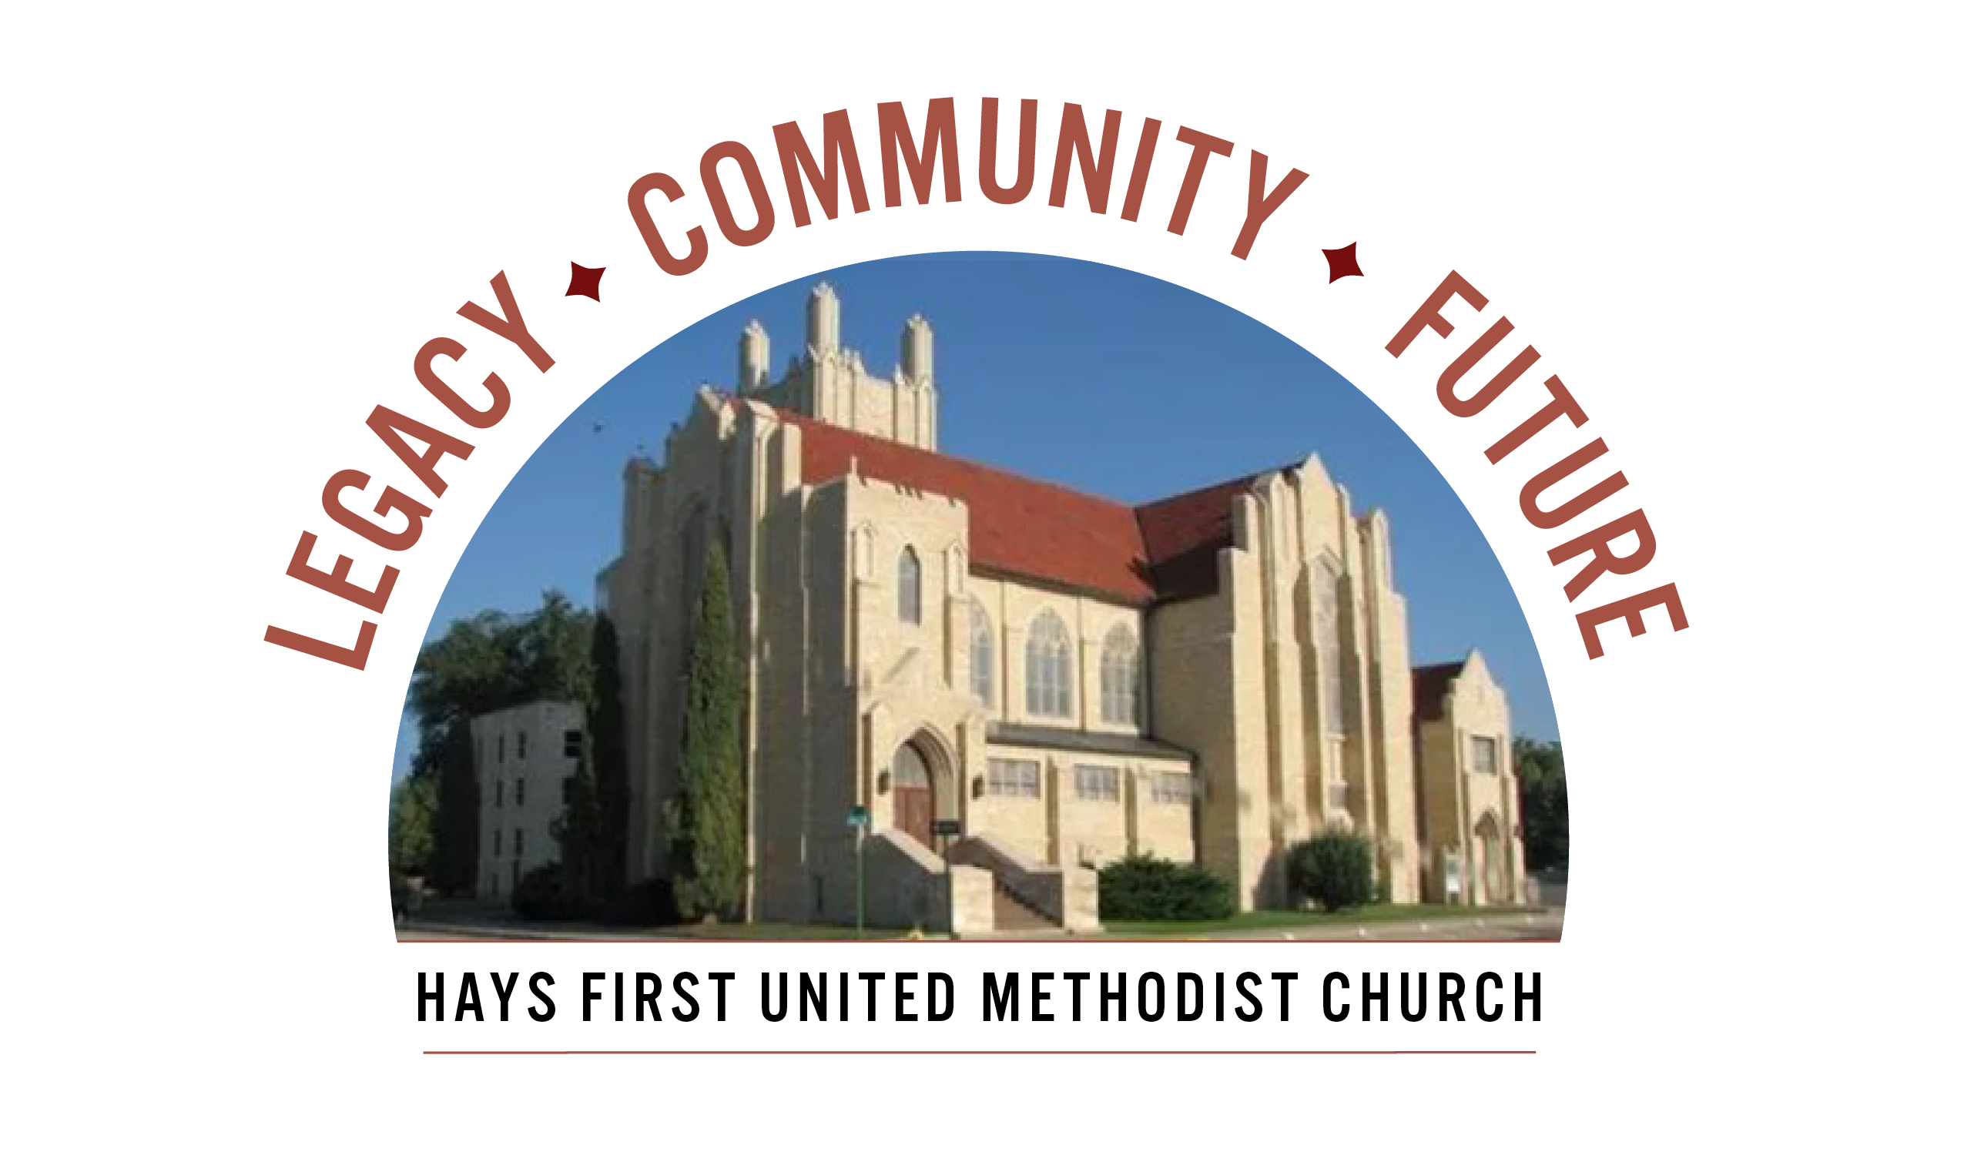 Announcements
Every church household should have received a campaign pledge packet (packet
pickup was on April 12 and leftover packets mailed on April 14). Please continue
Prayer & Discernment which runs 4/12 – 5/3 by using the 21-Day Prayer Guide for adults
and/or the Children’s Prayer Journal. A special thanks to the Prayer Team for creating
These meaningful prayer resources. Key Campaign Dates: April 29, Ambassadors begin phone calls to answer questions. May 3, Commitment Sunday, please bring your completed pledge cards to worship. Thank you.
Those of you who will write checks for the Capital Campaign, please include this on the memo line and place in the pledge basket on May 3.

- Open Table – Young Adults – dinner/Bible Study – Wednesday, 6 pm
- We have Children’s Church and child care available at 10:45 am.
- There are two Adult Sunday School classes-Room 103 and 207.
- Please call the office with your graduates from college and university.
- American Red Cross Blood Drive, Monday, May 4 from 12:30-6:30, please call the office.
- We are looking for a Children’s Program Co-Ordinator. Please contact
Matt Dumler at 785-625-3408 or matt@haysfumc.com for questions or
to apply.
Birthdays: April 26: Lorena Kellogg; April 27: Sandy Henningsen, Isaac Schumacher, Noah Schumacher; April 28: Nathan Chung; April 29: Rose McCormick; May 1: Chuck Ames, Alexis Schaben, Anne Long; May 2: Megan Skipper; May 3: Tayte Lewallen.
Altar Foundation ($153.00) Steve & Marilyn Wood, Wendy Beougher, Jim & Hannah Barrett, Jeff & Marla Copper, Mike & Jill Arensdorf, Eric Leuschner & Jacinda Johnson, Randy & Barbara Clinkscales, Jaci Gottschalk, Dave & Karen Hendrickson, Marva Miller, Duane & Shirley Steffen, Josh & Callie Thomas, Rick & Diane Wolfe, Keith & Kathy Harper, Ron Katt, Troy & Sherri Brown, Mike Cooper, Greg & Gwen Daughhetee, Tom & Debra McDonald, Jarilyn Staab, Donna Weaverling, Carolyn Miller, Keith & Renee Eilts, Mike & Laura Gaughan, Betty Innes, Curt & Jennifer Kitson, Steve & Julie Paul, Ken Griffin & Marcia Bannister, Virginia Lehman, Phil & Linda Stahlman, Brad & Sarah Schumacher, Rodney Ruff, Davis & Marijo Rooney, Eric & Charlotte Rathke, Ernie & Pam Bryant, Joe & Jan Edwards, Sheryl Dreiling, Ralph & Lorraine Howerton, Mary Meckenstock, Gail & Linda Palmberg, Ed & Dixie Janzen, Mark & Becky Kellerman, Eric & Carol Harfmann, Sue Dolezal, Harvey & Susan Jansonius, Ken & Becky Johnson, Lorena Kellogg.

Welcome to Worship
April 26, 2026
Fourth Sunday of Easter

Response: Grant us clarity of vision so that our plans align with Your
will. Give wisdom to our leaders, courage to our members, and unity
to our church family. Let every meeting, every conversation, and
every decision, be guided by Your Spirit, and may Your name be
glorified. All: We trust You to lead us forward, step by step, into the
future you prepared, in Christ’s holy name. Amen.
Prayer Hymn Just a Closer Walk with Thee (Vs. 1) FWS 2158 Prayers of the People Troy Miller, Assoc. Pastor
Lord’s Prayer UMH 895
Scripture Matthew 25:14-30 Mary Meckenstock
Interview with Jacob Brubaker Pastor Susan
Sermon Good and Faithful Servant Pastor Susan
Faithful Stewardship Luke 6:38 Mary Meckenstock
“Give, and it will be given unto you. A good measure, pressed down,
shaken together and running over, will be poured into your lap. For
with the measure you use, it will be measured to you.”

Congregational Prayer: “Gracious God, You promise that as we give,
It will be given to us. Help us to give with a generous heart, without
hesitation or fear. Teach us to trust in Your abundant provision, and
to bless others as freely as You have blessed us. Amen.”
Offertory Precious Lord, Take My Hand (arr. Held) Jo Kraus, organist
Doxology Praise God From Whom All Blessings Flow UMH 95 Offertory Prayer Troy Miller *Closing Hymn Be Thou My Vision UMH 451
*Benediction Susan Murithi
*Postlude O God Beyond All Praising (arr. (Honore) Jo Kraus, organist

The Church Calendar
Today: 8:30 am Traditional Worship
9:45 am Contemporary Worship
10:45 am Traditional Worship
5:00 pm Hispanic Worship
Monday: 5:45 pm Education Meeting
7:00 pm Administrative Board – dining room
Tuesday: 10:00 am Management Team with Church Development
4:30 pm Spanish Class
Wednesday: 6:00 am Men’s Bible Study
12:10 pm Prayer Powerhouse
3:00 pm Kid’s Club
5:00 pm Final Worship on Wednesday or WOW
Meal: Cook’s Choice Casserole, French bread, salad
dessert
6:00 pm Spanish/English Bible Study with Pastor Troy
6:15 pm Bell Choir
7:00 pm Chancel Choir
Thursday: 4:30 pm Spanish class
Friday: 12:00 pm Bible Study – Twelve Women of the Bible
Prayer Concerns: Rachel Palmberg, Zachary Kuntz, Kyler Burk, Carla Cornett, Will & Finley Hayden, Kristin Haskett (Pyle), Cameron Daughhetee, Ruby Stephenson, Evelyn Zellmer, Al & Judy Hugh, Billie McCall, LaVaughn Hull.
If you or a family member are in the hospital, please call the church office if you would like to be on the prayer list or to let the pastor know at 785-625-3408.
Greeters: 8:30 Kathy Albers 10:45 Laurel Stephenson
04-19-26 Attendance 230 Sunday School 24 On-line 90

Rev. Dr. Susan Murithi-Senior Pastor Troy Miller-Associate Pastor
Matt Dumler, Director of Discipleship Bev Bearley-Administrative Secretary

