
9

Prelude All Hail the Power of Jesus’ Name Charlotte Rathke, organist

Welcome and Announcements please pass attendance pads located on
the inside aisle & pass it down. Susan Murithi, Senior Pastor
Silent Reflection and Opening Prayer
Greeting Time (You may stand up and welcome those around you with a
smile, a nod, or a friendly wave, as a sign of peace.)

*Opening Hymn Crown Him with Many Crowns UMH 327

Vision and Mission Recitation Mary Meckenstock

*Call to Worship Mary Meckenstock
Leader: Lift your eyes to heaven and behold the glory of God.
People: We come to worship the one who gives eternal life.
Leader: Christ has revealed the Father to us.
People: We receive his truth and walk in his ways.
Leader: We are held in God’s holy name.
People: We are one in Christ Jesus.
Leader: Come, let us glorify God together.
People: We worship with unity and joy.

than

Jese
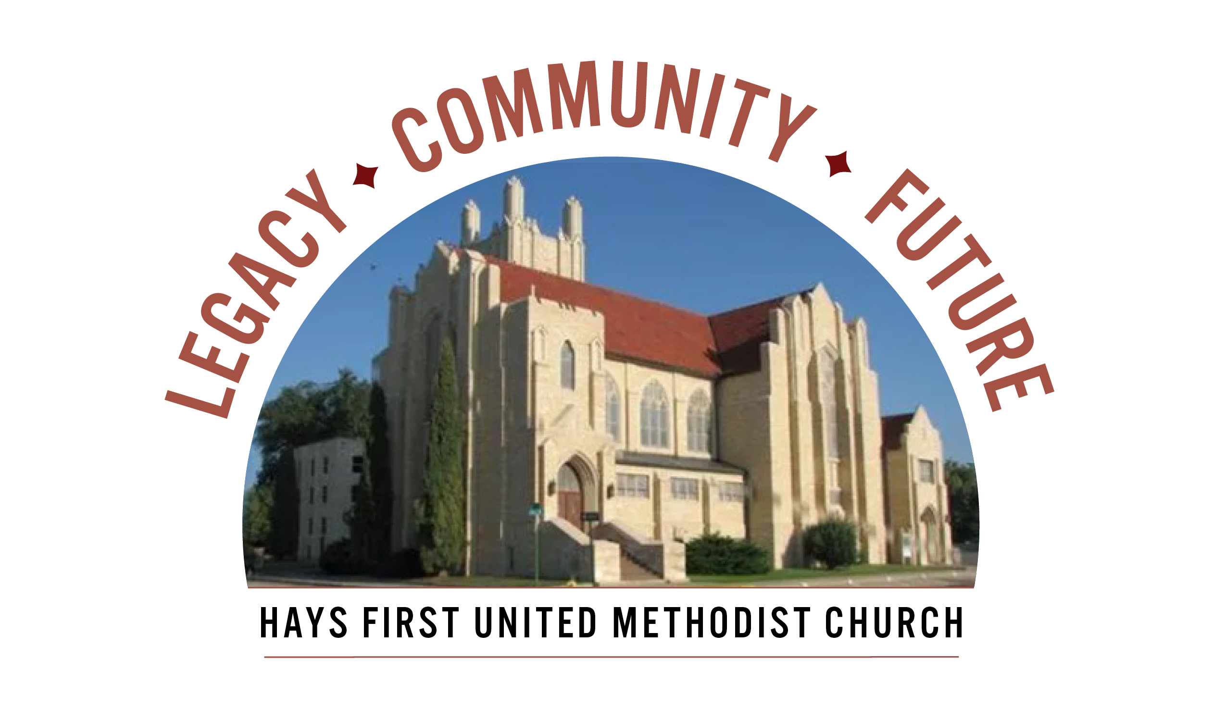 Announcements
- Next Sunday is Pentecost. Remember to wear red. We will celebrate the birthday of our church with a cake after worship.
- A special thank you to all of you who have brought their pledges and financial gifts to worship and also to all who worked in various committees of the capital campaign to make it the success it is.
- There are two Adult Sunday School classes-Room 103 and 207.
- We are looking for a Children’s Co-Ordinator, please contact Matt Dumler at 785-625-3408 or matt@haysfumc.com for questions or to apply.
- Outreach items are due in the office TODAY!

Birthdays: May 17: Mary Ann Craig, Sam Gross; May 18: Kay Fisher, John Irvin, Donovan States; May 19: Luke Coker, Reaghan Wamser, Isys Schmitt; May 20: Beckie Holmes; May 22: Wesley Bryant, Kathy Albers; May 23: Joey Roth.

Altar Foundation ($153.00) Steve & Marilyn Wood, Wendy Beougher, Jim & Hannah Barrett, Jeff & Marla Copper, Mike & Jill Arensdorf, Eric Leuschner & Jacinda Johnson, Randy & Barbara Clinkscales, Jaci Gottschalk, Dave & Karen Hendrickson, Marva Miller, Duane & Shirley Steffen, Josh & Callie Thomas, Rick & Diane Wolfe, Keith & Kathy Harper, Ron Katt, Troy & Sherri Brown, Mike Cooper, Greg & Gwen Daughhetee, Tom & Debra McDonald, Jarilyn Staab, Donna Weaverling, Carolyn Miller, Keith & Renee Eilts, Mike & Laura Gaughan, Betty Innes, Curt & Jennifer Kitson, Steve & Julie Paul, Ken Griffin & Marcia Bannister, Virginia Lehman, Phil & Linda Stahlman, Brad & Sarah Schumacher, Rodney Ruff, Davis & Marijo Rooney, Eric & Charlotte Rathke, Ernie & Pam Bryant, Joe & Jan Edwards, Sheryl Dreiling, Ralph & Lorraine Howerton, Mary Meckenstock, Gail & Linda Palmberg, Ed & Dixie Janzen, Mark & Becky Kellerman, Eric & Carol Harfmann, Sue Dolezal, Harvey & Susan Jansonius, Ken & Becky Johnson, Lorena Kellogg

Welcome to Worship
May 17, 2026
Ascension Sunday
Heritage Sunday

10:45 am Honoring our Heritage Member: Sheryl Dreiling

Special Music His Eye is on the Sparrow (arr, Schrader)
Caitlin Glassman
Children’s Time Caitlin Glassman

Capital Campaign Pledge Reveal

Prayer Hymn Surely the Presence of the Lord UMH 328
Prayers of the People Troy Miller, Assoc. Pastor
Lord’s Prayer UMH 895

Choral Anthem Go Ye Therefore (Mary MacDonald) Charlotte Rathke
Scripture John 17:1-11 (NIV) Mary Meckenstock

Sermon That They May Be One Susan Murithi, Senior Pastor

Offertory Nearer My God, to thee Charlotte Rathke
Doxology Praise God From Whom All Blessings Flow UMH 95 Offertory Prayer Troy Miller
*Closing Hymn He Is Exalted (sing twice) FWS 2070
*Benediction Susan Murithi
*Postlude I Will Praise Thee Charlotte Rathke

The Church Calendar
Today: 8:30 am Traditional Worship
9:45 am Contemporary Worship
10:45 am Traditional Worship
5:00 pm Hispanic Worship
Tuesday: 10:00 am Management Team with Church Development
4:30 pm Spanish Class
Wednesday: 6:00 am Men’s Bible Study
Thursday: 4:30 pm Spanish class
7:00 pm Trustees – Rm 207
Friday: 12:00 pm Bible Study – Twelve Women of the Bible
Saturday: 11:00 am Leora Forssberg – Logan, KS graveside

Prayer Concerns: Rachel Palmberg, Zachary Kuntz, Kyler Burk, Carla Cornett, Will & Finley Hayden, Cameron Daughhetee, Ruby Stephenson, Evelyn Zellmer, Al & Judy Hugh.
If you or a family member are in the hospital, please call the church office if you would like to be on the prayer list or to let the pastor know at 785-625-3408.

Greeters: 8:30 Ron Katt 10:45 Joe Edwards
05-10-26 Attendance 260 Sunday School 15 On-line 71

Rev. Dr. Susan Murithi-Senior Pastor Troy Miller-Associate Pastor
Matt Dumler, Director of Discipleship Bev Bearley-Administrative Secretary

