
Announcements
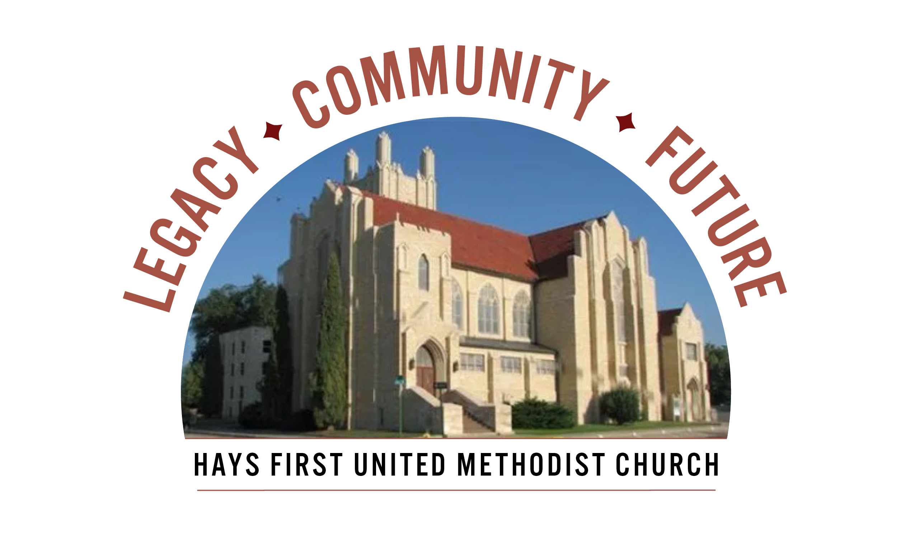We invite every church household to attend an upcoming Capital Campaign event. Each event will feature a presentation of our proposed campaign projects and how they support the mission of the church (Q&A included). Attending an event is the best way to fully understand the details of our Capital Campaign. Please stop by the Parlor to see a complete listing of events and RSVP for the event of your choice.
A, Combined Adult Sunday School Classes and Walkaround from 9:30-10:30 am.
in the Miler’s Classroom, today.
B. Carrot cake at the Clinkscales, 309 W. 22nd, 7-8:15 pm, Monday, April 6
C. Combined Women of Faith Potluck. Meet in Fellowship Hall, Wed., April 8,
11:15-1:00 pm.
- Maundy Thursday Service at 7:00 pm on April 2, Worship Center downstairs.
- Good Friday Service at 7:00 pm on April 3.
- Open Table – Young Adults – dinner/Bible Study – Wednesday, 6 pm
- We have Children’s Church and child care available at 10:45 am.
- There are two Adult Sunday School classes-Room 103 and 207.

Prayer Concerns: Rachel Palmberg, Zachary Kuntz, Kyler Burk, Carla Cornett, Will & Finley Hayden, Kristin Haskett (Pyle), Cameron Daughhetee, Ruby Stephenson, Allen Guy (Jan Edwards uncle), Evelyn Zellmer,
Leora Forssberg.
If you or a family member are in the hospital, please call the church office if you would like to be on the prayer list or to let the pastor know at 785-625-3408.
Birthdays: March 29: Summer Schneider; March 30: Logan Cunningham,; March 31: John Booze,Johnnie Craig, Abbey Klein, Corey Musil, Sage Zweifel; April 2: Alan Borthwick; April 3: Bev Bearley.
Altar Foundation ($153.00)Steve & Marilyn Wood, Wendy Beougher, Jim & Hannah Barrett, Jeff & Marla Copper, Mike & Jill Arensdorf, Eric Leuschner & Jacinda Johnson, Randy & Barbara Clinkscales, Jaci Gottschalk, Dave & Karen Hendrickson, Marva Miller, Duane & Shirley Steffen, Josh & Callie Thomas, Rick & Diane Wolfe, Keith & Kathy Harper, Ron Katt, Troy & Sherri Brown, Mike Cooper, Greg & Gwen Daughhetee, Tom & Debra McDonald, Jarilyn Staab, Donna Weaverling, Carolyn Miller, Keith & Renee Eilts, Mike & Laura Gaughan, Betty Innes, Curt & Jennifer Kitson, Steve & Julie Paul, Ken Griffin, Virginia Lehman, Phil & Linda Stahlman, Brad & Sarah Schumacher, Rodney Ruff, Davis & Marijo Rooney, Eric & Charlotte Rathke, Ernie & Pam Bryant, Joe & Jan Edwards, Sheryl Dreiling, Ralph & Lorraine Howerton, Mary Meckenstock, Gail & Linda Palmberg, Ed & Dixie Janzen, Mark & Becky Kellerman, Eric & Carol Harfmann.
Condolences: to the family of Harl Stump who passed on March 13. Services will be held at Hays Memorial Chapel on Monday, April 6 at 2:30 pm To the family of Caitlin Glassman in the loss of her mother, Marianna Carney.

Prelude All Glory, Laud and Honor Charlotte Rathke, organist
Welcome and Announcements please pass attendance pads
Matt Dumler, Director of Discipleship

Silent Reflection and Opening Prayer
Greeting Time (You may stand up and greet those around you with a
fist bump.)
*Opening Hymn Hosanna, Loud Hosanna (Vs1-3) UMH 278
Palm Procession
Children’s Time Paityn Homan
Vision and Mission Recitation

Capital Campaign Prayer: Mary Meckenstock

Leader: Heavenly Father, may the work we do in this Capital Campaign become
a living testimony of your faithfulness, inspiring those who will come after us to continue the mission. Let this be more than a project, for it is an act of worship,
a declaration of trust, and a legacy of love for Your Kingdom.
Response: Grant us clarity of vision so that our plans align with your will. Give wisdom to our leaders, courage to our members, and unity to our church
family. Let every meeting, every conversation, and every decision be guided
by your Spirit and may your name be glorified. In Christ’s holy name. Amen.

than

Jese
Welcome to Worship
March 29, 2026
Palm Sunday

Prayer Hymn What Wondrous Love Is This (Vs1) UMH292
Prayers of the People Troy Miller, Associate Pastor
Lord’s Prayer UMH 895

Special Music Antiphonal Hosanna Charlotte Rathke

Scripture John 12:12-16 Mary Meckenstock
Sermon Returning to the Heart of Christ: Living in Covenant Matt Dumler, Director of Discipleship
Faithful Stewardship Deuteronomy 15:10 Mary Meckenstock
“Give generously and do so without a grudging heart; because then the
Lord your God will bless you in all your work and in everything you put
your hand to.”

Congregational Prayer: “Generous Father, you call us to give freely,
not reluctantly or grudgingly, and you promise blessing when we do.
Teach us to open our hands and hearts to those in need, to give with
joy, not hesitation. May our generosity flow from trust in Your good-
ness, and may our giving reflect Your love. Bless the work of our
hands, as we seek to be a blessing to others. Amen.”
Offertory In the Garden Charlotte Rathke
Doxology Praise God From Whom All Blessings Flow UMH 95 Offertory Prayer Troy Miller *Closing Hymn Lord of the Dance (Vs.1-3) UMH 261
*Benediction Matt Dumler
*Postlude Palm Sunday Triumphant Charlotte Rathke

The Church Calendar
Today: 8:30 am Traditional Worship-Palm Sunday
9:45 am Contemporary Worship
10:45 am Traditional Worship
5:00 pm Hispanic Worship
Monday: 7:00 pm Administrative Board -dining room
Tuesday: 10:00 am Church Development on zoom
4:30 pm Spanish Class – west dining room
Wednesday: 6:00 am Men’s Bible Study
10:00 am United Women in Faith Exec. Bd. -dining rm 12:10 pm Prayer Powerhouse
3:00 pm Kid’s Club
5:00 pm Worship on Wednesday or WOW
Meal: BBQ meatballs, mac n cheese, peas, salad,
rolls and dessert
6:00 pm Spanish/English Bible Study with Pastor Troy
6:15 pm Bell Choir
7:00 pm Chancel Choir
Thursday: 4:30 pm Spanish Class – west dining room
7:00 pm Maundy Thursday Communion in sanctuary
Friday: 12:00 pm Bible Study – Twelve Women of the Bible
7:00 pm Good Friday Service in sanctuary

Greeters: 8:30 Ron Katt 10:45 Billie McCall

03-22-26 Attendance 240 Sunday School 30 On-line 54

Rev. Dr. Susan Murithi-Senior Pastor Troy Miller-Associate Pastor
Matt Dumler, Director of Discipleship Bev Bearley-Administrative Secretary

