
9

Prelude I Sing the Mighty Power of God Hannah Barrett, organist
(Hayes arr. Wagner)
Welcome and Announcements please pass attendance pads located on
the inside aisle & pass it down. Susan Murithi, Senior Pastor
Silent Reflection and Opening Prayer
Greeting Time (You may stand up and welcome those around you with a
smile, a nod, or a friendly wave, as a sign of peace.)

*Opening Hymn I Sing the Almighty Power of God UMH 152

Children’s Time- Hays High Graduates

Vision and Mission Recitation Mary Meckenstock

*Call to Worship Mary Meckenstock
Leader: Come, all who love the Lord and seek to follow his ways.
People: We come, longing to keep Christ’s commands.
Leader: God has not left us alone.
People: The Spirit of truth dwells within us.
Leader: In Christ, we are never abandoned.
People: We are held in God’s love forever.
Leader: Come, let us worship the One who lives in us.
People: We worship with grateful and obedient hearts.

than

Jese
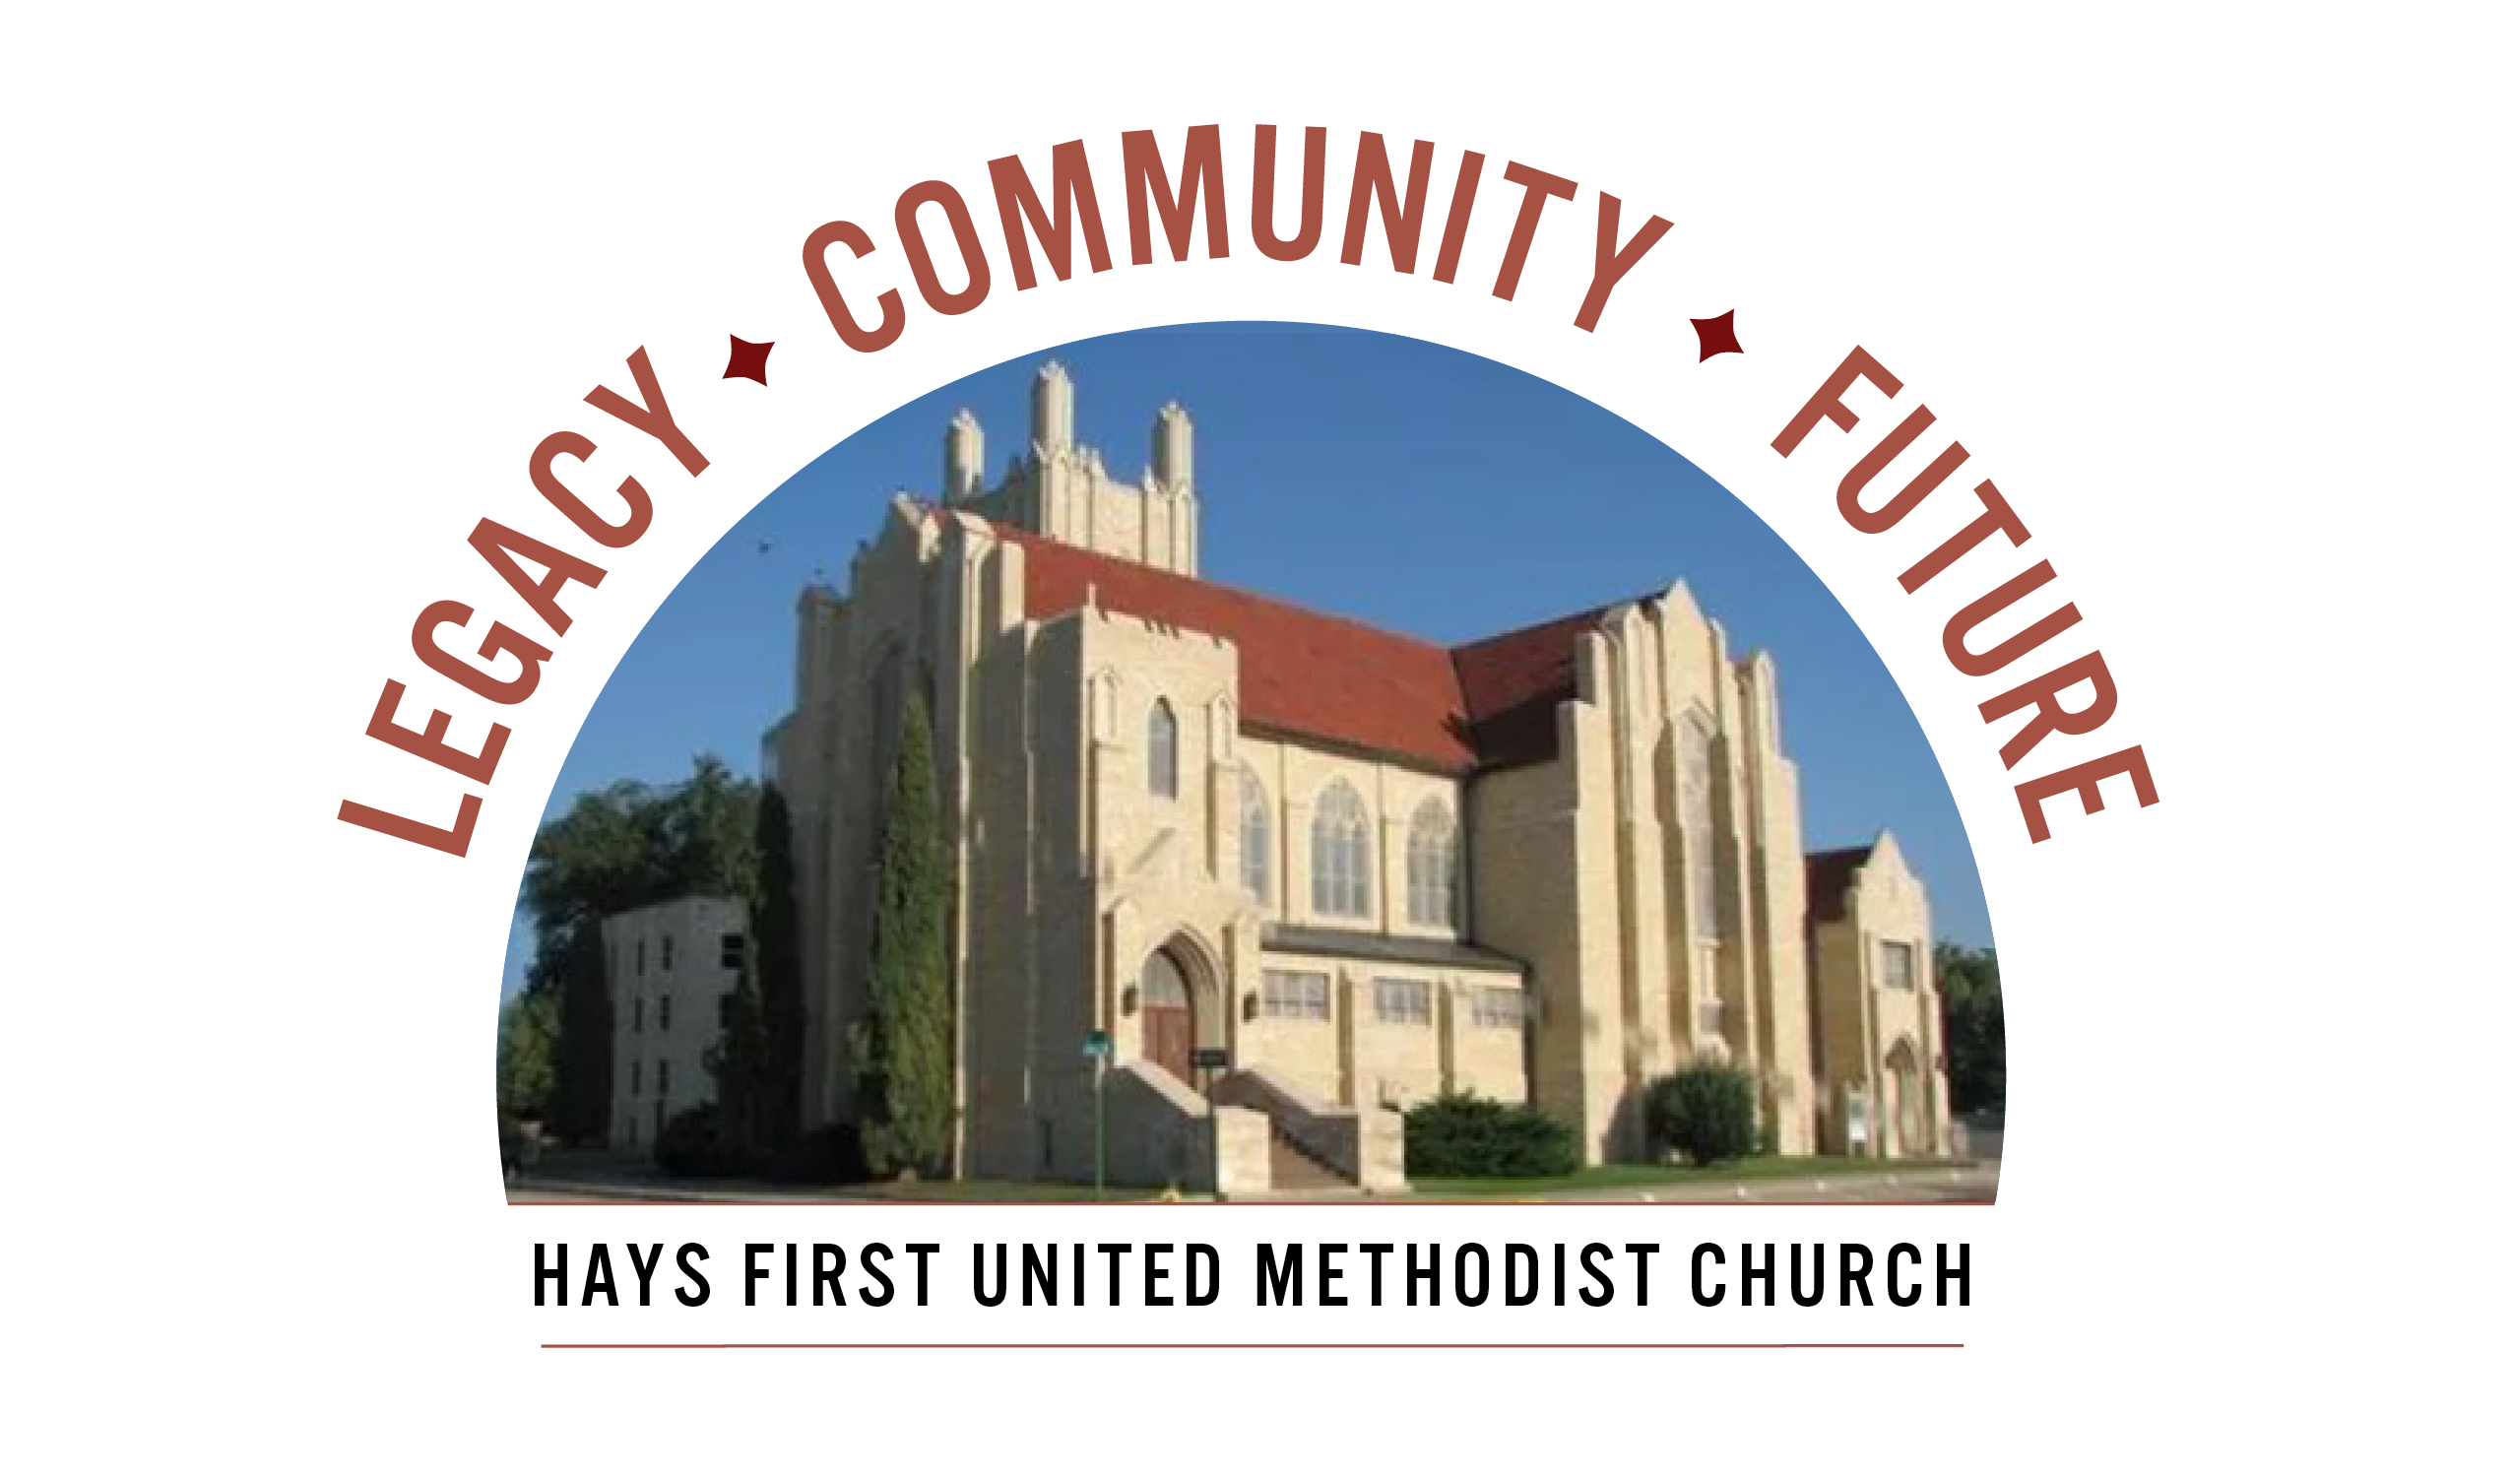 Announcements
- Thank you to all of you who brought pledges and financial gifts this last Sunday. If you are planning to bring yours in, there is time. We will be announcing the total number of pledges we have received soon.
- There are two Adult Sunday School classes-Room 103 and 207.
- We are looking for a Children’s Co-Ordinator, please contact Matt Dumler at 785-625-3408 or matt@haysfumc.com for questions or to apply.
Birthdays: May 10: McKenzie Cunningham, Kash Cutting, Liam Thomas; May 12: Kendra Delzeit; May 13: Barbara Clinkscales; May 14: Weston Moeder, Heidi Wamser; May 15: Haley Roth; May 16: Alexander Sturgeon; May 17: Mary Ann Craig, Sam Gross.
Altar Foundation ($153.00) Steve & Marilyn Wood, Wendy Beougher, Jim & Hannah Barrett, Jeff & Marla Copper, Mike & Jill Arensdorf, Eric Leuschner & Jacinda Johnson, Randy & Barbara Clinkscales, Jaci Gottschalk, Dave & Karen Hendrickson, Marva Miller, Duane & Shirley Steffen, Josh & Callie Thomas, Rick & Diane Wolfe, Keith & Kathy Harper, Ron Katt, Troy & Sherri Brown, Mike Cooper, Greg & Gwen Daughhetee, Tom & Debra McDonald, Jarilyn Staab, Donna Weaverling, Carolyn Miller, Keith & Renee Eilts, Mike & Laura Gaughan, Betty Innes, Curt & Jennifer Kitson, Steve & Julie Paul, Ken Griffin & Marcia Bannister, Virginia Lehman, Phil & Linda Stahlman, Brad & Sarah Schumacher, Rodney Ruff, Davis & Marijo Rooney, Eric & Charlotte Rathke, Ernie & Pam Bryant, Joe & Jan Edwards, Sheryl Dreiling, Ralph & Lorraine Howerton, Mary Meckenstock, Gail & Linda Palmberg, Ed & Dixie Janzen, Mark & Becky Kellerman, Eric & Carol Harfmann, Sue Dolezal, Harvey & Susan Jansonius, Ken & Becky Johnson, Lorena Kellogg
University Graduates:
Mallory Henderson, daughter of Shawn & Marie Henderson, FHSU, B.S. in Biology and minor in Chemistry.
Paityn Homan, FHSU, accepted into Veterinary School, Iowa State.
Brandon Kennemer, son of Rob & Traci Kennemer, FHSU, M.S. in Biology
High School Graduate
Jaelyn Harper, Eudora High, granddaughter of Kathy & Keith Harper.

Welcome to Worship
May 10, 2026
Sixth Sunday of Easter
Mother’s Day-Graduation Sunday

Special Music It Is Well (Kristene DiMarco) Johanna Jones

Graduate Recognition HHS: Johanna Jones, Sophie Miller,
Aubrey Preston, Brynn Zweifel,
Abby Martinez, Sofia Aguayo-Luna

Prayer Hymn O Lord, May Church and Home Combine (Vs 1&2) #695
Prayers of the People Troy Miller, Assoc. Pastor
Lord’s Prayer UMH 895

Choral Anthem Children of the Heavenly Father Charlotte Rathke

Scripture John 14:15-21 (NIV) Mary Meckenstock

Sermon Won’t Let Go! Susan Murithi, Senior Pastor

Offertory For the Beauty of the Earth Hannah Barrett
(Hayes/Gaspard)
Doxology Praise God From Whom All Blessings Flow UMH 95 Offertory Prayer Troy Miller
*Closing Hymn Loving Spirit (Vs1,2&4) FWS 2123
*Benediction Susan Murithi
*Postlude Prepare the Way, O Zion (Smith) Hannah Barrett

The Church Calendar
Today: 8:30 am Traditional Worship
9:45 am Contemporary Worship
10:45 am Traditional Worship
5:00 pm Hispanic Worship
Tuesday: 10:00 am Management Team with Church Development
10:00 am Good Samaritan-Pastor Troy
4:30 pm Spanish Class
Wednesday: 6:00 am Men’s Bible Study
Noon- Ellis Co. Ministerial Alliance Assoc. here 6:30 pm HHS Baccalaureate
7:00 pm Chancel Choir
Thursday: 11:00 am Homestead Worship-Pastor Troy
4:30 pm Spanish class
Friday: 12:00 pm Bible Study – Twelve Women of the Bible

Prayer Concerns: Rachel Palmberg, Zachary Kuntz, Kyler Burk, Carla Cornett, Will & Finley Hayden, Cameron Daughhetee, Ruby Stephenson, Evelyn Zellmer, Al & Judy Hugh.
If you or a family member are in the hospital, please call the church office if you would like to be on the prayer list or to let the pastor know at 785-625-3408.
Our sympathy to the family of LaVaughn Hull April 26. Celebration of Life on Sunday, May 24 from 2-4pm at The Venue, Thirsty’s.
Greeters: 8:30 Gail & Linda Palmberg 10:45 HHS Graduates
05-03-26 Attendance 249 Sunday School 21 On-line 51

Rev. Dr. Susan Murithi-Senior Pastor Troy Miller-Associate Pastor
Matt Dumler, Director of Discipleship Bev Bearley-Administrative Secretary

