
9

Prelude Hail the Risen Lord Charlotte Rathke, organist
Welcome and Announcements please pass attendance pads located on
the inside aisle & pass it down. Susan Murithi, Senior Pastor
Silent Reflection and Opening Prayer
Greeting Time (You may stand up and greet those around you with a
fist bump.)
*Opening Hymn Come, Thou Almighty King UMH 61
Children’s Time Alan Nelson
Special Music Prayer (Ernest Bloch) Martha Miller, cellist
Vision and Mission Recitation Mary Meckenstock
Capital Campaign Prayer Mary Meckenstock
Leader: Heavenly Father, we ask You to show us how to use our talents, our financial gifts and our time to help us as we place this campaign in Your hands, trusting that You will supply every need. Bless each other with peace, joy, and a deeper sense of Your presence. Multiply these offerings so they may bear fruit
far beyond what we can imagine.
Response: May these gifts help strengthen Your church. May they ensure a legacy that future generations may know Your love, hear Your truth and be transformed in faith.
Leader: May the work we do now become a living testimony of Your
faithfulness, inspiring those who will come after us to continue the mission.
Let this be more than a project—it is an act of worship, a declaration of trust,
and a legacy of love for Your Kingdom.

than

Jese
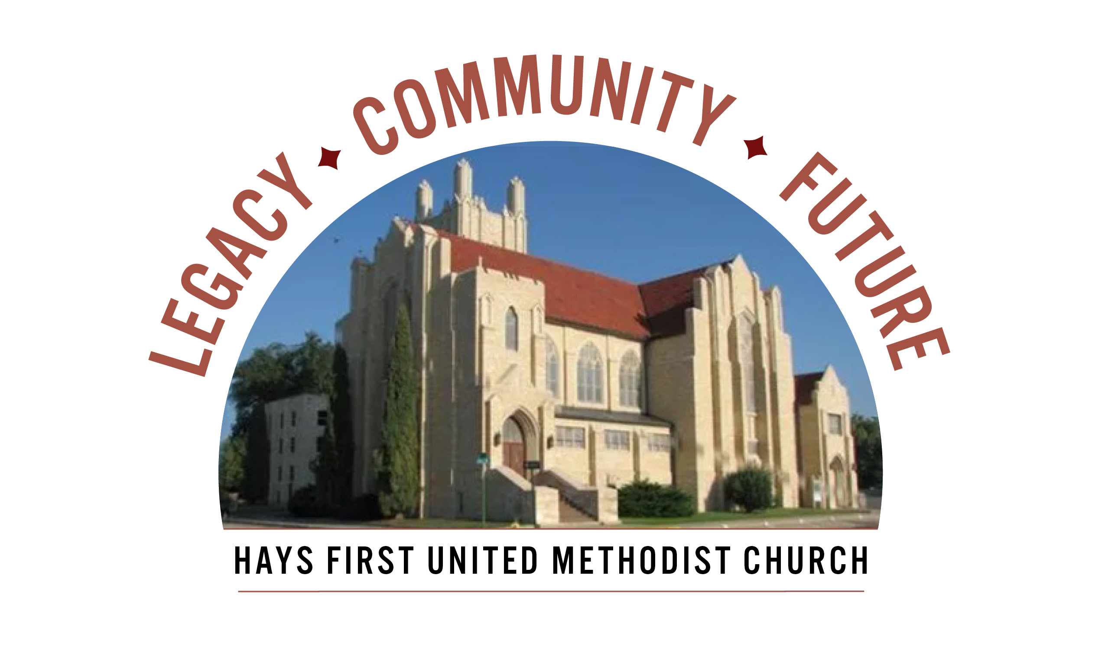 Announcements
Every church household should have received a campaign pledge packet (packet
pickup was on April 12 and leftover packets mailed on April 14). Please continue
Prayer & Discernment which runs 4/12 – 5/3 by using the 21-Day Prayer Guide for adults
and/or the Children’s Prayer Journal. A special thanks to the Prayer Team for creating
These meaningful prayer resources.
Key Campaign Dates: April 29, Ambassadors begin phone calls to answer questions.
May 3, Commitment Sunday, please bring your completed pledge cards to worship.
Thank you.
- Today, April 19, 11-noon, Church Walkaround – meet in parlor
- OUTREACH ARTICLES DUE TODAY!
- Tuesday, April 21, 7-8:15, 7-8:15 pm, carrot cake at Clinkscales, 309 W. 22nd
- Open Table – Young Adults – dinner/Bible Study – Wednesday, 6 pm
- We have Children’s Church and child care available at 10:45 am.
- There are two Adult Sunday School classes-Room 103 and 207.
- Please call the office with your graduates from college and university.
- American Red Cross Blood Drive, Monday, May 4 from 12:30-6:30, please call the office.

Birthdays: April 19: Donna Bieker, Michael Cutting, Benjamin Dumler, Sophie Miller; April 21: Dylan Coker; April 22: Brody Burns, Eli Reed, Landon Thomas; April 25: Theresa Roe, Shyla Sturgeon; April 26: Lorena Kellogg.
Altar Foundation ($153.00) Steve & Marilyn Wood, Wendy Beougher, Jim & Hannah Barrett, Jeff & Marla Copper, Mike & Jill Arensdorf, Eric Leuschner & Jacinda Johnson, Randy & Barbara Clinkscales, Jaci Gottschalk, Dave & Karen Hendrickson, Marva Miller, Duane & Shirley Steffen, Josh & Callie Thomas, Rick & Diane Wolfe, Keith & Kathy Harper, Ron Katt, Troy & Sherri Brown, Mike Cooper, Greg & Gwen Daughhetee, Tom & Debra McDonald, Jarilyn Staab, Donna Weaverling, Carolyn Miller, Keith & Renee Eilts, Mike & Laura Gaughan, Betty Innes, Curt & Jennifer Kitson, Steve & Julie Paul, Ken Griffin & Marcia Bannister, Virginia Lehman, Phil & Linda Stahlman, Brad & Sarah Schumacher, Rodney Ruff, Davis & Marijo Rooney, Eric & Charlotte Rathke, Ernie & Pam Bryant, Joe & Jan Edwards, Sheryl Dreiling, Ralph & Lorraine Howerton, Mary Meckenstock, Gail & Linda Palmberg, Ed & Dixie Janzen, Mark & Becky Kellerman, Eric & Carol Harfmann, Sue Dolezal, Harvey & Susan Jansonius, Ken & Becky Johnson, Lorena Kellogg.

Welcome to Worship
April 12, 2026
Third Sunday of Easter

Response: Grant us clarity of vision so that our plans align with Your
will. Give wisdom to our leaders, courage to our members, and unity
to our church family. Let every meeting, every conversation, and
every decision, be guided by Your Spirit, and may Your name be
glorified.
All: We trust You to lead us forward, step by step, into the future you
prepared, in Christ’s holy name. Amen.
Prayer Hymn Make Us One FWS 2224
Prayers of the People Troy Miller, Assoc. Pastor
Lord’s Prayer UMH 895
Choral Anthem Because He Lives (Gaither) Charlotte Rathke
Scripture Acts 2: 42-47 Mary Meckenstock
Interview with Jarrod Jones Pastor Susan
Sermon Generosity: A Way of Building Community Pastor Susan
Faithful Stewardship Proverbs 22:9 Mary Meckenstock
“A generous person will be blessed.”

Prayer: “Lord of mercy, You say the generous will be blessed, for
they share their bread with the poor. Soften our hearts to see the
needs around us. Make us quick to give, slow to hold back, and
joyful in sharing what You’ve provided. Let our hands reflect Your
kindness. Amen.”
Offertory There’s Power in the Blood Charlotte Rathke, organist
Doxology Praise God From Whom All Blessings Flow UMH 95 Offertory Prayer Troy Miller *Closing Hymn Help Us Accept Each Other UMH 560
*Benediction Susan Murithi
*Postlude There’s Power in the Blood (Reprise) Charlotte Rathke

The Church Calendar
Today: 8:30 am Traditional Worship
9:45 am Contemporary Worship
10:45 am Traditional Worship
11:00 am Capital Campaign walk around & presentation
5:00 pm Hispanic Worship
6:30 pm Capital Campaign Advisory Meeting
Monday: 10:30 am Staff Meeting
6:30 pm Women’s Fellowship – dining room
Tuesday: 10:00 am Management Team with Church Development
4:30 pm Spanish Class
7:00 pm Finance, rm 207
Wednesday: 6:00 am Men’s Bible Study
12:10 pm Prayer Powerhouse
3:00 pm Kid’s Club
5:00 pm Worship on Wednesday or WOW
Meal: pulled pork sandwiches, tator tots, carrots/peas,
salad bar, dessert
6:00 pm Arcade
6:00 pm Spanish/English Bible Study with Pastor Troy
6:15 pm Bell Choir
7:00 pm Chancel Choir
Thursday: 4:30 pm Spanish class
Friday: 10:00 am Good Samaritan-Pastor Troy
12:00 pm Bible Study – Twelve Women of the Bible
Prayer Concerns: Rachel Palmberg, Zachary Kuntz, Kyler Burk, Carla Cornett, Will & Finley Hayden, Kristin Haskett (Pyle), Cameron Daughhetee, Ruby Stephenson, Evelyn Zellmer, Al & Judy Hugh, Billie McCall.
If you or a family member are in the hospital, please call the church office if you would like to be on the prayer list or to let the pastor know at 785-625-3408.
Greeters: 8:30 Marva Miller 10:45 Joe Edwards
04-12-26 Attendance 246 Sunday School 21 On-line 120

Rev. Dr. Susan Murithi-Senior Pastor Troy Miller-Associate Pastor
Matt Dumler, Director of Discipleship Bev Bearley-Administrative Secretary

