

PRELUDE The Strife Is O’er, The Battle Done (Johnson)
Hannah Barrett, organist
Welcome and Announcements please pass attendance pads
Susan Murithi, Senior Pastor

Silent Reflection and Opening Prayer
Risen Lord Jesus as the dawn broke over the empty tomb, hope rose again
in the world. Quiet our busy hearts now and center us in your presence. Roll
away the stones of fear, doubt, and distraction that keep us from seeing
your glory. Fill this place with resurrection joy, and awaken in us the wonder
of new life. As we worship today, make us mindful that you are here among
us—living, loving, and making all things new. Amen.
Greeting Time (You may stand up and greet those around you with a
fist bump.)
TRUMPET INTROIT Crown Him with Many Crowns
Rob Kennemer and Abby Kennemer
*Call to Worship Mary Meckenstock
Leader: Easter people, Christ is risen! God is doing a new thing!
People: Hallelujah! Christ is Risen!
Leader: Life has conquered death! Love has overcome fear!
People: Hallelujah! Christ is risen!
Leader: Christ has transformed a dead end into a new start!
People: Easter people, raise your voices! Christ is risen!
All: Christ is risen indeed! Hallelujah!
Children’s Time Jenna Brubaker

Vision and Mission Recitation

than

Jese
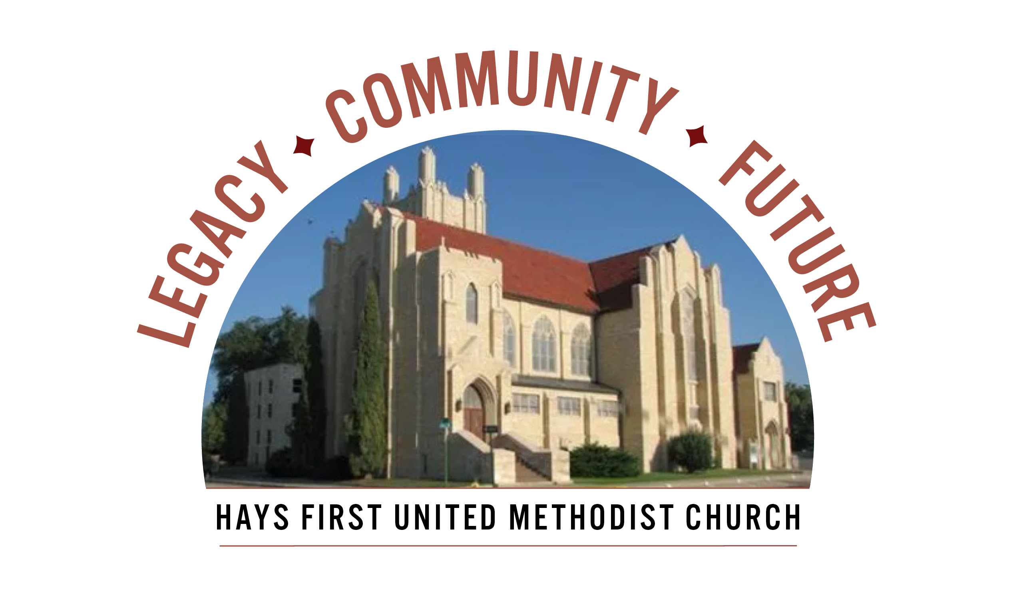 Announcements
We invite every church household to attend an upcoming Capital Campaign event featuring a presentation of our proposed campaign projects and how they support the mission of the church (Q&A included). Attending an event is the best way to fully understand the details of our Capital Campaign. Please stop by the Parlor to see a complete listing of events and RSVP for the event of your choice.
A. Carrot cake at the Clinkscales, 309 W. 22nd, 7-8:15 pm, Monday, April 6
B. Combined Women of Faith Potluck. Meet in Fellowship Hall, Wed., April 8,
11:15-1:00 pm.
C. Church Walkaround meet in parlor at 9:30-10:30, April 12.
D. Rhubarb and Mixed Berry Cobbler with Marcia and Ken for Arbor
Valley Estates, Monday, April 13 from 7:00-8:15 pm.
E, Prayer Vigil, all members, in the chapel and sanctuary, Thursday, April 16
from 7 am – 7 pm. Lets rally in prayer for our church, its members and its
vision.
- Open Table – Young Adults – dinner/Bible Study – Wednesday, 6 pm
- We have Children’s Church and child care available at 10:45 am.
- There are two Adult Sunday School classes-Room 103 and 207.

Birthdays: April 8: Terry Blide, Jarrod Jones, Geoffrey Iringo,; April 9: Dee Beougher, Thomas Decker, Carl Miller, Jacob Brubaker; April 10: Melody Davidson, Camden Luck, Cyler Luck, Calie Sherman; April 12: Garrett Brening.
Altar Foundation ($153.00)Steve & Marilyn Wood, Wendy Beougher, Jim & Hannah Barrett, Jeff & Marla Copper, Mike & Jill Arensdorf, Eric Leuschner & Jacinda Johnson, Randy & Barbara Clinkscales, Jaci Gottschalk, Dave & Karen Hendrickson, Marva Miller, Duane & Shirley Steffen, Josh & Callie Thomas, Rick & Diane Wolfe, Keith & Kathy Harper, Ron Katt, Troy & Sherri Brown, Mike Cooper, Greg & Gwen Daughhetee, Tom & Debra McDonald, Jarilyn Staab, Donna Weaverling, Carolyn Miller, Keith & Renee Eilts, Mike & Laura Gaughan, Betty Innes, Curt & Jennifer Kitson, Steve & Julie Paul, Ken Griffin & Marcia Bannister, Virginia Lehman, Phil & Linda Stahlman, Brad & Sarah Schumacher, Rodney Ruff, Davis & Marijo Rooney, Eric & Charlotte Rathke, Ernie & Pam Bryant, Joe & Jan Edwards, Sheryl Dreiling, Ralph & Lorraine Howerton, Mary Meckenstock, Gail & Linda Palmberg, Ed & Dixie Janzen, Mark & Becky Kellerman, Eric & Carol Harfmann.
Welcome to Worship
April 5, 2026
Easter Sunday

*Opening Hymn Christ the Lord Is Risen Today (Vs1-4) UMH 302
Vision and Mission Recitation

Prayer Hymn He Lives UMH 310
Prayers of the People Troy Miller, Associate Pastor
Lord’s Prayer UMH 895

Choral Athem Risen Today! Charlotte Rathke
Rob Kennemer and Abby Kennemer, trumpets
Scripture John 20:1-18 Mary Meckenstock
Sermon Resurrection: Beyond the Predictable Routine Susan Murithi, Senior Pastor
Faithful Stewardship Mary Meckenstock
“A generous person will prosper; whoever refreshes others will be refreshed.”

Congregational Prayer: “Gracious God, Help us to live with open hearts
and may our generosity reflect your goodness. Amen.

Offertory Amazing Grace (My Chains Are Gone) (arr Hayes/Gaspard) Hannah Barrett
Doxology Praise God From Whom All Blessings Flow UMH 95 Offertory Prayer Troy Miller
*Communion (As projected on the screens)
*Closing Hymn Easter People, Raise Your Voices UMH 304
*Benediction Susan Murithi
*Postlude He Is King of Kings (arr Wagner) Hannah Barrett
The Church Calendar
Today: 8:30 am Traditional Worship
9:30 am Easter Egg Hunt
9:45 am Contemporary Worship
10:45 am Traditional Worship
5:00 pm Hispanic Worship with dinner following
Monday: Office Closed for Easter Monday
1:30 pm Harl Stump visitation-Hays Memorial
2:30 pm Harl Stump funeral-Hays Memorial
Tuesday: 10:00 am Management Team with Church Development
3:30 pm Loving Hands/Loving Hearts
4:30 pm Spanish Class
6:00 pm CCM meeting & fellowship
Wednesday: 6:00 am Men’s Bible Study
11:15 am Naomi & Rebekah Circle Luncheon
Capital Campaign program
12:10 pm No Prayer Powerhouse
3:00 pm Kid’s Club
5:00 pm Worship on Wednesday or WOW
Meal: chicken/noodles/mashed potatoes, broccoli,
Salad, dessert
6:00 pm Spanish/English Bible Study with Pastor Troy
6:15 pm Bell Choir
7:00 pm Chancel Choir
Thursday: 11:00 am Homestead Worship – Pastor Troy
4:30 pm Spanish class
Friday: 12:00 pm Bible Study – Twelve Women of the Bible

Prayer Concerns: Rachel Palmberg, Zachary Kuntz, Kyler Burk, Carla Cornett, Will & Finley Hayden, Kristin Haskett (Pyle), Cameron Daughhetee, Ruby Stephenson, Evelyn Zellmer, Leora Forssberg.
If you or a family member are in the hospital, please call the church office if you would like to be on the prayer list or to let the pastor know at 785-625-3408.
Greeters: 8:30 Gail & Linda Palmberg 10:45 Laurel Stephenson
03-29-26 Attendance 248 Sunday School On-line 37

Rev. Dr. Susan Murithi-Senior Pastor Troy Miller-Associate Pastor
Matt Dumler, Director of Discipleship Bev Bearley-Administrative Secretary

