
9

Prelude Praise to the Lord, the Almighty Charlotte Rathke, organist
Welcome and Announcements please pass attendance pads located on
the inside aisle & pass it down. Susan Murithi, Senior Pastor
Silent Reflection and Opening Prayer
Greeting Time (You may stand up and welcome those around you with a
smile, a nod, or a friendly wave, as a sign of peace.)

*Opening Hymn Come, Thou Fount of Every Blessing UMH 400

Children’s Time Matt Dumler, Dir. of Discipleship

Vision and Mission Recitation Mary Meckenstock

*Call to Worship Mary Meckenstock
Leader: All things come from the hand of the Lord.
People: We return to God with praise and thanks.
Leader: Riches and honor come from Him alone.
People: We worship the Lord with humble hearts.
Leader: We give from what God has first given us.
People: Our offerings are signs of gratitude and trust.
Leader: Come, let us bless the name of the Lord.
People: We celebrate His greatness and love.

than

Jese
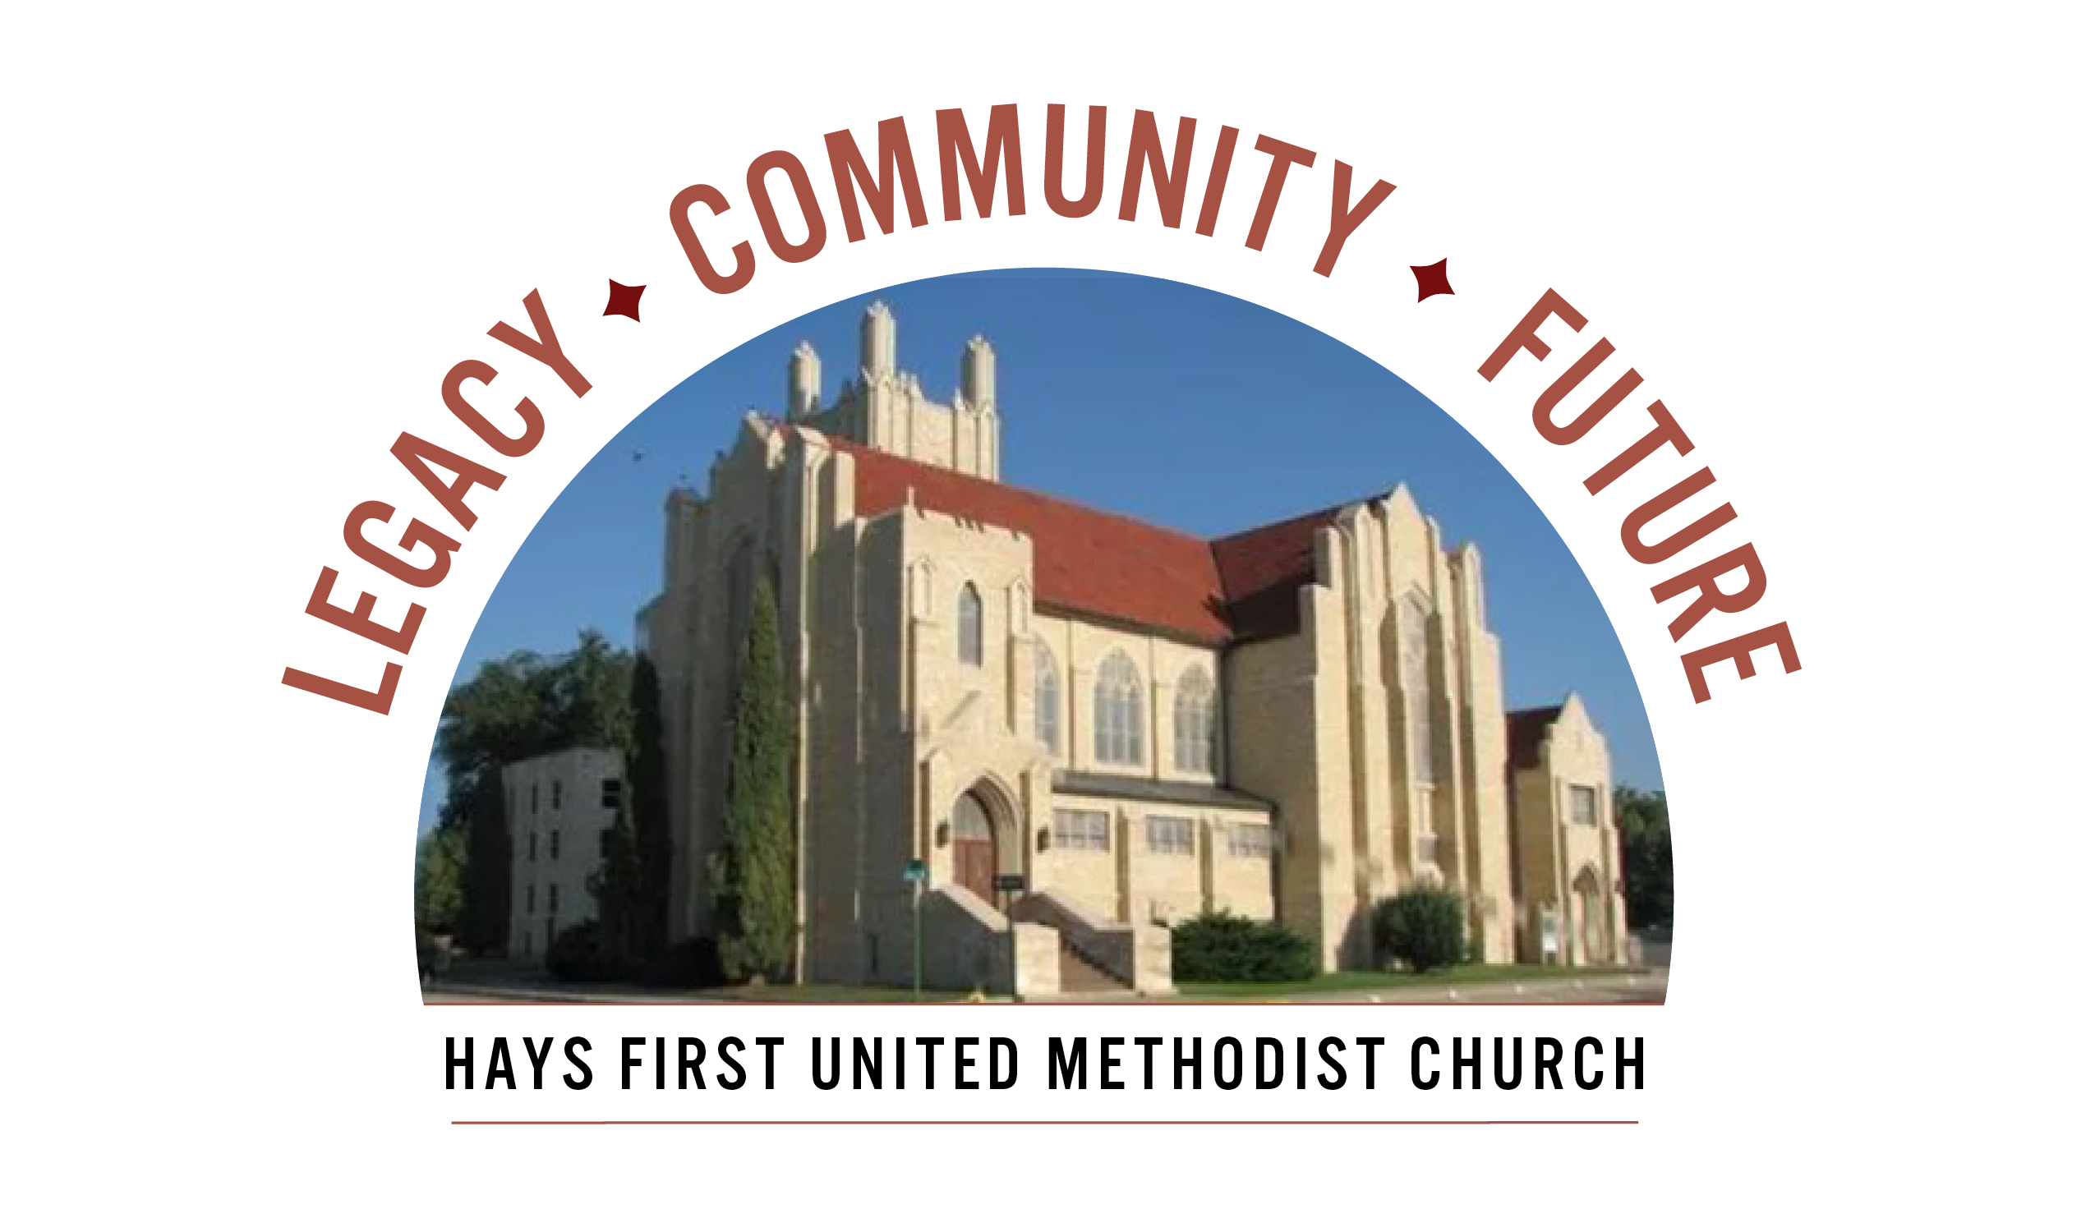 Announcements
Those of you who will write checks for the Capital Campaign, please include this on the memo line and place in the pledge basket today.

- Open Table – Young Adults – dinner/Bible Study – Wednesday, 6 pm
- We have Children’s Church and child care available at 10:45 am.
- There are two Adult Sunday School classes-Room 103 and 207.
- Please call the office with your graduates from college and university.
- American Red Cross Blood Drive, Monday, May 4 from 12:30-6:30, please call the office.
- We are looking for a Children’s Co-Ordinator, please contact Matt Dumler at 785-625-3408 or matt@haysfumc.com for questions or to apply.
- NorthWestKansasAreaAgencyonAging, Inc. hosting annual Information Day on Wednesday, May 6 from 9-3 pm at Big Creek Crossing
- World Day of Prayer at VFW at noon on Thursday, May 7.
Birthdays: May 3: Tayte Lewallen; May 4: Ashlyn Long; May 6: Darris Lewallen; May 7: Eric Rathke; May 8: Callie Lane; May 9: Rylea Barrett, Meredith Cory, Kelly Crain.
Altar Foundation ($153.00) Steve & Marilyn Wood, Wendy Beougher, Jim & Hannah Barrett, Jeff & Marla Copper, Mike & Jill Arensdorf, Eric Leuschner & Jacinda Johnson, Randy & Barbara Clinkscales, Jaci Gottschalk, Dave & Karen Hendrickson, Marva Miller, Duane & Shirley Steffen, Josh & Callie Thomas, Rick & Diane Wolfe, Keith & Kathy Harper, Ron Katt, Troy & Sherri Brown, Mike Cooper, Greg & Gwen Daughhetee, Tom & Debra McDonald, Jarilyn Staab, Donna Weaverling, Carolyn Miller, Keith & Renee Eilts, Mike & Laura Gaughan, Betty Innes, Curt & Jennifer Kitson, Steve & Julie Paul, Ken Griffin & Marcia Bannister, Virginia Lehman, Phil & Linda Stahlman, Brad & Sarah Schumacher, Rodney Ruff, Davis & Marijo Rooney, Eric & Charlotte Rathke, Ernie & Pam Bryant, Joe & Jan Edwards, Sheryl Dreiling, Ralph & Lorraine Howerton, Mary Meckenstock, Gail & Linda Palmberg, Ed & Dixie Janzen, Mark & Becky Kellerman, Eric & Carol Harfmann, Sue Dolezal, Harvey & Susan Jansonius, Ken & Becky Johnson, Lorena Kellogg.

Welcome to Worship
May 3, 2026
Fifth Sunday of Easter

Scripture 2 Corinthians 9:7-11 Mary Meckenstock

Sermon We Cheerfully Give Susan Murithi, Senior Pastor
Hymn Pass It On UMH572
Communion and Pledges Susan, Troy and Marie
Prayer Hymn More Like You FWS 2167
Prayers of the People & Blessing Pledges Troy Miller, Assoc. Pastor
Lord’s Prayer UMH 895

Choral Anthem Wake Up, Church, Wake Up! (Pepper Joplin)

Faithful Stewardship 1 Chronicles 29:14 Mary Meckenstock
“Everything comes from you, and we have given you only what comes
from your hand.”

Congregational Prayer: Sovereign Lord, Everything comes from You,
and we have only given what already belongs to You. Keep us humble
and grateful, remembering that all we have is yours. Amen

Offertory The Lord is Gracious Charlotte Rathke Doxology Praise God From Whom All Blessings Flow UMH 95 Offertory Prayer Troy Miller
*Closing Hymn Take My Life, and Let It Be UMH 399
*Benediction Susan Murithi
*Postlude Praise to the Lord (Reprise) Charlotte Rathke

The Church Calendar
Today: 8:30 am Traditional Worship
9:45 am Contemporary Worship
10:45 am Traditional Worship
5:00 pm Hispanic Worship
Monday: 10:30 am Staff Meeting
12:30 am American Red Cross Blood Drive till 6:30 pm
7:00 pm Staff/Parish Meeting - library
Tuesday: 10:00 am Management Team with Church Development
3:30 pm Loving Hands/Loving Hearts - parlor
4:30 pm Spanish Class
Wednesday: 6:00 am Men’s Bible Study
6:00 pm Spanish/English Bible Study with Pastor Troy
6:15 pm Bell Choir
7:00 pm Chancel Choir
Thursday: Noon – National Day of Prayer - VFW
4:30 pm Spanish class
Friday: 12:00 pm Bible Study – Twelve Women of the Bible
Prayer Concerns: Rachel Palmberg, Zachary Kuntz, Kyler Burk, Carla Cornett, Will & Finley Hayden, Cameron Daughhetee, Ruby Stephenson, Evelyn Zellmer, Al & Judy Hugh, Billie McCall.
If you or a family member are in the hospital, please call the church office if you would like to be on the prayer list or to let the pastor know at 785-625-3408.
Greeters: 8:30 Marva Miller 10:45 Virginia Lehman
04-26-26 Attendance 181 Sunday School 34 On-line 66

Rev. Dr. Susan Murithi-Senior Pastor Troy Miller-Associate Pastor
Matt Dumler, Director of Discipleship Bev Bearley-Administrative Secretary

