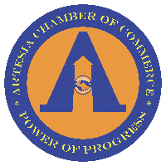

**Artesia Chamber of Commerce**

Board of Directors Regular Meeting  
Tuesday, May 4, 2021 - 12p VIA ZOOM

1. Call to order President, Faiz Baig
2. Quorum Secretary, Larry Caballero
3. Review & Approve Past Meeting Minutes (Apr) Secretary, Larry Caballero
4. Treasurer’s Report Treasurer, Norma Rodriguez
5. Membership Committee Report Neelam “Rain” Nega, 1st VP
6. Executive Director’s Report Executive Director, Chris Craig
   1. Action Items
      1. Chamber – city partnerships
      2. Council presentation May 10 & Grant support
      3. Closing in on quote for pens, stickers, and stationery
      4. Branded folders.
   2. For BOD:
      1. Scholarships committee – Parimal, Norma, Larry, Faiz, Rain
      2. Insurance needs to cover cybersecurity
      3. Have we used a local CPA/bookkeeper to make sure we’re reporting properly? Taxes due May 17th. – Parimal & Norma
      4. Programming & Calendar - Norwalk Chamber’s Ambassador Networking Event (5/26)
         1. Programming committee to discuss events – Frank Calsvrs
7. Round Table Discussion All Board
8. Adjourn President, Faiz Baig