Soft Shell Crab Bloody Mary

14

Shrimp Cocktail 17

Raw Oysters on

Half Shell 19 dz

Lump Crab Cakes 21

Pan seared with a classic remoulade

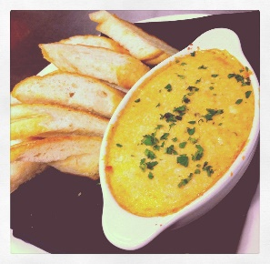

Crab Fondu 18

Savory cream sauce with lump crab meat, melted mozzarella cheese, and chives, crostini

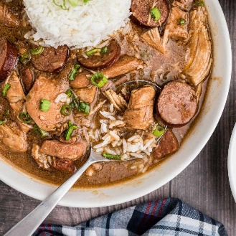

Chicken & Sausage Gumbo 12

Louisianna Crawfish  8 per lb

Add $2 for red potatoes & corn on the cob

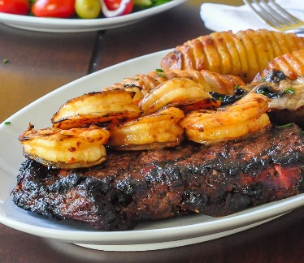

Steak Monica 35

14 oz Ribeye with sauteed shrimp kissed with a Cajun Monica sauce served with mashed potatoes and grilled asparagus

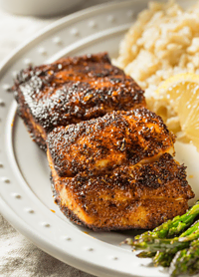Blackened Redfish with Crab Cake 28

Redfish & our popular crab cake kissed with a creamy Monica sauce; served with Dirty rice and asparagus

Louisianna Sauteed Catfish 16

served with rice and grilled vegetables

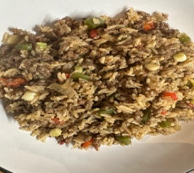

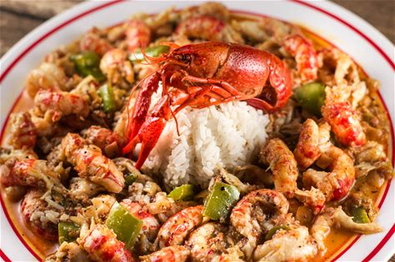Add or substitute Dirty Rice for any item 2.50 Cajun

Crawfish Etouffee  17