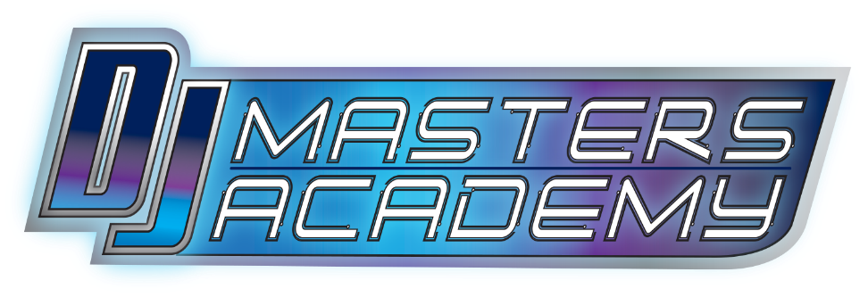
REGISTRATION FORM
(929) 899-0939

Student Name: ________________________________DOB: _____________
Parent’s Name:________________________________ Phone: ____________
Address: ______________________________________________________
E-mail Address: _________________________________________________
Method of Payment: ______________________________________________
For Self Direction Clients Only:
FI: __________________________ Contact Name: _____________________
Contact Phone:__________________ Contact Email: _____________________
Medical Alerts (i.e. seizure disorder, allergies, etc) :
____________________________________________________________________________________________________________________________________________________________________________________
Communication, Traveling and ADL Skills (i.e. verbal, gestures, utilizes technology, independent):
____________________________________________________________________________________________________________________________________________________________________________________
Other Physical Health Restrictions/Safeguards (i.e. limitations, phobias, behavioral issues, sensory issues, triggers):
____________________________________________________________________________________________________________________________________________________________________________________

Other information we should know:
____________________________________________________________________________________________________________________________________________________________________________________
There is a 24-hour cancellation policy. There are no refunds for missed lessons or no-shows. Make-up lessons will be offered if the lesson needs to be cancelled.
DJ Frankie J Productions Inc and DJ Masters Academy assumes no responsibility for the safety of any users or equipment or loss or damage to personal property.
Parent/Guardian Signature: _______________________ Date: _____________
Photography Consent: I give permission for DJ Frankie J Productions Inc and DJ Masters Academy to take and use photographs and/or digital images of my child and his/her work for use in printed or electronic publications and/or social media.
Parent Signature: _____________________________ Date: ______________

