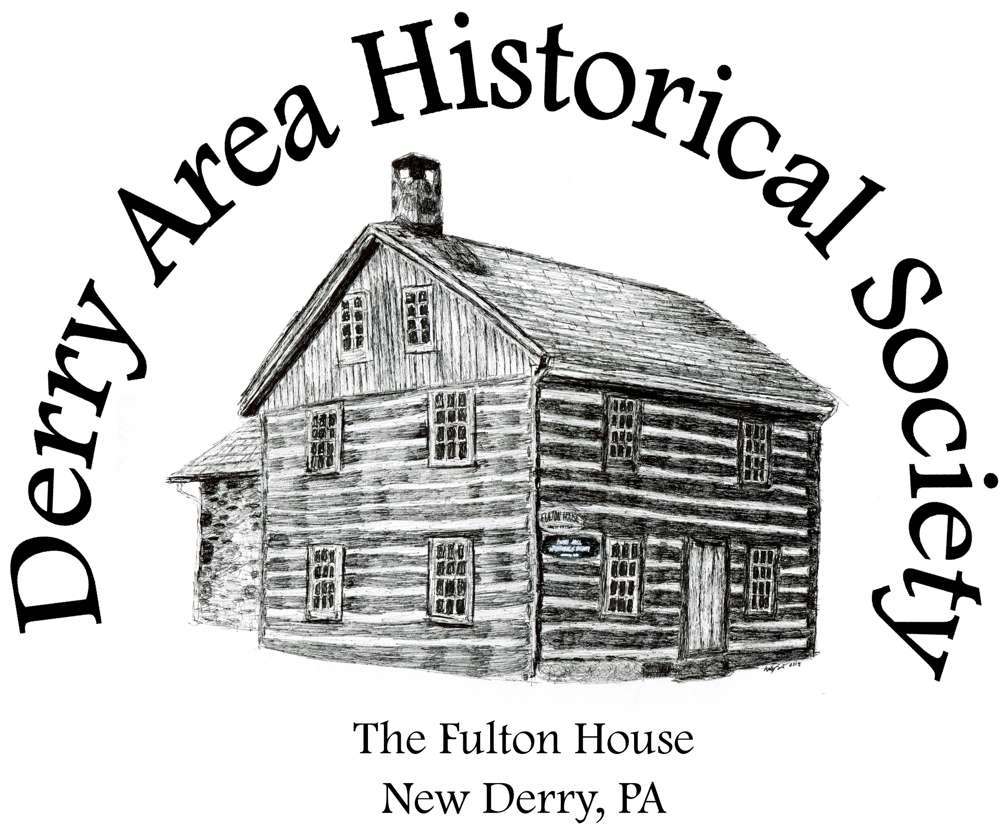
Derry Area Historical Society
P.O. Box 64
New Derry, Pennsylvania 15671

Email: derryareahistoricalsociety@gmail.com

Support local history while advertising your business in 2026!

Dear Community Member:

The Derry Area Historical Society holds numerous, well-attended community & educational events throughout the year. We also publish a bi-annual newsletter filled with details about our events, interesting local history stories, family research information, local hometown historical figure bios, and so much more! With the ever-rising costs of publishing and distributing our “Fulton House News” we are looking to gain community support to help defray the costs of both our newsletter and our events. Our “Fulton House News” is distributed throughout our region and beyond, making it a great opportunity to advertise your business.

Supporting the DAHS not only helps to preserve our mutual past, but is also an excellent way to tell our community that you feel that preservation is important! So much of our cultural heritage is lost on a regular basis; we all need to do what we can to save that heritage to help to educate future generations. The DAHS is so much more than a newsletter or our many fun filled events that occur throughout the year, but it is also an archival treasure trove of information concerning local events, local families, and local industries. Your support will help to guarantee that which we hold so precious will remain for generations beyond our own. Thank you in advance for your support!

Cordially,
Denise Frisko Wood
President, Derry Area Historical Society

Derry Area Historical Society is classified as a 501(c)(3) non-profit organization by the standards of the Internal Revenue Service (IRS). Therefore, your donation may be tax-deductible to the extent allowed by law. Tax ID Number: 25-1790484
Platinum Sponsor ($500+)
- Total Event Sponsor Signage – Platinum sponsors will receive recognition on a standard-sized yard sign (approximately 24X18) to be placed at the entrance to the Fulton House grounds or in another visually prominent location on the Fulton House grounds during one of our many community events, listing your business as the total event sponsor for that event. If you have a preference as to which event, in particular, you’d like to sponsor, please let us know. Otherwise, the event will be chosen randomly.
- Business card sized advertisement in BOTH the Spring/Summer and Fall/Winter issues of our newsletter, The Fulton House News. We ask that you either design an ad and submit it by email or mail/email us your business card for us to scan. If neither of those options is possible, we can also publish your logo along with any contact information you wish.
- Recognition on Derry Area Historical Society social media including our Facebook page which is highly active & averages 150,000-180,000 views per month.

Gold Sponsor ($250+)
- Business card sized advertisement in either the Spring/Summer or Fall/Winter issues of our newsletter, The Fulton House News. We ask that you either design an ad and submit it by email or mail/email us your business card for us to scan. If neither of those options is possible, we can also publish your logo along with any contact information you wish.
- Recognition on Derry Area Historical Society social media including our Facebook page which is highly active & averages 150,000-180,000 views per month.

Silver Sponsor ($100+)
- Business name listed as a sponsor in either the Spring/Summer or Fall/Winter issues of our newsletter, The Fulton House News.
- Recognition on Derry Area Historical Society social media including our Facebook page which is highly active & averages 150,000-180,000 views per month.

Bronze Sponsor ($50+)
- Recognition on Derry Area Historical Society social media including our Facebook page which is highly active & averages 150,000-180,000 views per month.

Business Name: _______________________________________________________________________

Contact Info: _________________________________________________________________________

Electronic graphics/logos can be emailed to: derryareahistoricalsociety@gmail.com - Checks can be made payable to Derry Area Historical Society. If you have any questions you may call 724-717-3187.
To be included in the Spring 2026 newsletter, please return this form by April 1, 2026.

