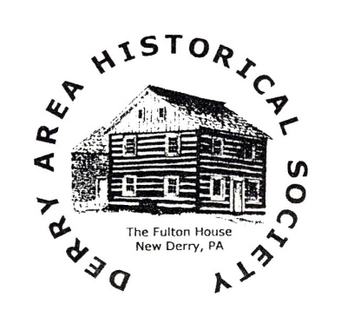

**Derry Area Historical Society**

P. O. Box 64

357 Pittsburgh Street

New Derry, PA 15671

724 – 694 – 8808

[www.derryhistory.org](http://www.derryhistory.org)

Dear DAHS Supporter:

For more than a decade the Fulton House Innkeepers Program has made it possible for your historical society to cover the operating expenses of maintaining the Historic Fulton House in New Derry. This has allowed us to pay the utility bills while your dues and other donations are used to provide our research services and hold special events throughout the year.

If you would like to become an innkeeper (or renew as an innkeeper), please return the bottom half of this letter along with **your tax deductible donation of $175** to our address, listed at the top of the letter. We look forward to seeing you at upcoming events this year at the Fulton House. Follow us on Facebook at “Derry Area Historical Society Official” to keep up with all the latest news. Thank you for your continued support! *We genuinely appreciate you*.

Sincerely,

Peter Wood

Treasurer

**YES, I would like to be an Innkeeper for 2025!**

Name and/or business name: ______________________________________________________

Address: _____________________________________________________

______________________________________________________

______________________________________________________

Phone: ______________________________________________________

Email: ________________________________________________________________________