Derry Area Historical Society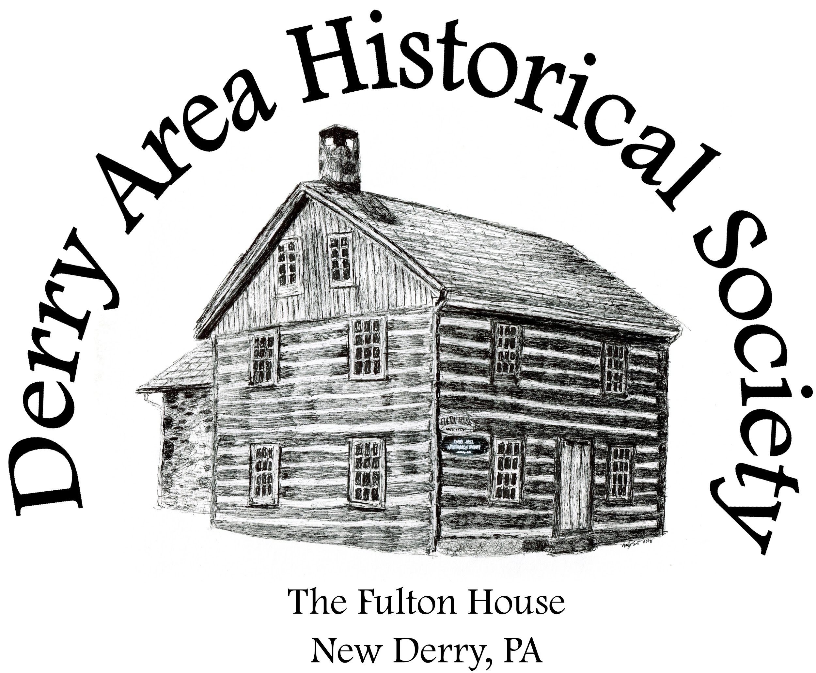

P.O. Box 64

New Derry, Pennsylvania 15671

Email: derryareahistoricalsociety@gmail.com

**Support local history while advertising your business!**

Dear Community Member:

The Derry Area Historical Society publishes a bi-annual newsletter filled with details about our events, interesting local history stories, family research information, and local hometown historical figures bios, and so much more! With the ever-rising costs of publishing and distributing our “Fulton House News” we are looking to gain community support to help defray costs. Our “Fulton House News” is distributed throughout our region and beyond. Supporting the DAHS not only helps to preserve our mutual past, but is also an excellent way to tell our community that you feel that preservation is important! So much of our cultural heritage is lost on a regular basis; we all need to do what we can to save that heritage to help to educate future generations. The DAHS is so much more than a newsletter or our many fun filled events that occur throughout the year, but it is also an archival treasure trove of information concerning local events, local families, and local industries. Your support will help to guarantee that which we hold so precious will remain for generations beyond our own. Thank you in advance for your support!

Cordially,

Denise Frisko Wood

President, Derry Area Historical Society

*Derry Area Historical Society is classified as a 501(c)(3) non-profit organization by the standards of the Internal Revenue Service (IRS). Therefore, your donation may be tax-deductible to the extent allowed by law.* Tax ID Number: 25-1790484

My business is interested in donating to assist with the publication of the 2025   
“Fulton House News” by becoming a: (please circle one)

**Platinum Sponsor** ($500+) - Advertisement in the “Fulton House News” for **BOTH** Spring and Fall 2025 editions. Name/logo in any and all event programs as well as event signage featured at the Fulton House for the duration of 2025. Promotion on Derry Area Historical Society social media (Facebook/Instagram) as well as your business name being featured on the Derry Area Historical Society web page (derryhistory.org)

**Gold Sponsor** ($250-$499) - Advertisement in the “Fulton House News” for **either Spring or Fall** 2025 editions (donor’s choice; please circle your choice above). Name/logo in any and all event programs as well as event signage featured at the Fulton House for the duration of 2025. Promotion on Derry Area Historical Society social media (Facebook/Instagram) as well as your business name being featured on the Derry Area Historical Society web page (derryhistory.org)

**Silver Sponsor** ($100-$249) - Name/logo in any and all event programs as well as event signage featured at the Fulton House for the duration of 2025. Promotion on Derry Area Historical Society social media (Facebook/Instagram) as well as your business name being featured on the Derry Area Historical Society web page (derryhistory.org)

**Bronze Sponsor** ($50**-**$99)Promotion on Derry Area Historical Society social media (Facebook/Instagram)

**\*\*\*Gift Certificates/Gift Cards/Baskets:** If your business would like to donate to our fundraiser raffles we hold throughout the year, please mail gift cards/certificates or contact us to arrange basket pick up.

Business Name: _______________________________________________________________________

Contact Person: _______________________________________________________________________

Address: _____________________________________________________________________________

Phone Number: _______________________________________________________________________

E-Mail Address: _______________________________________________________________________

Electronic graphics/logos can be emailed to: derryareahistoricalsociety@gmail.com - Checks can be made payable *to Derry Area Historical Society*. If you have any questions you may call 724-717-3187.  
**To be included in the Spring 2025 newsletter, please return this form by March 21, 2025.**