Bounce for All – Funded Access Programme

About Bouncy Bees CIC
Bouncy Bees CIC provides a safe, sensory-rich environment for children, young people and adults who may struggle to access traditional community spaces. Our unique exclusive-use model allows individuals and families to enjoy a private session without the pressures often associated with public venues.

Our sensory space includes equipment such as a rebound trampoline, swing, ball pit, sensory lighting and soft play resources, creating opportunities for regulation, movement, play and connection in a safe and supportive environment.

About the Funded Access Programme
Thanks to funding from The National Lottery Community Fund, Bouncy Bees CIC are able to offer funded access to individuals and families who may otherwise be unable to access the service due to financial or other significant barriers.

The programme aims to increase access to sensory play and community participation for those who need it most, while ensuring support is allocated fairly and sustainably.

Who Can Refer?
Referrals are welcomed from professionals and organisations supporting individuals and families, including:

• Schools and nurseries
• Additional Support for Learning staff
• Social workers
• Health professionals
• Family support workers
• Charities and third sector organisations
• Carer support organisations
• Community-based support services

Who May Benefit?

Individuals may be considered where they:

• Would benefit from access to a sensory environment such as Bouncy Bees
• Experience barriers to accessing traditional community settings
• Have additional support needs, disabilities, anxiety, behavioural challenges or other factors impacting community participation
• Are experiencing financial barriers that may prevent independent access to the service

A formal diagnosis is not required.

Referral Process
1. A referral is submitted by an eligible professional or organisation.
2. Referrals are reviewed by Bouncy Bees CIC against programme criteria.
3. Approved referrals will receive an initial allocation of funded sessions.
4. The family or individual will be contacted directly by Bouncy Bees CIC.
5. A unique booking code will be issued for use through our online booking system.
6. Following attendance, feedback may be gathered to help evaluate the impact of the programme and determine whether further support may be beneficial.

How Referrals Are Prioritised
As funding is limited, referrals will be considered on an individual basis.

Priority may be given to:
• Individuals who have not previously attended Bouncy Bees
• Individuals experiencing significant financial hardship
• Individuals facing substantial barriers to accessing other community provision
• Individuals with complex additional support needs

Important Information
• Submission of a referral does not guarantee funded access.
• Funding is limited and referrals will be reviewed throughout the lifetime of the programme.
• Family consent must be obtained before a referral is submitted.
• Funded sessions are intended to reduce barriers to access and increase opportunities for participation, wellbeing and belonging.

Contact Us
For further information regarding the Funded Access Programme, please contact:

Bouncy Bees CIC
Email: referrals@bouncybees.uk
 | 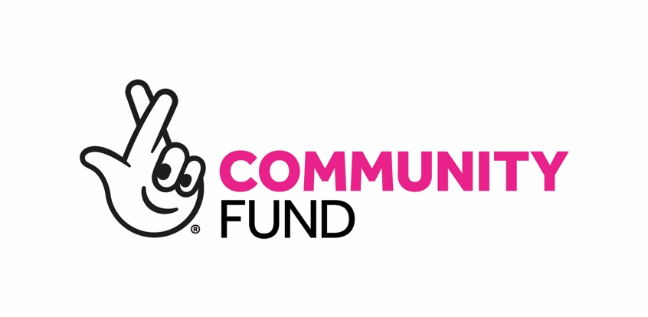
Website: www.bouncybees.uk

