Laser Cutting Training Manual
Bell Metal Club | For Cutting 14 to 20 Gauge Metal
Version: 3.7
Date: August 31, 2026

HOW TO USE THIS MANUAL
Who this is for. Club members learning to run the laser cutter on 14 to 20 gauge metal. You must complete hands-on training and sign out the key before operating the laser on your own.
This manual and Club policy. Club Rules and Policies govern everything here. They are posted in the Club and at bellmetalclub.com. Always follow the posted current version. If this manual conflicts with Club Rules, Policies, or the manufacturer’s instructions, those take precedence. RCSC requires training before members use powered equipment.
How it is organized. Safety comes first; read it before your first session. Know the Equipment names every control the procedures use. The Operating Procedure runs in three stages: Start Up, Make the Cut, and Finish. Troubleshooting, the Glossary, and the Transition from Plasma Cutter page are at the back. The one-page Process Overview and the Competency Sign-Off Sheet are printed separately and posted at the machine.
How to read the steps. Each numbered step is one action, in order. Bold text names a button, switch, or on-screen control. Click paths read in order: File > Import means click File, then click Import. Italic lines starting with ✓ tell you what you should see or hear when the step worked. Every marker also works in black-and-white print: cues are italic with a check mark, and safety boxes are labeled with their signal word.
Safety boxes. Three kinds. When you see one, read it:
WARNING: You could be injured. The box tells you the hazard and how to avoid it.
CAUTION: You could get a minor injury, such as a pinch or burn.
NOTICE: The equipment could be damaged. These protect the club’s machine.
Figures. Photos and screenshots are framed and numbered as figures, under the step each one supports. When a figure has numbered callouts, the caption or the legend table below it explains each number. Windows offers several ways to do most tasks; this manual gives one standard method for each.
CONTENTS
How to Use This Manual 1
Safety 3
Rules That Always Apply 3
Emergency Stop 3
Fire Response 4
Approved Materials 4
Know the Equipment 5
The Work Area 5
Wall Switches 6
The Remote Control 8
The Computer and 2d Cut Software 9
Before You Arrive 11
Operating Procedure 12
Stage 1: Start Up 12
Power Up the Equipment 12
Start the Software 15
Stage 2: Make the Cut 18
Load Your Material 18
Load the Design 20
Verify the Nozzle and Gas 25
Calibrate the Laser Height 27
Set the Zero Point and Check the Frame 27
Pre-Cut Checklist 27
Cut 28
Stage 3: Finish 29
Remove Parts and Clean Up 29
Clear Your Program and Eject Your USB 31
Hand Off or Shut Down 32
Troubleshooting 34
Glossary 36
Transition from Plasma Cutter 37
Revision History 38

SAFETY
These rules apply every time you use the laser. The ones that matter most are repeated at the exact step where they apply.

Rules That Always Apply
- If unfamiliar or unsure, stop and ask the on-duty Monitor. This is the Club-wide rule for every machine in the shop.
- Report any injury or near-miss to the on-duty Monitor, and report damaged equipment the same way.
- Keep the door closed while cutting. Laser light can injure your eyes and skin. It is safe to watch the cut through the window in the laser’s door; the enclosure and door interlock are what make that safe.
- Stay at the machine for the entire cut. Cut pieces can tilt up and obstruct the head. Watch through the window with a finger over Pause. Club Safety Policy: do not leave equipment running unattended.
- Treat cut metal as hot. Metal gets hot when the laser cuts with oxygen (used for thicker material), and cut edges are sharp on any job. It is not always hot, but always be cautious: let parts cool or use gloves and the pickup tools.
- Two safety blocks keep the laser from firing. The K4 light (red targeting dot) on the remote: while the light is on, the laser will not fire. The Layer screen in the 2d Cut software: the laser cannot fire while it is open. Always press K4 (red light on) before reaching into the laser cabinet. Use the Layer screen when changing a nozzle or lens or cleaning inside the machine.
- Laser safety glasses are required only for work inside the machine. The maintenance team keeps two pairs.
- Door and tray interlock. The tray locks while the machine is running and releases when the job is done. The machine should not run unless the tray is locked in place.
- Bottom tray (wagon). Pinch and trip hazard. Always tuck the handle in and slide the wagon into position under the laser doors.
- Shop basics apply at the laser. Eye protection in the Shop Area, closed-toe sturdy shoes, no loose clothing or jewelry, long hair tied back. The Club Safety Policy and the Basic Safety training have the full list.
- Material rules. Never let the laser cut off the edge of the metal. Stop the job if a cut will run off the edge; the frame check catches this before you start. Do not set the zero point on top of a rail peak. The laser is not for trimming metal to size (see Transition from Plasma Cutter).

Emergency Stop
The E-stop is the red knob on the operator console. Press it to stop the equipment immediately. To release it, turn it clockwise slightly until it pops out. There is no visible difference between pressed and released; check by feel.
CAUTION: Turning the E-stop counterclockwise unscrews the knob, and an unscrewed E-stop may not work when you need it. Release it clockwise only.
The E-stop is for EMERGENCIES. For routine problems during a cut, such as an obstruction or a tilted part, use Pause or Stop on the remote control instead. During any calibration or job start, keep a finger over the remote’s Stop button, even though the machine should stop automatically.
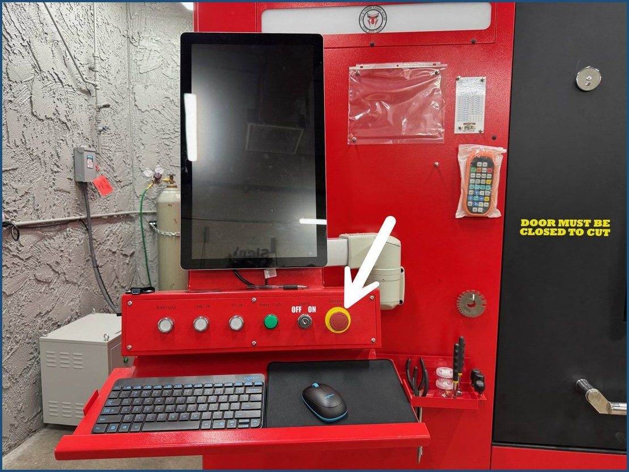
Figure 1. The E-stop is the red knob on the right end of the operator console (arrow). Release it by turning it clockwise until it pops out.

Fire Response
Know your resources before your first cut: fire extinguishers, fire alarms, first aid kits, and the eyewash station are marked on the Club’s Fire & First Aid map posted in the Club. The AED is at Bell Center.
- Press Stop on the remote (or the E-stop) to stop the laser.
- If the fire is anything more than a small flare-up at the cut, evacuate and activate the fire alarm.
- Alert the on-duty Monitor.

Approved Materials
The approved materials list is the metal list configured in the 2d Cut software; the maintenance team manages it. Do not cut metal that is not in the list. If you are not sure about a metal, ask before cutting.
- This manual covers metal 14 to 20 gauges with full cut-through designs. The minimum piece size is 12 by 12 inches; smaller pieces can be blown out of place by the air pressure.
- Do not change preconfigured metal settings.
WARNING: Never cut galvanized, zinc-plated, painted, or oiled metal unless it is in the software list. Zinc and coating fumes are hazardous to breathe.
- Material 1/8 inch or thicker uses oxygen (see Verify the Gas). Oxygen cutting makes the metal hot.

KNOW THE EQUIPMENT
Learn these names before your first cut. Every procedure uses them.

The Work Area
- Laser cutter: the large red machine. Door with stainless steel handle and viewing window, gantry and laser head, pull-out cutting table, and catch trays underneath. The gantry is the laser head plus all the parts that move it.
- Operator console: computer monitor, E-stop, keyed power switch (O = off, I = on), LAMP-SW interior light button, USB slot, keyboard, and wireless mouse.
- Tools, mounted on the laser cutter: pliers to handle metal safely, punches and a small screwdriver to push out small cut pieces, and three magnets. Small magnet poles (in the toolbox) pick up small pieces. The medium magnet (black shaft, orange handle) reaches into the cutter to retrieve pieces without disturbing the sheet. The large magnet (yellow) cleans the catch trays. The medium and large magnets have a release handle; pull it and the metal drops off.
- Chiller: rear of the cutter. Cutters do not touch it; the maintenance team manages it. If it beeps, note the error code and report it.
- Dryer and compressor: behind the cutter, reached from the right side. The dryer drain is now automated; no cutter action needed.
- Transformer: white box against the wall on the cutter’s left. Never touch the transformer or the switch above it.
- Exhaust fans: wall fan and roof fan, both on wall switches. Both must run whenever the laser is cutting.
- Oxygen cylinder: used only for material 1/8 inch or thicker. When it is used, cut metal may be hot.
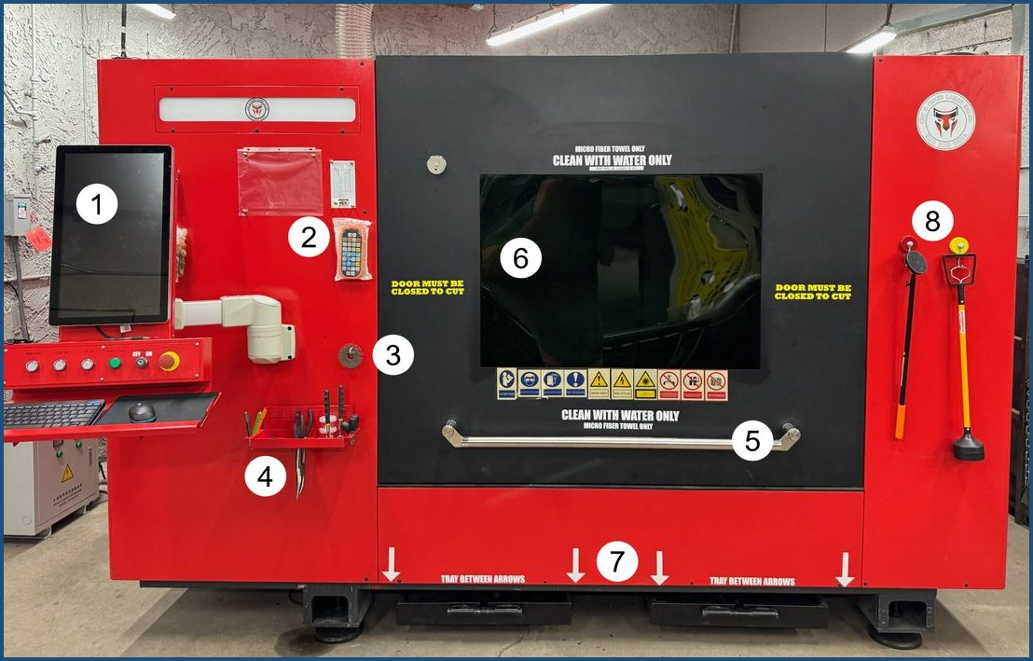
Figure 2. The laser cutter. The numbers mark the items in the legend below; find each one before your first cut.
1 | Operator console: monitor, buttons, keyed switch, E-stop | 5 | Door, with the stainless steel handle
2 | Remote control, in its protective bag | 6 | Viewing window: watch the cut from here
3 | Metal gauge tool | 7 | Catch trays, between the arrows
4 | Tools: pliers, punches, small screwdriver | 8 | Magnet tools, with release handles

Wall Switches
Switch / label | Powers | Location | Shown in
Switch #1 | Main power: laser cutter, chiller, transformer | On the wall, left of the laser cabinet | Figure 3
Switch #2 | Laser cutter on/off (rotary switch) | Left side of the laser cabinet | Figure 3
Switch #3 | Automated dryer and interior light | On the wall, left of the laser cabinet | Figures 3 and 7
Switch #4 | Compressor | On the wall right of the laser cabinet, behind the laser | Figure 4
Roof exhaust fan | Roof fan | On the wall right of the laser cabinet, on the other side of the doorway | Figure 8
Wall exhaust fan | Wall fan | On the wall right of the laser cabinet | Figure 4
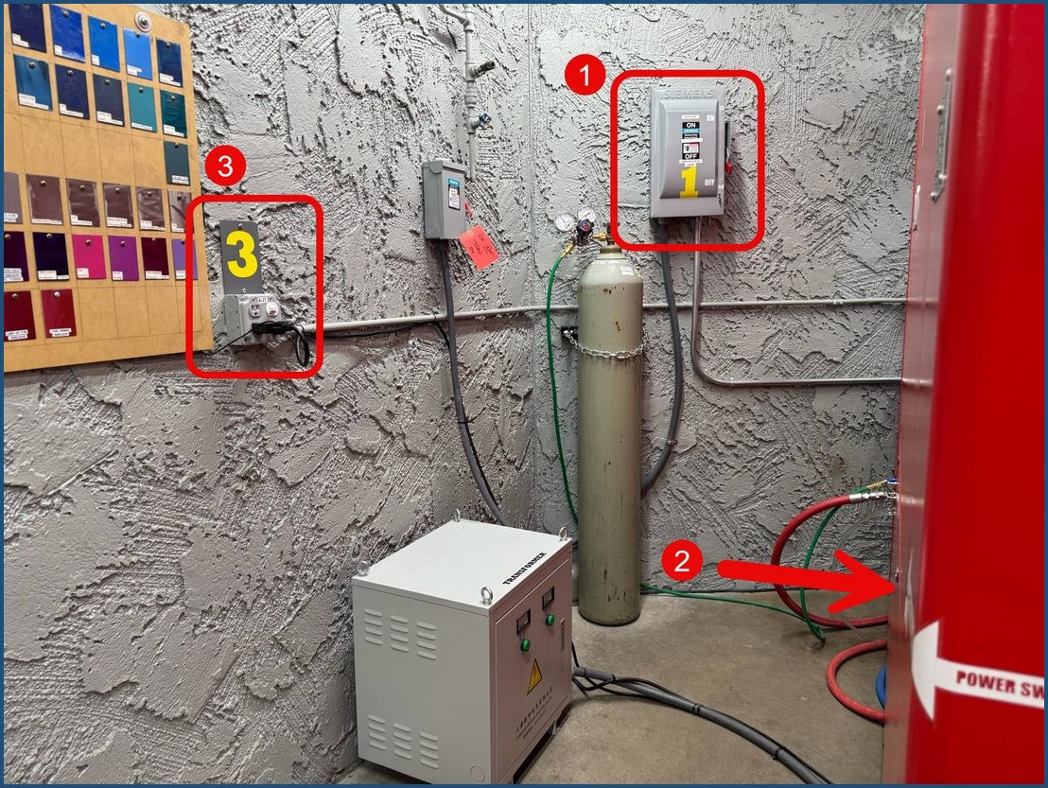
Figure 3. Left of the cabinet: 1 = Switch #1, 2 = Switch #2 (rotary, on the side of the cabinet), 3 = Switch #3. The white box is the transformer; the tan cylinder is the oxygen.
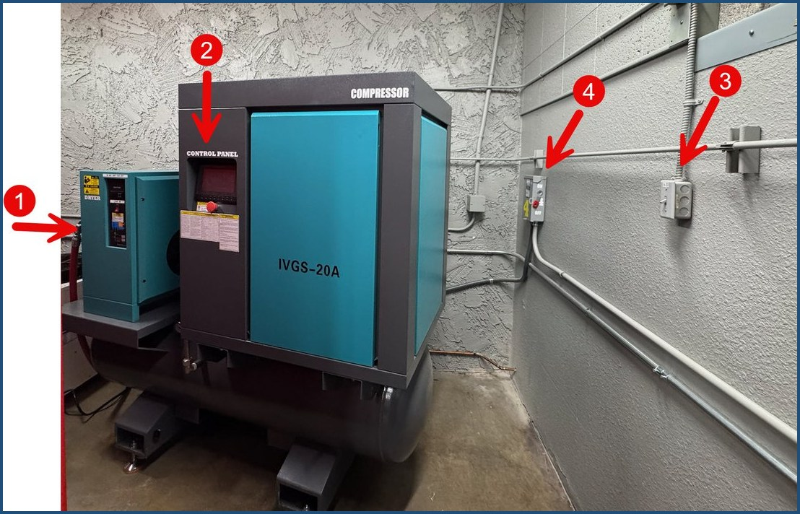
Figure 4. Right side, behind the laser: 1 = compressor regulator gauge (side of the dryer), 2 = compressor control panel, 3 = wall fan switch, 4 = Switch #4.

The Remote Control
The remote is kept in its protective bag and stays in the bag during use.
 | 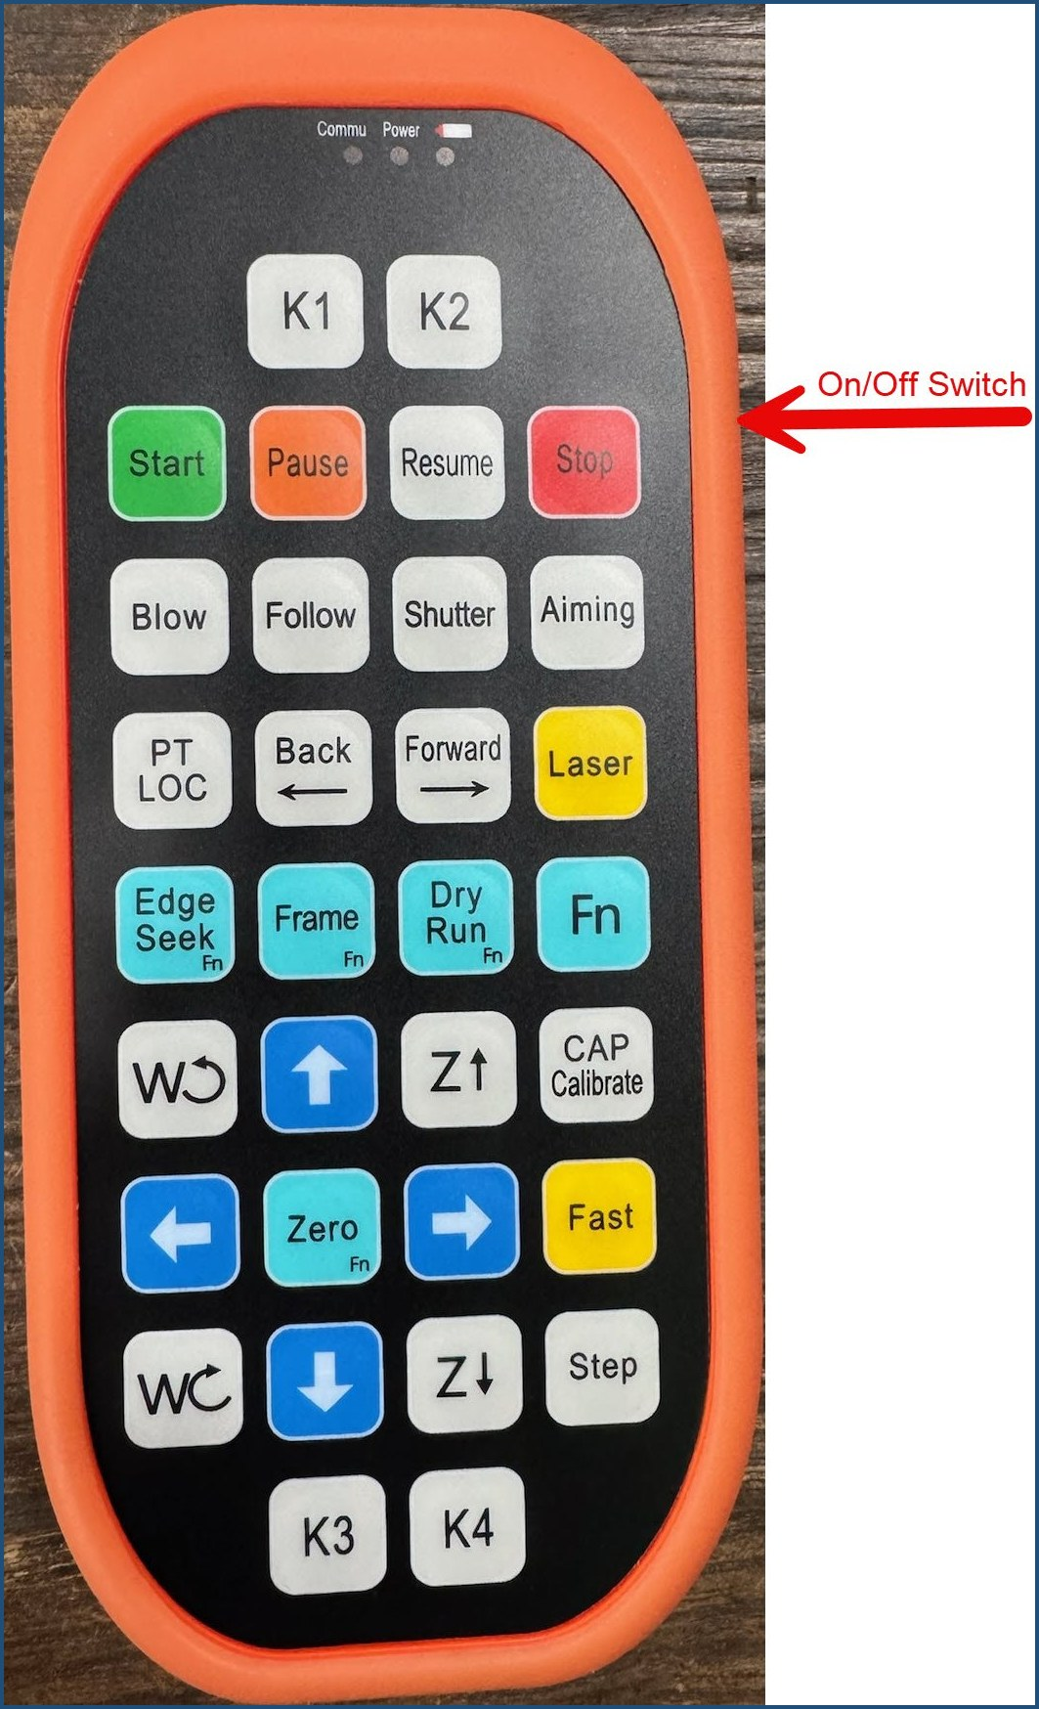  Figure 5. The remote control. The On/Off switch is on the side (arrow). Edge Seek, Frame, Dry Run, and Zero are used together with the Fn key; K4 is at the bottom right.
  Button | What it does
  On/Off (side) | Powers the remote.
  Blue arrows | Up moves the gantry back; down moves it forward. Left and right move the cutting head. Press and hold for continuous movement.
  STEP + arrow | Small movements for fine positioning.
  Z↑ / Z↓ | Raise / lower the laser head. Lowering makes the red dot smaller and sharper.
  K4 | Red targeting dot on/off. While the light is on, the laser will not fire.
  CAP CALIB | Calibrates the laser height.
  Fn + Edge Seek | Finds the material edge and sets the zero position (straight-edged metal). Edge Seek is the label on the remote; the RayTools manual calls the feature Edge Detect.
  ZERO | Sets the 0,0 position manually.
  Fn + Frame | Traces a box around the cut area without cutting.
  DRY RUN | Traces the full design without cutting (slow).
  LASER (yellow) | Test-fires the laser to confirm it is active.
  START / PAUSE / RESUME / STOP | Run controls for the cutting job.

The Computer and 2d Cut Software
- G3 / MAX (blue icon): security software. It should start automatically; “MAX” on the screen means it is running.
- 2d Cut (green square RT icon, also called RayTools): loads designs and runs the cutter. It runs on the RayTools XC3000 motion-control system; this manual covers the Club workflow, and the Club’s copy of the XC3000 Series user manual covers everything else (bellmetalclub.com > Laser Documentation).
- Icon tray (bottom right): the hidden-icons arrow ( ∧ ) is where you eject your USB drive.

The 2d Cut Screen
- The white outlined box is the cutting area. Your whole design must fit inside it.
- A selected design shows solid lines; an unselected design shows dashed lines. A design must be selected before you can move, resize, or rotate it.
- File (top toolbar) imports your design. Layer (upper right) selects the metal. The Favorites bar holds Scale and Transform, the two adjustments cutters may use.
- The bottom of the screen has run controls, but members are trained to use the handheld remote while watching through the window.
- Keyboard shortcuts: mouse scroll wheel = zoom. Ctrl+A = select all. Ctrl+Z = undo. Ctrl+Y = redo. Esc = clear selection.
NOTICE: A configuration team manages every setting on this machine. Change only what this manual names: even a small change can ruin your cut, the next person’s cut, or the machine, because settings carry over.
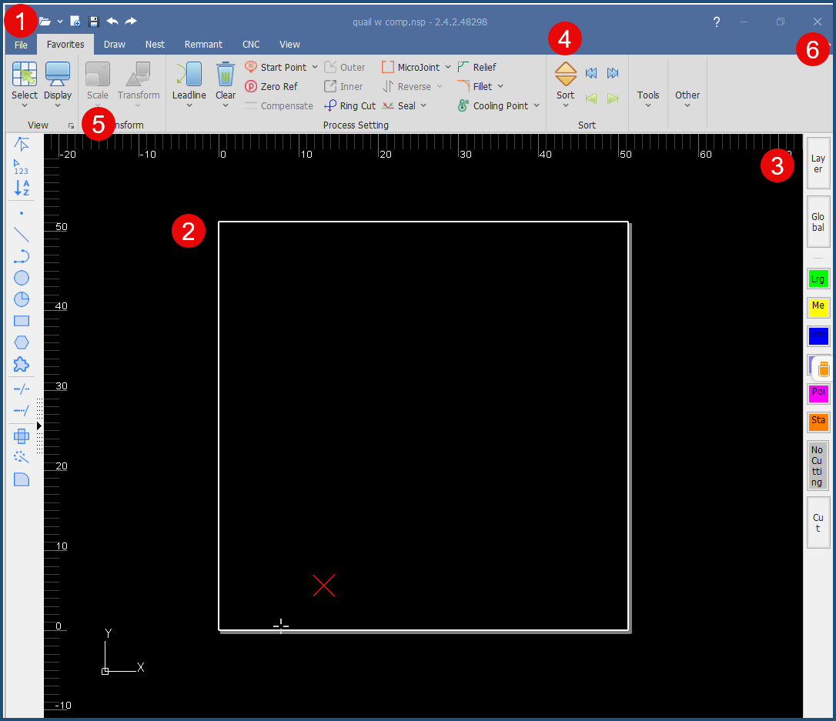
Figure 6. The 2d Cut home screen. The numbers mark everything a cutter uses; the legend below names each one.
1 | File: import your design | 4 | Sort: set the cutting sequence
2 | White box: the cutting area | 5 | Scale: resize (Favorites bar; Transform is beside it)
3 | Layer: select the metal | 6 | X: close 2d Cut when you are done

BEFORE YOU ARRIVE

Prepare Your Design File
Complete your design work before coming to the laser. The laser computer is not for designing; Design Edge and V-Carve remain the club’s standard design tools.
- Export a .dxf file from Design Edge or V-Carve onto a USB drive, using your normal export process.
- Designs cut completely through the metal.
- At the laser you may scale and rotate your design; everything else is designed before you arrive.
- Start with smaller designs. Avoid full-sheet cuts until you have experience; small cut pieces toward the back of the cutter are hard to see.

What You Need
- Your USB drive with the DXF file.
- Your metal, purchased before it goes in the cutter, and sized for the machine: minimum 12 by 12 inches, maximum 48 by 48 inches. Pieces smaller than 12 by 12 inches can be blown out of place by the air pressure.
- Gloves and personal protective equipment for handling cut, and possibly hot, metal.
- Training sign-off. You must be trained before operating the laser, and you must personally sign out the key.

OPERATING PROCEDURE
Three stages, in order: Start Up → Make the Cut → Finish. Taking over from another cutter? Sign out the key (Start Up, step 1), then skip ahead to Start the Software, step 2 (Open 2d Cut).

Stage 1: Start Up

Power Up the Equipment
- Sign out the key at the monitor station. Every cutter must personally sign out the key. The responsibility rules are in Hand Off or Shut Down.
- Turn on Switch #1 (on the wall, left of the laser cabinet): move the red lever up.
✓ The transformer’s green lights come on. Never touch the transformer or the switch above it.
- Turn on Switch #2 (left side of the laser cabinet): turn the rotary switch to the 3 o’clock position.
✓ The laser’s computer begins its start-up cycle.
- Turn on Switch #3 (on the wall, left of the laser cabinet): move the lever up. This powers the automated dryer and the interior light.
- Turn on the roof exhaust fan (switch on the wall right of the cabinet, on the other side of the doorway).
✓ The bulb by the roof fan switch is lit when the fan is on.
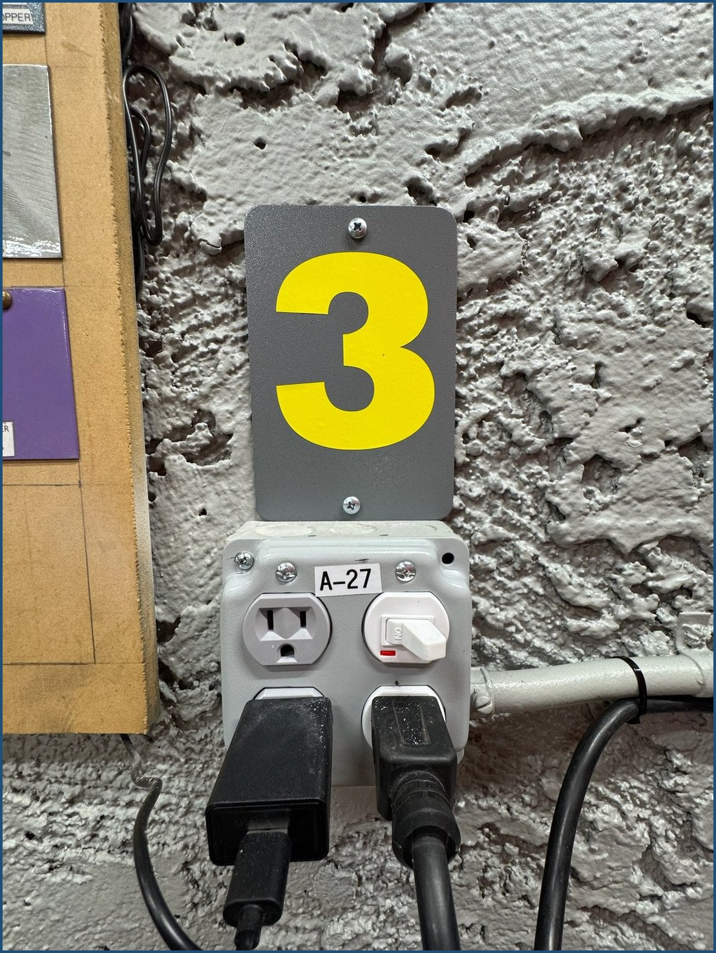  Figure 7. Switch #3 in the ON position. | 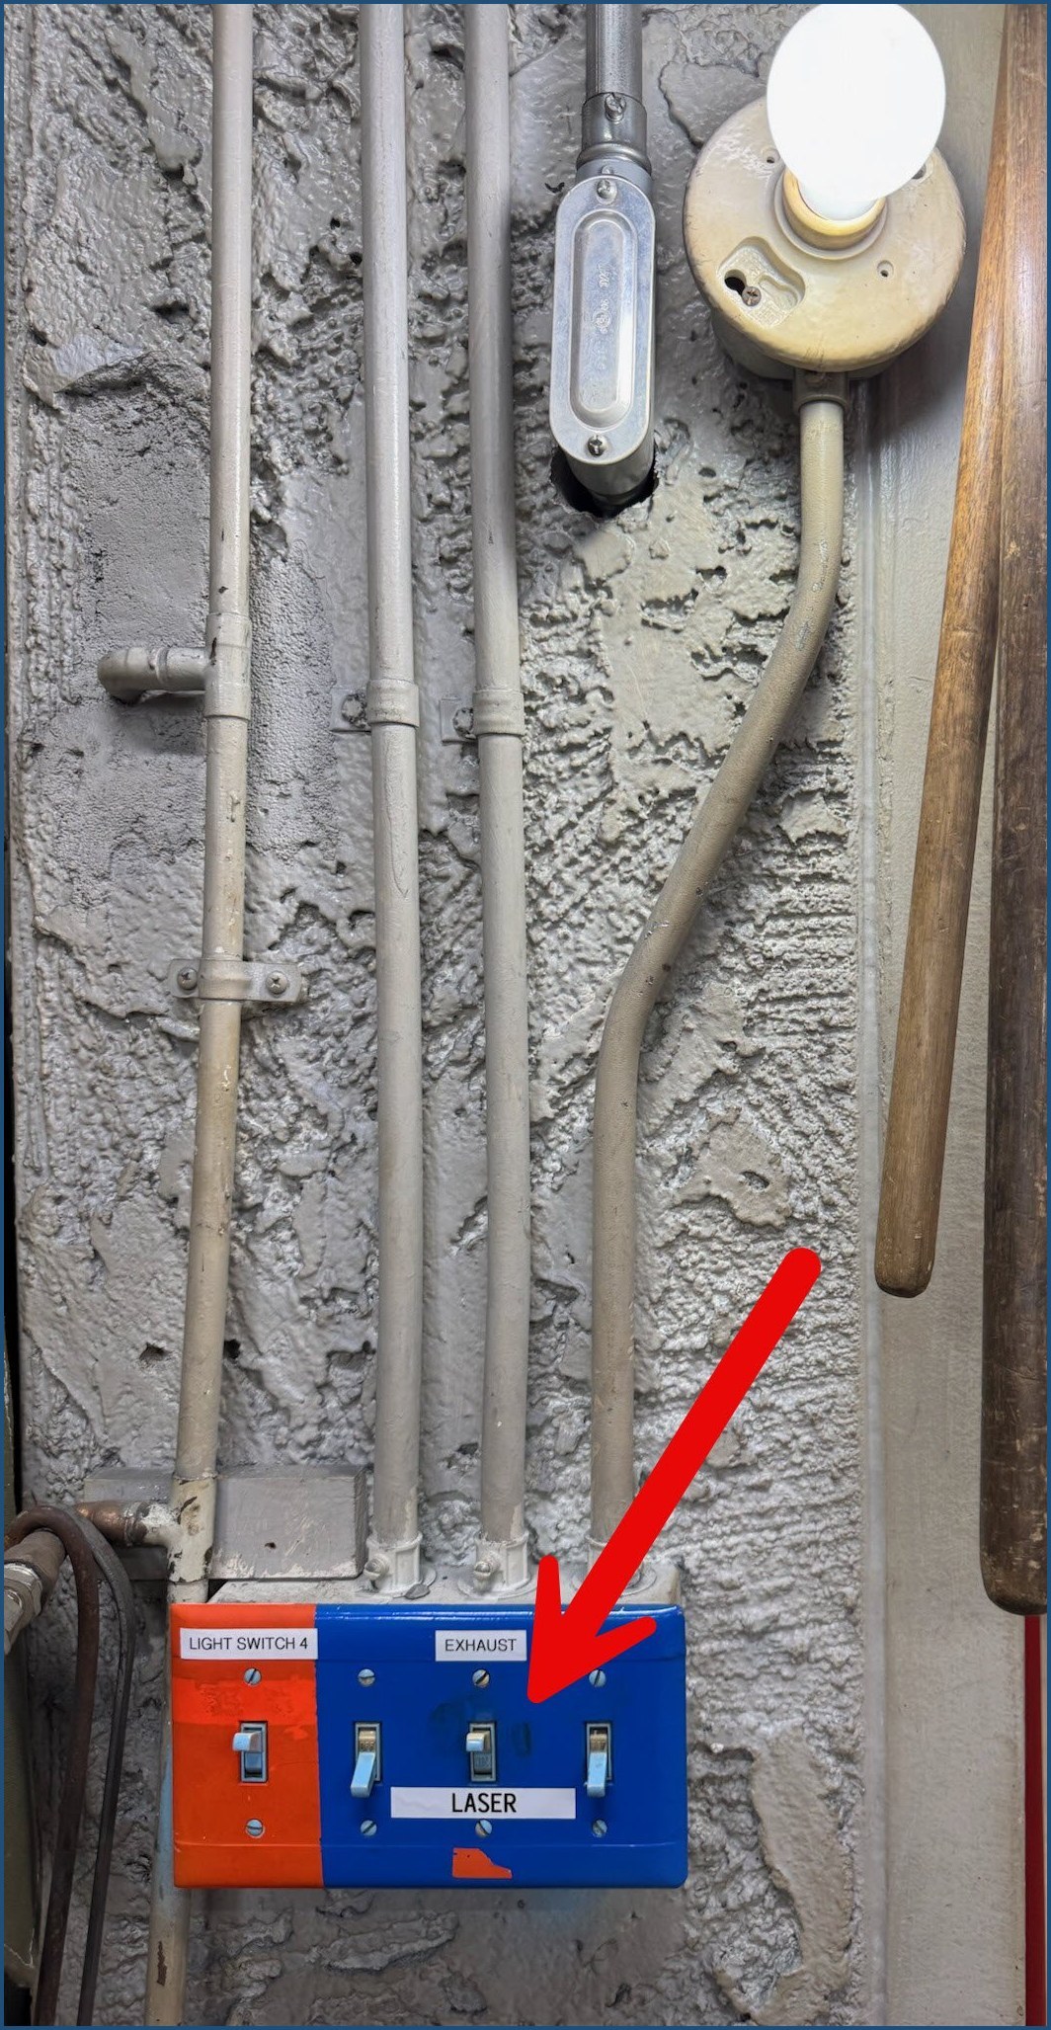  Figure 8. The roof exhaust fan switch is the middle toggle labeled LASER (arrow), by the doorway. The bulb above it lights when the fan is on.

- Set up the operator console:
  - Reset the E-stop: turn the knob right (clockwise); it pops out if it was locked.
  - Turn the keyed switch to I (on).
  - Press LAMP-SW.
✓ The LAMP-SW button lights up and the lights inside the cutter come on.
  - The mouse stays powered on. If the pointer does not move, check the switch on the underside of the mouse.
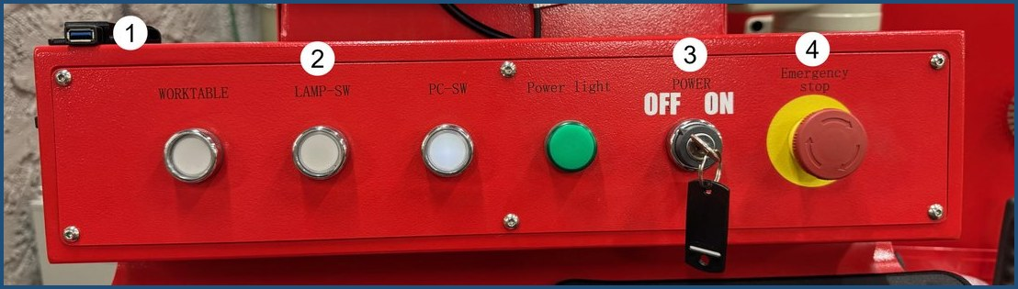
Figure 9. The operator console: 1 = USB slot (left end), 2 = LAMP-SW, 3 = keyed power switch (O = off, I = on), 4 = Emergency stop.
- Turn on Switch #4 (on the wall right of the cabinet, behind the laser): move the lever up. This powers the compressor.
- Start the compressor:
  - Tap the compressor’s screen to wake the display.
  - Press and hold the green START until the run light turns green.
✓ It is noisy at first, then quiets down. Continue with start-up while it finishes its countdown cycle.
- Turn on the wall exhaust fan (switch on the wall right of the cabinet).
The chiller and dryer run on their own. Cutters do not adjust them; the maintenance team manages both. If the chiller is beeping, note the error code and report it.
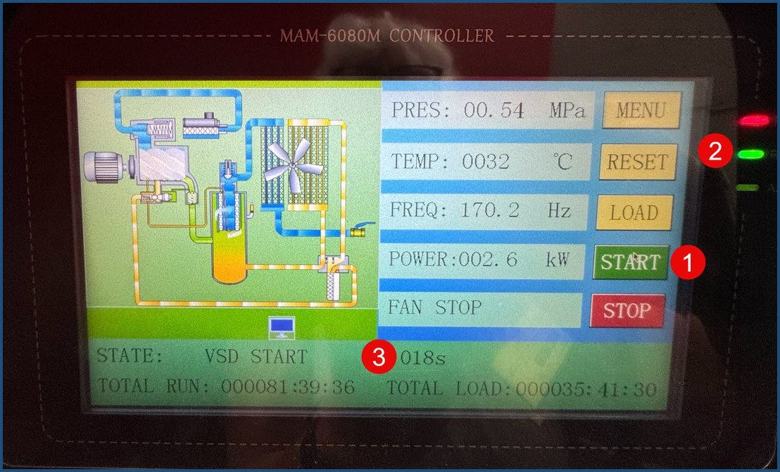
Figure 10. The compressor screen: 1 = the green START button (press and hold), 2 = the run light that turns green when you can let go, 3 = the countdown timer on the STATE line.

Start the Software
- Confirm security is running: tap the keyboard to wake the screen and look for “MAX”. There is no Windows log-on; the computer starts G3 automatically. If it is showing, skip to step 2. If not:
  - Double-click the blue G3 icon.
  - Click Login, then click OK on the next two screens.
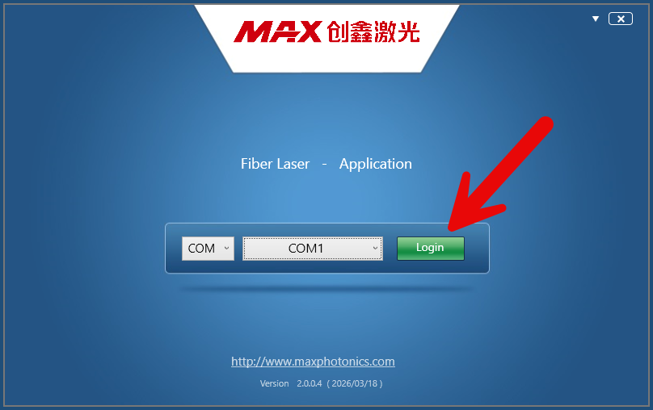
Figure 11. The MAX window. Click Login (arrow).
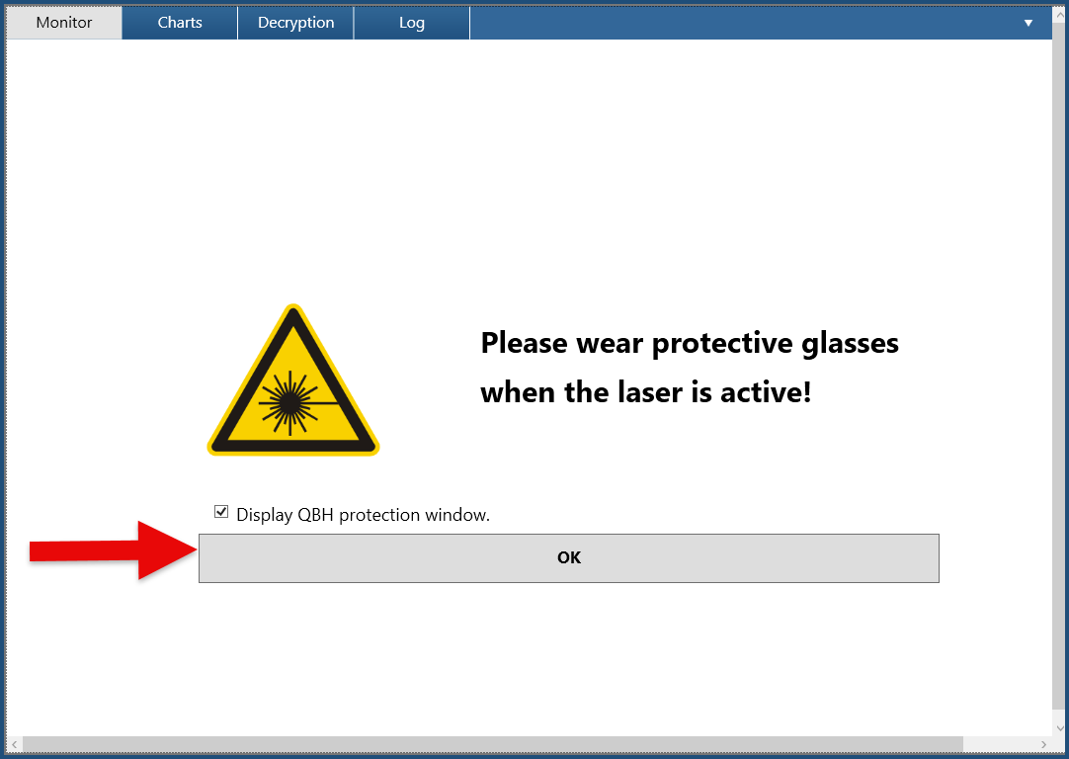  Figure 12. First screen: click OK (arrow). | 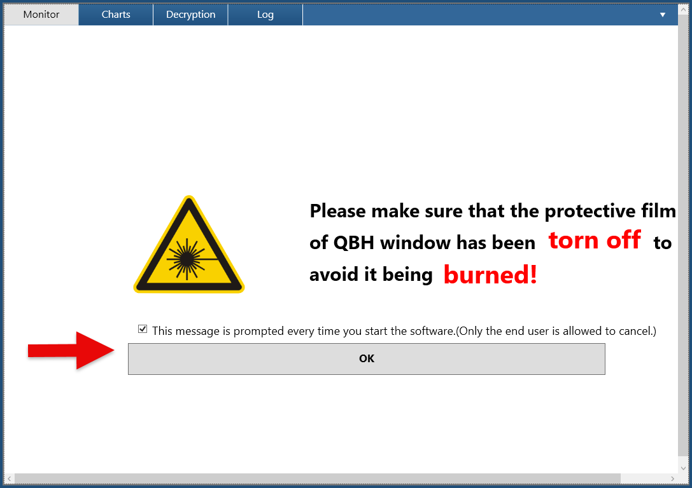  Figure 13. Second screen: click OK (arrow).

  - Click the power button at the upper right corner of the screen.
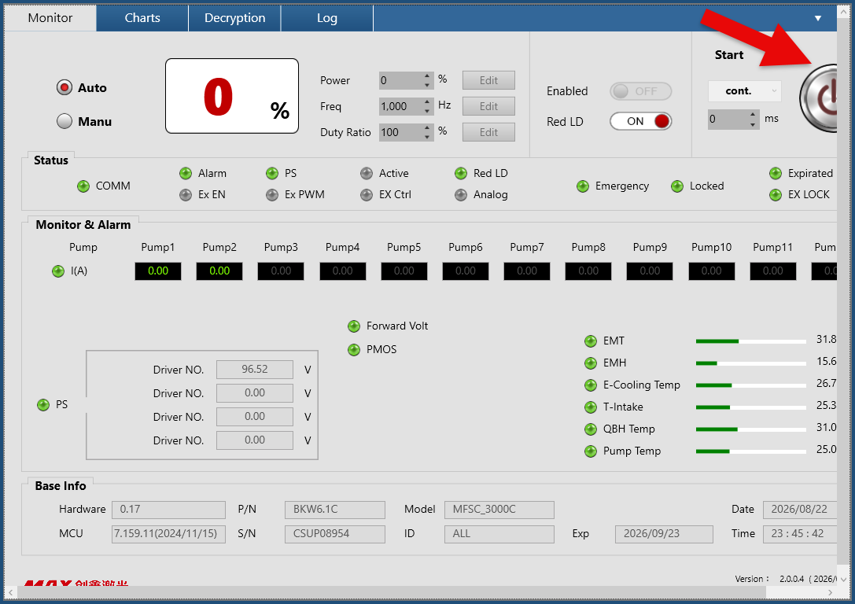
Figure 14. The power button, upper right (arrow).
  - Click OK on the “Laser is coming soon” message.
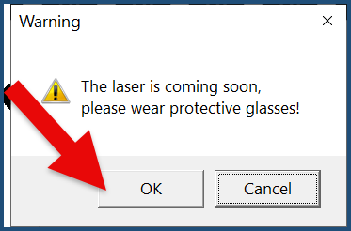
Figure 15. The warning message: click OK (arrow).
✓ The power button is red. Security is enabled.  - Close G3: right-click the G3 icon at the bottom of the screen, then click X Close Window. | 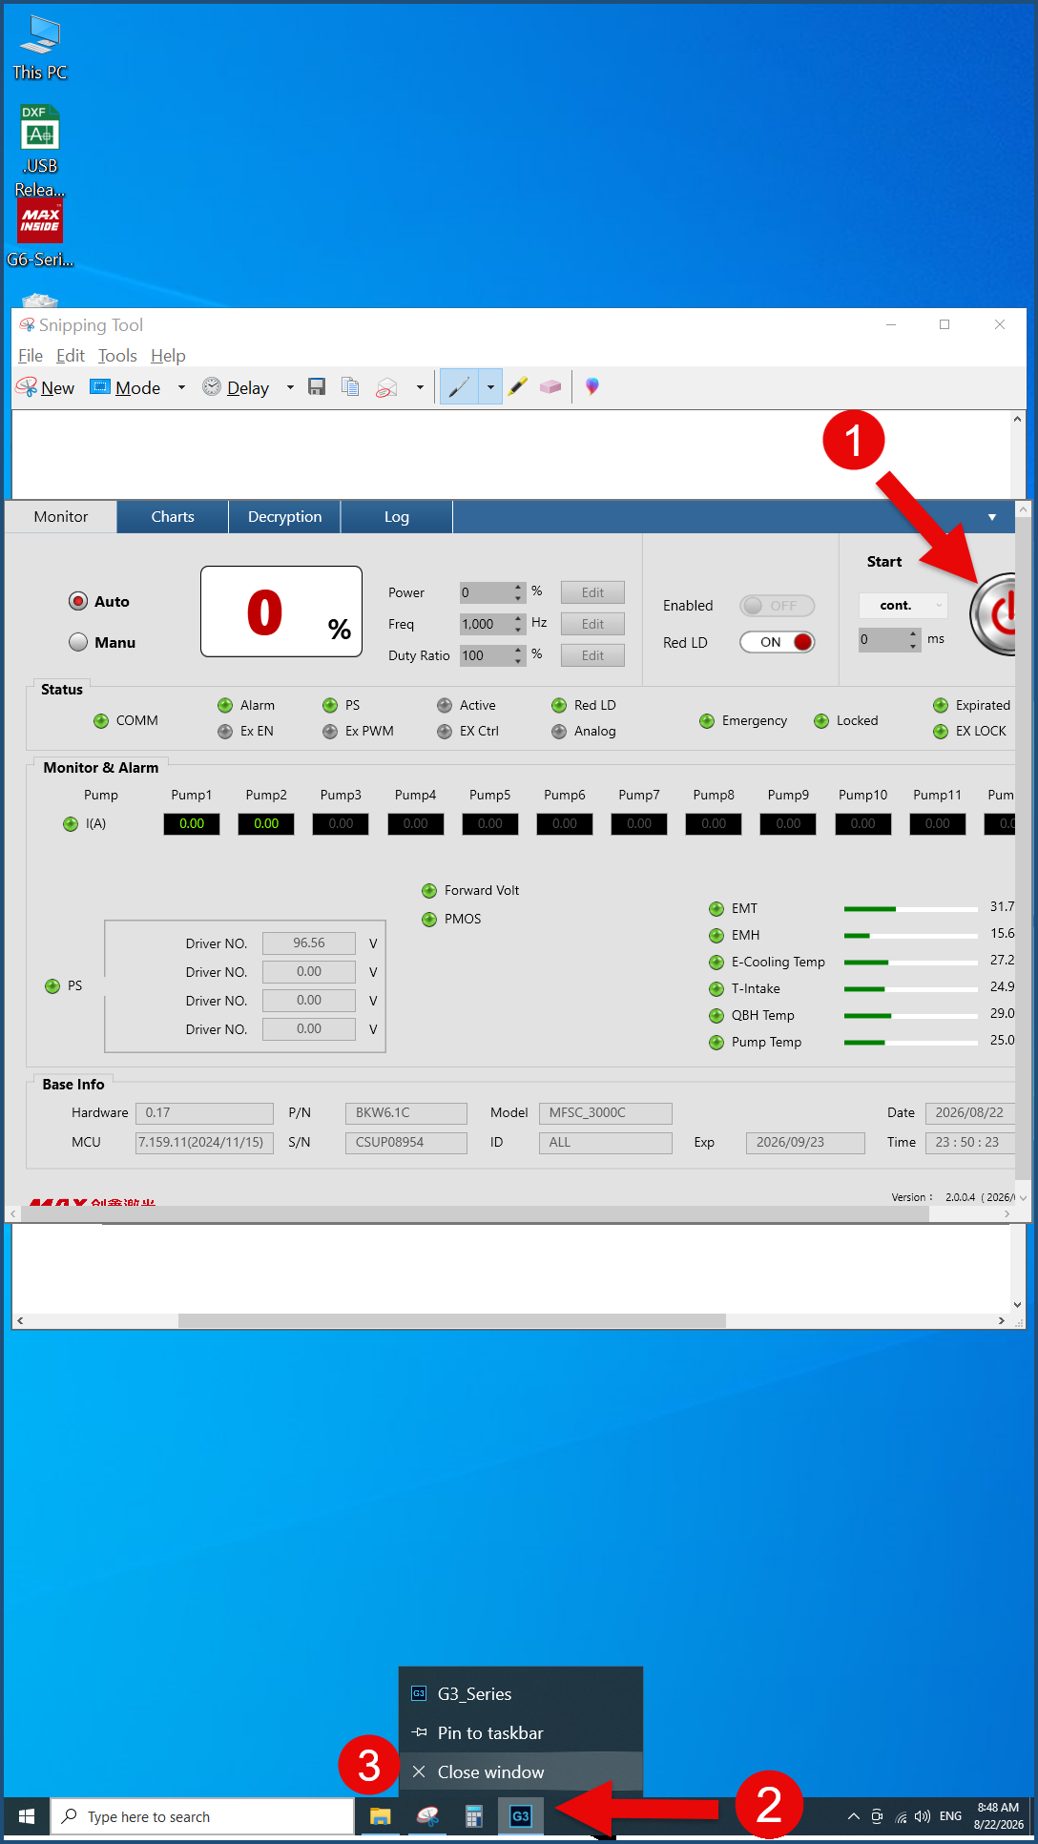  Figure 16. Closing G3: 1 = the power button, now red; 2 = right-click the G3 icon at the bottom of the screen; 3 = click Close window.

- Open 2d Cut: double-click the green square RT icon 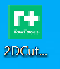 , then confirm the machine is homed:
  - If the X, Y, Z, F lights are GREEN: click EXIT.
  - If the X, Y, Z, F lights are RED: click Start Origin, then click EXIT when it completes.
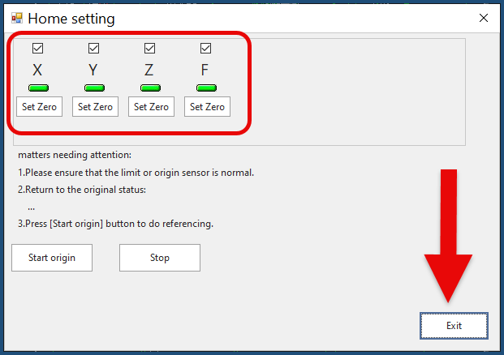  Figure 17. All four lights green (circled): click Exit (arrow). | 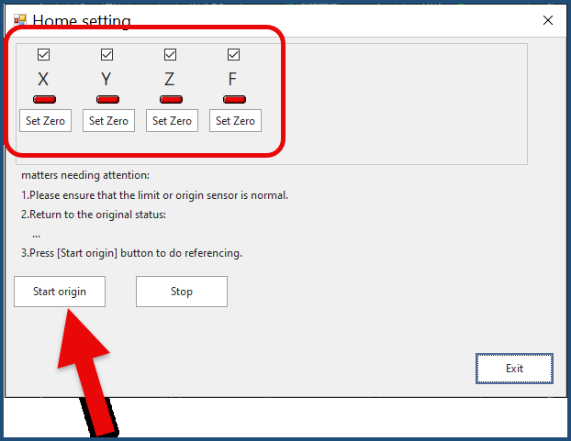  Figure 18. Lights red (circled): click Start origin (arrow), then Exit when they turn green.

- Clear any leftover design at every start-up: click inside the white design area, press Ctrl+A, then press Delete.
- Turn the remote control ON. It stays in its bag.

Stage 2: Make the Cut

Load Your Material
- Confirm the gantry is in the safe position (back and left) by looking through the window; move it with the blue arrows if needed. The safe spot: head to the left side between rails 2 and 3, back about even with the bar with the “no step” label on the left inner wall.
NOTICE: Do not bump the gantry when moving metal sheets in or out. Per club practice, the gantry is always left in the safe position.
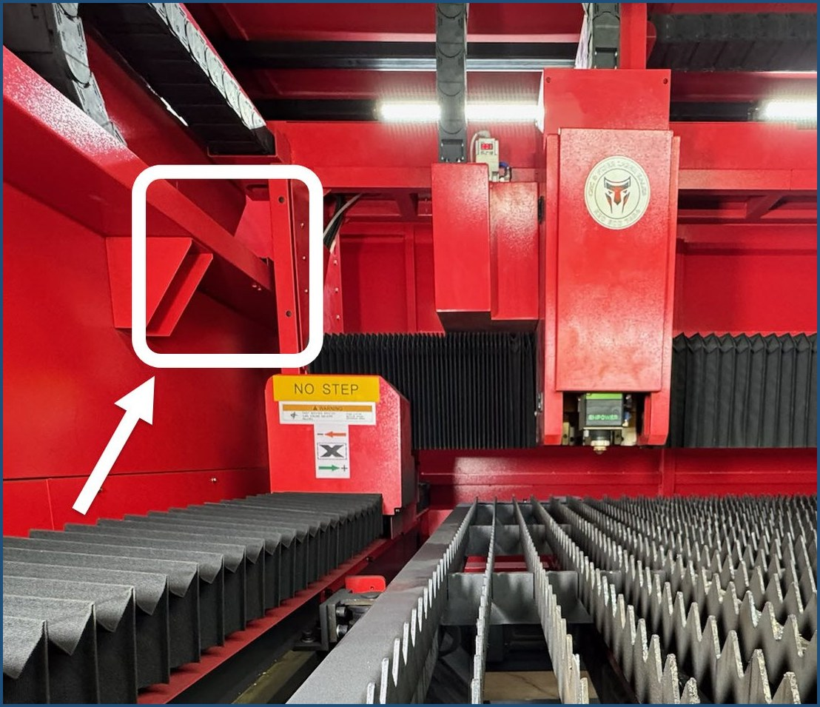
Figure 19. The gantry in the safe position. The boxed gap is what to look for: the gantry’s left support sits just past the NO STEP bar (arrow).
- Open the door: lift the stainless steel handle up.
- Pull the cutting table out: use two hands and a quick jerk on the table handle to release it, then pull. You may not need to extend the table for a small piece.
- Confirm the metal thickness with the gauge tool before loading the sheet. You will match it to the cutting parameter when you choose the layer.
- Load the material: align it to the 3rd rail on the left and the 2nd peak on the front. Orient the metal to match your design; this matters most for small or odd-shaped pieces.
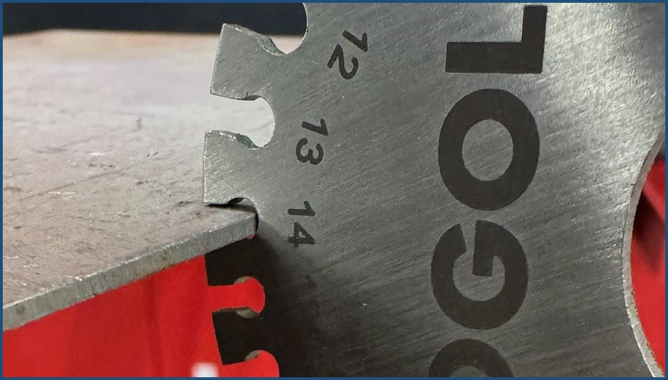  Figure 20. The gauge tool reads the thickness at the slot that fits snugly over the metal. This sheet reads 14 gauge. | 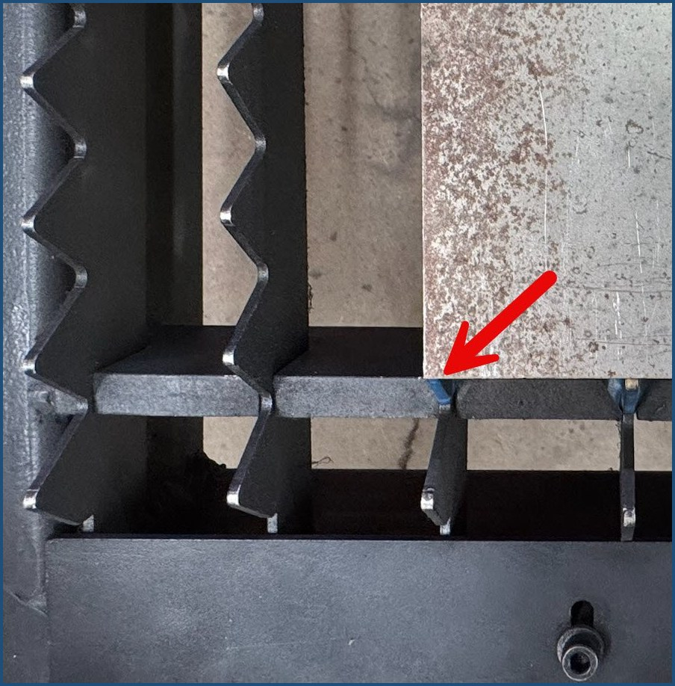  Figure 21. The lower-left corner of the sheet (arrow): 3 rails over from the left, 2 peaks up from the front.

- Push the table in until it stops.
- Insert your USB drive carefully into the USB slot on the operator console.

Load the Design
- Import your file:
  - Select File > Import. Leave all import settings at their defaults.
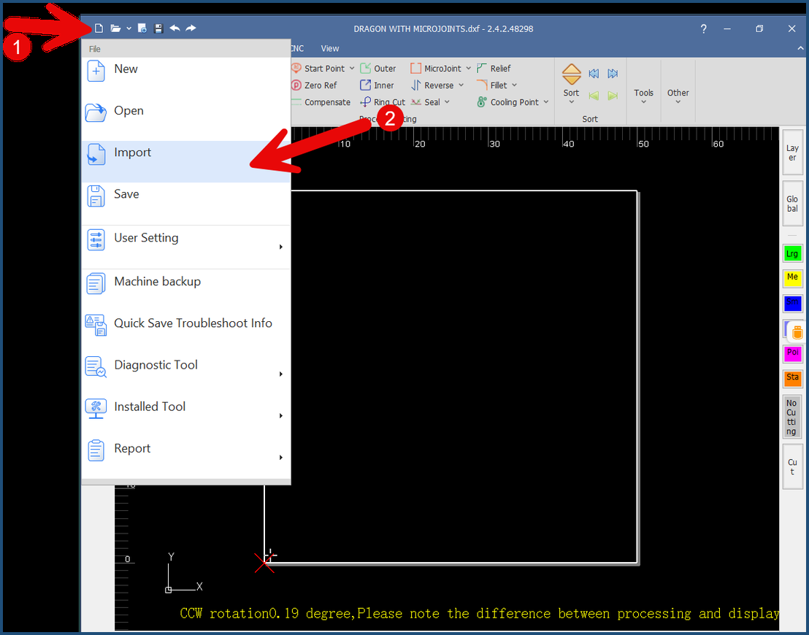
Figure 22. 1 = click File; 2 = click Import.
  - Browse to your USB drive and select your DXF file. Click the Name or Date modified column headers to sort; use the scroll wheel to see everything on the drive.
  - Click Open.
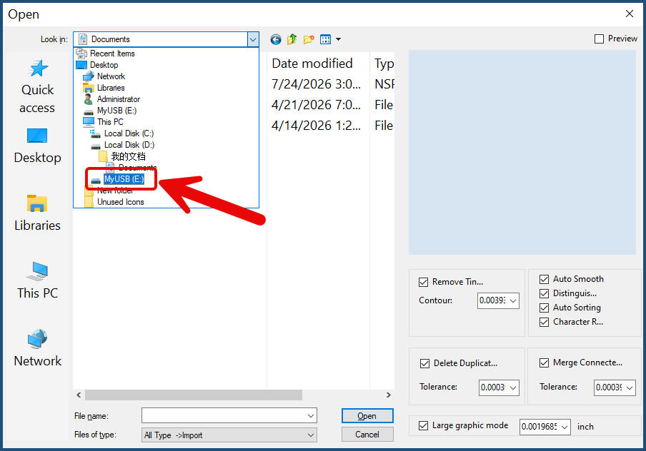  Figure 23. If your drive is not already showing, pick it from the list on the left; here it is MyUSB (E:) (boxed). | 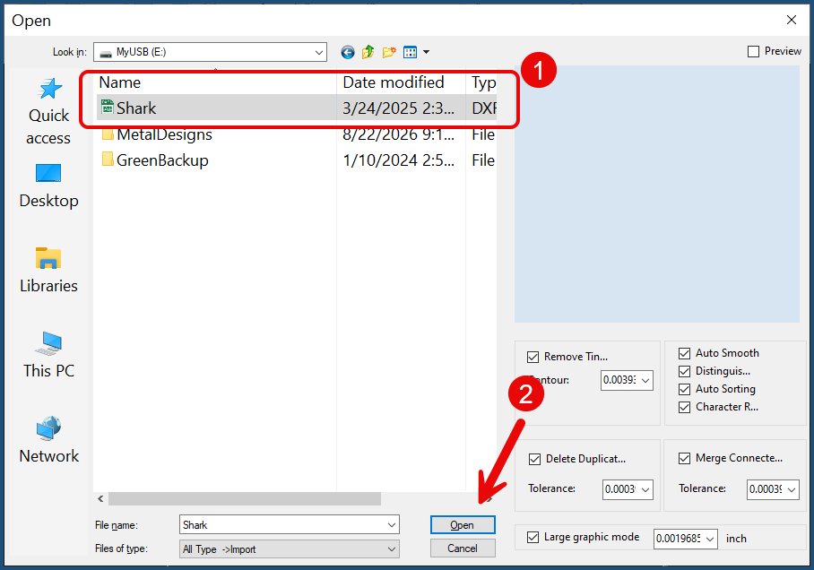  Figure 24. 1 = click your DXF file; 2 = click Open. Leave the settings on the right at their defaults.

- Position the design:
- The design arrives selected and moves with the mouse. Place the whole design inside the white box, toward the bottom left corner, and click to release it.  - Zoom out with the scroll wheel and confirm the whole drawing is inside the box.  - To reposition: press Ctrl+A, point at a line in the drawing, hold the left mouse button, move, and release. | 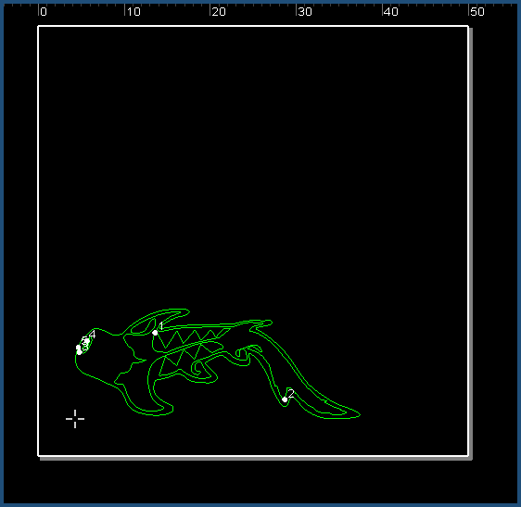  Figure 25. The design placed inside the white box, toward the bottom left corner.

- Resize or rotate if needed (the design must be selected; solid lines):
  - To resize: on the Favorites bar, click the Scale icon (the icon itself, not the arrow under it). The left number is width (X); the right is height (Y); leave placement at Center. Type the new width in inches, press Tab, and the height scales automatically. Click OK.
  - To rotate: click the Transform icon and choose a rotation.
  - Ctrl+Z undoes a change; Ctrl+Y redoes it.
- Sort the cutting sequence: click the drop-down arrow under Sort and select Smaller Shape Prior. Inside pieces cut before outlines.
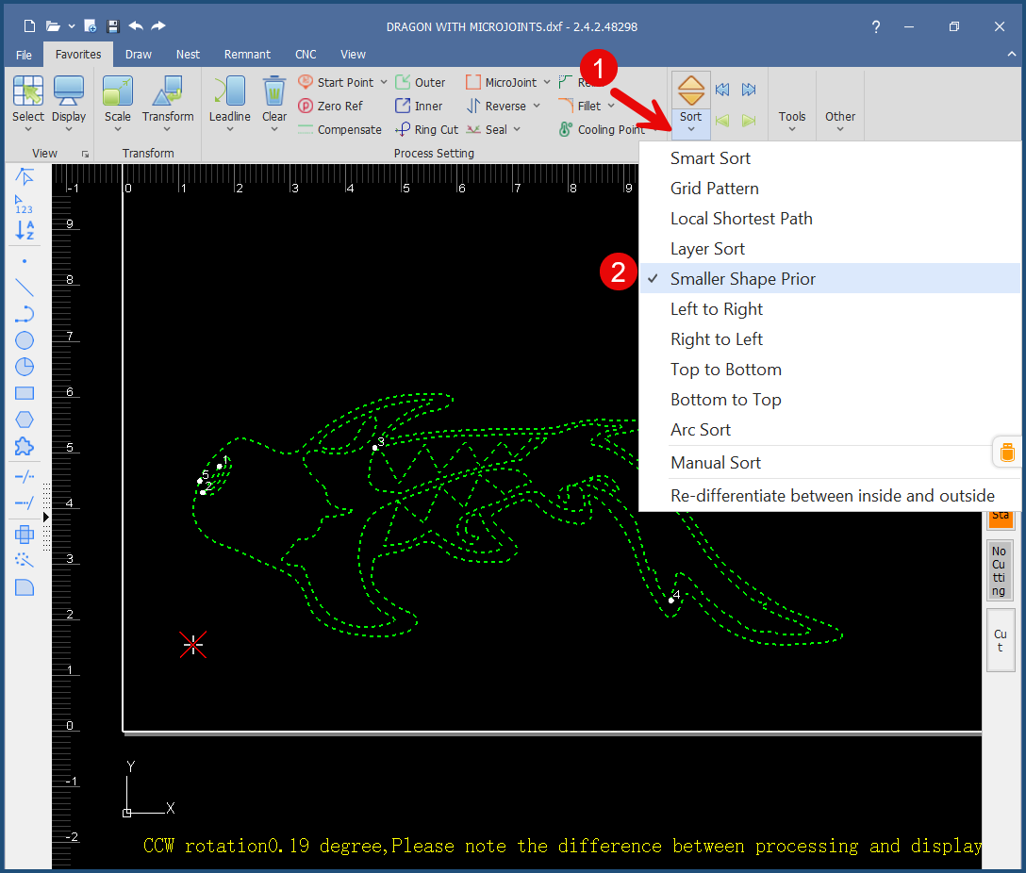
Figure 26. 1 = click the small drop-down arrow under Sort (not the two arrow buttons beside it); 2 = select Smaller Shape Prior.
- Select the metal:
  - Click Layer (upper right menu of the software window).
  - In the Layer screen, click Import (lower right). If the metal list does not appear, click the button labeled in Chinese characters.
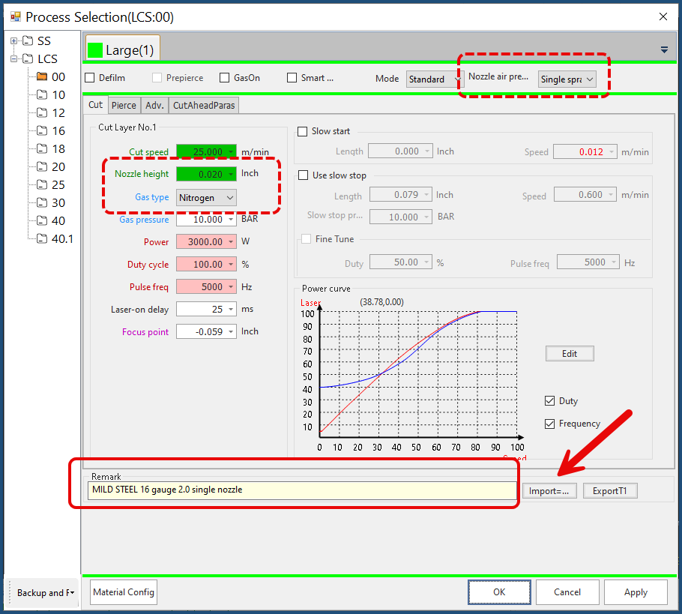
Figure 27. The Layer screen. Solid boxes mark what you use: the Import button (arrow) and the Remark field, which names the nozzle size and type for this cut. The dashed boxes are informational: the nozzle and gas settings the Remark description is based on. Do not change them.
  - Click the cutting parameter that matches your material and thickness, then click Open. The file name lists the material, thickness, and nozzle.
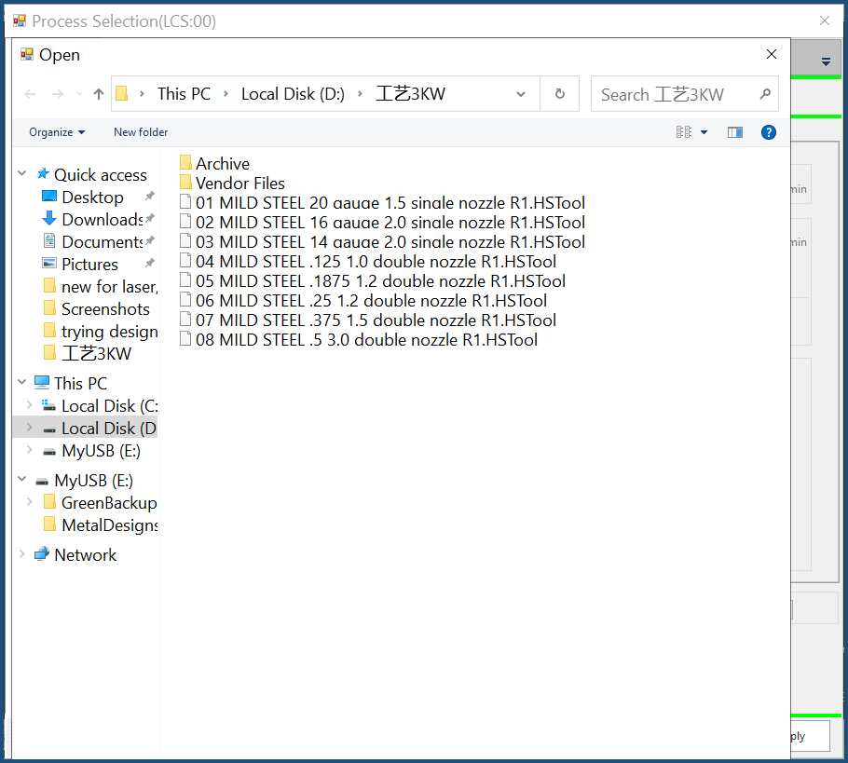
Figure 28. The metal list. Pick the file that matches your material and thickness, then click Open.
NOTICE: Do not cut metal that is not in this list, and do not modify the loaded parameters.
  - Read the nozzle size and type for this cut in the Remark field of the window. You will check them next.
  - Click Apply > OK. Nothing obvious changes on screen after Apply. That is normal.

Verify the Nozzle and Gas
While the K4 light is on, the laser will not fire; keeping the Layer screen open blocks it too and keeps the job’s requirements on screen for double-checking.
- Bring the gantry forward over the metal with the blue arrows until you can see the red dot on the metal, with the head about 1 to 1.5 inches from the front edge. If there is no red dot, press K4.
Tip: pull up a chair in front of the open door. From the chair you can run the remote and watch the gantry and metal until the frame check is done.
- Read the job’s requirements from the Layer screen:
On the Layer screen | What it tells you
Remark field | Nozzle size and type for this cut
Nozzle air pressure (upper right) | Nozzle type: single or double
Nozzle height (mid left) | Nozzle size (engraved on the nozzle)
Gas type | Oxygen or Nitrogen
Figure 27 shows where each of these lives: the Remark field (solid box) and the nozzle and gas settings (dashed boxes).
- Confirm the mounted nozzle matches. Two nozzles of the same type, in different sizes, are stocked. The Remark field tells you which size the job needs. One nozzle is mounted; the other is in its labeled container in the toolbox to the left of the door. If the nozzle you need is in its container, change nozzles. If it is not, verify the mounted one is the correct size; the size is engraved on it.
- To change the nozzle:
  - Bring the empty container to the metal rack by the gantry.
  - Take the replacement nozzle out and close its container.
  - With the replacement in one hand, gently unscrew the mounted nozzle and immediately mount the replacement, finger-tight, plus the ring above it. If there is any delay, cover the open hole with a finger to keep dust out.
  - Wipe the unit with a dry paper towel.
  - Put the removed nozzle in its correct container and return it to the toolbox. Nozzles are reusable. Always validate the engraved number.
NOTICE: Nozzle threads are very fine. Finger tight only. Absolutely no tools when removing or installing nozzles.
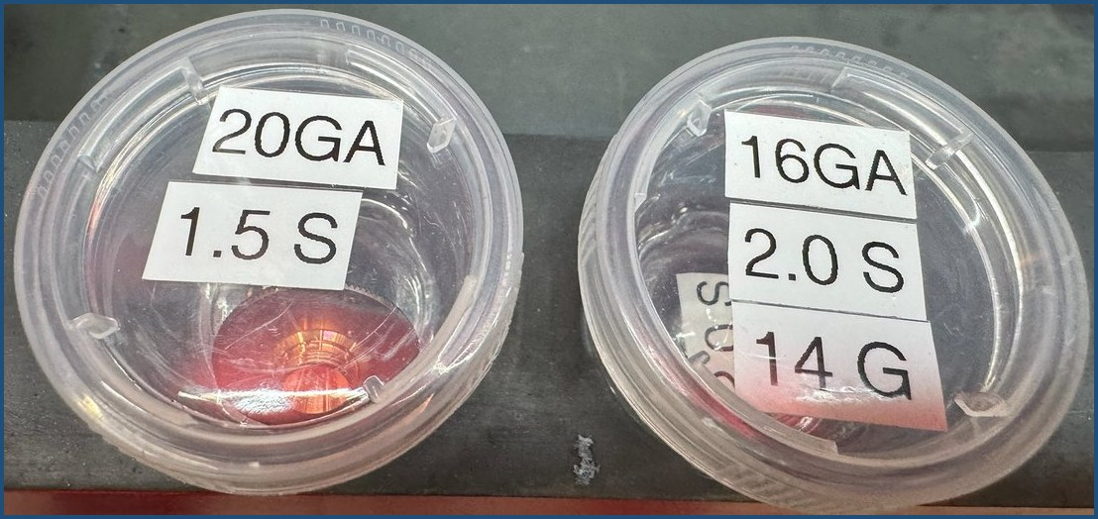  Figure 29. The labeled nozzle containers in the toolbox. The labels give the gauge and the nozzle size; the size is also engraved on each nozzle. | 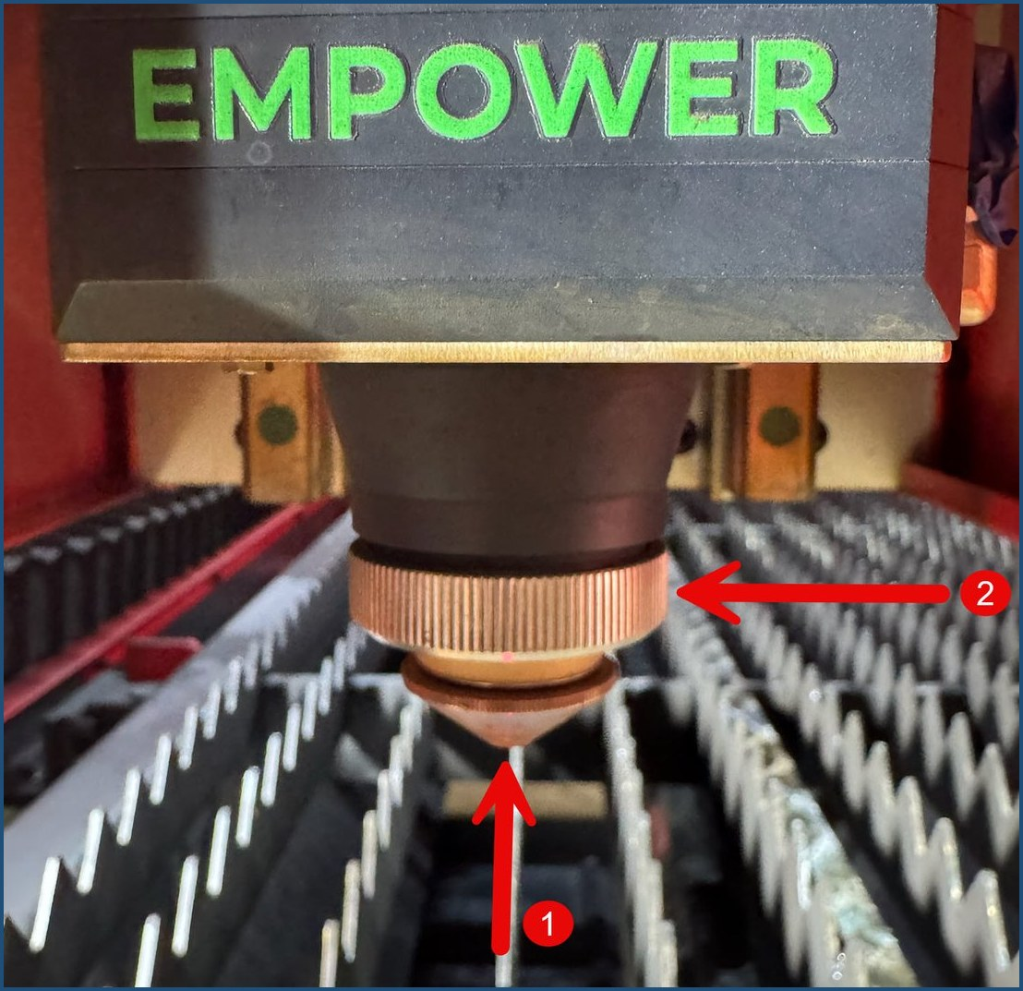  Figure 30. On the laser head: 1 = the nozzle, 2 = the nozzle ring above it. Both are finger-tight only.

- Set up the gas:
  - Nitrogen: nothing to do. The oxygen cylinder stays closed.
  - Oxygen (material 1/8 inch or thicker): open the oxygen bottle valve ¼ turn. Do not change the regulator pressure (120 PSI). Keep oil and grease away from the oxygen cylinder and its fittings. The maintenance team teaches oxygen cutting one-on-one before you cut thicker material.
The oxygen cylinder is in the corner left of the laser cabinet, next to Switch #1 (see Figure 3).

Calibrate the Laser Height
NOTICE: Calibrate at every material change. Skipping calibration ruins cuts.
- Using the blue arrows, position the laser head over a clean, flat area of the material, not at an edge. The gantry is the head plus everything that moves it.
- Using Z↑ and Z↓, position the head about 1 inch above the material. Press STEP with the Z buttons to move slowly. Starting close matters because the calibration descent is slow.
- Keep a finger over the remote’s Stop button, then press and release CAP CALIB. Press Stop immediately if the head malfunctions.
✓ The head slowly lowers, barely touches the material, and quickly rises.

Set the Zero Point and Check the Frame
Choose ONE way to set the zero point, then confirm the cut area with the frame check. This confirms the design and metal are ready.
- Straight-edged metal: press and release both Fn + Edge Seek buttons on the remote. The machine finds the edge and sets the zero position automatically, about half an inch in from the bottom and left edges.
- Odd-shaped metal, or to place the zero yourself: move the red dot to your zero position with the blue arrows (STEP + arrow for small moves; Z↓ makes the dot smaller and sharper), then press the ZERO button.
NOTICE: Do not set the zero point on top of a rail peak.
- Frame check: press Fn + Frame. The head traces a box around the cut area without cutting.
✓ The box stays fully on the metal. If it runs off, reposition the sheet or the zero point and check again.

Pre-Cut Checklist
The design and metal are ready. Now confirm the equipment before every cut. If any line fails, fix it before pressing START.
 | Check | It should be
☐ | Red dot off: press K4 | Red dot is out.
☐ | Door closed: push the stainless steel handle fully down | Door latched.
☐ | Laser active: press and release the yellow LASER button | A visible flash on the metal. If the head is high, the flash may be hard to see.
☐ | Compressor regulator | Between 160 and 180 PSI. If low, wait for it to come up.
☐ | Dryer dew point | Below 3 °C. The display shows one decimal, such as 1.5; a reading of 1 to 2 is typical. If higher, wait for it to come down.
☐ | Both exhaust fans | Running.
Optional deeper checks: Simu in 2d Cut plays an on-screen simulation of the cut path; nothing on the machine moves. DRY RUN traces the entire design with no laser and no gas. It is much slower. Pause and Stop work during a dry run.
NOTICE: If you pause a dry run, press DRY RUN again to continue it. Pressing START while paused begins the real cut from that position. STOP resets the job to the beginning.
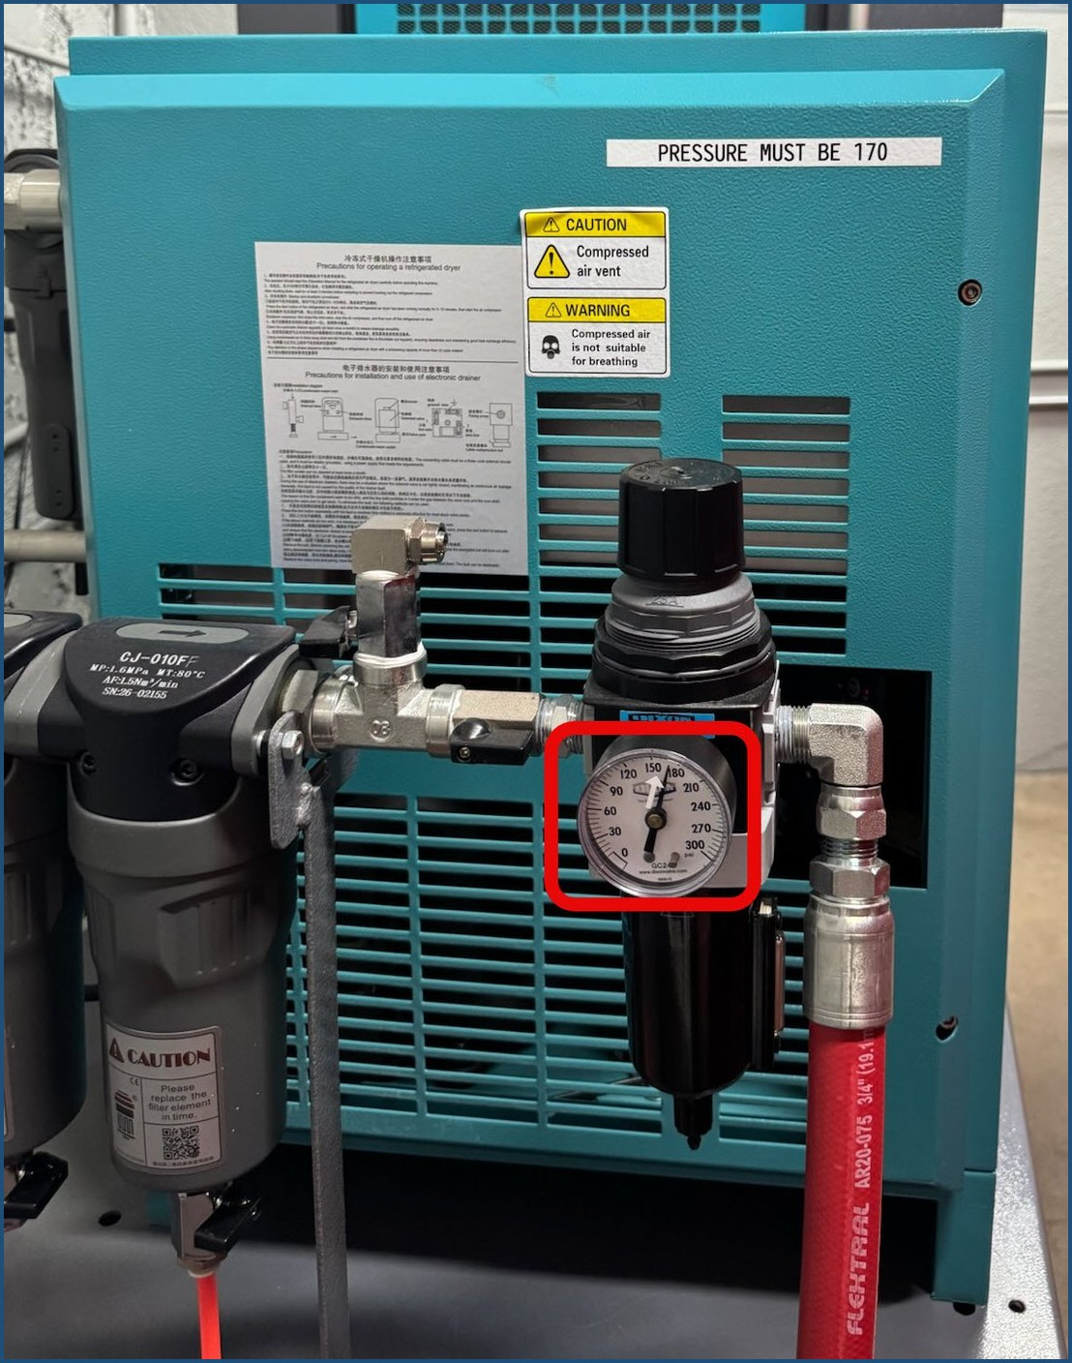  Figure 31. The compressor regulator gauge (boxed), on the side of the dryer behind the cutter. The white arrow sticker on the dial marks the target; 160 to 180 PSI is the range. | 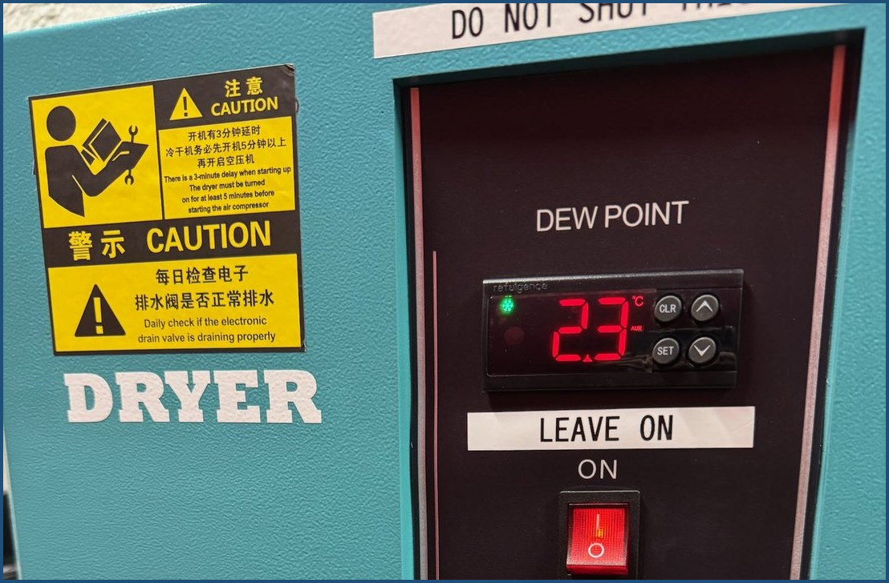  Figure 32. The dryer’s DEW POINT display, here reading 2.3 °C. Below 3 °C is ready to cut. The dryer switch stays on; cutters never touch it.

Cut
- Press START on the remote.
✓ Normal behavior: the machine starts cutting, pauses briefly, then continues.
- Stay at the machine and watch the cut through the door window. Watching through the window is safe.
- If a cut piece tilts up or something goes wrong, press Pause. Clear the problem, then press Resume.
- Watch for small cut pieces. The air pressure can blow a small piece aside instead of dropping it through the slats. Keep a finger over Pause. Some design techniques reduce this; ask the maintenance team when you design small pieces.
WARNING: Before reaching into the laser cabinet, press K4 and confirm the red light is on. The laser cannot fire while the K4 light is on.
WARNING: The material may be HOT, and cut edges are sharp. Use tools and gloves when clearing obstructions.

Stage 3: Finish

Remove Parts and Clean Up
- Wait for the job to finish.
✓ The door unlocks when the job is done.
- Move the gantry to the safe position (back and left) with the blue arrows.
- Open the door (stainless steel handle up) and pull the table out (two hands, quick jerk).
WARNING: Before reaching into the laser cabinet, press K4 and confirm the red light is on.
- Remove your parts. Treat them as hot and the edges as sharp. Use the pliers, the medium magnet (black shaft, orange handle) to reach inside the cutter, and the punches or screwdriver to push out small pieces. Pull a magnet’s release handle to drop the metal off.
NOTICE: Do not hit the laser head with the metal. Realignment is very costly. Pay particular attention toward the back of the cutter.
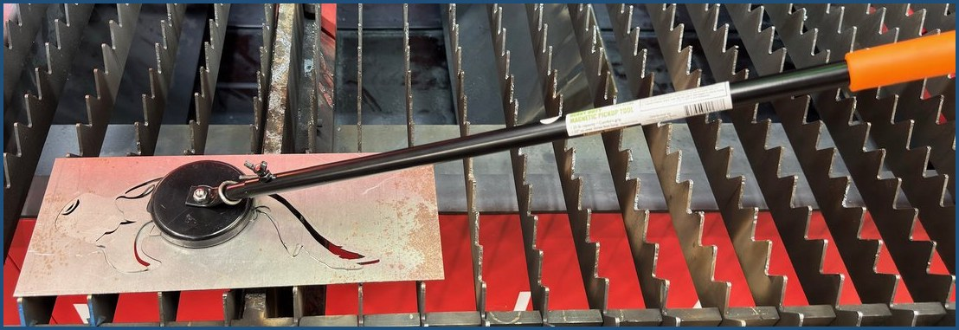
Figure 33. The medium magnet (black shaft, orange handle) lifting a cut part without disturbing the sheet.
- Remove the skeleton and drops from the slats.
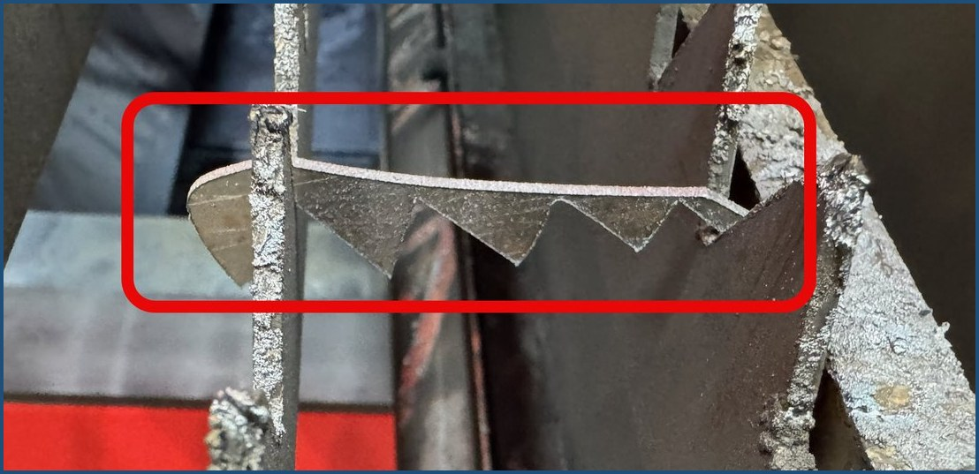
Figure 34. Skeleton pieces caught in the slats (boxed). Pull these off when you clear the table; they ruin the next cut if they stay.
- Push the table in until it stops and close the door (handle fully down).
- Clean the catch trays: pull each tray from under the cabinet, dispose of the scrap (the large yellow magnet helps), and replace the tray between the arrows on the front of the machine.
NOTICE: Clean the door windows with water and a microfiber cloth only.
Your cleanup after a session is what these steps cover: your parts, the skeleton and drops, and the catch trays. Leave any deeper cleaning of the machine to the maintenance team.
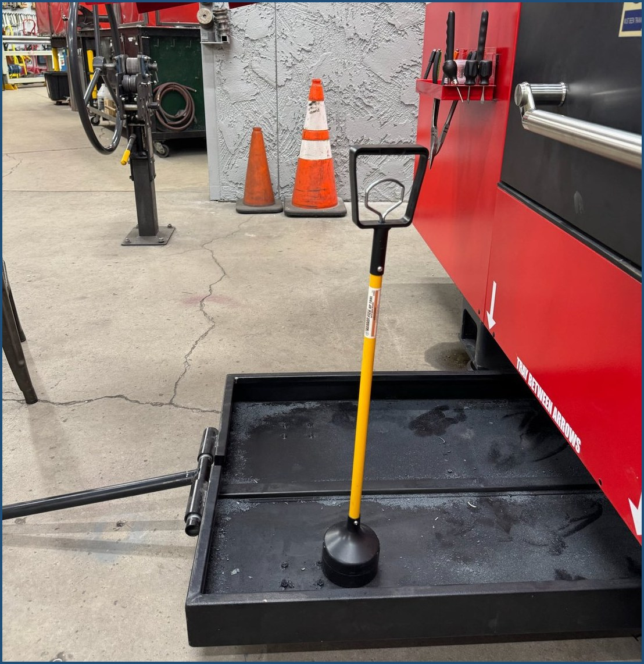  Figure 35. A catch tray pulled out, with the large yellow magnet standing in it. The tray handle is folded down: leave it tucked in so it is not a trip hazard. | 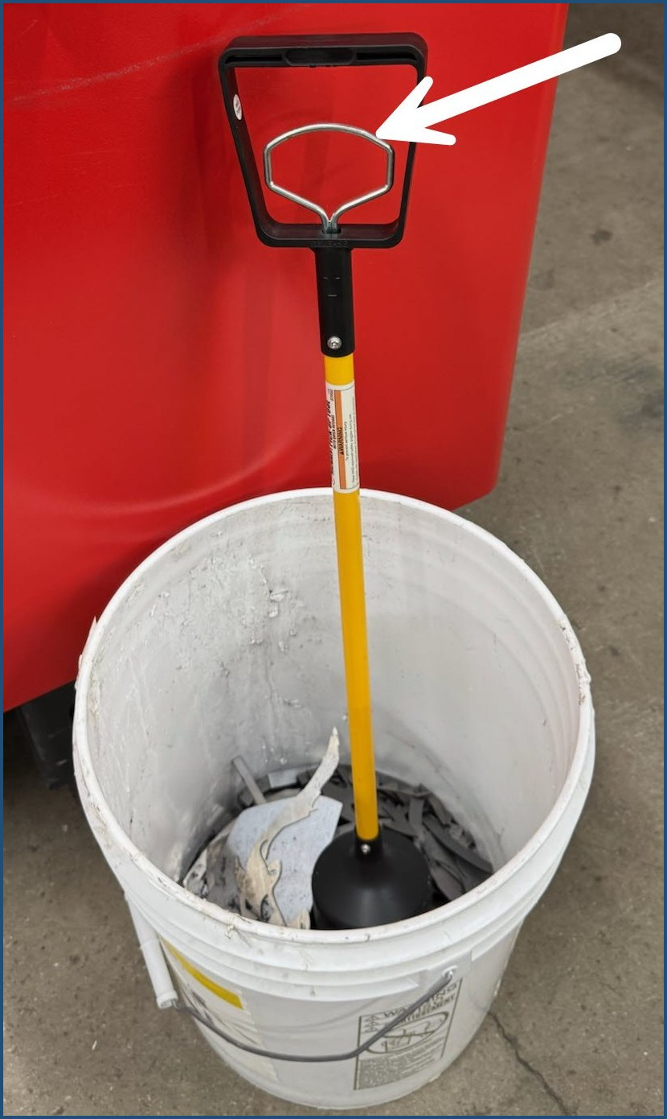  Figure 36. Emptying the yellow magnet over the scrap bucket: pull the silver release handle inside the black handle (arrow) and the metal drops off.

Clear Your Program and Eject Your USB
- Delete your design: press Ctrl+A, then press Delete.
- Close 2d Cut: click the X in the upper right corner, then click Exit on the confirmation window.
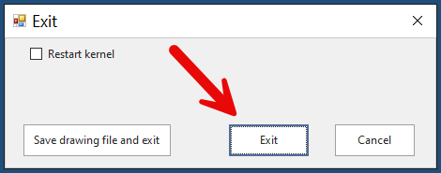
Figure 37. The confirmation window: click Exit (arrow).
- Eject the USB drive: in the icon tray, click ∧, click your flash drive, click Eject USB, and remove the drive carefully when it is safe.
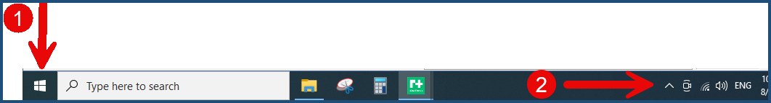
Figure 38. On the taskbar: 1 = the Windows button (used at shutdown); 2 = the hidden-icons arrow ( ∧ ) where you eject your USB drive.
NOTICE: Skipping the safe eject damages the USB reader and your drive over time. Never pull the drive while a “Drive in Use” message is showing.
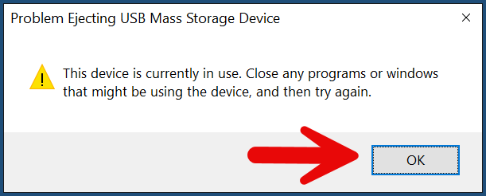
Figure 39. If this message appears, the drive is still in use: click OK (arrow), make sure 2d Cut is closed, then eject again.

Hand Off or Shut Down
If another qualified cutter is ready: the equipment stays running. The next cutter signs out the key at the monitor station, then picks up at Open 2d Cut (Start the Software, step 2).
You are responsible for the laser the entire time the key is signed out to you. The hand-off happens at the monitor station: the next cutter signs the key out before touching the laser, and you sign back in. Allowing use without signing may cost laser privileges.
If nobody is next, shut down:
- Shut down the compressor: tap its screen, press and hold STOP until the countdown timers start, then release.
✓ Two timers count down: 20 seconds, then 100 seconds. Continue with the next steps while they run.
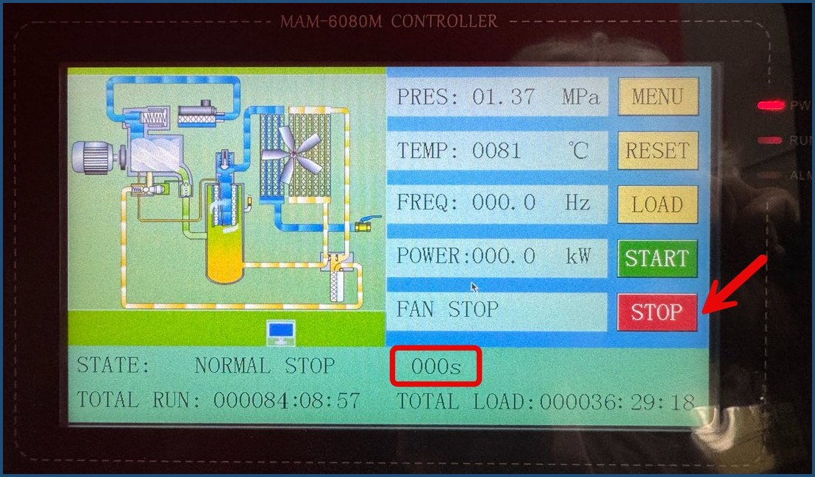
Figure 40. The compressor screen at shutdown: press and hold STOP (arrow). The timers count down on the STATE line; when the boxed timer reads 000s, it is safe to turn off Switch #4.
NOTICE: Leave Switch #4 on until the compressor screen shows STATE: NORMAL STOP 000s. Cutting its power early can damage the compressor.
- Shut down the computer: click the Windows icon > Shutdown. Wait about 15 seconds and confirm the computer is fully off. Cutting power too soon can damage it.
- Set the operator console: turn the keyed switch to O (off) and press LAMP-SW off. The E-stop stays out; leave the mouse on.
- Turn the remote control OFF. Leave it in its bag on the outside of the laser cabinet.
- Close the oxygen bottle valve (if you opened it).
- Turn off Switch #2 (left side of the laser cabinet).
- Turn off Switch #1 (on the wall).
- Turn off Switch #3 (on the wall, left of the cabinet).
- Turn off the roof exhaust fan.
- Confirm the compressor screen shows “STATE: NORMAL STOP 000s” (the boxed timer in Figure 40). Then turn off Switch #4 (right of the cabinet, behind the laser).
- Turn off the wall exhaust fan.
- Return the key to the monitor station and sign it in.

TROUBLESHOOTING
The rule for new operators: if you are not sure, stop and get help. Press Pause or Stop, leave the machine safe, and tell the on-duty Monitor. The Monitor can reach the laser maintenance team. Do not experiment with settings.
Symptom | Likely cause | What to do
Bad cut quality | Dirty or damaged lens (even a speck of dust ruins a cut), or laser height not calibrated | Re-run CAP CALIB. If cuts are still bad, stop and tell the maintenance team. Lens changes are maintenance-only.
Laser will not fire | K4 light on, Layer screen open, door open, or MAX security not running | Press K4 to turn the red dot off, close the Layer screen, close the door, and confirm “MAX” is on the computer screen.
Chiller beeping | Chiller error | Note the error code and report it to the maintenance team. Cutters do not adjust the chiller.
Dew point stays at 3 or above | Dryer still cycling | Wait a few minutes. If it does not drop, contact the maintenance team.
Regulator below 160 PSI | Compressor still building pressure | Wait a few minutes. If it does not recover, contact the maintenance team.
Frame runs off the metal | Design or zero point too close to the edge | Reposition the sheet or reset the zero point, then repeat the frame check.
Cut piece tilts up during the job | Small parts can tip on the slats | Press Pause, clear it with tools (the metal may be hot), then press Resume.
Metal list does not appear in the Layer screen | Known software quirk | Click the button labeled in Chinese characters, then continue with Import.
Error messages in G3 at start-up | Rare; the software normally starts clean | Note what the message says and tell the on-duty Monitor, who can reach the maintenance team.
Equipment damaged, guards missing, or tagged out | Any | Do not use it. Tell the on-duty Monitor. A Maintenance Request Form is available for items that work but need preventative maintenance (Club Safety Policy).
Lens or ceramic ring needs replacement | Wear or damage | Maintenance team only. The ceramic ring is fragile and must seat a specific way.

GLOSSARY
Term | Meaning
2d Cut / RayTools / RT | The software on the laser computer that loads designs and runs the cutter. The desktop icon is a green square labeled RT.
Detent | The stopping point you feel when the cutting table locks into place.
Dew point | The dryer’s moisture reading, shown in °C with one decimal. It must be below 3 before cutting; 1 to 2 is typical.
Drops / skeleton | The waste pieces (drops) and leftover frame of metal (skeleton) after parts are cut out.
DXF | The design file format the laser accepts, exported from Design Edge or V-Carve.
Edge Seek | Remote function (Fn + Edge Seek) that finds the material edge and sets the zero position automatically. The RayTools manual calls it Edge Detect.
E-stop | Emergency stop. The red knob on the operator console that cuts off the equipment immediately.
Gauge tool | The thickness gauge used to confirm the metal’s gauge before choosing the cutting parameter.
G3 / MAX | The security app on the laser computer. “MAX” on screen means it is running; it should start automatically.
Gantry | The laser head plus all the parts that move it over the material.
Layer screen | The 2d Cut screen where you pick the metal. The laser cannot fire while it is open.
Nozzle (single / double) | The tip the laser fires through. Jobs specify a type and size (in the Remark field); the size is engraved on the nozzle.
Zero point (0,0) | The origin position on the material that the design is cut relative to. Set by Edge Seek or the ZERO button.

TRANSITION FROM PLASMA CUTTER
If you also cut on the plasma table, note these differences.
- Your plasma safety glasses are NOT adequate for laser work. Laser glasses are needed only for working inside the machine, and the maintenance team holds them.
- Do not use SheetCam. Its .tap format is for plasma and does not work on the laser. Export a DXF instead.
- Laser cuts have no slag. Laser-cut metal can go straight to the shear.
- The laser cuts a much thinner line than plasma. A design made for plasma may come out differently on the laser; check the dimensions that matter before you cut.
- Cut metal to size on the shear or the manual plasma cutter. Never trim metal to size on the laser.
- No lead-ins. Club material cuts cleanly without lead lines.
- Cut order is two clicks. Sort > smaller shape prior orders inside cuts before outlines. No manual sequencing like plasma.
- Scaling. Use the 2d Cut Scale feature to resize an existing plasma design.
- Separate qualification. Plasma certification does not carry over; the laser has its own training and key sign-out, and plasma has its own policy (Club Plasma Table Cutter Policy).

REVISION HISTORY
Version | Date | Description
3.7 | 8/31/26 | Applied the team review: 12 by 12 inch minimum material size (air pressure can move smaller pieces), a step to watch for small cut pieces blown out of place during the cut, a recommendation to start with smaller designs before full-sheet cuts, and a note that the laser cuts a much thinner line than plasma.
3.6 | 8/27/26 | Added the final photos and screenshots as numbered figures at the step each one supports, so every control is shown where it is used. Removed the photo placeholders and the Related Documents page.
3.5 | 8/25/26 | Added the first photo set.
3.4 | 8/22/26 | Stated the key hand-off, cleanup scope, fire response, and maintenance contact directly in the manual so no step depends on a separate document. Added dew point units (°C, one decimal).
3.3 | 8/21/26 | Applied the maintenance team review: confirmed the Edge Seek and Start Origin labels, the Sort option (Smaller Shape Prior), the nozzle stock, and the oxygen scope.
3.2 | 8/21/26 | Matched wording and step order to Laser Checklist R3.13, confirmed the switch functions, and moved the process overview and competency checklist to separate posted documents.
3.1 | 8/12/26 | Applied reviewer edits and answered open items. Resequenced start-up and shutdown to Checklist R3.10. Safety fixes: Switch #4 shutdown gate, fire evacuation step, coated-metal warning, injury reporting.
3.0 | 8/12/26 | Applied the training team review and Checklist R3.7a: chiller and dryer marked hands-off, switch locations corrected, 160 to 180 PSI range, gauge tool and Remark field steps, nozzle change procedure.
2.0–2.2 | 8/4/26 | Restructured with safety boxes, verification cues, a pre-cut checklist, and a glossary, so each step can be checked as it is done.
1.0–1.1 | 8/3–8/4/26 | Combined Training Draft V.04 and the Laser Operation Checklist into one manual.
V.01–V.04 | 7/13–7/25/26 | Original working drafts by Patti Lee with content from Linda Nelson, Dean Seidler, Tony Evans, and Sandy Wilson.

