2018 Board of Directors
 | President: Zach Springer  Heritage House Realty  2805 N. Baltimore  Kirksville, MO63501  Cell: 660-341-2405  Office: 660-665-5638  Email: zach@kirksvillerealestate.com
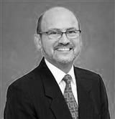 | Vice President: Keith Jackson  C21 Whitney Agency  1605 S. Baltimore, Ste. A  Kirksville, MO 63501  Cell: 660-342-5817  Office: 660-665-5678  Email: keithnjackson@yahoo.com
 | Secretary: Alicia Davis  United Country – Midwest Realty  1821 S. Baltimore  Kirksville, MO 63501  Cell: 660-956-2928  Office: 660 -665-5199  Email:adavisucmidwest@gmail.com
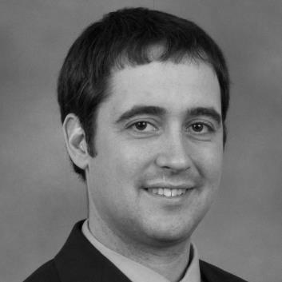 | Treasurer: Darin Porter  Four Horizons Realty  703 N. Marion St.  Kirksville, MO 63501  Cell: 660-349-9692  Office: 660-665-3400  Email: darin.porter557@gmail.com
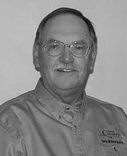 | Local Director: Ron Davis  United Country – Midwest Realty  1821 S. Baltimore  Kirksville, MO 63501  Cell: 660-341-5199  Office: 660-395-9551  Email: rondavis@unitedcountry.com
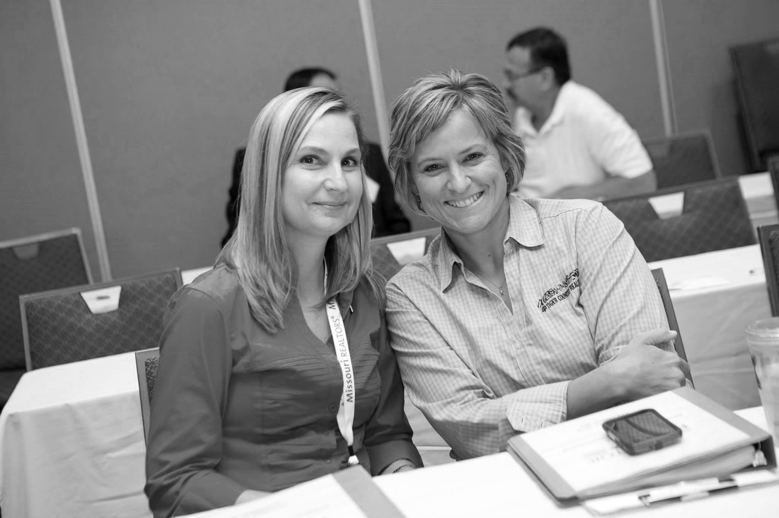 | Local Director:Sonja Legan  Tiger Country Realty  409 BCCD Road  Macon, MO 63552  Cell: 660-651-4107  Office: 660-385-PAWS  Email: realtorlegan@yahoo.com
 | Local Director: Mark Simler  United Country- Midwest Realty  1821 S. Baltimore  Kirksville, MO 63501  Cell: 660-626-7215  Office: 660-665-5199  Email:ucmidwest@att.net
 | State Director: Mike LaBeth  Heritage House Realty  2805 N. Baltimore  Kirksville, MO63501  Cell: 660-216-7144  Office: 660-665-5638  Email: mike@homesinkirksville.com
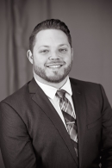 | State Director: Scott Lyons  Heritage House Realty  2805 N. Baltimore  Kirksville, MO63501  Cell: 660-988-7616  Office: 660-665-5638  Email: Scott@kirksvillerealestate.com

