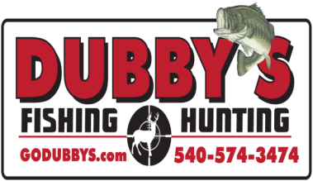
DUBBY'S PREDATOR TOURNAMENT

This year Dubby's is doing a Tournament Series again. There will be FOUR (4) Tournaments. At the end of the series a Champion Team will be announced based on Total Points for the series. Any team can hunt any tournament but to be eligible for the Championship award a team must hunt At Least THREE (3) of the events. The entry fee will be $150.00 per tournament. $100.00 will go to the payout of the current tournament. $10.00 will go to the Big Bobcat of the current tournament. $10.00 will go to Big Coyote of the current tournament. $10.00 will go to Big Red Fox of the current tournament. $10.00 will go to the Big Gray Fox. $10.00 will go to the Points Champion Team at the end of the Series.

Please read the rules for additional tournament information.
For More Information Call 540-574-FISH
Or Stop By 100 Waterman Drive

Dubby's Fishing and Hunting
100 Waterman Drive
Harrisonburg Va. 22802
540-574-FISH (3474)
Closed Sundays and Mondays

Tournament Details

WHEN
Friday November 2nd 2018 Through Sunday November 4th 2018
Friday December 14th 2018 Through Sunday December 16th 2018
Friday January 11th 2019 Through Sunday January 13th 2019
Friday February 15th 2019 Through Sunday February 17th 2019

Sign-in Hours to begin Tournament
Friday 3pm to 5pm
Check-in Hours to end Tournament
Sunday 1pm (Don’t Be Late)
Any Team Checking in after 1:00pm
WILL BE DISQUALIFIED
(One Team Member must come to Friday Sign-in)
(All Team Members must come to Sunday Check-in)

WHERE
Dubby's Fishing and Hunting
100 Waterman Drive
Harrisonburg Va. 22802
540-574-FISH (3474)

Hunting IN
Virginia And West Virginia
(See Rules For Off Limits)

REGISTRATION & COST
Register at Dubby’s. Stop by
100 Waterman Drive or Call for info
540-574-3473 1-855-574-3474
(Cash, Check)
Kill blocks are required on every Predator and will
be provided by Dubby's Fishing and Hunting.
See Rules on specs and placement.

Door Prize's / To Be Determined.

$150.00 Entry Fee – 2 to 3 Person teams.
(Absolutely No Single’s Hunting)

> Main Tournament – Total combined Point’s
of all your predators.
> Biggest Bobcat
> Biggest Coyote
> Biggest Red Fox
> Biggest Gray Fox

POTENTIAL PAYOUT BASED ON 50 TEAMS
1 Place for Every 5 Teams.
1st) $1315.00
2nd) $925.00
3rd) $640.00
4th) $450.00
5th) $350.00
6th) $285.00
7th) $245.00
8th) $215.00
9th) $175.00
10th) $145.00

Dubby's Fishing and Hunting
100 Waterman Drive
Harrisonburg Va. 22802
540-574-FISH (3474)
Closed Sundays and Mondays

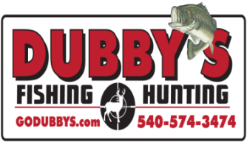

Dubby's Predator Tournament Rules
Page 1

- Team cancellation request must be received 72 hours in advance of the start of the tournament for refund. Any team that pre-registers and does not show (ALL Team Members Must Hunt) is considered a forfeit. You may not switch teams after you have registered.
- Only 2 or 3 people on a team (no single man team allowed for safety reasons). You cannot have aid with transportation, driving, retrieving or transporting Predator’s. No pooling of kills between teams.
- Off Limits are any Commercial or Privately-owned lands that you do not have written Permission to hunt on. Any Posted land that you do not have written Permission to hunt on. Any land restricted by State or Local Authorities.
- Legal Species by Virginia and West Virginia Regulations: Coyote, Red Fox, Grey Fox and Bobcat. No Trapping or Snaring. No Road Kill.
- Predators can be taken with any Firearm caliber Legal and capable of taking that Predator swiftly.
- Each Team Member must have a Valid Hunting license. You are responsible for following all laws and regulations.
- There is no Limit to how many Predators’ you bring in. Winner will be determined by the total points of tournament kill. Teams are responsible to have their kill ready to be checked in, Kill Block in place.
- You must use one vehicle while hunting the tournament and it must be the same vehicle.
- Kill Blocks will be provided by Dubby's Fishing and Hunting. Kill Blocks must be placed in the mouth of every Predator at the time of kill with team number, team member name and time of kill written on the block at the location of the kill. Please take pictures of each kill at the time of the kill. (See attached for Kill Block Info.)
- Each team will be given two tokens with their team number on it. A team member must present one token to a staff member at Dubby’s Fishing and Hunting for Check-in. Points cannot be counted without the token.
- No frozen Predators allowed.

Dubby's Coyote Tournament Rules
Page 2

- Teams must respect others in the field and out. No crowding and no harassing other teams.
- Absolutely no teaming up, no buddy system and no transferring or transporting of kill from one team to another.
- Disposal of your kill is your responsibility. Please do so respectably. If you do not want them let us know, someone else may want them. NO DUMPING OF YOUR KILL ALONG THE ROAD.
- Any participant involved in poor sportsmanship, heated arguments or similar behavior will have their team warned or disqualified at DFnH staff option. We will not allow any altercation, including inappropriate cursing of others before, during or after the tournament. All TEAMS involved will be warned or disqualified regardless of fault. You are guilty by involvement. Zero tolerance.
- Any physical altercations by participants will result in the team being disqualified and banned from any future DFnH Tournaments and will be asked to leave immediately.
- No alcohol or drugs permitted, during the hunt or at Check-in. If you are perceived under the influence you will not be allowed to enter or will be disqualified. Final determination of a disputed claim will be determined by
local on-call law enforcement.
- No live decoys and /or dogs. (No running or tracking wounded with dogs.) No baiting.
- Mouth calls, hand calls and electronic calls can be used.
- Any Predator brought to Check-in after 1:00pm will not be counted.
- You have to locate and call your own coyotes. You cannot have a second team or individual out scouting for you.
- All entrants must be present and available for truth verification at Final check-in Sunday . If you are not willing to participate in truth verification please do not enter this tournament.
- All prize money will be awarded after official results have been determined and verified.
- The scoring system will be a points system from 1 to 4
- Bobcat = 4-Pt’s Coyote = 3-Pt’s / Red Fox = 2-Pt’s Grey Fox = 1Pt.
- (In case of a tie, the team with the largest total combined weight of animals wins)
- ALL TEAMS MEMBERS MUST BE PRESENT TO WIN!!!

Dubby's Coyote Tournament Rules
Page 3

- VDGIF is working with us and will notify us of any complaints and incidents. Any citation will be called in to DFnH staff and get you disqualified.
- DFnH has the right to change and enforce rules as deemed necessary and has the right to deny entry and/or disqualify any team at any time for any reason as they see fit to preserve safety and the integrity of our tournament.
- Failure to comply with tournament rules will result in disqualification and entry fee will be forfeited.
- The decision of tournament results will be final.
- Any accusation of a team cheating must be accompanied by a $100 protest fee and concrete evidence of such. Photos, videos, proof of citation etc. If tournament staff agrees with your protest, the protest fee will be refunded and the accused team will be disqualified.
- DFnH Tournament staff will have final decision on all protest claims and complaints.

Dubby's Fishing and Hunting
100 Waterman Drive
Harrisonburg Va. 22802
540-574-FISH (3474)
Closed Sundays and Mondays

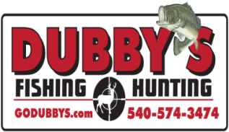

A kill block is an object that is placed into the predator’s mouth upon death. Dubby's Fishing and Hunting will be providing kill blocks. Each kill block must contain the time of death, the team number and the team members name or initials. Holes are placed at each end to secure the block into the mouth of a coyote or Fox with plastic zip tie or string. If a predator is turned in without a “kill block” in its mouth that predator is disqualified. The correct placement of the blocks should be inserted into the mouth with the team number, time of death and the shooters name written on the block. If there are any questions on “kill block” specs please feel free to contact Dubby’s Fishing and Hunting.

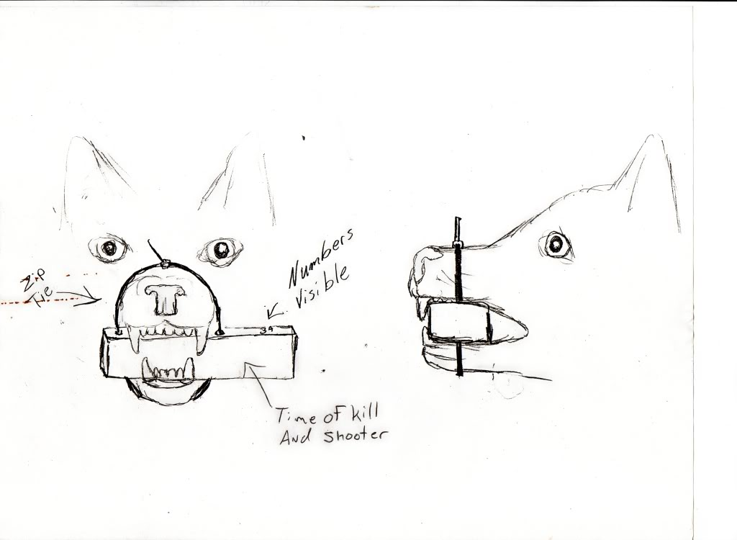

Dubby's Fishing and Hunting
100 Waterman Drive
Harrisonburg Va. 22802
540-574-FISH (3474)
Closed Sundays and Mondays

DUBBY'S PREDATOR TOURNAMENT REGISTRATION
For More Information Call 540-574-3474

_____11/02 -04/2018 _____12/14 - 16/2018 _____01/11 -13/2019 _____02/15 - 17/2019
Team Member - 1
NAME: _____________________________________________________________
PHONE: _____________________________________________________________
EMAIL: _____________________________________________________________
ADDRESS: ____________________________________________________________
CITY: _____________________________________________________________
STATE: ____________________________________________________________
ZIP: ______________________________________________________________
Team Member - 2
NAME: _____________________________________________________________
PHONE: _____________________________________________________________
EMAIL: _____________________________________________________________
ADDRESS: ____________________________________________________________
CITY: _____________________________________________________________
STATE: ____________________________________________________________
ZIP: _____________________________________________________________

Team Member - 3
NAME: _____________________________________________________________
PHONE: _____________________________________________________________
EMAIL: _____________________________________________________________
ADDRESS: ____________________________________________________________
CITY: _____________________________________________________________
STATE: ____________________________________________________________
ZIP: _____________________________________________________________

HOLD HARMLESS AGREEMENT

Each team member must fill out one of these and print, sign and date below. If you participated last year and all your info is still the same, then this is not required. We will use the one on file.

Be aware that Rules for this Tournament are for your protection but are not all the rules. Activities like this require additional common-sense safety precautions. Please apply these as you are a part of this tournament or any activity in the outdoors.

I, ____________________________________, have read the above and I understand that I am the only person who can be held responsible for the safety of me and others around me as I operate my hunting equipment, automobile or anything I deem necessary to compete in this tournament . I hold harmless Dubby’s Fishing and Hunting, Dubby Carr and Cindy Carr, the owners, or any staff helping with the tournament.

______________________________________
Signature

_____________
Date

Dubby's Fishing and Hunting
100 Waterman Drive
Harrisonburg Va. 22802
540-574-FISH (3474)
Closed Sundays and Mondays
HOLD HARMLESS AGREEMENT

Each team member must fill out one of these and print, sign and date below. If you participated last year and all your info is still the same, then this is not required. We will use the one on file.

Be aware that Rules for this Tournament are for your protection but are not all the rules. Activities like this require additional common-sense safety precautions. Please apply these as you are a part of this tournament or any activity in the outdoors.

I, ____________________________________, have read the above and I understand that I am the only person who can be held responsible for the safety of me and others around me as I operate my hunting equipment, automobile or anything I deem necessary to compete in this tournament . I hold harmless Dubby’s Fishing and Hunting, Dubby Carr and Cindy Carr, the owners, or any staff helping with the tournament.

______________________________________
Signature

_____________
Date

Dubby's Fishing and Hunting
100 Waterman Drive
Harrisonburg Va. 22802
540-574-FISH (3474)
Closed Sundays and Mondays

HOLD HARMLESS AGREEMENT

Each team member must fill out one of these and print, sign and date below. If you participated last year and all your info is still the same, then this is not required. We will use the one on file.

Be aware that Rules for this Tournament are for your protection but are not all the rules. Activities like this require additional common-sense safety precautions. Please apply these as you are a part of this tournament or any activity in the outdoors.

I, ____________________________________, have read the above and I understand that I am the only person who can be held responsible for the safety of me and others around me as I operate my hunting equipment, automobile or anything I deem necessary to compete in this tournament . I hold harmless Dubby’s Fishing and Hunting, Dubby Carr and Cindy Carr, the owners, or any staff helping with the tournament.

______________________________________
Signature

_____________
Date

Dubby's Fishing and Hunting
100 Waterman Drive
Harrisonburg Va. 22802
540-574-FISH (3474)
Closed Sundays and Mondays

