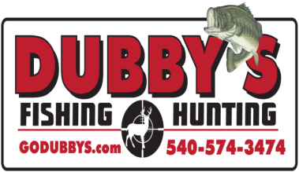

HOLD HARMLESS AGREEMENT

Each team member must fill out one of these and print, sign and date below. If you participated last year and all your info is still the same, then this is not required. We will use the one on file.

Be aware that Rules for this Tournament are for your protection but are not all the rules. Activities like this require additional common-sense safety precautions. Please apply these as you are a part of this tournament or any activity in the outdoors.

I, ____________________________________, have read the above and I understand that I am the only person who can be held responsible for the safety of me and others around me as I operate my hunting equipment, automobile or anything I deem necessary to compete in this tournament . I hold harmless Dubby’s Fishing and Hunting, Dubby Carr and Cindy Carr, the owners, or any staff helping with the tournament.

______________________________________
Signature

_____________
Date
Dubby's Fishing and Hunting
100 Waterman Drive
Harrisonburg Va. 22802
540-574-FISH (3474)
Closed Sundays and Mondays

