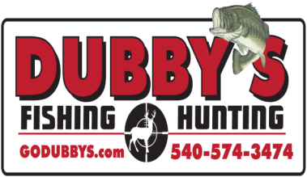
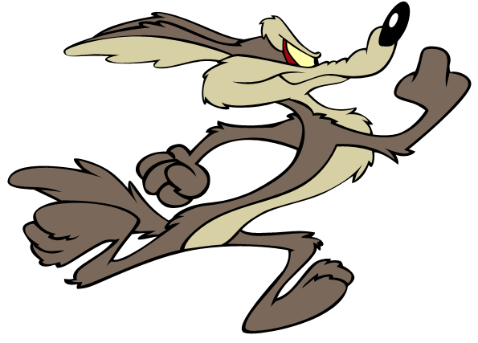
DUBBY'S SUMMER COYOTE TOURNAMENT

This year Dubby's is doing a Summer Coyote only Tournament. The entry fee will be $150.00 per team. $125.00 will go to the payout of the current tournament. $15.00 will go to 1st Big Coyote. $5.00 will go to 2nd Big Coyote.

Please read the rules for additional tournament information.
For More Information Call 540-574-FISH
Or Stop By 100 Waterman Drive

Dubby's Fishing and Hunting
100 Waterman Drive
Harrisonburg Va. 22802
540-574-FISH (3474)
Closed Sundays and Mondays

Tournament Details

WHEN
Saturday June 22nd 2019 Through Sunday June 23rd 2019

Sign-in Hours to begin Tournament
Saturday 3pm to 5pm
Check-in Hours to end Tournament
Sunday 8AM (Don’t Be Late)
Any Team Checking in after 8:00AM
WILL BE DISQUALIFIED
(One Team Member must come to Saturday Sign-in)
(All Team Members must come to Sunday Check-in)

WHERE
Dubby's Fishing and Hunting
100 Waterman Drive
Harrisonburg Va. 22802
540-574-FISH (3474)

Hunting IN
Virginia And West Virginia
(See Rules For Off Limits)

REGISTRATION & COST
Register at Dubby’s. Stop by
100 Waterman Drive or Call for info
540-574-3473 1-855-574-3474
(Cash, Check)
Kill blocks are required on every
Coyote.

Door Prize's / To Be Determined.

$150.00 Entry Fee – 2 to 3 Person teams.
(Absolutely No Single’s Hunting)

> Tournament – Total combined Point’s
of all your Coyotes.
> 1st Biggest Coyote
> 2nd Biggest Coyote
POTENTIAL PAYOUT BASED ON 50 TEAMS
1 Place for Every 5 Teams.
1st) $1725.00
2nd)$1195.00
3rd) $835.00
4th) $590.00
5th) $415.00
6th) $415.00
7th) $300.00
8th) $300.00
9th) $215.00
10th) $215.00

Dubby's Fishing and Hunting
100 Waterman Drive
Harrisonburg Va. 22802
540-574-FISH (3474)
Closed Sundays and Mondays

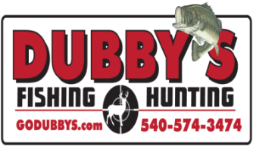

Dubby's Coyote Tournament Rules
Page 1

- Team cancellation request must be received 72 hours in advance of the start of the tournament for refund. Any team that pre-registers and does not show (ALL Team Members Must Hunt) is considered a forfeit. You may not switch teams after you have registered.
- Only 2 or 3 people on a team (no single man team allowed for safety reasons). You cannot have aid with transportation, driving, retrieving or transporting Predator’s. No pooling of kills between teams.
- Off Limits are any Commercial or Privately-owned lands that you do not have written Permission to hunt on. Any Posted land that you do not have written Permission to hunt on. Any land restricted by State or Local Authorities.
- Legal Species by Virginia and West Virginia Regulations: Coyote. No Trapping or Snaring. No Road Kill.
- Coyotes can be taken with any Firearm caliber Legal and capable of taking that Coyote swiftly.
- Each Team Member must have a Valid Hunting license. You are responsible for following all laws and regulations.
- There is no Limit to how many Coyotes’ you bring in. Winner will be determined by the total points of tournament kill. Teams are responsible to have their kill ready to be checked in, Kill Block in place.
- You must use one vehicle while hunting the tournament and it must be the same vehicle.
- Kill Blocks Must be provided by you. Kill Blocks must be placed in the mouth of every Predator at the time of kill with a number that will be provided at registration It must be written on the block at the location of the kill. Please take pictures of each kill at the time of the kill. (See attached for Kill Block Info.)
- Each team will be given two tokens with their team number on it. A team member must present one token to a staff member at Dubby’s Fishing and Hunting for Check-in. Points cannot be counted without the token.
- No frozen Coyotes allowed.

Dubby's Coyote Tournament Rules
Page 2

- Teams must respect others in the field and out. No crowding and no harassing other teams.
- Absolutely no teaming up, no buddy system and no transferring or transporting of kill from one team to another.
- Disposal of your kill is your responsibility. Please do so respectably. If you do not want them let us know, someone else may want them. NO DUMPING OF YOUR KILL ALONG THE ROAD.
- Any participant involved in poor sportsmanship, heated arguments or similar behavior will have their team warned or disqualified at DFnH staff option. We will not allow any altercation, including inappropriate cursing of others before, during or after the tournament. All TEAMS involved will be warned or disqualified regardless of fault. You are guilty by involvement. Zero tolerance.
- Any physical altercations by participants will result in the team being disqualified and banned from any future DFnH Tournaments and will be asked to leave immediately.
- No alcohol or drugs permitted, during the hunt or at Check-in. If you are perceived under the influence you will not be allowed to enter or will be disqualified. Final determination of a disputed claim will be determined by
local on-call law enforcement.
- No live decoys and /or dogs. (No running or tracking wounded with dogs.) No baiting.
- Mouth calls, hand calls and electronic calls can be used.
- Any Coyote brought to Check-in after 1:00pm will not be counted.
- You have to locate and call your own coyotes. You cannot have a second team or individual out scouting for you.
- All entrants must be present and available for truth verification at Final check-in Sunday. If you are not willing to participate in truth verification, please do not enter this tournament.
- All prize money will be awarded after official results have been determined and verified.
- The scoring system will be a points system.
- Coyote = 1-Pt.
- (In case of a tie, the team with the largest total combined weight of animals wins)
- ALL TEAMS MEMBERS MUST BE PRESENT TO WIN!!!

Dubby's Coyote Tournament Rules
Page 3

- VDGIF is working with us and will notify us of any complaints and incidents. Any citation will be called in to DFnH staff and get you disqualified.
- DFnH has the right to change and enforce rules as deemed necessary and has the right to deny entry and/or disqualify any team at any time for any reason as they see fit to preserve safety and the integrity of our tournament.
- Failure to comply with tournament rules will result in disqualification and entry fee will be forfeited.
- The decision of tournament results will be final.
- Any accusation of a team cheating must be accompanied by a $100 protest fee and concrete evidence of such. Photos, videos, proof of citation etc. If tournament staff agrees with your protest, the protest fee will be refunded and the accused team will be disqualified.
- DFnH Tournament staff will have final decision on all protest claims and complaints.

Dubby's Fishing and Hunting
100 Waterman Drive
Harrisonburg Va. 22802
540-574-FISH (3474)
Closed Sundays and Mondays

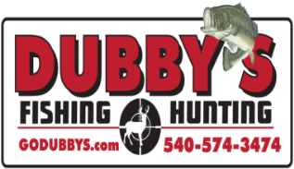

A kill block is an object that is placed into the Coyotes mouth upon death. You must provide your own kill blocks. Each kill block must contain the number provided at registration and the team number. Place the block long ways into the mouth of a coyote so it is completely inside and secure with plastic zip tie around the mouth. If a Coyote is turned in without a “kill block” in its mouth that Coyote is disqualified. The correct size of the kill block should be L-2” X W-1” X D-1”

