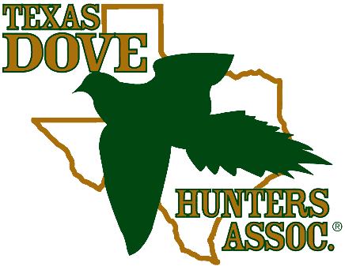

Texas Dove Hunters Association
P.O. Box 127, Bulverde, TX 78163 Office phone: 210-764-1189 Email: info@texasdovehunters.com www.texasdovehunters.com
Texas Dove Hunters Association
16601 N. Blanco Rd., Ste. 205 San Antonio, Texas 78232 office phone: 210-764-1189 fax: 866-233-0507 www.texasdovehunters.com

$1,000 Academic Scholarship

Texas Dove Hunters Association will be selecting (2) high school seniors – one male and one female – to each receive a scholarship in the value of $1,000.

Requirements:
- Students must be graduating from a Texas high school this spring and pursuing a degree at an accredited institution of higher learning (junior college, tech school or four-year university)
- Students must be hunting enthusiasts and support the preservation of hunting and must submit a copy of proof of completion of a hunter safety course or their current Texas hunting license
- Must include one letter of reference from a teacher, counselor, community leader or clergy (may not be a relative)
- Students must provide an OFFICIAL sealed transcript
- If chosen as a scholarship recipient, must be able to travel to San Antonio on May 16, 2026, for our TDHA Sporting Clay Shoot. We will present the two recipients with the awards that day, take photos, and we’d love for them to participate by shooting the event, if desired. (TDHA Staff will coordinate these details with the two selected recipients.)

Completed application must be postmarked by Friday, April 24, 2026

Name: _______________________________________________________________________

Permanent Address: ____________________________________________________________

City: ______________________________________ State: ________ Zip Code: ____________

Telephone # (______) ________________ Email address: ____________________________

Date of Birth: _______________________

Name of Parent/Guardian(s) with whom you reside: _______________________________

Which dove hunting zone do you live in (circle one): North Central or South

TDHA Scholarship Application page 2 Name of Applicant: ___________________________________

Please complete the questions below. You may use a separate piece of paper if needed. All questions PLUS the essay must be completed and mailed to TDHA’s PO Box to officially apply for the 2026 TDHA Academic Scholarship.

List membership in school-related organizations:

List any activities that demonstrate community leadership and/or involvement (i.e. Scouts, 4-H, civic group or clubs, church, volunteer work, etc.):

List job experiences (i.e. after school, summer, paid/unpaid, internships, etc.):

How did you learn about the Texas Dove Hunter’s Association Scholarship?

High School: ____________________________________ Expected Graduation Date: _______________

Address: _________________________________________________________________________

Names of school(s) applied to or planning to attend:

_____________________________________ _____________________________________

_____________________________________ _____________________________________
Major and/or Minor Area of Study: ___________________________________________

What would you like to do for your profession once out of college? (If you don’t know yet, that is OK, and you can leave blank)

ESSAY REQUIRED:
Choose ONE of the topics below and write a brief essay. Essay must be typed, double-spaced and should not exceed three pages.

- My Favorite Family Hunting Memory
- My Views on the Preservation of the Second Amendment

TDHA Scholarship Application page 3 Name of Applicant: _________________________________

You will also need one letter of reference from a teacher, counselor, community leader or clergy (may not be a relative).

Release
By signing this form, I hereby grant the Texas Dove Hunters Association the unconditional right to use my name, photo, essay, and thank you letter in connection with press releases, social media, and/or publications.

___________________________________________ ______________________
Signature of Applicant Date

___________________________________________ ______________________
Signature of parent or guardian (if applicant is under 18) Date

Does your high school have an awards banquet? (circle one) Yes No If so, when? __________________

Before mailing this application please check for the following:

❒ I remembered to complete and enclose ALL pages of my application
❒ I have enclosed my ESSAY (If I am a winner, I will provide TDHA with an electronic copy)
❒ I have enclosed my LETTER OF REFERENCE
❒ I have enclosed OFFICIAL, SEALED TRANSCRIPTS
❒ I have enclosed proof of my hunter safety course or hunting license

Applications must be postmarked by Friday, April 24, 2026

Mail completed application to:
Texas Dove Hunters Association
P.O. Box 127
Bulverde, Texas 78130

