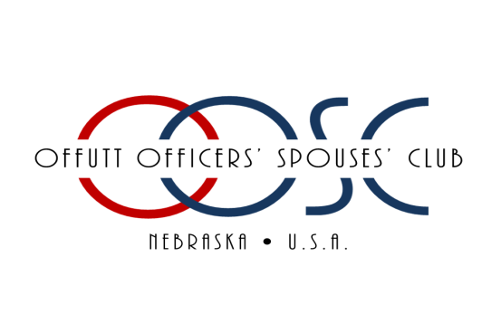
THE OFFUTT OFFICERS' SPOUSES' CLUB CHARITABLE ASSOCIATION, INC.
2023-2024 ACADEMIC SCHOLARSHIP AWARD APPLICATION FOR HIGH SCHOOL SENIORS
Due March 17, 2023
Please Print: Name:
_____________________________________________________________________________________
LAST FIRST MIDDLE
Address: _____________________________________________________________________________________
STREET CITY STATE ZIP
Cell Phone: ______________________________________
E-mail Address: _____________________________________________
High School: _____________________________________________________________________________________
High School Address: ___________________________________________________________________________________
Current High School Counselor: _____________________________________________________________________________________
School Phone: _____________________________Counselor’s Extension: ________________________________
Indicate your qualifications for eligibility:
- Sponsor active duty
- Sponsor retired (rank and year)
- Sponsor deceased while on active duty or retired
- Sponsor employed at, or retired from Offutt AFB
- Sponsor is a military member assigned to a local military unit assigned to Offutt AFB
Name of Sponsor *Must be affiliated with Offutt AFB*
_____________________________________________________________________________________
PLEASE INDICATE SPONSOR RANK and (unit and contact number if applicable). _____________________________
Please submit all of the following materials by March 17, 2023:
a. One official or unofficial transcript including most recent seven semesters of high school work.
b. An official or unofficial copy of current ACT or SAT scores (if they are not required for your college or program, please email us at scholarshipsoosc@gmail.com with your name and the date of your application)
c. Completed application form
d. A separate resume of education and activities in the school and community (outside school hours, to include volunteer work, community involvement, sports, and/or work) *maximum of two pages
f. A 300- 500 word essay answering the following: “If you were to give a TED talk or a lecture, what would your topic be on? Discuss a time/experience that helped you be knowledgeable about this topic.”
NOTES: Applicant MUST be enrolled for Fall 2023 in order to receive this scholarship. Scholarships will be sent directly to the School/Institution enrolled for Fall 2023.
I hereby authorize the OOSC Scholarship Awards Committee and Selection Panel to examine my school transcript(s) and other school records. I understand that this application and supporting documents will be kept in strict confidence. I certify that the information contained in this application is accurate to the best of my knowledge and belief. If awarded a scholarship administered by the OOSC, I agree to abide by and fulfill all requirements pertaining to those scholarships. I further acknowledge that I have read and fully understand the Scholarship Information Page.

_____________________________________________________________________________________
APPLICANT SIGNATURE DATE

_____________________________________________________________________________________
PARENT OR GUARDIAN SIGNATURE DATE
Please email completed completed application to scholarshipsoosc@gmail.com or mail to address below postmarked no later than March 17th, 2023
Offutt Officers Spouses Club
Charitable Association
PO BOX 13016
Offutt AFB
Omaha, NE 68113

***Please review the OOSCCA Academic Scholarship Policies and Procedures BEFORE submitting your application. We are not responsible for applications that get lost in the mail.***

