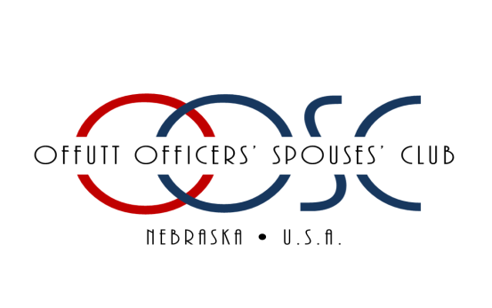
THE OFFUTT OFFICERS' SPOUSES' CLUB CHARITABLE ASSOCIATION, INC.
2023-2024 ACADEMIC SCHOLARSHIP AWARD APPLICATION FOR SPOUSES & DEPENDENTS
Due March 17, 2023
Please Print: Name:
_____________________________________________________________________________________
LAST FIRST MIDDLE
Address: _____________________________________________________________________________________
STREET CITY STATE ZIP
Cell Phone: ______________________________________
E-mail Address: _____________________________________________
School of Current Enrollment:
_______________________________________________________________________________________
School Address:
__________________________________________________________________________________________________
Course of Study:
__________________________________________________________________________________________________
School Phone: _______________________________________
Indicate your qualifications for eligibility:
- Sponsor active duty
- Sponsor retired (rank and year)
- Sponsor deceased while on active duty or retired
- Circle ONE of the following:
  - I am dependent age 18-24
  - My spouse is my sponsor
Name of Military Sponsor:
_______________________________________________________________________________________

Please submit the following materials by the March 17, 2023 application deadline:
a. Official or unofficial transcript(s) and GPA showing courses related to field of study, or documentation of enrollment in an accredited trade school. Note: Applicant MUST be enrolled for Fall 2023 in order to receive this scholarship.
b. Completed application form
c. Resume including any accolades, awards, and community service activities
d. A 300- 500 word essay answering “If you were to give a TED talk or a lecture, what would your topic be on? Discuss a time/experience that helped you be knowledgeable about this topic.”
NOTE: Scholarships will be sent directly to the School/Institution enrolled for Fall 2023.

I hereby authorize the OOSC Scholarship Awards Committee and Selection Panel to examine my school transcript(s) and other school records. I understand that this application and supporting documents will be kept in strict confidence. I certify that the information contained in this application is accurate to the best of my knowledge and belief. If awarded a scholarship administered by the OOSC, I agree to abide by and fulfill all requirements pertaining to those scholarships. I further acknowledge that I have read and understand fully the Scholarship Information Page.

_____________________________________________________________________________________
APPLICANT SIGNATURE DATE

Please email completed completed application to scholarshipsoosc@gmail.com or mail to address below postmarked no later than March 17th, 2023
Offutt Officers Spouses Club
Charitable Association
PO BOX 13016
Offutt AFB
Omaha, NE 68113

***Please review the OOSCCA Academic Scholarship Policies and Procedures BEFORE submitting your application. We are not responsible for applications that get lost in the mail.***

