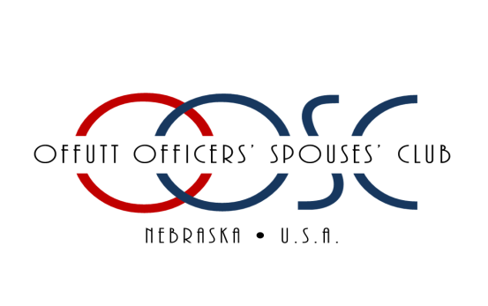

THE OFFUTT OFFICERS' SPOUSES' CLUB CHARITABLE ASSOCIATION, INC.

2022-2023 ACADEMIC SCHOLARSHIP AWARD APPLICATION

Due March 18, 2022

Please Print: Name:

_____________________________________________________________________________________

LAST FIRST MIDDLE

Address: _____________________________________________________________________________________

STREET CITY STATE ZIP

Cell Phone: ______________________________________

E-mail Address: _____________________________________________

School of Current Enrollment:

_______________________________________________________________________________________

School Address:

__________________________________________________________________________________________________

Course of Study:

__________________________________________________________________________________________________

School Phone: _______________________________________

Indicate your qualifications for eligibility:

* Sponsor active duty
* Sponsor retired (rank and year)
* Sponsor deceased while on active duty or retired

Name of Military Sponsor: _______________________________________________________________________________________

Please submit the following materials by the **March 18, 2022** application deadline:

a. Official or unofficial transcript(s) and GPA showing courses related to field of study, or documentation of enrollment in an accredited trade school. Note: Applicant MUST be enrolled for **Fall 2022** in order to receive this scholarship.

b. Completed application form

c. A 300- 500 word essay answering “Pick a quote that describes you, and explain why you connect with it.”

NOTE: Scholarships will be sent directly to the School/Institution enrolled for Fall 2022.

I hereby authorize the OOSC Scholarship Awards Committee and Selection Panel to examine my school transcript(s) and other school records. I understand that this application and supporting documents will be kept in strict confidence. I certify that the information contained in this application is accurate to the best of my knowledge and belief. If awarded a scholarship administered by the OOSC, I agree to abide by and fulfill all requirements pertaining to those scholarships. I further acknowledge that I have read and understand fully the Scholarship Information Page.

_____________________________________________________________________________________

APPLICANT SIGNATURE DATE

_____________________________________________________________________________________

PARENT OR GUARDIAN SIGNATURE DATE

**POSTMARKED NO LATER THAN MARCH 18, 2022**

***Please review the OOSCCA Academic Scholarship Policies and Procedures BEFORE submitting your application. We are not responsible for applications that get lost in the mail.***