

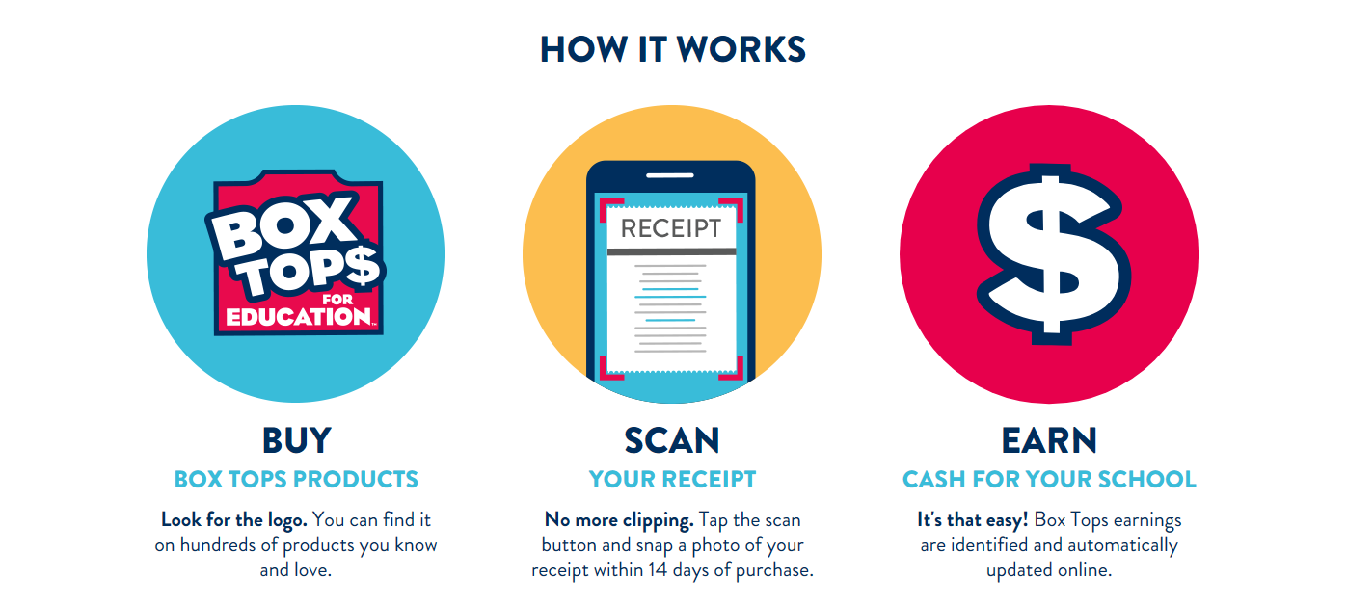

Join for Free!

**Sewell Elementary School** or **Centre City Elementary School**

Scan your receipt for real time earnings!

No more clipping & sending to school!

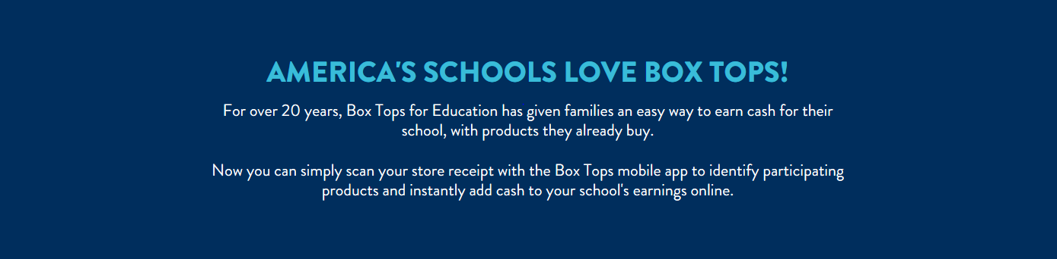

**You can still clip them and send them to school.**  Physical Box Top clips are being phased out of production, but may continue to be found on many products throughout the store.  Send your clipped Box Tops, along with any unexpired clips you may have at home, to school.*