📋 Program Rules
Welcome! We want everyone to feel safe, happy, and respected.

😊 1. Be Kind
🤝 Be nice to others
🗣️ Use kind words
🚫 No hitting, pushing, yelling, or threatening
Everyone has the right to feel safe.

🛑 2. Stay Safe
👂 Listen to staff
🏢 Stay in the building or with the group
🤕 Tell staff if you feel sick or hurt
🆘 Ask for help when you need it

🎨 3. Activities & Choices
🧩 You can choose activities. Each individual will help with planning the monthly calendar.
🎵 We will offer different options
🙋 It is okay to say “no” and choose something else
We want you to enjoy your day!

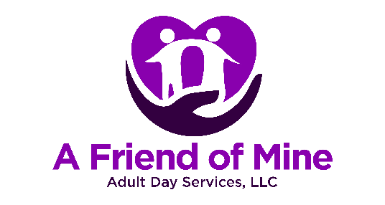

🎒 4. Personal Items
🏷️ Put your name on your things
📱 Bring only what you need
⚠️ The program is not responsible for lost, stolen or broken items

💊 5. Health Rules
💊 All medication will be given by trained staff
🚭 Smoke only in approved areas (if allowed)
🚫 No alcohol or illegal drugs

⏰ 6. Attendance
📅 Come on your scheduled days
📞 Call if you will be absent
🕓 Arrive and leave at your scheduled time

⚖️ 7. Your Rights
💜 You have the right to be respected
🗣️ You can speak up if something is wrong
🛡️ You will not get in trouble for sharing a concern
📢 Tell staff if you have a complaint
We are here to help you.

Agreement
I understand these rules. I will follow them so everyone can have a safe and good day.
Participant Name: ___________________________
Signature: _________________________________ Date: __________
Guardian (if needed): _______________________ Date: __________
Staff Signature: ____________________________ Date: __________

