Regulation: | Policy:  Camera Use
Issued: February 2026 | Revised: | Page(s): 1 of 4

Purpose
The purpose of this policy is to outline the appropriate use of video monitoring cameras at A Friend of Mine Adult Day Services to promote the safety, security, and well-being of individuals, staff, and visitors while respecting individual rights to privacy, dignity, and confidentiality.

Scope
This policy applies to all individuals receiving services, employees, volunteers, contractors, visitors, and authorized representatives.

Policy Statement
A Friend of Mine Adult Day Support utilizes video monitoring cameras in limited and specific areas of the facility for safety, security, and monitoring of building access. Cameras are not used to replace direct supervision or for continuous monitoring of individual behavior. The program is committed to ensuring that camera use complies with all applicable federal, state, and DBHDS regulations, including protections for privacy and confidentiality.
Cameras are installed only in common and exterior areas and are never placed in private areas such as bathrooms, changing areas, or any location where an individual has a reasonable expectation of privacy.
The use of video monitoring does not replace, reduce, or diminish direct staff supervision or support of individuals. Staff remain responsible for active supervision, engagement, and implementation of individualized supports at all times.

Regulation: | Policy:  Camera Use
Issued: February 2026 | Revised: | Page(s): 2 of 4

Camera Locations
Video cameras are currently located in the following areas:
- Common areas within the facility (e.g., shared activity spaces)
- Exterior areas surrounding the building (e.g., parking lot and building perimeter)
- Ring camera at the front entrance door for monitoring entry and exit
No audio recording is conducted.

Purpose of Camera Use
Cameras are used for the following purposes:
- To enhance the safety and security of individuals, staff, and visitors
- To monitor building access and prevent unauthorized entry
- To support incident review when safety concerns arise
- To assist with investigations related to health, safety, or security incidents
Cameras are not used for:
- Routine staff performance evaluations
- Behavior management or disciplinary monitoring of individuals
- Any form of surveillance that infringes upon individual dignity or rights

Access to Recordings
- Access to live feeds and recorded footage is limited to authorized personnel only (e.g., Program Director, Law enforcement, APS,and .
- Recordings are reviewed only when necessary for safety, security, incident investigation, or as required by licensing or regulatory authorities.
- Video footage will not be shared with unauthorized persons.
- Recordings may be released only with proper authorization, legal requirement, or written consent from the individual or their authorized representative.
- Law enforcement, Adult Protective Services (APS), and the Office of Human Rights will be granted access to stored video data when required as part of an official investigation or regulatory review, in accordance with applicable laws and regulations.

Regulation: | Policy:  Camera Use
Issued: February 2026 | Revised: | Page(s): 3 of 4

Storage and Retention
- Video recordings are stored securely using password-protected systems.
- Recordings are retained for a limited period consistent with operational needs and legal requirements, after which they are automatically deleted unless needed for an active investigation or legal matter.
- Recordings are maintained for thirty (30) days and are automatically deleted after this period unless they are required for an active investigation, legal matter, or regulatory review.

Confidentiality and Privacy
- All video footage is considered confidential
- Video recordings are handled in accordance with HIPAA and applicable state confidentiality laws.
- Staff are trained on confidentiality requirements and appropriate use of video monitoring systems.

Notification of Camera Use
- Individuals and their parents or authorized representatives are informed of the presence and purpose of cameras prior to or at the time of enrollment.
- Written notification and acknowledgment of camera use is obtained during the enrollment process.
- Signage is posted at facility entrances indicating the use of video monitoring.

Rights of Individuals
- Individuals retain all rights to privacy, dignity, and respect.
- Individuals or authorized representatives may ask questions regarding camera placement and use.
- Concerns related to camera use may be reported to the Program Director without fear of retaliation.

Staff Responsibilities
- Staff must not tamper with, disable, or misuse camera equipment.
- Staff must immediately report any malfunction or concern related to camera systems.
- Unauthorized viewing, sharing, or distribution of video footage is strictly prohibited and may result in disciplinary action.

Regulation: | Policy:  Camera Use
Issued: February 2026 | Revised: | Page(s): 4 of 4

Procedure
- Cameras are installed and maintained by authorized personnel only.
- Camera placement is reviewed periodically to ensure compliance with privacy standards.
- Authorized personnel may review footage only for approved purposes.
- Any request for footage is documented and reviewed by the Program Director.
- Incidents involving camera footage are documented according to program policy.

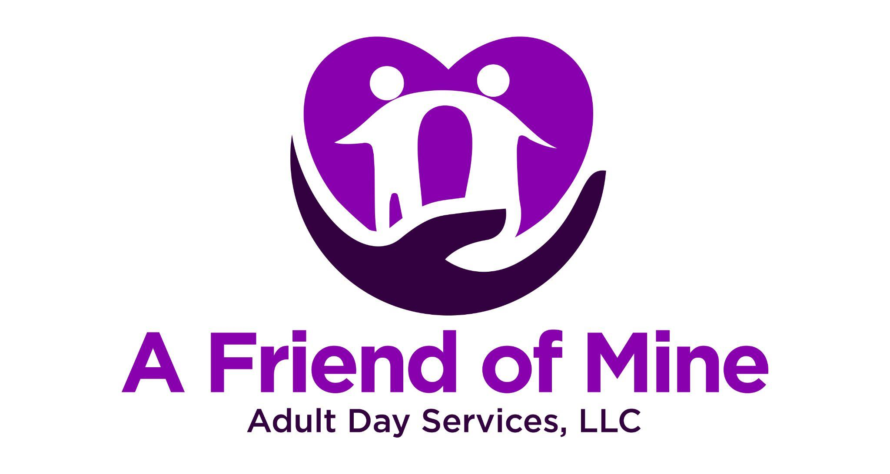

Camera Use Notification and Acknowledgment
Program Name: A Friend of Mine Adult Day Services
I acknowledge that I have been informed that A Friend of Mine Adult Day Support utilizes video monitoring cameras in common areas, exterior areas of the building, and a Ring camera at the front entrance for safety and security purposes.
I understand that:
- Cameras are not located in private areas such as bathrooms or changing spaces
- Video recordings are used only for safety, security, and incident review purposes
- All recordings are kept confidential and accessed only by authorized personnel
I have had the opportunity to ask questions regarding camera use and have received satisfactory answers.
Individual Name: ________________________________
Parent/Authorized Representative Name (if applicable): ________________________________
Relationship to Individual: ________________________________
Signature: ________________________________
Date: ________________________________

