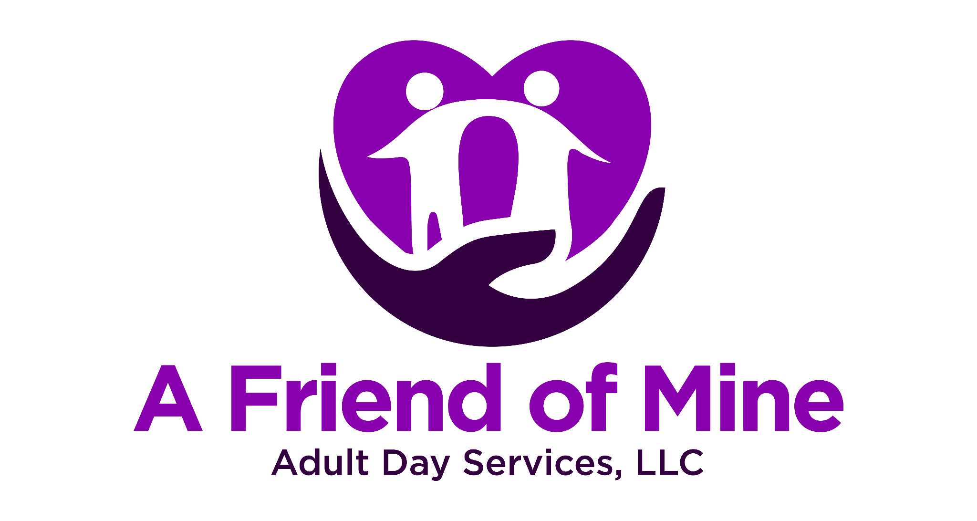
Liability Waiver and Release Agreement
This Liability Waiver and Release Agreement (“Agreement”) is entered into between A Friend of Mine Adult Day Services, LLC and the undersigned participant or their legal guardian/representative _______________________________________________
By signing this Agreement, the undersigned agrees to the following terms and conditions:

1. Acknowledgment of Services
The Participant acknowledges that A Friend of Mine Adult Day Services, LLC provides services, activities, and programs designed to support adults with developmental disabilities. While the Center makes every effort to provide a safe environment, there are inherent risks associated with participation in activities, including, but not limited to:
- Accidental injury (e.g., falls, minor cuts, or scrapes).
- Health-related incidents (e.g., medical emergencies, allergic reactions).
- Behavioral incidents involving other participants.

2. Assumption of Risk
The Participant understands and agrees that participation in Center programs and activities may involve certain risks. The undersigned voluntarily assumes all risks, both known and unknown, associated with participation, including those arising from the negligence of the Center, its employees, volunteers, or agents.

3. Release of Liability
The Participant, on behalf of themselves, their heirs, legal representatives, and assigns, hereby releases, waives, discharges, and agrees to hold harmless A Friend of Mine Adult Day Services, LLC, its employees, volunteers, agents, affiliates, and sponsors from any and all claims, liabilities, demands, or causes of action arising out of or related to:
- Injuries sustained while participating in Center activities.
- Any loss or damage to personal property.
- Any unforeseen incidents occurring during transportation to or from the Center.

4. Medical Consent
In the event of a medical emergency, the undersigned authorizes A Friend of Mine Adult Day Services, LLC to seek medical treatment for the Participant. The Participant assumes full financial responsibility for any medical expenses incurred.
☐ Check here if specific medical or emergency instructions are attached.

5. Behavioral Risks and Responsibilities
The Participant acknowledges that some activities may involve group settings and interactions with other participants. The undersigned agrees to cooperate with Center staff in managing behaviors to ensure the safety of all participants and understands that disruptive or unsafe behavior may result in temporary or permanent removal from the program.

6. Photographic/Video Consent
The undersigned grants permission for the Participant’s photograph or video to be used by the Center for promotional or educational purposes.
☐ I consent.
☐ I do not consent.

7. Governing Law
This Agreement shall be governed by and construed in accordance with the laws of the state of Virginia.

8. Acknowledgment of Understanding
The undersigned has read and fully understands the terms of this Agreement. They acknowledge that they are signing voluntarily and with full knowledge of its legal significance.
Participant Information
Participant Name: ___________________________
Guardian/Representative Name (if applicable): ___________________________
Address: ___________________________
___________________________________
___________________________________
Phone Number: ___________________________

Signature
Signature of Participant or Legal Guardian/Representative:
________________________________________________________
Date: ___________________________
Witness Signature : _______________________________________
Date: _______________________

