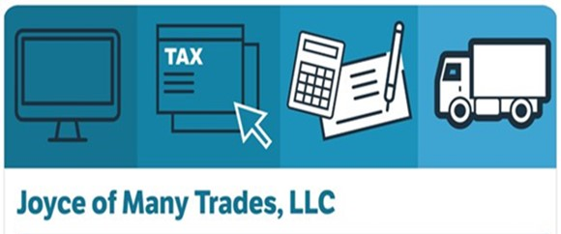
Joyce Jones, MBA
CEO
215-866-6953
joyceofmanytrades.org

BUSINESS SUMMARY
Joyce of Many Trades, LLC is skilled in various aspects of business processes. I created this company in September of 2019 to utilize my multitude of skills and knowledge for self profit. I am an honest, hard working individual that put herself through college and graduate school while working a 40 hour workweek. I am extremely knowledgeable in tax preparation, dispatching, bookkeeping, audit/ compliance, notary public, operations management, resume/cover letter creation and critiques. Additionally, I am skilled in various aspects of tutoring/presentations of all ages.
DIFFERENTIATORS
Joyce of Many Trades, LLC is different than the H&R Block, Liberty Tax Firms, FedEx Copy Centers, SmartHop and Metromax Dispatch to name a few in the sense that I cater to companies and urban professionals that want a detailed oriented person who is efficient, accurate and time conscious. In fact, I pride myself on educating my clients while saving them money in the area they seek assistance.
CORE COMPETENCIES
Joyce of Many Trades, LLC is able to provide any individual or company various administrative tasks as well as professional tax services. I am highly skilled in project and operations management as it relates to my core competencies. In addition, I am very comfortable in presenting several types of educational and financial information to small and large groups of people.
- Former IRS employee extemely knowledgeable about tax law and preparation
- Dispatching
- Bookkeeping
- Audit and compliance
- Small Business LLC Formation
- Capable of maintaining and monitoring substantial payroll records, as well as human resources accounts
- Create and critique resumes
- Various types of letter creation, i.e. credit repair, business follow up
COMPANY DATA
- DUNS 113997064
- Accept direct payments via Zelle, Cashapp, Paypal
- Minority, female owned business
- NAICS Codes
- 488510 561499
- 541199 561990
- 541213 611110
- 541214 611410
- 541219 611430
- 541612 611519
- 541618 611691
- 561110 611710
- 561410
- 561439

