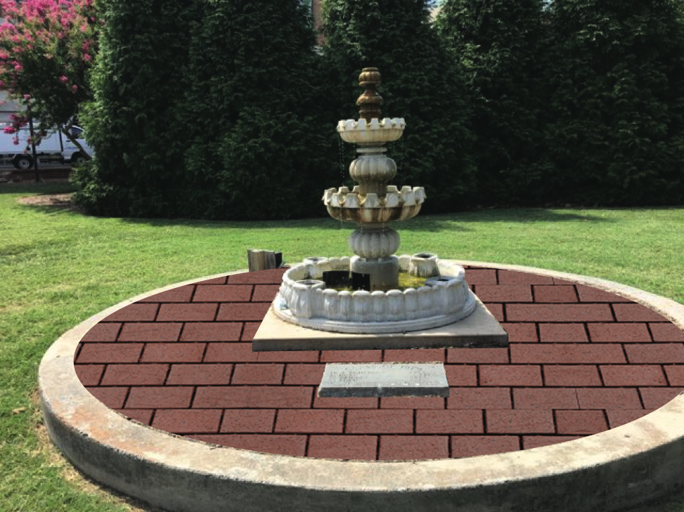  Class of 1979 Brick Fundraiser  “Eagles in Flight Legacy” | NCCU Legacy Brick Fundraiser Application  The “Eagles in Flight Legacy” Brick Fundraiser is a fundraiser for the NCCU Foundation and Class of 1979. We anticipate unveiling the completed project at Homecoming 2019. The campaign is open to Non-Class of 1979 members i.e., sponsors, friends of Class of 1979 and others. There a limited number of spaces so don’t hesitate to be apart of Eagles in Flight Legacy. The members of Class of 1979 are proud to contribute to NCCU’s Beautification, Our Launch Pad of Life.

Applicant Information
First Name |  |  |  | Last |  |  | M.I. |  | Date
Street Address |  |  |  |  |  |  | Apartment/Unit #
City |  |  |  | State |  |  | ZIP
Phone |  |  |  | E-mail Address
Deadline: |  |  |  |  |  |  |  |  |  |  |  |  | x

Brick Cost Lines Letters per Line (Early Eagle Prices) Brick Text Samples
In Memory of
Kevin Numbers
Class of 1979
4” x 8” 3 Lines 19 Characters per line $325
Adrian Bootstrap
Biology Major
Class of 1979
8” x 8” 6 Lines 19 Characters per line $475
12” x 12” 8 Lines 19 Characters per line $695

Brick Information (Please Print) Adhere to Number of characters (19 Letters per line maximum)
Line 1 ____________________________________________________________________________
Line 2 ____________________________________________________________________________
Line 3 (125 Bricks) @ 4”x 8” _____________________________________________________ $325
Line 4 ____________________________________________________________________________
Line 5 ____________________________________________________________________________
Line 6 (12 Bricks) @ 8”x8” ________________________________________________________$475
Line 7 ____________________________________________________________________________
Line 8 (12 Bricks) @12”x12”_______________________________________________________$695

Brick payment
Make Payment To: Michael Bohannon. For Brick Fundraiser. The net proceeds goes to the NCCU Foundation and for Construction, Brick or Paver, Shipping, Placement and Administrative Cost.
Payment made to: Michael Bohannon for Eagle Pride, Soaring Eagle and for Legacy Eagle bricks and pavers.
Send To: Michael Bohannon, Attention NCCU Fundraiser, 160 Fiddlers Ridge, Atlanta, GA 30214
Actual Brick Samples

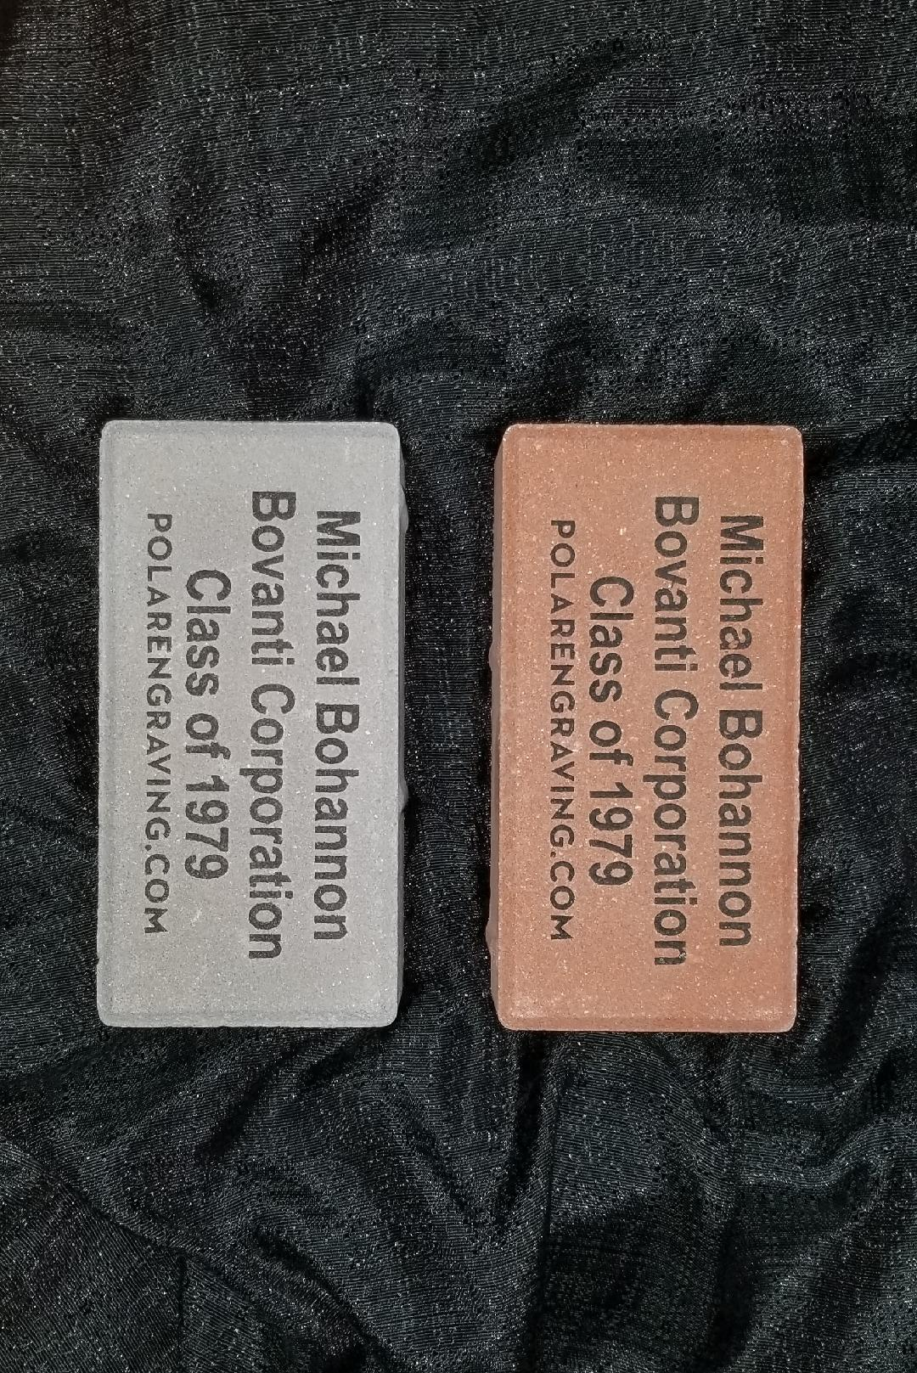
Signature: | ____________________________________________ | Date | ____________________________________

