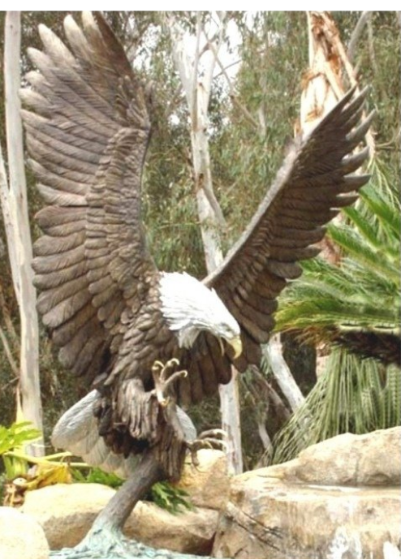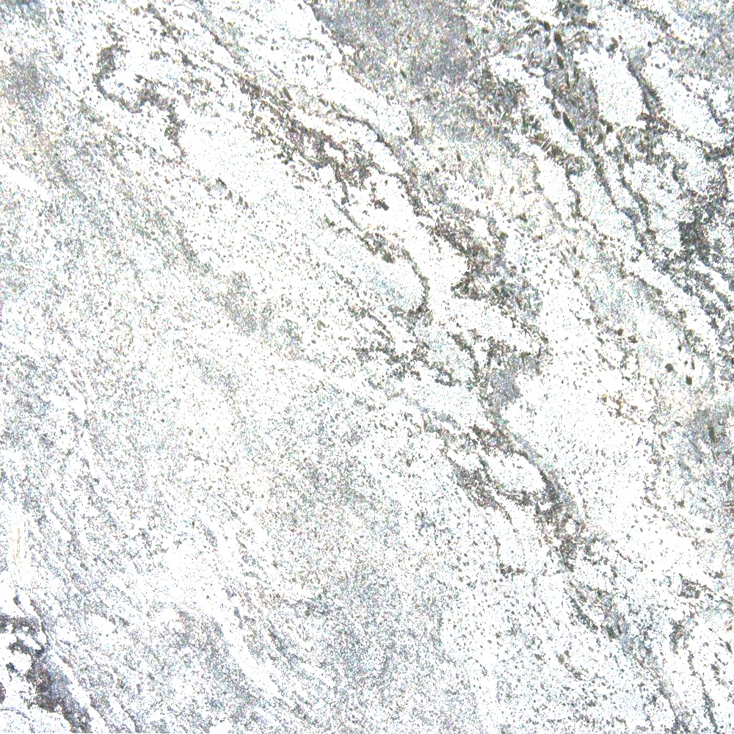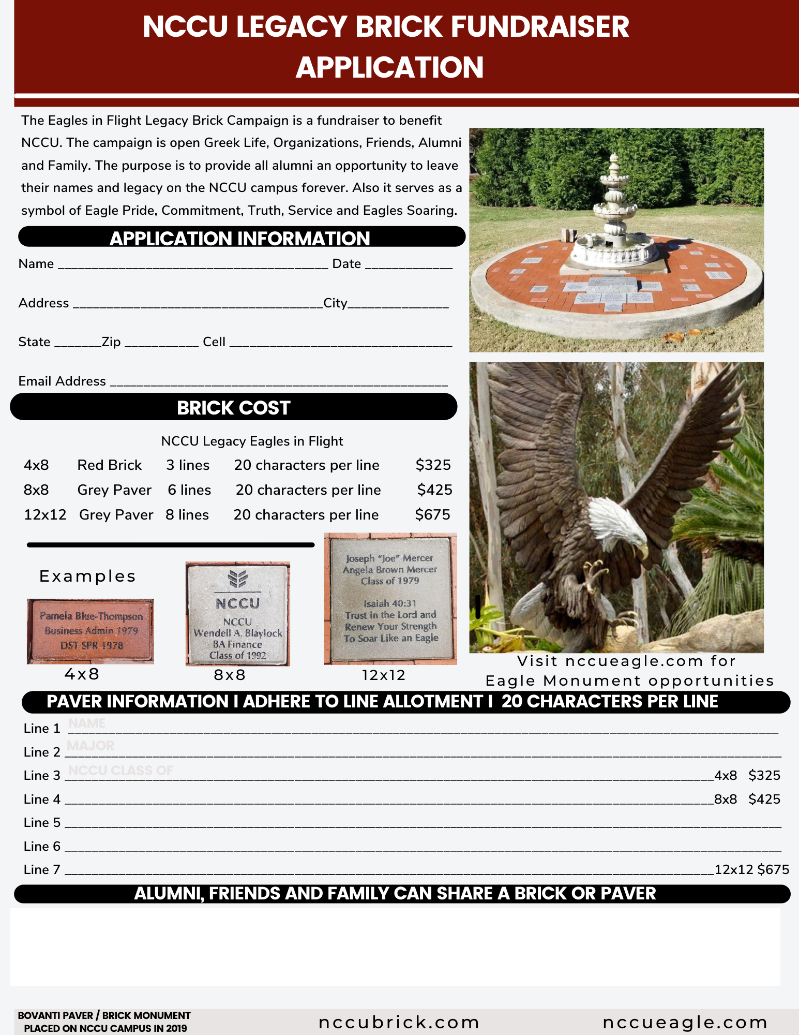

$2,950 General

$3,500 Board Mem.

$5,000 Front

The NCCU Eagle Monument is 8 ft. tall with a Wing span of 7 ft. Color Deep Maroon.



The NCCU Eagle is 8 ft 5inche with a 7 ft wing spang. Perched on its petistal total about 12 feet high

The NCCU Eagle Monument “Flight of Fame” is a fundraiser to benefit North Carolina Central University. Alumni, Alumni Chapters, Greek Organizations, Famous Graduates, Friends and Supporters are welcome to place your name or organization on the NCCU Campus forever with a grey paver. The Eagle serves as a symbol of Eagle Pride, Commitment, Truth & Service. The target date for completion is May 1st, 2022.

**SAMPLES**

**SAMPLES**

**“NCCU Eagle Flight of Fame”**

Eagles in Flight price begins at $2,950. Price depends on positioning and time of purchase. Eagles in Flight 12x12 pavers start around the perimeter of the Eagle Monument. Donor receives: 12x12 paver on the NCCU Legacy Eagle Monument, Certificate of Authenticity and a Gift Pack. The prices are subject to change due to category, product production and construction cost.

P L A N S

NCCU  
Chancellor

James E. Shepard

1910

Donald Byrd

NCCU

Music Director

1975-1980

Ricky Murphy

NCCU

Class of 1979

Ivan Dixon

Actor

NCCU

Class of 1954

H. M. Mickey

Michaux

NCCU

BS/JD

NC Senate

20th District

NCCU EAGLE MONUMEMT FUNDRAISER APPLICATION

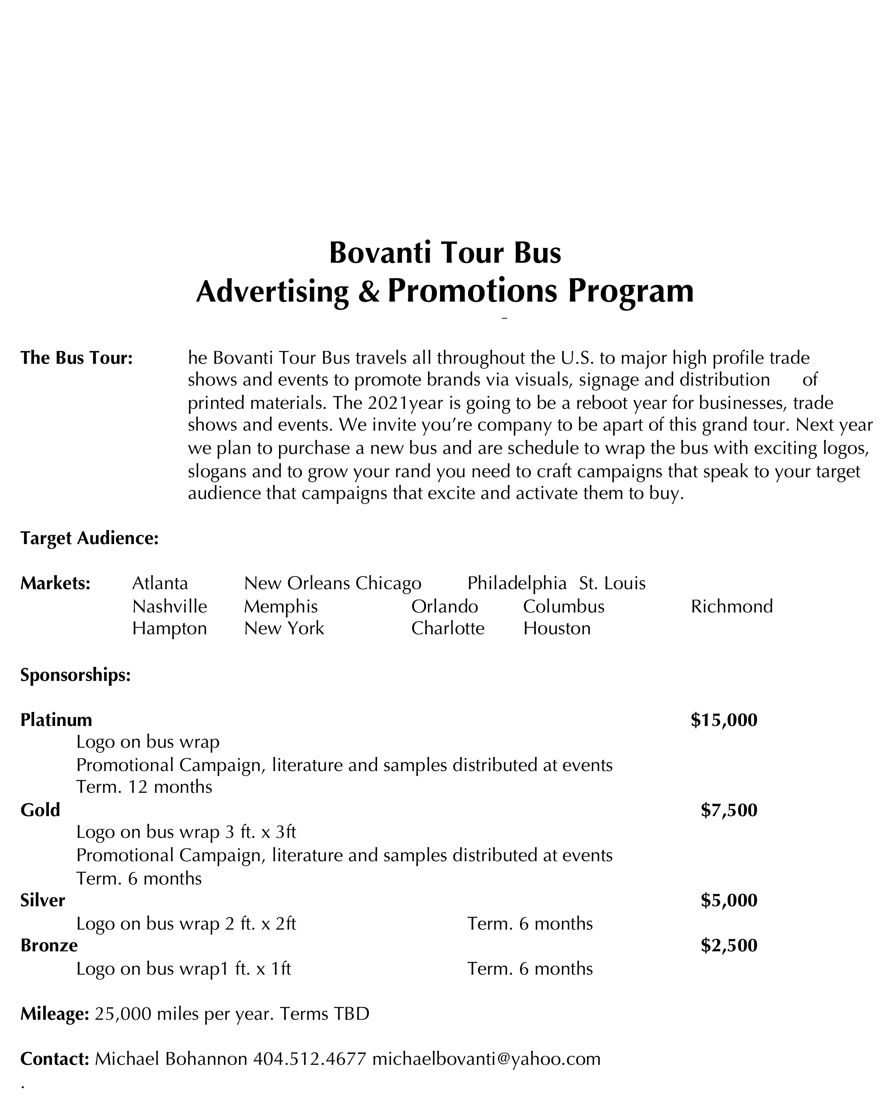

Make Payment to Bovanti: Net proceeds benefit NCCU. Mail To: 160 Fiddlers Ridge, Fayetteville, GA 30214

Bovanti Fundraising revenue goes to the cost of the Eagle Monument. The cost includes administrative, shipping, and construction of the platform. Please download the application, fill out, photograph app and send to michaelbovanti@yahoo.com